Jen Corkran Rabobank
Rabo-research is an independent arm of Rabobank, only bank in NZ that focusses on Agri and strives to have an industry good profile/focus.
Jen is part of the animal protein team – looks at production of meat and milk.

Geopolitics
Relates to inter-countries relationships and how countries manipulate/share/collaborate resources and trade.
In NZ 90% of beef, 95% of lamb and 95% of dairy is exported and USA and China take up to 70% of these.
The high percentage of exports is the opposite of other countries which means we are dependent on global trade. However, the country has the ideal conditions to produce these products as they need temperate climate and that is not achieved closer to the equator. A temperate climate means that can grow good, high-quality forages eg ryegrasses and white clover which prefer low night-time temperatures, eg Kikuya does not and it is poor quality.
Also have a variable weather the length of the country. Also have new sols that are high in carbon and fertile as haven’t been growing on them very long. Means don’t have tot rely on grains like other countries.
Does mean have to grow seasonally but are good at turning that green protein into an export protein which tends to be higher in fatty acids especially Omega 3s.
Global Impacts
Uncertainty, which means countries/business will be cautious – the disruption will not be dissimilar to Covid.
Trump causes trade tension and policy uncertainty and is fostering protectionism which creates more uncertainty.
Our dollar is low = high price for our exports but pay a high price for our imports due to currency volubility.
Geopolitical conflict which will lead to a slower recovery of the economy.
Trumps tariffs (tax on imports – make imported goods more expensive and helps protect local industries). Tariffs can lead to disputes as it is protectionism. This has downward effect on economic growth, lowers living standards and there is less emphasis on comparative advantage. Could also mean that NZ products are not wanted and could end up being sold here at low prices.
NZ had thrived off FTAs however, countries are doing more protectionism.
Recent drop OCR was weaker than expected and that indicates that NZ economy is weaker than expected. NZ$ is weak at US$0.58.
Global beef production is shrinking and is expected to be low in 2026 so prices will be strong. 48% of NZ beef went to USA this year and this is concerning because of the tariffs. However, the price for beef to USA is the highest it’s been. China did have African Swine Fever in 2022 which meant that they ate more beef but China prices down again.
Brazil beef production is down 4-5% but milk is up – exports are also up despite lower production. Brazil pays a 74% tariff into USA. They usually send as much as NZ but this tariff will keep them out of the market. Australia’s production and exports are up and they are only facing a 10% increase in tariff to USA.
Demand for imports is likely to remain high until 28/29 but USA is looking to rebuild their beef herd – it will take up to 5yrs but will be helped by low feed costs. They will need more imports and do less exports while they build their herds.
NZ has 15% tariff with beef but that is not a concern and won’t be until around Nov Dec which is when the US consumers feel the effect.

Lamb
Sheep meat prices are also strong. Lamb export volumes have changed (see graph below) which works well for NZ as it gives diversity of trade. Demand is higher from the UE because they used to import a lot from UK but the UK sheep numbers have dropped. This is partly due to blue tongue https://www.woah.org/en/disease/bluetongue/ a disease that causes weight loss and death and Schmallenberg virus that causes congenital malformations and stillbirths (both diseases are spread by biting midges). Also NZ lamb is smaller than Australia so the UK prefer our cuts eg leg roast. Lamb is less eaten compared to beef and tends to be more niche, more expensive and less versatile.
NZ and Australia are the main exporters of sheep – Australia has more sheep, but they also supply more to their domestic market which makes them less exposed to global volatility. However, Australia lamb slaughter numbers have dropped 20% in recent months – which will be good for NZ.
Global demand is high for sheep meat and that has also reduced the competition from Australia. Lamb prices are up for our exports and outlook is strong into 2026.
China’s local supply of red meat and dairy is down and their economy is flat so that is also good for NZ exports
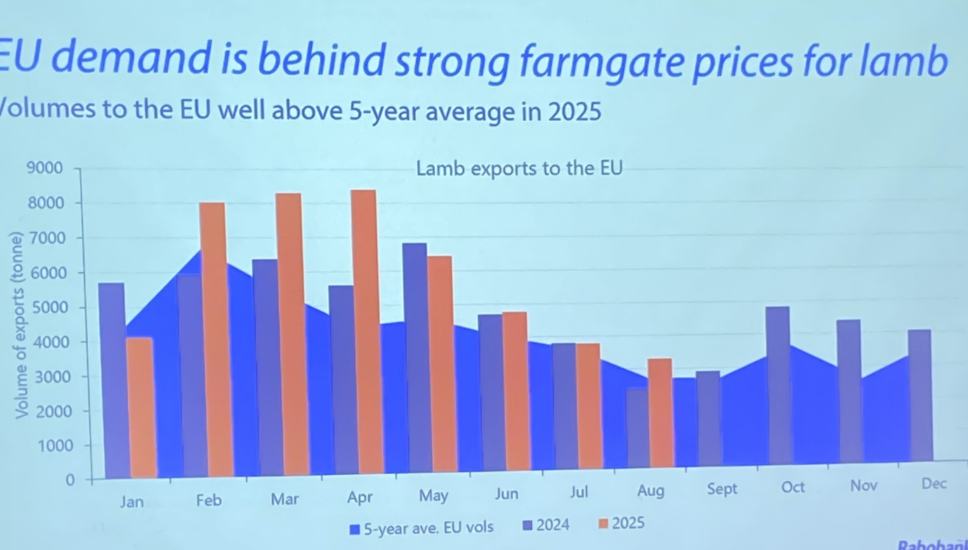
Lamb Prices

Lamb Export Countries
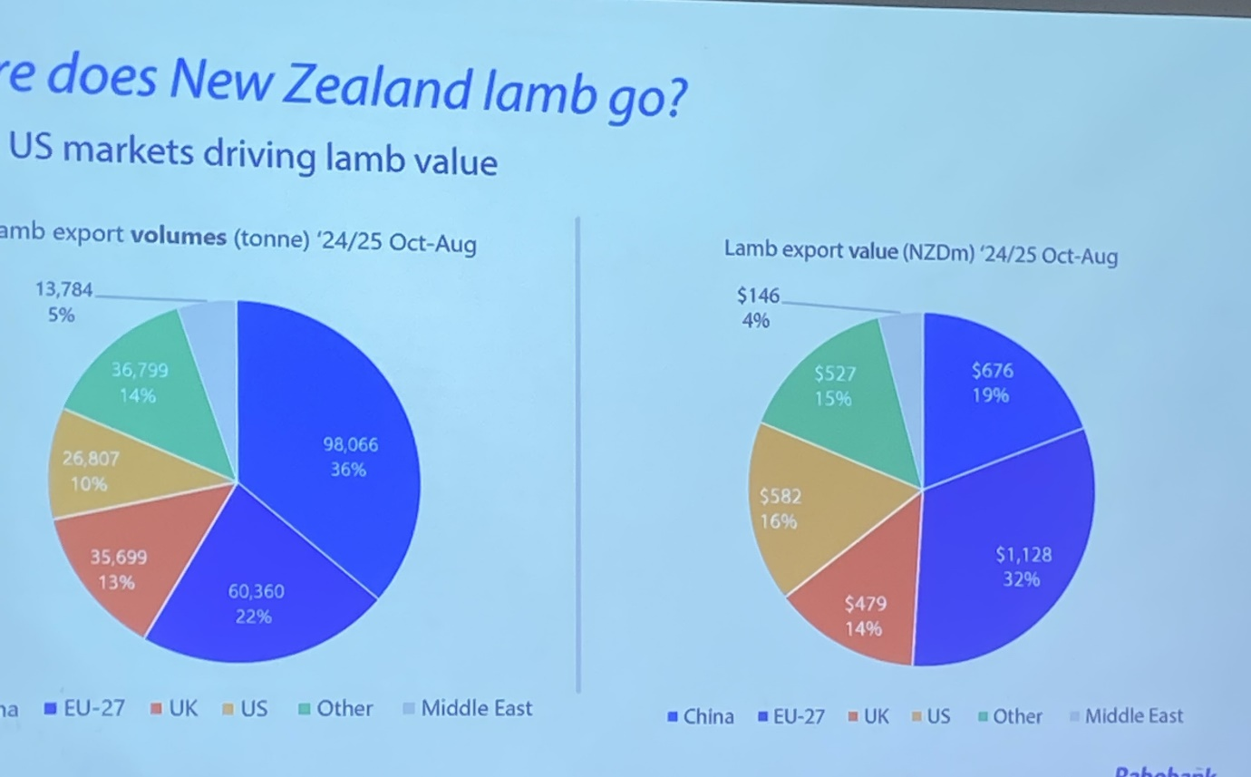
Risks and Wild Cards
- Animal health and disease challenges, also diseases in crops.
- Trade and trade agreements into the future - NZ has thrived on trade agreements and the recent volatility has/will make that more difficult.
- Sustainability and regulation, globally and with our key markets – has been a recent change due to change in govt which has given more certainty to farmers/producers.
- Weather is always something to watch.
- BIOSCURITY is, and has always been, and always will be, the biggest risk

Final Points
2023 and 2024 have been challenging but the outlook looks positive into 2026.
165,000 more calves being breed this year because beef prices are strong – expected increase is to come from dairy beef – this could lead to more beef and less sheep in NZ.
Australia supply of wool is down so China has wanted more of NZ wool which has increased wool prices. However, expect that will be a levelling out of ewes and an increase in beef.
Really high beef prices for calves in the US has slowed their herd increase because the stock are worth so much – expect that prices for us will be high for the next 4yrs and then it will level out as US herd numbers increase.
25% of US hamburger is NZ beef so the 15% tariff is not going to increase the cost of burgers enough for it to affect consumers.

Farm Expenses
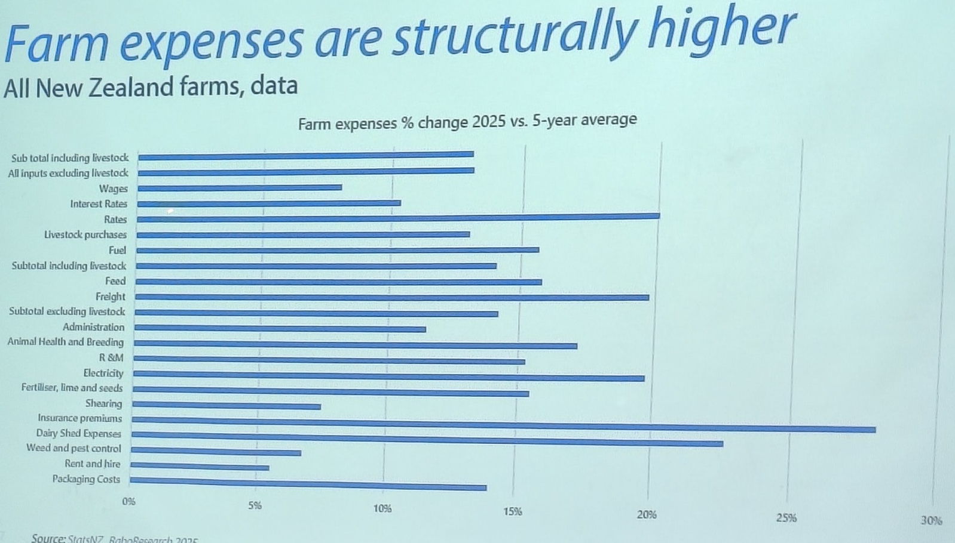
Graph showing changes in farm costs and % that they have increased. Many of these eg insurance (which has gone up due to frequency of climate events), rates (local govt increases), electricity (power companies have increased prices) and freight (cost of fuel) will not drop back down.

