New Zealand Horticultural Industry

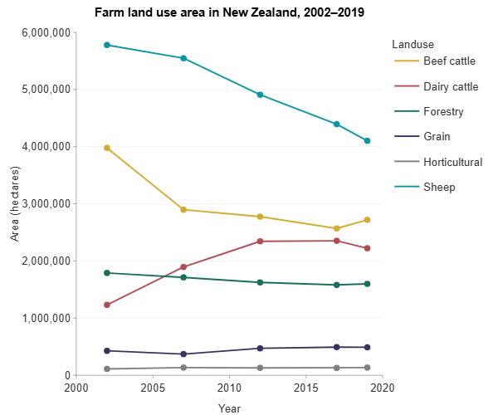
New Zealand's horticultural industry is diverse, producing a wide variety of fruits, vegetables, and flowers. The industry is vital to the country’s economy, both domestic and export. The key regions for horticulture are Hawke’s Bay, Bay of Plenty, Nelson, and Canterbury.

Main Crops and Products
The horticultural industry in New Zealand produces many different types of crops, some of the main ones include:
- Kiwifruit: green, gold and red
- Apples: Royal Gala, Braeburn, and newer ones such as JAZZ™, ENVY™, DAZZLE™, and Koru
- Avocados: demand is growing, especially in international markets
- Citrus fruits: oranges, lemons, and mandarins are grown primarily in the North Island
- Vegetables: huge range of vegetables, including potatoes, carrots, onions, and squash, with large-scale production in areas like the Waikato and Canterbury
- Flowers and Nursery Products: flowers and plants for both domestic sale and export

Markets and Export Destinations
The New Zealand horticultural industry is a major exporter of fresh produce, especially to markets in:
- Asia: particularly kiwifruit, to countries like China and Japan
- North America: kiwifruit, apples, and avocados are exported to the United States and Canada
- Australia: Australia is a key market for many NZ fruits and vegetables

Challenges and Issues Facing the Horticultural Industry
The horticultural industry faces a number of challenges that impact both production and sustainability:
- Climate Change: changes in weather patterns can affect crop yields, especially for temperature-sensitive crops like kiwifruit and avocados
- Water Availability: adequate irrigation is essential for many crops, and water management is a critical issue for growers
- Labour Shortages: many parts of the horticultural industry, especially in fruit picking and packing, face labour shortages, often relying on seasonal workers
- Pest and Disease Management: pests and diseases like psyllid (which affects kiwifruit) and fruit fly or BMSB can damage crops, requiring careful management and biosecurity measures

Innovation and Sustainability in Horticulture
To address these challenges and stay competitive, the horticultural industry in New Zealand is focusing on:
- Sustainable Farming Practices: using fewer chemicals, reducing water usage, and promoting soil regeneration and health
- New Varieties: researching and developing new varieties of crops that are more resistant to pests, diseases, and climate change
- Technology: innovations in crop monitoring, automation, and precision agriculture such as smart irrigation are helping increase efficiency and reduce costs
- Global Certification: many growers are getting certifications for their products, ensuring high-quality standards and traceability for both domestic and export markets

Short Answer Questions

- Which New Zealand region is famous for growing kiwifruit?

- What are two major fruit exports from New Zealand?

- What are some key challenges faced by the New Zealand horticultural industry?

- Why is water availability an important issue for horticulture in New Zealand?

- What is the main vegetable crop grown in New Zealand for export?

- Which country is a major market for New Zealand’s kiwifruit?

- What is one of the key benefits of using sustainable farming practices in horticulture?

- Which crop is grown extensively in Hawke's Bay, aside from kiwifruit?

- Why are pests and diseases a concern for New Zealand’s horticultural industry?

- What is one technological advancement being used in New Zealand’s horticultural industry?

Long Answer Questions
- Explain the importance of the New Zealand horticultural industry. Discuss the main crops grown, key export destinations, and the regions where these crops are produced.

- Discuss the challenges of climate change on New Zealand’s horticultural industry. How are growers addressing these challenges?

- How does New Zealand manage water use in horticulture? Why is water availability a growing issue for farmers in the horticultural sector?

- What are the benefits and drawbacks of relying on seasonal labour in New Zealand's horticultural industry? How are labour shortages being addressed?

- Explain how innovation is helping to overcome challenges in New Zealand’s horticultural industry. Focus on new crop varieties and technological advancements.

- What is the significance of the Asian market for New Zealand's horticultural exports? Which crops are most important for this market?

- How does sustainable farming contribute to the future of New Zealand’s horticultural industry? Provide examples of practices that help reduce environmental impact.

- Describe how the horticultural industry in New Zealand uses pest and disease management strategies to protect crops. Include examples of specific pests or diseases and their impact.

- Compare and contrast the horticultural practices in the North Island and South Island of New Zealand. What crops are most common in each region?

- Why is New Zealand’s horticultural industry focusing on global certification, and what does this mean for the quality of produce being exported?

Answers to Short-Answer Questions

- Which New Zealand region is famous for growing kiwifruit?
Bay of Plenty.

- What are two major fruit exports from New Zealand?
Kiwifruit and apples.

- What are some key challenges faced by the New Zealand horticultural industry?
Climate change, water availability, labour shortages, and pest and disease management.

- Why is water availability an important issue for horticulture in New Zealand?
Many crops, such as fruit trees and vegetables, require irrigation, and water scarcity can affect crop yields.

- What is the main vegetable crop grown in New Zealand for export?
Potatoes.

- Which country is a major market for New Zealand’s kiwifruit?
China.

- What is one of the key benefits of using sustainable farming practices in horticulture?
Answer: Reducing environmental impact and ensuring long-term soil and water health.

- Which crop is grown extensively in Hawke's Bay, aside from kiwifruit?
Apples.

- Why are pests and diseases a concern for New Zealand’s horticultural industry?
They can damage or destroy crops, reducing yield and quality, and increasing the need for chemical treatments.

- What is one technological advancement being used in New Zealand’s horticultural industry?
Smart irrigation systems that use sensors to optimize water usage.

Answers to Long-Answer Questions

- Why is the horticultural industry important to New Zealand? What crops are grown, and where are they grown?
The horticultural industry is important because it helps feed New Zealand and makes a lot of money from exports. Crops like kiwifruit, apples, and vegetables are grown in places like Bay of Plenty (kiwifruit), Hawke’s Bay (apples), and Canterbury (vegetables).

- How does climate change affect the horticultural industry in New Zealand? How are farmers trying to solve these problems?
Climate change causes more unpredictable weather, which can hurt crops. For example, it may be too hot or too rainy for some crops. Farmers are trying to solve this by growing crops that are better suited to these changes and using better water management systems.

- Why is water so important for horticultural crops, and how is it being managed in New Zealand?
Crops need a lot of water to grow, and without enough water, they can’t survive. Water is being managed carefully by using smart irrigation systems that save water and make sure it is used efficiently.

- What problems does New Zealand face when it comes to finding workers for horticulture?
New Zealand has trouble finding enough workers to pick and pack fruits, especially during the busy season. This is a challenge for farmers who rely on seasonal workers.

- How is new technology helping farmers in the horticultural industry?
Technology like smart irrigation and automated tools helps farmers use water and resources more efficiently. This helps improve productivity and reduce waste.

- Why is the Asian market important for New Zealand's horticultural exports?
Countries like China and Japan buy a lot of New Zealand’s kiwifruit and other fruits. This market is very important for the industry because it helps bring in money from abroad.

- How do sustainable farming practices help New Zealand’s horticultural industry?
Sustainable farming helps protect the environment by using less water, reducing chemicals, and keeping the soil healthy for future crops.

- How do New Zealand farmers manage pests and diseases?
Farmers use careful pest control methods, such as monitoring crops for signs of pests and diseases, using safe pesticides, and growing resistant crop varieties.

- What crops are grown in the North Island compared to the South Island?
The North Island grows lots of kiwifruit, citrus fruits, and avocados. The South Island grows vegetables like potatoes and onions.

- Why do New Zealand’s horticultural products need to meet global standards?
Meeting global standards ensures that New Zealand's produce is of high quality and safe for consumers. It helps farmers sell their products in overseas markets.

