New or refreshed Agribusiness Resources 2026

AS91865 Demonstrate understanding of future proofing influences that affect business viability
- Scheme updated.
- Free Range Eggs Assessment

AS91866 Conduct an inquiry into the use of organisms to meet future needs
- Subtropical crops - starter ideas, resources and links to a range of resources

AS91867 Demonstrate understanding of a primary industry business structure that best meets the strategic needs of a business.
- Scheme updated.
- Agri cooperatives better together (WS1)
- Cooperative models offer many benefits (WS)
- Exploring NZ Cooperatives (WS2)
- Meat Cooperative Past or present (WS 3)
- Keeping the wheels turning - The John Austin Ltd Story (WS)
- Vege growers review industry structure (WS)
- NZ cooperatives – notes
- The Day of reckoning (WS)
- Beyond transactions - building trust with Māori agribusiness (WS)
- Māori-owned winery first in NZ to be regenerative certified (WS)
- Picking advisors for exact skills your team is missing (WS)
- Te Hou Farms (WS)
- Value of advisory boards versus management in broadening discussions (WS)
- Market forces nudge succession trends (WS)
- Taranaki herd home pays off for cows and waterways (WS)
- Blending old with new (WS)
- Untapped Māori land has huge agri potential

AS91868 Demonstrate understanding of cashflow forecasting for a business.
- Scheme updated.
- HB growers still rebuilding 3 years after Cyclone Gabrielle (WS)
- Repeat budget blowouts set to impact exporters (WS)
- Farm Focus Resources
  - Demo Farm Workbook
  - Worksheet 1 – Quiz
  - Worksheet 2 – Cashflow Forecast
  - Worksheet 3 – Variance Report
  - Worksheet 4 – Performance and Profitability
  - Video 1 – Managing Farm Business Actuals
  - Video 2 – Farm Financial Management and Budgeting
  - Video 3 – Farm Performance Report, KPIs and Benchmarking

AS91869 Analyse future proofing strategies to ensure long term viability of a business
- Agribusiness in New Zealand Current Issues WS.
- Agribusiness in New Zealand Current Issues Lessons Purple Prism ppt

AS91870 Analyse the effect of financing options of a strategic capital expenditure decision on a business
- Scheme updated.
- Dream realised as Tangaroa Walker gets his farm (WS)
- Sourcing the funds (WS)
- To lease or not to lease (WS)
- Agricultural Financing Options (WS)
- Calculation Profit for Loans and Shares
- When the going gets tough (WS)
- Funding flurry as Tangaroa Walker eyes land purchase (WS)
- Tools for growth (WS)
- Dairy Shelters Assessment
- Blueberry Orchard Assessment
- Cherry Orchard Assessment

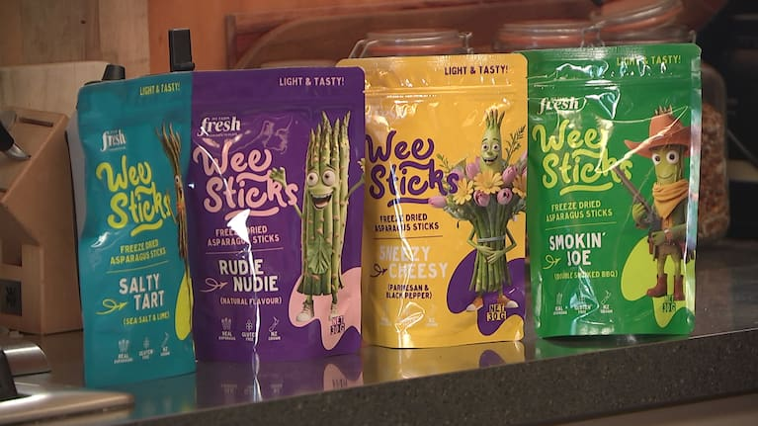
AS91871 Analyse how a product meets market needs through innovation in the value chain
- Scheme updated.
- Asparagus into snacks (WS)
- Turning Sheep Skin into Collagen Gold (WS)
- Innovation Case Study: Growing Pears in New Zealand.
- Updated Agribusiness Examples 2026 PPT
- Updated Directory for the Agribusiness Examples 2026 PPT

Other
- Horticultural Industry Worksheet

