
Unit 1
Primary Production in
New Zealand
Teachers Guide

Unit 1
Primary Production in New Zealand
Teachers Guide

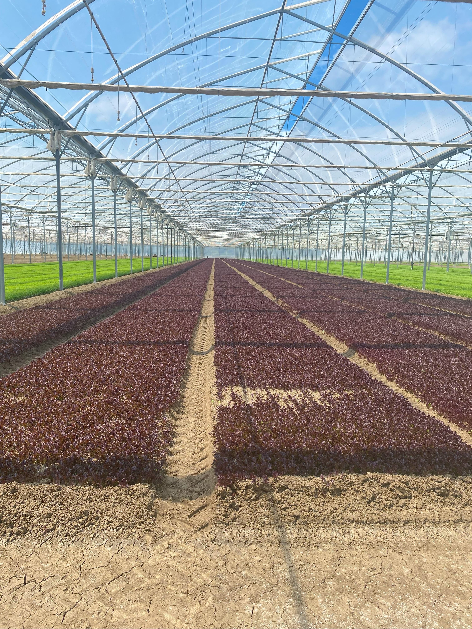

The primary production sector is well established in New Zealand Society and vital to the economy and standard of living. It is a sector of opportunities and challenges.
Teaching years 7-10
We invite and encourage you to teach and inspire students about the primary production sector.
We have developed a resource for you.
Included is
- Teacher guide
- Engaging activities

This resource has been developed by Sow the Seed in conjunction with HATA
For more resources and teaching material for agriculture and horticulture science we invite you to join the Horticulture and Teachers Association HATA

Introduction

Primary Production is a 54 billion+ industry in Aotearoa New Zealand.
In Aotearoa New Zealand, primary production is the process of producing raw materials and products from natural resources, land and water. The main primary industries are agriculture and horticulture, forestry, fishing, and aquaculture, others are turf culture and equine.
A primary production system is a sum of all components, including the growing environment and management practices, that work together in the production of a primary product. Some examples of primary production systems include, dairy farming, sheep and beef farming, orchards such as apple, kiwifruit and cherries.
Primary production is the key driver of New Zealand’s economic, social, and environmental development. The products of primary production are a source of well-being for the present generation and will be so for future generations.

What is agricultural and horticultural science?
The Agricultural and Horticultural Science subject looks at the management practices that occur behind the farm, orchard gate or on boat as well as beyond, to produce a product. This practically orientated subject uses all the primary sector contexts of sheep, beef and cropping, dairying, horticulture, seafood and aquaculture, forestry, equine and sports turf. The application of good production management practices ensures that the primary products demanded by local and world markets are made available in an ecologically and economically sustainable manner. Agricultural and horticultural science deals with contexts, issues, and problem solving drawn from a broad agenda that includes, for example:
- products (for example, pork, poultry, avocados, honey, timber, milk, wool, apples, grapes)
- environments (for example, waterways, erosion, landscape, soil, shelter, glasshouses, effluent, pollution; environmental modification and sustainable management practices)
- solutions for particular management issues (for example, irrigation, cropping, harvesting and milking equipment, data, information and communication digital technologies, shelter and shade construction, and cultivation technologies).

Teacher Guide Notes
This unit of work is designed to increase the knowledge and understanding of primary production in New Zealand.

Key Learning Outcomes
Students will gain an understanding of: -
- the seven primary production sectors.
- the importance of the primary production sectors to the New Zealand economy.
- the major factors influencing the location and distribution of primary production systems.
- each sector, pastoral farming, horticulture production systems, forestry, seafood, equine and sport turf.
- the diversity of careers opportunities in the primary industry.
Supporting Resources
- PPT New Zealand Primary Sectors
- PPT Unit 1 Primary Production Activities
- PTT Location of primary production in NZ
- PPT Pastoral farming production system in NZ
- PPT Primary Production Systems Horticulture
- PPT Who am I cattle & Sheep breeds
- PPT Am I a primary product
- Primary Production systems Glossary mix match (A)
- Primary industry cards (g)
- Who am I cards(g)
- Card Sharks game large cards
- Card Sharks game small cards
- GO FISH game large cards
- GO FISH game small cards
- Equine Industry Word find
- Primary Industry Crossword
- Primary Industry Crossword Answers
- Primary Industry Word find
- Primary Production Word find
Timeframe
Lessons are generally designed in a one-hour blocks but feel free to modify to suit you and your students. You do not need to complete all the lessons or activities.

Recommendations
Within each lesson there are multiple activities for students to do. We recommend you select the activity or activities that suit your student’s.
Note: Suggestions on how to approach this unit of work.
We suggest you do lessons 1-4 which provide an overview of New Zealand’s primary industry.
You can then choose to select one of the primary sector lessons 5-9 that is most relevant to your region to do with your students
OR
divide the class into groups giving each group a primary sector to research.
You will need to provide guidance on which activities are appropriate for your students.

Contents
Introduction 3
Primary Production is a 54 billion+ industry in Aotearoa New Zealand. 3
What is agricultural and horticultural science? 3
Teacher Guide Notes 4
Key Learning Outcomes 4
Supporting Resources 4
Timeframe 4
Recommendations 5
Lesson 1: - Introduction to primary production 8
Activity 1: - Mix match primary sector definitions 9
Activity 2: - Matching primary industries to sectors 10
Activity 3: - Am I a primary product 11
Lesson 2: - Primary production in New Zealand 12
Activity 1: - Recording activity 12
Activity 2: - Research and writing activity 12
Lesson 3: - New Zealand’s strength is primary production. 13
Activity 1: - Mapping. 15
Activity 2: - Data and information gathering. 15
Activity 3: - Primary production in my region. 15
Activity 4: - PPT Geographic distribution sorting 16
Activity 5: - Primary production word finds and crosswords 16
Lesson 4: - A closer look at pastoral farming, our biggest primary production sector 17
Activity 1: - Terminology Primary Production 19
Activity 2: - Match the words to the right heading- 19
Activity 3: - Game- “Who am I” 19
Activity 4: - Research 19
Activity 5: - Wool in schools 20
Activity 6: - House of Science 20
Activity 7: - Careers in the agriculture sector 20
Lesson 5: - A closer look at horticulture production systems 21
Activity 1: - Writing activity 21
Activity 2: - Recording activity 22
Activity 3: - Careers in the horticulture sector 22
Lesson 6: - A closer look at the forestry sector 23
Activity 1: - About Forestry 23
Activity 2: - Wood is good. 24
Activity 3: - Careers in the forestry sector 25
Lesson 7: - A closer look at the seafood sector. 26
Activity 1: - Story time 27
Activity 2: - Explore traditional Māori methods of fishing 27
Activity 3: - Games 27
Activity 4: - Guest Speaker 27
Activity 5: - Careers in the seafood sector 27
Lesson 8: - A closer look at the equine sector 29
Activity 1: - Guest speaker 29
Activity 2: - Explore careers in the equine sector 29
Activity 3: - Equine industry word find. 29
Lesson 9: - A closer look at the sports turf sector. 30
Activity 1: - Sport turf in the school 30
Activity 2: - Chat with the school grounds person 30

Lesson 1: - Introduction to primary production
Primary products are raw products or unprocessed goods or materials that are harvested from natural resources the land and sea. They are produced by the primary industries.
Classroom discussion questions
Ask your students
- What are some primary products grown in New Zealand?
  - In groups or as a class make a list of primary products.
Hints- think about- food production
sport
timber
clothing materials.
Any fruit and vegetable, meat, milk, wool, logs, wheat, etc

Introduce Primary Production in New Zealand
Ask your students
- How big is New Zealand in hectares?
Guess / Write down how many hectares New Zealand is on a post it note. Keep the guessing game going with hints until a student guesses correctly.
New Zealand’s is about 26.8 million hectares. About half, 13.5million hectares is used for producing a range of agriculture, horticulture and forestry products. New Zealand’s temperate climate, range of soil types, and geographical conditions create an ideal environment for producing these primary products
Note:
1 ha = 10,000m²
An international rugby field is 100mx100m - 1ha
How many rugby fields fit into New Zealand?

Use the Power point “New Zealand Primary Sectors” to introduce the seven primary sectors.
Suggestion: - If primary production is completely new to the class, we recommend you start by using slides 2,5,6, 8,10,12.14.15 to introduce the seven main primary production systems.
The seven primary production sectors.
There are 7 primary industries agriculture, dairy manufacturing, equine, forestry, horticulture, seafood, and sports turf.
- Agricultural main products; dairying, lamb, beef, wool, deer, arable.
- Dairy manufacturing from raw milk, processed milk, & dairy substitutes. Products produced are milk powders, whole-milk, skim-milk and buttermilk powder; cream products, butter, milk fat and ghee; cheese, mainly cheddar, and specialist cheeses; protein products such as casein and caseinates; alcohols.
- Horticulture main products; fruit – wine grapes, kiwifruit, apples, pears; vegetables – onions, squash, potatoes.
- Forestry main products; forestry (planning, establishment, silviculture, and harvesting of trees); sawmilling and remanufacturing; wood panels; pulp, paper and tissue; and furniture.
- Seafood & aquaculture main products are harvesting fish from deep-sea or inshore fishing, e.g. rock lobster, hoki, squid, and orange roughy; aquaculture – growing and harvesting fish and shellfish in marine farms, e.g. green shell mussels, king salmon and oyster farming; processing fish and shellfish (at sea or on shore).
- Equine – breeding and management of racehorses
- Sports Turf - sports turf managers and groundskeepers.

Activity 1: - Mix match primary sector definitions
Use the Student Activity / PPT- Drag and Drop
OR
as a game - Print the below table onto cards and cut up. Hand out to students - they move to match up name and meaning.
Agriculture | The science of farming, growing crops, rearing of animals to provide food, wool and other products.
Horticulture | The science of growing and producing managed crops such as fruits, vegetables, flowers, trees, shrubs and plants.
Aquaculture | The science of breeding and growing marine or freshwater fish, such as salmon and Yellow Tail Kingfish or shellfish, such as oysters and mussels, under controlled conditions.
Forestry | The science of developing, growing and caring for forests, native and exotic.
Fishing | Catching fish and other seafood for commercial profit, from wild fisheries.
Viticulture | The science of growing grapes for wine making
Apiculture | Is beekeeping – the practice of caring for honeybees and harvesting honey
Dairy Farming | Dairy farming is a form of agriculture that is dedicated to the production of milk from dairy cows, goats or sheep.
Sheep & Beef Farming | Sheep and beef farming is a form of agriculture that is dedicated to the production of animal protein and wool.
Arable farming | The growing of crops for food production for humans and animals
Market gardening | Commercial vegetable production.
Covered crop | Growing commercial crops under glass or plastic e.g. tomatoes, cucumber and capsicums, berry crops

Within a primary production sector there are seven industries.

Activity 2: - Matching primary industries to sectors
Game: Print off the “Primary industry cards”. Give 4 students the sectors and spread them around the class or outside. Hand out the industry cards to the other students. Students move to the correct sector. Stimulate discussion as to why they are in each sector.
Or
Print sets and ask students to match the primary industries to the correct sector
Or
Drag and drop PPT Primary Production Activities Lesson 1 Activity 2
Note: - To make it harder remove the titles on the cards. You can add more primary industries or ask the students to find and add more industries e.g. avocados, cherries, green lipped mussels)

Primary Products
Ask your students
- What is the difference between a primary product and a secondary product?
  - Get the students to come up with ideas. Give them hints using examples
A primary product is a raw product or unprocessed good or material that is harvested from natural resources. For example, wheat. Primary products (i)are often the building block for secondary products.
A secondary product is created by processing or manufacturing of primary products. This involves transforming raw materials into finished products or intermediate products. For example, flour is made from wheat.

Activity 3: - Am I a primary product
Use the power point “Am I a primary product”
(i) Group activity -Print off slides (not answers)
  - Hand out a slide to groups/ pairs. Students decide which product(s) is/ are primary products, and which are not.
  - Students show their slide and share their answers with the rest of the class. They must explain why they think a product(s) is/are a primary product or not.
and/or
(ii) Whole class activity
Use the power point to have a quick-fire hands up quiz “Am I a primary product”.

Lesson 2: - Primary production in New Zealand
Find out what your students have learnt so far.
Quick Quiz
- How many hectares is New Zealand?
- How much land is used for producing primary products?
- What the seven primary sectors?
- Name five primary products.

Classroom discussion questions- Importance of primary production
Ask your students
- What primary products or products made from primary products does New Zealand sell to other countries? - make a list in groups – share with class.
- How much does New Zealand earn from exporting primary products grown in New Zealand?
  - Guessing competition- who gets the closest?

Resource Power point “New Zealand primary production sectors”
Use the Power point “New Zealand primary production sectors” again discuss each sector and why each is important in New Zealand.

Activity 1: - Recording activity
Ask your students to record. (There are templates in the student activity PPT)
- the export earnings for 6 primary industries-
- the top 5 export primary production exporting industries.
- the top 5 export markets for New Zealand’s primary production industries.
- how many people are employed in the primary production sectors?

Activity 2: - Research and writing activity
Research - Find out what primary production systems are in your region and how much they support your region in $ export earnings?
Writing activity- Write a paragraph about why you think primary production is important to New Zealand and your region.

Lesson 3: - New Zealand’s strength is primary production.
Find out what your students have learnt so far.
Quick Quiz
- Which primary sector earns the most export dollars?
- Name two of New Zealand’s main export markets?
- Name two primary products grown in your region.
- Why do you think primary production is important?
- How much of New Zealand’s land area, is used for producing primary products from agriculture, horticulture and forestry.

Classroom discussion questions
Ask your students
- What makes New Zealand particularly successful in primary product production?
Brainstorm ideas in groups or as a class
Teacher Notes
New Zealand is a long narrow country that has a
- temperature range that is suitable for growing plants and grazing animals outdoors all year round.
- regular rainfall or access to water for irrigation for growing pasture and crops
- flat to rolling land suitable for growing crops and animal that require lots of grass
- hilly and mountainous country suitable for grazing sheep and cattle as well as forestry
Other reasons
- Expertise- (New Zealand has a lot of people with expertise to help primary producers produce quality products efficiently and sustainably).
- Number 8 wire can do attitude- New Zealanders are known for finding practical solutions for solving problems.
- Small population- more area for producing primary products

Tip- think about the size and shape of New Zealand, the climate and shape of the land.

Use the Teacher Notes on the next page, “Physical factor affecting the location of primary production systems” below and the power point – “Location of Primary production systems in NZ” to complete activities 1-3.
Start by using slides 1-8 to show students New Zealand’s climate, soil and topography and discuss why these factors make New Zealand suitable for producing a range of primary products.
Teacher Notes

Physical factor affecting the location of primary production systems

New Zealand’s climate, soil types, and geographical conditions create an ideal environment for primary production. The temperate climate, characterised by sufficient rainfall and moderate temperatures, supports a diverse range of primary production. Fertile soils, especially in regions like the Canterbury Plains and Waikato, are well-suited for both cropping and grazing due to their nutrient richness and excellent drainage. The country’s varied topography, from flat plains to rolling and steep hills, results in a range of microclimates and conditions that accommodate different types of primary production, including dairy farming, mixed farming, sheep grazing, horticulture, and forestry.
The success of primary production systems depends on the alignment of land use with physical factors such as climate, topography, and soil type.

Temperature
New Zealand’s temperature plays a significant role in primary production. Soil temperature affects seed germination, emergence, and the growth rate of pastures and crops. Most crops thrive in average temperatures between 15°C and 20°C. However, some crops, like stone fruit and kiwifruit, require winter chilling to initiate flowering. Frost sensitivity also varies among crops; early or late frosts can damage them and impact quality. While temperature cannot be altered, growers can use measures such as wind machines, helicopters, and frost cloths to mitigate frost damage and optimise conditions.

Rainfall
Rainfall distribution across New Zealand varies significantly, with the west coast receiving more rain than the east coast. This variation affects crop ripening, harvesting, and overall quality. In regions with inconsistent rainfall, irrigation becomes essential to maintain productivity. Reliable water sources are crucial for intensive primary production systems to ensure successful crop growth and mitigate the impacts of irregular rainfall.

Topography
Topography is the shape of the land. Whether the land is flat, hilly or mountainous the slope and elevation influence primary production. Steeper slopes can limit access for livestock and machinery, restricting the types of farming and cropping systems that can be employed. High country soils, with thinner topsoil and higher erosion rates, are better suited to extensive pastoral farming and forestry, while flatter, more fertile areas are ideal for fruit production, market gardens, intensive cropping and grazing.

Soils
Soil types and characteristics across New Zealand influence primary production. Fertile soils with good drainage, such as those in the Canterbury Plains and Waikato, are ideal for cropping and grazing. Soil properties, including drainage, fertility, and organic matter content, determine the suitability for specific crops like grapes and avocados. Matching soil characteristics with crop requirements is essential for maximizing productivity and ensuring environmental sustainability.
Soil Map showing the diversity of soils in New Zealand and Soil Map Viewer- focus in on soils in a region.

Activity 1: - Mapping.
Use the PPT “Primary Production Activities /PPT” Slide 10 -Check your New Zealand geography.
Using the Map of NZ – draw arrow to match region with the correct number or other

Activity 2: - Data and information gathering.
Using the data and information in Power point slides 6 and 7 complete the table (Template in “Primary Production Activities /PPT slide12)
Which region has the- | Region
Highest rainfall
Lowest rainfall
Highest mean temperature
Lowest mean temperature
Highest sunshine hours
Lowest sunshine hours
Highest number of days with frosts
Lowest number of days with frost
Biggest temperature difference from very highest to very lowest.
Which Island has the most mountainous country
Which Island has the most plains (Flat land)
Which Island has the most, easy hill country

Use the power point Location of Primary production systems in New Zealand slides 11- 28 to discuss with your students the factors influencing the location of different primary production systems.

Activity 3: - Primary production in my region.
Using the map of New Zealand and information from power point “Location of Primary production systems in New Zealand”. There is a template in the Primary Production Activities /PPT as a guide for students to record information on their region.
For your region discuss with your students the
- climate, and topography.
- main primary products grown.

Activity 4: - PPT Geographic distribution sorting
Match primary production systems with regions

Activity 5: - Primary production word finds and crosswords
Note: -
The next set of lessons cover the pastoral farming, horticulture production systems, forestry, seafood, equine and sports turf industries. You don’t need to do them all.
You can then choose to select one of the primary sector lessons 4-8 that is most relevant to your region to do with your students
or
divide the class into groups giving each group a primary sector to research.
You will need to provide guidance on which activities are appropriate for your students

Lesson 4: - A closer look at pastoral farming, our biggest primary production sector
Optional unit

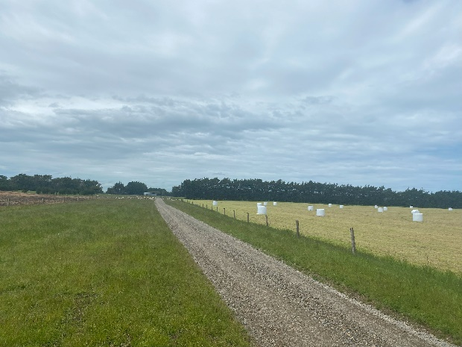
Farming is a deeply ingrained part of New Zealand society. New Zealand’s temperate climate and fertile soils have supported almost every kind of farming—from sheep and cattle to cropping, horticulture and forestry.
Although more than 85 percent of New Zealand’s population now lives in urban areas, the farming sector continues to play a fundamental role in New Zealand’s economy. There are about 50,000 farms in the country covering about 13.5m hectares. About half of New Zealand’s land area is classified as farmland.

Videos to watch
- Dairy Farming in Matamata | On Farm Story
- Sheep and Beef Farm – Telling New Zealand’s Positive Farming Story | On Farm Story
- Why I Farm – Orere Sheep and Beef Farmer | On Farm Story
- Canterbury Mixed Arable Farmer Uses Technology to Drive Profitability | On Farm Story
This video shows equipment be used in arable farming on the canterbury plains. Show first 3 minutes or skip along and show snippets from the video

Classroom discussion questions
Ask your students
- What is pasture?
- What is pastoral farming?
- Name a pastoral farming system?
- What primary products are produced from pastoral farming?

New Zealand’s pastoral farming
Pastoral farming is the dominant land use in New Zealand. The temperate climate and fertile soils enable farmers to grow abundant pasture, allowing animals to graze outdoors year-round. This efficient system produces high-quality animal products such as milk, lamb, and beef more efficiently than in any other country, positioning New Zealand's pastoral farming sector to compete effectively in international markets without relying on subsidies.
Subsidies
Subsidies paid to primary producers in Europe are financial support provided by governments to help farmers maintain stability, promote sustainable practices, and ensure food security, ultimately enhancing the competitiveness of the agricultural sector within the EU.
New Zealand primary producers are not subsidised for the products they produce.
New Zealand’s pastoral farming sector can be grouped into three main categories intensive, semi extensive and extensive based on how much pasture they grow and the amount of production they produce.

Intensive farming systems are found on high-value flat to rolling land, where they grow abundant pasture and produce a large quantity of high-value products.
Semi-extensive farming occurs on hill country with some flat land, where less pasture is grown compared to intensive farms due to harsher climate conditions and poorer soils resulting in smaller quantities of primary products.
Extensive farming is found in the South Island high country, where farms are large, and the weather is harsh in both summer and winter. With poorer soils, pasture growth is low, resulting in smaller quantities of primary products.

Using the power point “Pastoral farming systems.”
Ask your students
- Which regions have the most dairy farms and why?
- Why is dairy farming classed as intensive pastoral farming.
- To name the main dairy cattle breeds.
- To describe the topography, climate and soil conditions of semi-extensive and extensive farms
- To name the primary products produced on semi-extensive and extensive farms.
Arable farming is the growing of crops for human and animal consumption.
Ask our students
- What type of conditions does arable farming need and why do you think this is?
  - Answer (intensive, flat land, fertiliser soils with access to water for irrigation, that can grow high yields of grain crops which are easy to harvest)
- Which region has the largest area of arable farming?

Activity 1: - Terminology Primary Production
Ask students to: -
- Use the Primary Production “Introduction Glossary” to make a crossword puzzle and or a word find or a I have who has activity.

Activity 2: - Match the words to the right heading-
Drag and drop PPT Primary production activities lesson 4 activity 2 slide 16
Do his activity when you have been through the Power points “Who am I cattle & sheep breeds” and Pastoral farming Systems.

Activity 3: - Game- “Who am I”
- Print off the “Who am I cards”. Give 6 students the sector cards and spread them around the room or outside.
- Hand out the remaining cards to the other students. Students move to the correct sector. Stimulate discussion as to why they are in each sector.
Or
- Print sets of cards and ask students to match the cards to the correct primary industry
Note: -
To make it harder remove the titles on the cards. You can add more cards such as products produced by animals or machinery and technology used.

Activity 4: - Research
PPT Primary production activities Lesson 4 activity 4. This activity can be done individually or as a group.
Ask students to
- Find out what wheat, barley and oats are used for?
- Watch the Video wool-differences-between-breeds
- Find out what products are produced from Merino wool.

Activity 5: - Wool in schools
Contact Wool in schools and invite them to visit your school
Wool in schools
Our mobile “Wool Sheds” travel the length of New Zealand teaching primary and intermediate school children about the wonders of wool. Kids learn about wool processes, innovative thinking, design, and technology and they’ll have lots of fun along the way.

Activity 6: - House of Science
Bi-Lingual Science Resource kits for Year 0-8 students
If your school is registered with House of Science the Science the Science kit Moo to You provides engaging and relatable science activities that align well with this primary industry unit.
Contact House of Science

Activity 7: - Careers in the agriculture sector
PPT Primary Production Activities Lesson 4 activity 7
Most people think jobs in agriculture involve living in rural areas, working outside milking cows, shearing sheep, driving tractors, truck, tankers and harvesters. However, in reality, there is much more than this with many exciting careers in both rural and urban centres including science, business, marketing, innovation and technology. It is estimated that 80,000 people are employed in job related to the agriculture sector.
Guest speaker.
Contact a local young farmer or rural professional and invite them to talk to your students about their career and opportunities in the agriculture sector.
Ask your student to: -
- List all the careers you can think of in the agriculture industry
- List the types of technology being used in the agriculture industry.
Watch these videos to help you get started.
- Beef + Lamb NZ
- Dairy farming On Farm Story
- Dairy farming Farm Assistant- Edward
- Dairy Go for work you love
- Dairy farming Pasifika peoples
- Agriscience
- Agribusiness

Lesson 5: - A closer look at horticulture production systems
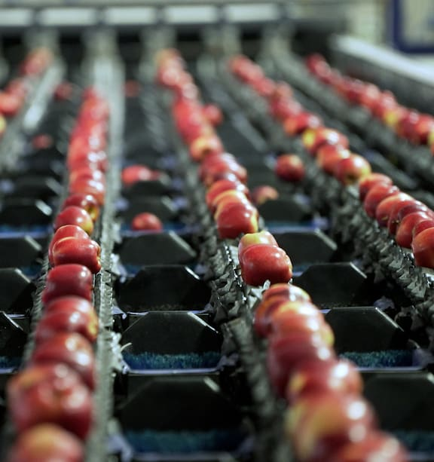

Optional unit
There are pockets of horticulture in both the North and South Islands. Horticulture is predominantly found on flat land with fertile soils and access to a good water supply for irrigation.
Crops are grown in regions that meet the temperature and sunshine hour requirements for good growth.

Watch New Zealand Horticulture Story
Go through the power point “Primary Production Systems Horticulture” with your students. There are some video links in Slide 9 to watch.
Classroom discussion questions
Ask your students; -
- Why is New Zealand good at producing primary product?
- To make a list of fruit and vegetables grown in New Zealand
- To name three stone fruit.
  - Peaches, nectarines, cherries, apricots
- To list fruit and vegetables that don’t grow or grow well in New Zealand and why don’t they grow or grow well in New Zealand?
- Why do you think horticulture fruit and vegetables crops are grown on flat or gently sloping land.
  - Ease of getting machinery into spray and harvest crops.
- Why are crops such as tomatoes, capsicums and cucumbers grown in glasshouses.

Activity 1: - Writing activity
PPT Primary Production Activities Lesson 5 Activity 1
Ask your students to: -
Make a list of the most important factors influencing where horticulture crops are grown in New Zealand.
ANSWER-Temperature, rainfall, sunshine hours, access to water, flat to gentle sloping land.
Activity 2: - Recording activity.
Template- PPT Primary Production Activities Lesson 5 Activity 2
Ask your students to use the maps and videos in slide 20 to: -
- Record the regions each crop is grown in.
- make a list of the equipment and technology used in growing each crop.

Activity 3: - Careers in the horticulture sector
PPT Primary production activities Lesson 5 Activity 3
Most people think jobs in horticulture involve planting, harvesting grading, driving tractors, harvester and trucks. However, in reality, there is much more than this with many exciting careers including science, business, marketing, innovation and technology. It is estimated that more than 40,000 people are employed in jobs related to the horticulture sector.

Guest speaker
Contact a local horticulturalist and invite them to talk to your students about their career and opportunities in the horticulture sector.

Ask your students to: -
- List the careers they can think of in the horticulture industry
- List the types of technology being used in the horticulture industry.
Watch these videos to help you get started.
- Orchard Supervisor
- Cheery grower
- Control operator https://www.youtube.com/watch?v=mRAILIXiK-A
- Just the job - Amenity Horticulture

Lesson 6: - A closer look at the forestry sector
Optional unit
New Zealand has a total of approximately 10.1 million hectares of forest, covering 38% of the country's land area. This is made up of two main types of forest:
- Native Forests: 8 million hectares, mostly Crown-owned and managed by the Department of Conservation (DOC). A significant portion of these forests is protected in national parks, scenic reserves, and other conservation areas.
- Plantation Forests: 2.1 million hectares, with 1.7 million hectares being productive forests used for timber production. The remaining areas are reserves and unplanted zones near bodies of water and infrastructure.
These two forest types differ in terms of biology, management, and the values they provide to New Zealanders.
Plantation forestry is spread across various regions, but the Central North Island holds the largest area, accounting for 34% of the country's total forest area. Otago and Southland have the second-largest plantation areas, closely followed by Northland. The West Coast has the smallest plantation forestry area. Most of New Zealand’s plantation forestry is concentrated in the North Island.
Forestry and wood products are New Zealand’s fourth-largest export, following horticulture, and contribute around $6 billion annually to the national economy.

Activity 1: - About Forestry
- Ask your students if they know the Māori mythology of Tāne Mahuta.
- Find a story about Tāne Mahuta.
In Māori mythology, the creator of the first human also created the forests, connecting the two forever. The story goes that the kaitiaki (guardian) Tāne Mahuta created the forests by separating his parents, Papatūānuku (the earth mother) and Ranginui (the sky father), letting light into the world.

The two classes of forestry are indigenous and exotic.
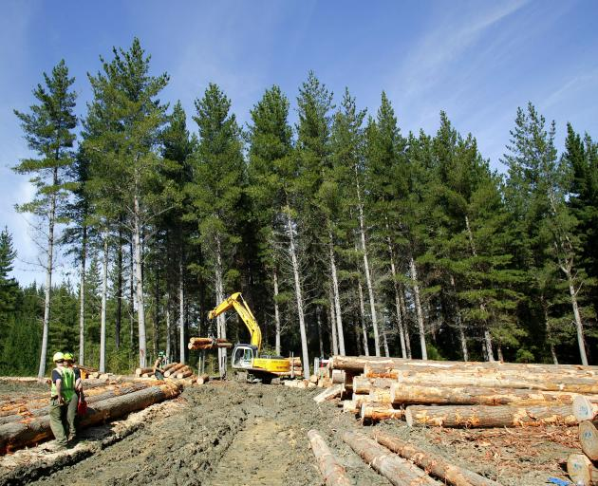
Ask your students
- What does indigenous and exotic mean?
- To find out
- What are the two main types of indigenous forest?
- What is the main type of exotic forest?
- What they think New Zealand would have looked like before people arrive?
- Why do they think this and what has changed and why?
- To use the resource Foresty distribution by region to find out how much forestry is in your region?

Activity 2: - Wood is good.
Check out the great resources Wood is Good
“Wood is Good” is a forestry and log transport programme developed for primary schools in New Zealand and funded by sector groups and the Ministry for Primary Industries.
“Wood is Good” is a tailored array of activities, videos, publications and demonstrations that are delivered to primary aged students to educate them on the valuable benefits of forestry. These include environmental topics, carbon storage, climate change, wood products and how plantation trees are grown and harvested in our country. Local log transport providers and forestry company professionals will deliver these sessions at your school and talk about what they do.
View a log truck, talk about logs and trees, find out how forests are and cared for, find out how forestry is valuable to your community.
Make sure you also take advantage of the published book series “Fred the Forester” which informs students about forestry – great for classroom reading sessions.

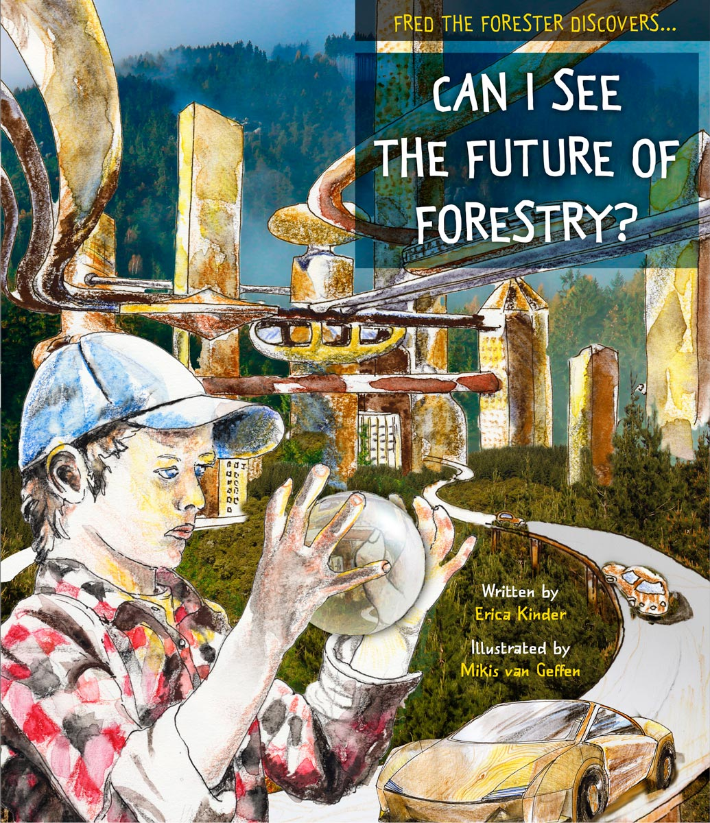

Activity 3: - Careers in the forestry sector
PPT Primary Production Activities Lesson 6 Activity 3
Most people think jobs in forestry involve planting, managing, milling and transporting logs, driving trucks. However, in reality, there is much more than this with many exciting careers including science, business, marketing, innovation and technology. It is estimated that over 100,000 people have jobs related to the forestry and wood industry.
Ask your students to -
- List as many careers as possible they can think of in the forestry and wood industry.
- List the types of technology being used in the horticulture industry.
Contact
Forest Owners Association or your local Wood Council- Forestry careers and invite a quest speaker (young employee) to come in and talk to students about their career and other opportunities in the forestry and wood industry.
Watch
- Forestry Industry Big Day Out - Shideen's Story
Here are some ideas to get you started.
- Furniture makers
- Timber merchants
- Builders
- Paper makers
- Architects
- Engineers

- Future forester videos- there are several great videos of young people working in the forestry industry.
- Forestry and Wood - Northland, New Zealand

Challenge
Ask you student to draw a mind map of jobs related to the forestry and wood industry.

Lesson 7: - A closer look at the seafood sector.
Optional unit
New Zealand has a coastline stretching over 15,100 km and boasts the world’s fourth-largest Exclusive Economic Zone, covering 1.3 million km². The country is home to more than 16,000 marine species, with 130 species commercially fished.
The seafood industry is an important part of New Zealand’s economy, contributing around $2 billion in export earnings and providing jobs for more than 16,500 people. These workers supply both New Zealand and the world with high-quality, nutritious, and delicious seafood.
The industry is dedicated to offering great career opportunities in local communities through sustainable and innovative seafood production. The New Zealand aquaculture sector, which focuses on farming aquatic plants and animals, is an efficient system that produces some of the world’s best seafood. It has a much lower environmental impact compared to other forms of protein production.
New Zealand is internationally recognized for its sustainably farmed products, including:
- New Zealand Greenshell™ Mussels
- Pacific Oysters
- King/Chinook Salmon
Our clean waters, sheltered harbours, and rich plankton provide the perfect conditions for aquaculture, and there is plenty of room for growth in the industry.

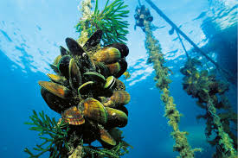

Activity 1: - Story time
Share a story from Māori mythology such as
- Māui and the giant fish Te Ika a Maui - The Great Fish of Māui - and how Aotearoa got ...
- Tangaroa - Tangaroa: Māori God of the Ocean Explained

Activity 2: - Explore traditional Māori methods of fishing
Links
Traditional Māori methods of fishing
Māori Fishing Technology

Activity 3: - Games
These two games are interactive and informative. Print off the cards and rules.
- Go Fish – (Print 4 sets)
- Card Sharks

Activity 4: - Guest Speaker
Contact and invite a local fisher to be a quest speaker (young employee) to come in and talk to students about their career and other opportunities in the sea food industry as well as the importance of caring for the ocean.
Seafood New Zealand can suggest and help you find local people to speak to your students. You can find contact details here.

Activity 5: - Careers in the seafood sector
PPT Primary Production Activities Lesson 7 Activity 5
Ask your students
- To list the products produced by the New Zealand aquaculture industry.
- Why do you think the aquaculture industry is an important and growing industry?
- To make a list the of
- jobs in the seafood industry.
- technology used in the seafood industry.
Most people think jobs in the seafood involve fishing, diving, shelling and filleting fish. However, in reality, there are many exciting careers including science, innovation and technology. It is estimate there are 16,500 people working in the seafood industry.

Students can watch some of these video’s using what they hear and see to add to their list of jobs and technology in the seafood industry.
- Aquaculture - Northland, New Zealand
- Aquaculture: New Zealand's future.
- Seafood New Zealand careers
- New Zealand Sustainable Aquaculture
- Blue Endeavour - New Zealand King Salmon's open ocean.
- Tio aquaculture at Moana New Zealand

Lesson 8: - A closer look at the equine sector
Optional unit
The New Zealand equine industry is an important part of the country’s economy and culture, particularly in the fields of horse racing, breeding, and training. New Zealand has a rich history of producing world-class racehorses, and its racing industry is highly regarded internationally. Career opportunities in the equine sector are diverse, ranging from roles in horse training, breeding, and veterinary care to positions in equine nutrition, farriery, and racecourse management. Many career paths also exist in the business side of the industry, such as marketing, event coordination, and media. The main racing stables are primarily located in areas with strong equine traditions, including the Waikato region (home to the country's largest concentration of breeding farms), where the majority of thoroughbred training operations are based. Other key locations include the Canterbury and Auckland regions.

Ask your students: -
- What they know about the thoroughbred horse racing industry?
- Do they know anyone working in the racing industry?

Activity 1: - Guest speaker
Invite a guest speaker from the wider equine industry to come in and speak to students about their career and wider opportunities in the equine industry.

Activity 2: - Explore careers in the equine sector
With your student Watch
- NZ Through Bred Racing Academy
- Explore careers in the Horseracing industry

Activity 3: - Equine industry word find.


Lesson 9: - A closer look at the sports turf sector.
Optional unit
New Zealand’s strong sporting culture means there is a big need for dedicated grounds people to look after sports fields, golf courses, school grounds, racecourses, and bowling rinks. These playing surfaces, whether they are made from natural or artificial turf, need to be created and maintained carefully so that athletes can perform at their best. Sports like rugby, cricket, netball, and football are a big part of New Zealand's identity, and the quality of the fields plays an important role in the success of these sports.
Sports turf managers in New Zealand work hard to make sure fields, courts and pitches are in top condition, no matter the weather. This requires a lot of knowledge and skill, as well as using the latest technology to meet the needs of each sport. For example, natural grass like ryegrass and fescue is most commonly used for rugby and cricket, but synthetic turf is becoming more popular in cities because it’s durable, easy to maintain, and works in all kinds of weather. Hybrid turf, which is a mix of natural and synthetic grass, is also being used for high-performance fields. Turf managers need to know about soil care, watering systems, and how to use advanced tools like GPS, automated machines, and climate control technology. They also use data to keep track of the field’s condition, which helps them take better care of the turf and make it last longer.

Activity 1: - Sport turf in the school
Take your students for a walk around the school.
Ask your students to
- think about the sports played at school and the types of surfaces the sports are played on.
- make a list of sports played in New Zealand then beside each sport write down if the turf is natural or artificial.
- make a list of questions to ask a guest speaker such as the school grounds person.

Activity 2: - Chat with the school grounds person
PPT Primary Production Activities Lesson 9 Activity 2
Invite the school grounds person to speak to the students about
- what they do to look after the school sports fields, courts and grounds.
- what equipment they use?
- other expertise they use to maintain the sports fields, courts and grounds.
Watch
- Sports Turf Management Careers
Ask your students to make a list of
- careers in the sports turf industry.
- the types of equipment and technology being used.

