
Unit 2
Careers in the Primary Industry
Teachers Guide

Unit 2
Careers in the Primary Industry
Teachers Guide
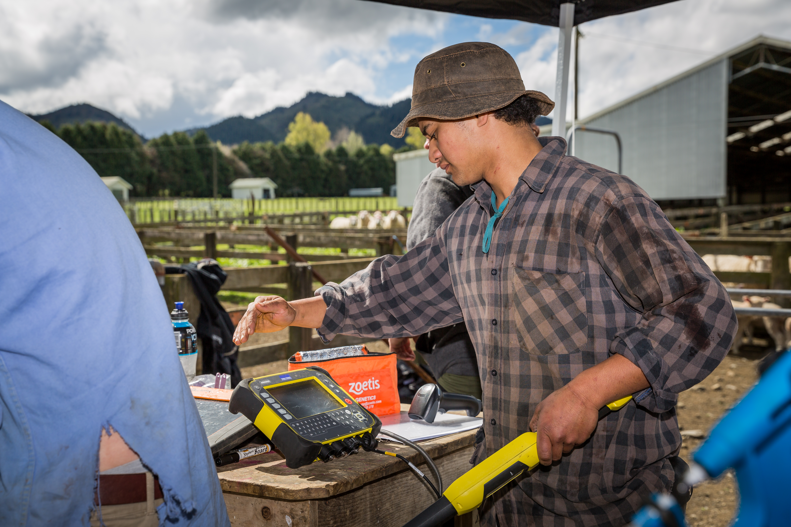

The primary production sector is well established in New Zealand Society and vital to the economy and standard of living. It is sector of opportunities and challenges.
Teaching years 7-10
We invite and encourage you to teach and inspire students about the primary production industry.

We have developed a resource for you.
Included is
- Teacher guide
- Engaging activities

This resource has been developed by Sow the Seed in conjunction with HATA.
For more resources and teaching material for agriculture and horticulture science we invite you to join the Horticulture and Teachers Association HATA

Introduction

Primary Production is a 54 billion+ industry in Aotearoa New Zealand.
In Aotearoa New Zealand, primary production is the process of producing raw materials and products from natural resources, land and water. The main primary industries are agriculture and horticulture, forestry, fishing, and aquaculture, others are turf culture and equine.
A primary production system is a sum of all components, including the growing environment and management practices, that work together in the production of a primary product. Some examples of primary production systems include, dairy farming, sheep and beef farming, orchards such as apple, kiwifruit and cherries.
Primary production is the key driver of New Zealand’s economic, social, and environmental development. The products of primary production are a source of well-being for the present generation and will be so for future generations.

What is agricultural and horticultural science?
The Agricultural and Horticultural Science subject looks at the management practices that occur behind the farm, orchard gate or on boat as well as beyond, to produce a product. This practically orientated subject uses all the primary sector contexts of sheep, beef and cropping, dairying, horticulture, seafood and aquaculture, forestry, equine and sports turf. The application of good production management practices ensures that the primary products demanded by local and world markets are made available in an ecologically and economically sustainable manner. Agricultural and horticultural science deals with contexts, issues, and problem solving drawn from a broad agenda that includes, for example:
- products (for example, pork, poultry, avocados, honey, timber, milk, wool, apples, grapes)
- environments (for example, waterways, erosion, landscape, soil, shelter, glasshouses, effluent, pollution; environmental modification and sustainable management practices)
- solutions for particular management issues (for example, irrigation, cropping, harvesting and milking equipment, data, information and communication digital technologies, shelter and shade construction, and cultivation technologies).

Teacher Guide Notes
This unit is designed to help students appreciate the broad scope and value of New Zealand's primary industry, as well as the many people in both rural and urban areas who contribute to these sectors. While most people associate primary industry jobs with rural areas—such as milking cows, shearing sheep, harvesting fruit and vegetables, or driving tractors and harvesters—there is much more to it. Many exciting careers in science, business, marketing, innovation, and technology also exist in both rural and urban centres. It is estimated that 359,000 people, or 12.8% of the total workforce, are employed in the primary industry. While primary production is spread across the country, processing and commercialisation activities are concentrated in major towns and cities.

Key Learning Outcomes
Students will gain an understanding of: -
- the diversity of careers in the primary sector across the value chain.
- the importance of the primary industries in meeting many of the Sustainable Development Goals (SDGs)
- 21st century skills required to succeed in a world that is aways changing.
- subjects that are linked to careers in primary sector.

Supporting resources
- Jobs in the primary industry
- Careers in the PI Form_2026.
- 21st Century skills
- Careers Primary Industry A3 POSTER
- kiwi-cards[1]
- kiwi-cards-activity-guide [1]
- Possible Kiwi Card Primary Industry interpretations
- PPT Kiwi Cards with career ideas
- PPT Unit 5 Skills & Career Links
- PPT Value chain diagrams
- Careers in the Wool Industry
- Careers in Wool

Timeframe
Lessons are generally designed in a one-hour blocks but feel free to modify to suit you and your students. You do not need to complete all the lessons or activities.

Recommendations
Within each lesson there are multiple activities for students to do. We recommend you select the activity or activities that suit your student’s.

Contents
Introduction 3
Primary Production is a 54 billion+ industry in Aotearoa New Zealand. 3
What is agricultural and horticultural science? 3
Teacher Guide Notes 4
Key Learning Outcomes 4
Supporting resources 4
Timeframe 4
Recommendations 5
Lesson 1: - Introduction to careers in the primary industry 7
Activity 1: - Find all the careers. 7
Activity 2: - Careers in the Primary Industries 8
Activity 3: - Kiwi cards 8
Activity 4: - The Horticulture Card Game 9
Lesson 2: - Sustainable development goals and 21st-century skills 10
Activity 1: - Find your career in the Primary Industry. 13
Activity 2: - Leaving School New Zealand-Primary industry career profiles 13
Activity 3: - Research a career in the primary industry 14
Resources and Links to primary industry careers. 15
Careers NZ 15
Other industries that connected to careers in the primary sector 15
Forestry sector careers 15
Dairy sector careers 15
Dairy processing careers 15
Horticulture sector careers 16
Beef & Lamb sector careers 16
Meat processing careers 16
Fishing and aquaculture sector careers 16
Sports turf sector careers 16
Racing industry careers 17
Biosecurity careers 17
Environmental Science careers 17
Agri -Technology careers 17
Food industry careers 17
Soil Science careers 17

Lesson 1: - Introduction to careers in the primary industry
Classroom discussion questions
Ask students to brainstorm four things about working in the primary sector.
- A career/occupation
- Average amount earned per year
- Type of work area (e.g. city/town/rural)
- Skills needed for the career/occupation
- What was the general consensus of the class?
- Were lots of different jobs identified?
- Were these jobs seen as highly paid?
- Where were these jobs located?
- Where 21 century skills for these jobs identified?
In these activities, students will explore the misconception that jobs in the primary sector are all unskilled, low-paying roles mainly found on farms, orchards, fishing boats, or in forestry in rural areas. In reality, the primary industry is much more diverse and requires a wide range of skilled workers at various stages across the value chain. The value chain refers to the series of activities involved in getting a product from the producer to the consumer, such as production, processing, packaging, and distribution.
In New Zealand, the primary industry plays a key role in the economy, employing over 12.8 % of the workforce, which is about 358,000 people. These people are involved in many parts of the value chain, not just in rural areas, and their expertise is crucial in ensuring products reach consumers.
Through discussion and activities, students will learn that the primary industry is more complex and offers many skilled career opportunities across various sectors and environments. They will also discover that this industry contributes significantly to achieving the sustainable development goals (SDGs), especially SDG 2: Zero Hunger and SDG 15: Life on Land. The primary sector plays a vital role in food security, poverty reduction, environmental sustainability, and supporting rural livelihoods, while also impacting many of the other 17 SDGs.

Activity 1: - Find all the careers.
Resource: Jobs in the primary industry.
Print off a poster “Jobs in the primary industry” for each group.
Ask students to find all the careers listed in the image.

Activity 2: - Careers in the Primary Industries
Resource: Careers Primary Industry A3 Poster. Print off copies of the poster.
Discuss the types of careers in each sector with your students.
Ask your students
- Why some careers can fit under sector headings.
- What types of skills are needed in all the sectors?
- Are skills transferable across sectors?

Activity 3: - Kiwi cards
This resource and activities have been adapted from CareersNZ Kiwi cards Activity guide. For more information and ideas on how to use kiwi cards refer to this resource.
Resources
- Kiwi cards- Print off kiwi cards
- Possible kiwi card primary industry interpretations
- Or use power point “Kiwi cards with career ideas”

Note: -Cards 1, 6, 9 & 18 are a little difficult to match to a primary industry career. Students will need to think outside the square to link them to a career in the primary industry or people working in the industry.
You could leave these cards out if you have enough cards for each student.

- Hand out a card to each student.
- Give students 1 minute to come up with a primary industry related job to their card.
- Each student then shows their card to the class and states their job.

- Many jobs are linked
- ask students to move around the class to find two other jobs that are connected or related.
- ask students to explain the connections or relationship between the jobs.

Repeat this exercise several times to show the diversity of different connections.
- ask students to add a fourth and fifth job that could be connected.
e.g.
  - Farmer- vet, stock agent,
  - Farmer, banker, builder
  - Wine maker, quality controller, marketing agent
  - Grower, consultant, engineer, harvester, packhouse manager, biosecurity officer, marketing agent, graphic designer, Sea captain, retail merchant

Challenge: ask the students
- to see how many jobs they can link across the value chain. They must be able to tell a story about the connection between jobs.
- to discuss where the jobs could be located.

- In these groups get students to discuss
- The skills they think are needed for these jobs
- The subjects they think would be useful to prepare for these jobs.

- In the primary sector people regularly move jobs as they gain experience and expertise. They can move within a sector and across sectors. Ask students
- to move and find their next job.
- give a reason why this could be their next job- Link to related skills and interest.
e.g
- rural banker to farmer or consultant
- retail salesperson to retail manager
- livestock agent to training officer

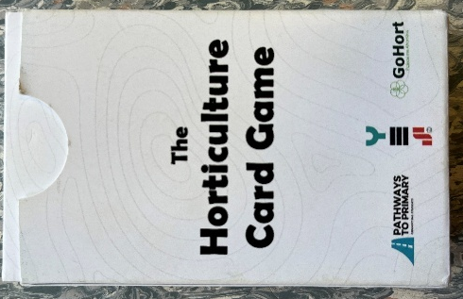
Activity 4: - The Horticulture Card Game
Resource- sets of “The Horticulture Card Game”.
If you have a set or sets of “The Horticulture Card Game” this is a game students can play to find out more about careers in the horticulture sector.

Lesson 2: - Sustainable development goals and 21st-century skills
With your students discuss
- Sustainable Development Goals (SDGs)- what these are and their aim.
  - How the primary industries contribute to the sustainable development goals?
- 21 century skills
  - Why it is important to know what these skills are?
  - Why they are important?
  - Why they need to start developing these skills now?
Sustainable Development Goals (SDGs)
The Sustainable Development Goals (SDGs) are a set of 17 global objectives established in 2016 by the United Nations to provide a comprehensive and universal framework for addressing the world’s most urgent social, economic, and environmental challenges by 2030. These goals serve as a roadmap for countries, organisations, and individuals to work together toward a more equitable, sustainable, prosperous, and resilient future. The SDGs aim to end poverty, promote equality, ensure quality education, combat climate change, and foster sustainable development worldwide, emphasising cooperation among nations for a more equitable and resilient future.
The primary industry contributes significantly to achieving the sustainable development goals (SDGs), especially SDG 2: Zero Hunger and SDG 15: Life on Land. This sector also plays a vital role in food security, poverty reduction, environmental sustainability, and supporting rural livelihoods, while also impacting many of the other 17 SDGs.

21st Century Skills
The 21st century is marked by rapid technological advancements, globalisation, and changing economic environments. To thrive it’s crucial for young people to develop the adaptability and resilience needed to navigate these changes. Building 21st-century skills is essential, as these competencies such as problem-solving, creativity, communication, and teamwork are highly valued in almost every career. With technology continually progressing, students must also become comfortable using new tools and collaborating with people from diverse backgrounds. By fostering these skills now, students will be better equipped to take on future challenges and make a positive impact in their future careers, communities and the world.

Source: www.un.org/en/sustainable-development-goals 

Skills of the future.
From AgriFutures “Careers in Agriculture”
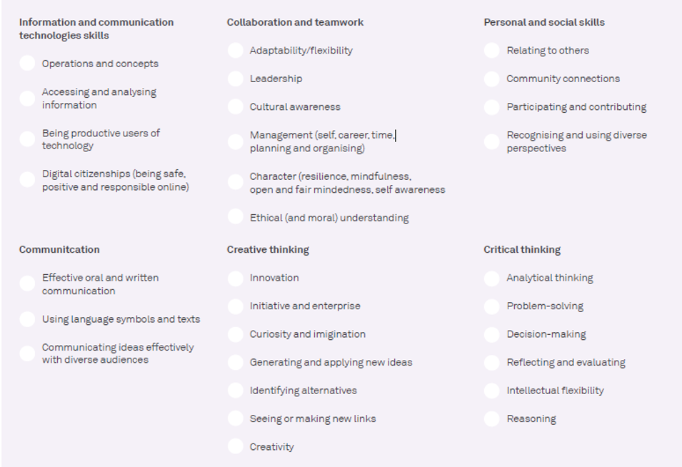

The next activities are about discovering more about primary industry careers and the skills required.
Before you start- Ask your students
- How many people do you think work in the primary industry?
- What does across the value chain mean?
- What skills will you need to succeed in a changing world?

Watch - Careers in the primary sector-Meet some of our primary industry champions
With your class discuss the-
- careers these primary industry champions are doing.
- skills needed for these roles. Use the 21st Century skills list to help you.

Activity 1: - Find your career in the Primary Industry.
- Resource ““Find your career in the Primary Industry”
The purpose of this resource activity is to find out what student’s current interests are. Are they practical and outdoors or business or science orientated? It is a starting point for a discussion about interests, how they could relate to a career in the primary industry and the importance of subject selection.

This resource can be used to form groups of students with similar or different interests for activity 2.
Ask your student to-
- take their time to answer questions carefully then add up the totals.
Discuss the result with each student

Activity 2: - Leaving School New Zealand-Primary industry career profiles
This resource utilises the Leaving School Career Profiles and Index. Find here Career Profiles
The Index is as a spreadsheet, so that the data can be sorted into criteria of your interest such as job, person’s name, school attended, qualifications etc.
These cards can be used for many activities such as those below.
- Posters.
Select and print a range of primary production career profiles to display on the classroom walls.
- Name the Career.
Give each student a different career profile (could be printed and laminated), which they read. In pairs (or groups or in front of the class), the students need to ask yes and no questions only to work out what career the other person is. The winner is the person who asks the minimal number of questions to get the correct career.
- Research a Career.
Students to pick (from a range provided) a career profile and research the career in more depth and present a 30 second video on that career.
A big thank you to Oliver Lee for the use of his Leaving School Career Profiles. His contact details can be found at www.oliverlee.co.nz/leavingschool-issue31

Activity 3: - Research a career in the primary industry
On the next page and in the Power point “Unit 5 Skills & Career Links” there are links to videos and information on each primary sector and related careers and career pathways. This is not an exhaustive list so encourage students to search for more information. Encourage your students to find out if they can find someone working in the sector they are exploring to talk to about their career and others.

Allocate small groups of students a primary industry or related primary industry career. Provide the group with links to videos and resources to help them get started.

Ask your student to: -
- Brainstorm and write down all the jobs they can think of related to that sector.
- Research career opportunities in the sector and add to their list.
- Each student in the group is to select a different career opportunity in the primary sector and prepare a presentation to present to the class. This could be a poster, video, promotional flyer, or other creative ways to showcase the career.
Include -
- Name of industry.
- What the job involves?
- Location of the job.
- 21st century skills needed for the job. Use the 21st century skills list to help you.
- Subjects that would be useful to prepare you for this job.
- How could the job help meet a sustainable development goal?
- Other information of interest.

Resources and Links to primary industry careers.

Careers NZ
- Farming, fishing, Forestry and Mining
- Animal care and conservation

Other industries that connected to careers in the primary sector
- Business
- Engineering, Government, law and safety
- Manufacturing
- Science
- Transport and logistics.

Forestry sector careers
- Forestry study and careers | Te Uru Rākau – New Zealand Forest Service
- Futures Foresters
- Futures Foresters- Drones
- Futures Foresters- Innovation & technology

Dairy sector careers
- Dairy farm Career Pathway
- GoDairy Farm roles
- Dairy farming Farm Assistant- Edward
- GoDairy Careers in dairy
- Technology Halter, Cow collars
- GoDairy Agribusiness
- GoDairy Agriscience
- Dairy farming On Farm Story

Dairy processing careers
- Fonterra Chemical and mechanical engineering
- Fonterra Processing & Packing Career https://www.youtube.com/watch?v=gEMbG7bKzoU
- Fonterra Graduate roles

Horticulture sector careers
- GoHort Horticulture careers
- Careers in Horticulture- Central Otago
- Just the job – Council Horticulture Careers
- Just the job – Horticulture careers - Amenity
- Science careers Entomologist
- Pipfruit careers Karla Bradley

Beef & Lamb sector careers
- Beef + Lamb NZ Rural professional
- Beef, sheep and arable farming in the Wairarapa- Mark Guscott
- Living the Dream in the Taihape High-Country | On Farm Story-Mairi Whittle
- Careers in wool PDF resource

Meat processing careers
- Join MPI’s verification services team. Hear Ju-Young's story
- Silver Fern farms Career Story – Sam Pike
- Silver Fern Farms Apprenticeship
- Meat Your Career
- Butcher-Just the Job- Butcher Careers
- Stock Agent-Carrfields Livestock

Fishing and aquaculture sector careers
- Fishing for a new job?
- Seafood New Zealand careers
- Just the Job Fishing Careers
- Innovation in Fishing
- Aquaculture Careers - Mussel Farming in New Zealand

Sports turf sector careers
- A glimpse inside New Zealand's sports turf industry
- Just the Job - A Career in Sports Turf Management
- Sports Turf Management Careers

Racing industry careers
- NZ Through Bred Racing Academy
- Explore Careers in the Horseracing Industry

Biosecurity careers
- Biosecurity – Protecting to grow New Zealand
- What is it like to work in Biosecurity/Biodiversity?

Environmental Science careers
- Drones and wilding pines
- Environmental consultant

Agri -Technology careers
- Drones and wilding pines
- Irrigation technology
- Robotics technology
- Technology Halter, Cow collars

Food industry careers
- Quality control
- Global account manager

Soil Science careers
- Careers in soil science
- Engineering geologist
- Social scientist
- Soil Chemist

