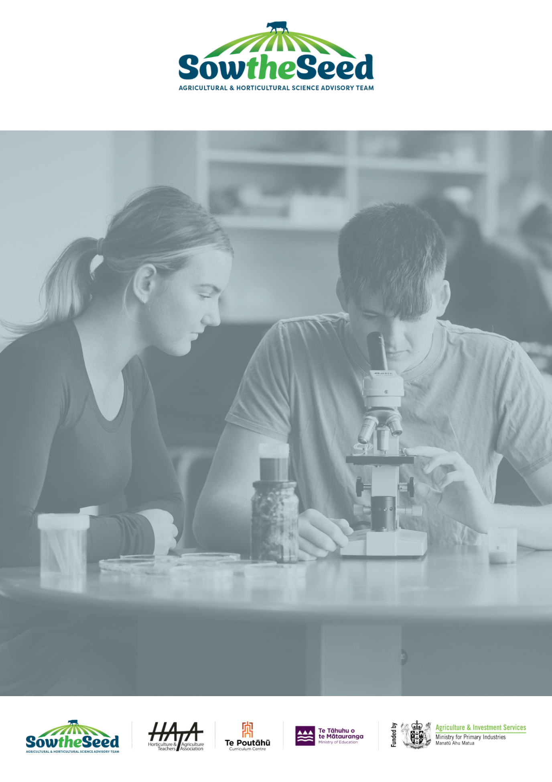
Unit 3
Seeds

Teachers Guide

Unit 3
Introduction to seeds, the start of plant life.
Teachers Guide

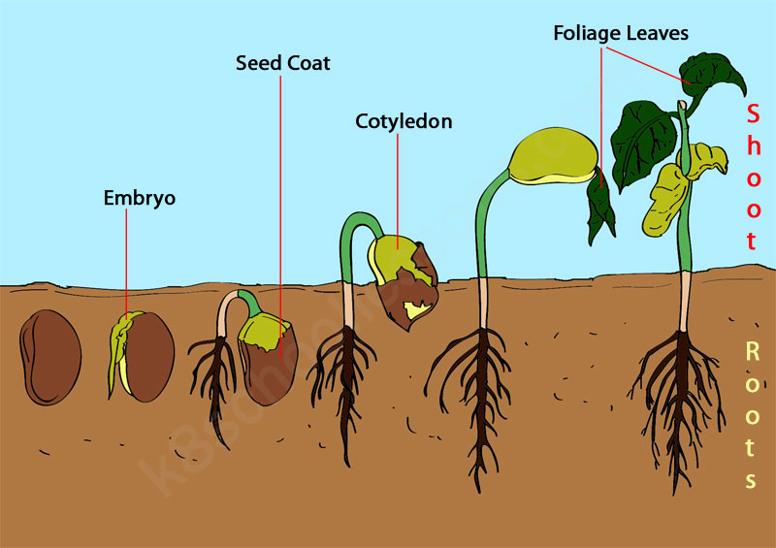

The primary production sector is well established in New Zealand Society and vital to the economy and standard of living. It is sector of opportunities and challenges.
Teaching years 7-10
We invite and encourage you to teach and inspire students about the primary production sector.
We have developed a resource for you.
Included is
- Teacher guide
- Engaging activities

This resource has been developed by Sow the Seed in conjunction with HATA.
For more resources and teaching material for agriculture and horticulture science we invite you to join the Horticulture and Teachers Association HATA

Introduction

Primary Production is a 54 billion+ industry in Aotearoa New Zealand.
In Aotearoa New Zealand, primary production is the process of producing raw materials and products from natural resources, land and water. The main primary industries are agriculture and horticulture, forestry, fishing, and aquaculture, others are turf culture and equine.
A primary production system is a sum of all components, including the growing environment and management practices, that work together in the production of a primary product. Some examples of primary production systems include, dairy farming, sheep and beef farming, orchards such as apple, kiwifruit and cherries.
Primary production is the key driver of New Zealand’s economic, social, and environmental development. The products of primary production are a source of well-being for the present generation and will be so for future generations.

What is agricultural and horticultural science?
The Agricultural and Horticultural Science subject looks at the management practices that occur behind the farm, orchard gate or on boat as well as beyond, to produce a product. This practically orientated subject uses all the primary sector contexts of sheep, beef and cropping, dairying, horticulture, seafood and aquaculture, forestry, equine and sports turf. The application of good production management practices ensures that the primary products demanded by local and world markets are made available in an ecologically and economically sustainable manner. Agricultural and horticultural science deals with contexts, issues, and problem solving drawn from a broad agenda that includes, for example:
- products (for example, pork, poultry, avocados, honey, timber, milk, wool, apples, grapes)
- environments (for example, waterways, erosion, landscape, soil, shelter, glasshouses, effluent, pollution; environmental modification and sustainable management practices)
- solutions for particular management issues (for example, irrigation, cropping, harvesting and milking equipment, data, information and communication digital technologies, shelter and shade construction, and cultivation technologies).

Teacher Guide Notes
This unit of work is designed to enhance understanding of the life cycle of plants, focusing on the role of seeds as the starting point of plant growth. It covers key concepts such as seed structure, germination, fertilisation, and the process of sowing seeds.

Key learning outcomes
Students will gain an understanding
- Why seeds are important?
- What seeds are?
- The process of seed formation.
- How new plants grow from seeds.
Supporting Resources
- PPT Unit 3 Lesson Activities
- PPT Seed types and germination
- PPT Steps involved in sowing seeds
- PPT Seed Investigations
- PPT Seed dispersal
- Seed Terminology
- Investigation -Do seeds need light to germinate
- Investigation -Do seeds need water to germinate
- Helicopter seeds (A)
- Investigation Fresh vs Dry Weight
- NZ-Seed-Dispersal (WS)
- Pass the pollen (SLH)
- Pollination pairs (SLH)
- The seed drawing activity
- Flower-dissection-sheet-far.org.nz
- Pollinators-in-New-Zealand-far.org.nz
- How-do-these-seeds-disperse-far.org.nz
- Colour and Label Flower
- Terms on seed packets

Timeframe
Lessons are generally designed in a one-hour blocks but feel free to modify to suit you and your students. You do not need to complete all the lessons or activities.

Recommendations
Within each lesson there are multiple activities for students to do. We recommend you select the activity or activities that suit your student’s.
The best time to do this unit on seeds is in term 1 and 4 when there are plenty of flowers around and the temperature is warm to grow seeds.

Contents
Introduction 3
Primary Production is a 54 billion+ industry in Aotearoa New Zealand. 3
What is agricultural and horticultural science? 3
Teacher Guide Notes 4
Key learning outcomes 4
Supporting Resources 4
Timeframe 4
Recommendations 5
Lesson 1: - Seeds 8
Activity 1: - Tāne Mahuta 8
Activity 2: - Importance of seeds as a food 8
Activity 3: - Where are seeds? 9
Activity 4: - How many seeds? 9
Lesson 2: - More about seeds 10
Activity 1: - Discover the parts of a seed 10
Lesson 3: - How to seeds grow into plants? 13
Activity 1: - Germination investigations 13
Activity 2: - Fun activities germinating seeds 15
Lesson 4: - Flowers and pollination. 16
Activity 1: - Flower dissection 16
Activity 2: - Flower parts and pollination. 17
Activity 3: - Secret flowers 18
Activity 4: – Writing exercise 19
Lesson 5: - More about Pollination 20
Activity1: - Counting pollinators. 21
Activity 2: - Pollination activities 21
Activity 3: - Growing Flowers for Bees. 21
Lesson 6: - Producing seeds - Fertilisation 22
Activity 1: - Comparing pollination and fertilisation. 22
Lesson 7: - Seed dispersal 23
Activity 1: - Exploring seed dispersal 23
Activity 2: - Making Seed Bombs 23
Activity 3: - How do seed travel? 23
Activity 4: - NZ seed dispersal (WS) 24
Lesson 8: - Let’s grow plants from seeds. 25
Activity 1: - Interpreting seed packets. 25
Activity 2: - Sowing seeds 25

Lesson 1: - Seeds
Find out what students know about seeds.
Seeds are baby, (juvenile) plants.
Ask your students
- Does anyone know what a seed is?
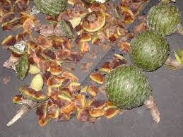
- Do we need seeds?
- Why do you think this?
Use one or more of the following activities to get students thinking and curious about seeds?
At the end of the activities ask students the questions above again.
Reflection task- Ask your students
- What do you know about seeds?
- What do you want to find out about seeds?

Activity 1: - Tāne Mahuta (New Zealand’s largest Kauri tree found in Waipoua)
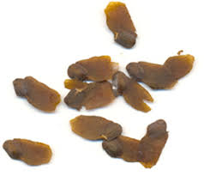
PPT Unit 3 lesson Activities
Over1200 years ago, Tāne Mahuta was a kauri seed.
Ask your students to find out
- how big Tāne Mahuta is now. The height and circumference
- who is Tāne Mahuta named after?
- how old Tāne Mahuta is.
Story time- Tāne Mahuta

Activity 2: - Importance of seeds as a food
PPT Unit 3 lesson Activities
Group activity – In groups make a list of foods that are seeds or nuts we eat. Share ideas and get student to record seeds and nuts we eat.
Examples: - Pumpkin, Corn, Peas, Beans, Lentils, Sesame, barley, Nuts (Peanut, cashew, pinenuts etc)

Activity 3: - Where are seeds?
Whole class or group activity.
Provide students with a range of fruit, flower and fruit seed heads/pods, cones, (whatever is in season or can be found around the school)
Examples (broad beans pods, pea pods, kowhai pod apple, kiwifruit, feijoa, pumpkin, tomato, capsicum, avocado, mango, watermelon, sweetcorn, sunflower, flax pod, barley, wheat other seed pods/ heads, agapanthus seed heads)

Students cut open or the fruit/pod to: -
- Find the seeds
- Count the seeds, if you can
- Label the seed and take a photo of the seeds
As a class compare the seeds.
- Are seeds all the same.
- What makes them different?
- Why do you think seeds are different sizes, shapes, colours.
- Does the pod, fruit, flower and seed heads all have the same number of seeds?

Activity 4: - How many seeds?
This is a math activity
Resource: This resource is not only a useful guide but also a maths activity which you can use as a stand-alone activity or used alongside other activities.
One seed becomes many

https://www.far.org.nz/schools/one-seed-becomes-many

Lesson 2: - More about seeds
Recap lesson 1
Ask your students
- What are seeds?
- What are seeds for?
- Why are seeds different shapes and sizes?
Notes
A seed consists of
An embryo (the undeveloped seedling) from which the root (radicle) and shoot(plumule) will grow.
A food store which provides the energy for growing the root and shoot to grow and takes up most of the volume of the seed.
Cotyledons are the first leaves.
A coat called the testa which protects the seeds until conditions are suitable for germination.
Micropyle is a small hole that allow water to enter the seed.
Germination is when the embryo starts to grow.
Note: - At this level students only need to know the basic parts

Teacher Resources
- Basic seed facts
- Power point- Seed types and germination

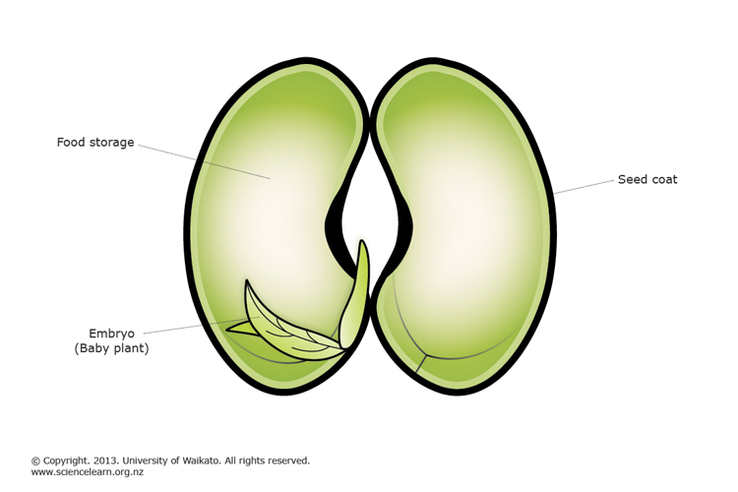

Activity 1: - Discover the parts of a seed
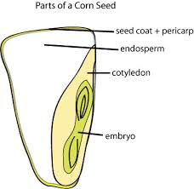
In preparation for this activity read the resources “The seed drawing activity” and “Bean seed dissection”.
You will need bean or peas seeds. (Broad beans are the best)
Resources:
Power point - Seed types and germination
- The seed drawing activity
- Bean seed dissection
Suggestion – Soak some corn seeds as well

Discuss the parts of the seed with your students.
Ask your students to
- Complete the “The seed drawing activity”.
Template in Unit 3 Lesson Activities Lesson 2 Activity 1
Notes
Types of seeds.
Seeds can be divided into groups.
- Dicotyledon
- Monocotyledon
Dicotyledon seeds have two cotyledons in each seed which act as food stores.
Monocotyledons seeds have one small cotyledon in each seed. There large food store is called the endosperm.

Ask your students-
- What do you think Di and Mono mean?
- Beans/peas seeds are dicotyledons. How many seed leaves do they have?
- Sweet corn seeds are monocotyledons. How many seed leaves do they have?

Challenge: - Find out what plants are dicotyledon and monocotyledons.
Take student for a walk around the school and point out plants that are dicotyledons and monocotyledons.
Ask students to look at these plants carefully. What can you see that makes them different?
Hint- look closely at their leaves.
Notes
Dicotyledon | Apples  Cabbage  Daisy  Tomato  Dahlia  Oak tree  roses
Monocotyledon | Grass  Flax  Cabbage tree  Agapanthus  Day lilies  Renga renga Lily  Daffodils
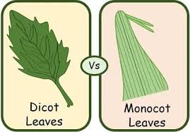

Lesson 3: - How to seeds grow into plants?
Class discussion
Quiz time Power point “Seed types and germination” - Slide 6
- What are the parts of a seed?
- What is the function of each part of the seed?
Introduction to germination
Ask your students
- Who has heard of germination?
- What does it mean?
- What do seeds need to germinate?
- Make a list of what you think seeds need to germinate?
- Have a vote on the suggestions?
Notes
Germination is when the embryo starts to grow
Seeds need three things to germinate
- Water
- Oxygen
W -Warmth
They need WOW

Activity 1: - Germination investigations.
Based on the level of your class select one or more of the investigations from the resource box.
Note: - PPT Seed investigations has templates to support investigations 1-3
- Do seeds need water to geminate?
- Do seeds need light to germinate?
- Investigation Fresh vs dry weight.

Resources- let’s investigate.
Power point “Seed types and germination” – diagrams of seed germination.
Investigations
- Do seeds need water to geminate?
- Do seeds need light to germinate?
- Investigation Fresh versus dry weight. This activity investigates germination and growth by observation and measuring fresh and dry weight,
Note: - You can simplify this investigation by only measuring the fresh weight of the seeds and seedling.
Skills - Weighing, observation, recording, math, graphing
- Discover what temperature is best for germination. Some like it hot
5. Stages of germination
This investigation involves the observation and recording the germination and growth of a broad bean seedling.
(NB- Pea seeds can also be used)
Suggestion. Split the class into groups. Half the class germinate pea or bean seeds and the other have germinate corn seeds.
- Compare how the difference between a dicotyledon and monocotyledon seed.
Note- corn requires temperature above 10ºC to germinate

- Follow the germination of a bean or pea seed from germination to emergence as a seedling.
What comes next?

Activity 2: - Fun activities germinating seeds
There are lots of fun activities to do germinating seeds. Select activities from the resource box below that suit your class. Have fun with seeds.
Resources
These investigations and activities are from FAR Resources for Schools
Germination Race-Try this experiment to find out if some vegetable seeds germinate faster than others
Germination Trials-Test different things that affect germination by setting up mini experiments.
Five seed race-Extend seed germination experimentation skills through practice and by 'going deeper'.
Egg grass heads-Create a grass head. Once grown, give it a haircut
Garden in a glove- Make a ‘little plants’ garden in a glove to study seed germination.
Egg carton caterpillar-Make and 'grow' fun egg carton caterpillars, then eat their 'sprouts'.
Microgreen sandwiches- Grow microgreens then eat them in a yummy sandwich.
Grassy numbers-Create a letter or number shape from germinating grass seeds.

Challenge
Do you want to challenge your students. Try this! Germinating kōwhai seeds

Lesson 4: - Flowers and pollination.
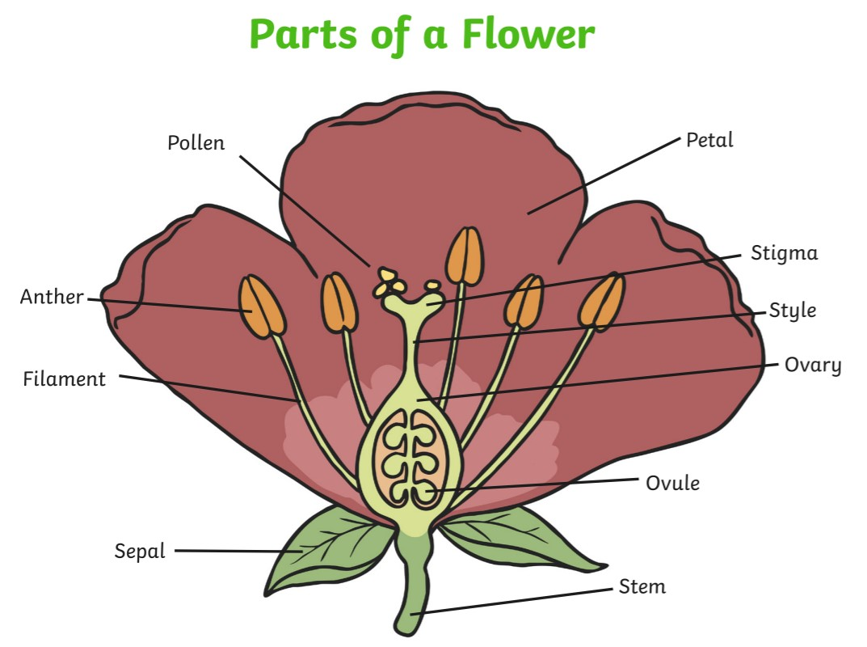
This lesson is best taught in spring and summer when there are lots of flowers around.
This activity provides an opportunity to observe flowers and explore the different parts and why flowers are the same but not the same.

Resources
You will need to provide a flower for each student?
Best flowers to collect are simple flowers such as:
- Fuchsias
- Lilies e.g. Day, Renga Renga (note lily pollen stains so you need to be careful using lilies)
- Alstroemeria
- Agapanthus
- Hibiscus
- Daffodils
- Flax
- Kōwhai

Ask your students
- How are seeds produced?
- Why do most plants have flowers?
- Why are flowers important?
- What the differences you can see between flowers?
Notes
Flowers are the reproductive parts of flowering plants. Without them, plants would not be able to produce seeds, and seeds are needed for the production of most of the food that humans and farm animals eat.

Activity 1: - Flower dissection
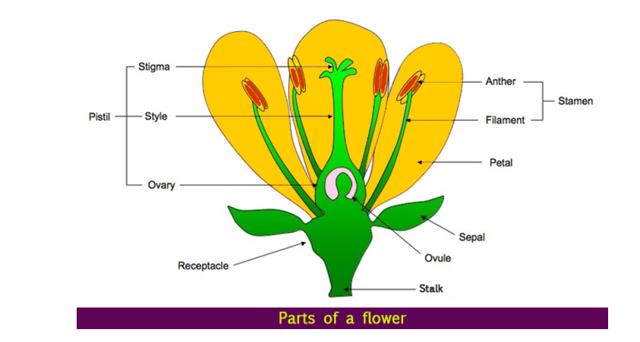
Use the flower dissection resource to dissect a flower and identify the different parts of the flower.
Resources
- Power point: - Power point: Unit 3 Lesson Activities. Slide 8-14
- Flower facts- Learn about flower parts and the differences between insect and wind-pollinated flowers
- Flower dissection Dissect flowers to learn what the different parts are and what they are for.
- Flower dissection sheet pdf download (A4)
- Colour and label flower- colouring activity

Activity 2: - Flower parts and pollination.
From the resource box choose the most suitable YouTube video to show your class flower parts and introduce them to pollination.
Do the
- Flower part definition drag and drop activity in Power point: Unit 3 Activities slides 9- 14
- The name the parts of the flower quiz. Slide 11 or in Te Reo slide 13
Resources- YouTube videos
- Parts of a flower and their function for kids
- Parts of flower- pollination
- htps://www.youtube.com/watch?app=desktop&v=SiFaN2xQg5g
- Parts of flower and their functions | Parts of flower and their functions | Parts of flower

Activity 3: - Secret flowers
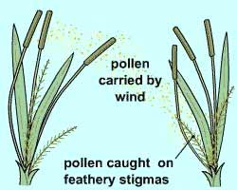
Notes
Secret flowers- flowers that are hidden
Many important plants have flowers that we don't really notice or recognise as flowers. Yet, these flowers are very important, because they belong to plants that produce our food (for example wheat, barley, and corn) and feed our sheep, cattle and deer (for example ryegrass in pastures). In this activity you are going on a hunt to find these secret flowers.

Resources
- Power point: - Power point: Unit 3 Lesson Activities. Slides 15-17
- Secret flowers -Discover the secret flowers of grass plants — wind pollinated flowers that are hidden, yet in plain view. They are everywhere around us and are incredibly important.
- Flower facts - Learn about flower parts and the differences between insect and wind-pollinated flowers
- Pollination explained - YouTube video
- This YouTube video shows clearly the difference between insect and wind pollination– start at 1.35-5.50

Use the resource Secret flowers to discover flowers that are hidden with your class.
- After watching the video YouTube video Pollination explained-take your students for a walk around the school and see if they can find plants that are insect pollinated and plants that are wind pollinated.
Hints and tips- finding wind pollinated plants.
Where to find suitable grasses: At school or home look for uncut grass plants along the edges of lawns and gardens, or the corn plants in a vegetable plot. On a farm look for wheat, barley, oats or maize plants grown as crops, or the grasses in pastures. You will also find various grasses along road verges and in wild areas.
Note: A list of wind and insect pollinated plants can be found in Flower facts

Challenge
Students work in groups to make a list of plants that have hidden flower- wind pollinated plants.

Activity 4: – Writing exercise
Now your students have learnt about flowers and pollination.
Ask student to write down
- What you know about flowers?
- What you know about pollination?
- Make a list the differences between insect and wind pollinated flowers.

Lesson 5: - More about Pollination
Class discussion- Now you know about flowers.
Ask your students: -
- What is pollination?
- Why do flowers need pollinating?
- How is pollen moved from flower to flower?
- How do plants get insects, animals and birds to visit flowers, so they are pollinated?
- How do plants advertise to pollinators that they have pollen ready?
Notes
Pollination is the process where pollen from the anther (the male part of the flower) moves to the stigma (the female part). This is important because it helps plants make seeds. Most plants need something, like insects or wind, to help with this.
Insect-Pollinated Flowers:
Flowers that are pollinated by insects are usually bright and colourful. They might also have a sweet smell or produce nectar to attract insects like bees and butterflies. The pollen on these flowers is big, sticky, and rough, so it sticks to the insects. The stigma is also sticky, so when the insect moves to another flower, the pollen sticks to it and helps the plant reproduce.
Wind-Pollinated Flowers:
Wind-pollinated flowers are usually small and don't have bright colours or strong smells. These flowers make lots of tiny, light pollen that can be carried by the wind. The stigma is often feathery and hangs outside the petals to catch the pollen as it blows by.

Resources
Moving pollen flower to flower Learn how pollen is moved from flower to flower. Which 'agents' achieve this on behalf of the flower, how do they do it, and why?
Pollinators in New Zealand (Teacher Guide) Discover a range of New Zealand pollinators in wild areas, in the garden or on the farm.
Pollinators in New Zealand
Pollination pulling power Observe flowers and assess them for their potential to attract a pollinator, that is, their 'pollinator pulling power'.
Flowers for bees Grow flowers for bees and assess which are most favoured. Which bees do the most work visiting flowers?

Activity1: - Counting pollinators.
Watch the videos in the Pollinators in New Zealand (Teacher Guide)
- Bee pollen slow motion flow
- The vibrating Bumblebee
- How bees collect nectar to make honey?
- Hoverfly
- New Zealand native Tui
Print off copies of Pollinators in New Zealand, enough for groups of students.
Take your students for a walk around the school to see if they can find identify and count insect and bird pollinators.

Activity 2: - Pollination activities
As a class or in groups get your students to do the interactive pollination activities.
- Pass the pollen (SLH)
- Pollination pairs (SLH)

Activity 3: - Growing Flowers for Bees.
If you have a garden or waste are at school grow flowers for bees.
- Grow and care for flowers that attract bees.
- Assess which flower types are most favoured by bees.
- Assess which bee types might be the best pollinators.

Lesson 6: - Producing seeds - Fertilisation
Class discussion
Ask your students: -
- Why do plants have flowers?
- What is pollination?
- What is fertilisation?

Introduce the role of fertiliser in producing seeds.
Notes
Steps in fertilisation
Step one: After pollen has landed on the stigma, it grows a pollen tube down through the style to the ovary.
Step two: The nucleus of the pollen grain travels down the pollen tube and fertilises the nucleus in the ovule.
Step three: The fertilised ovule develops into a seed.

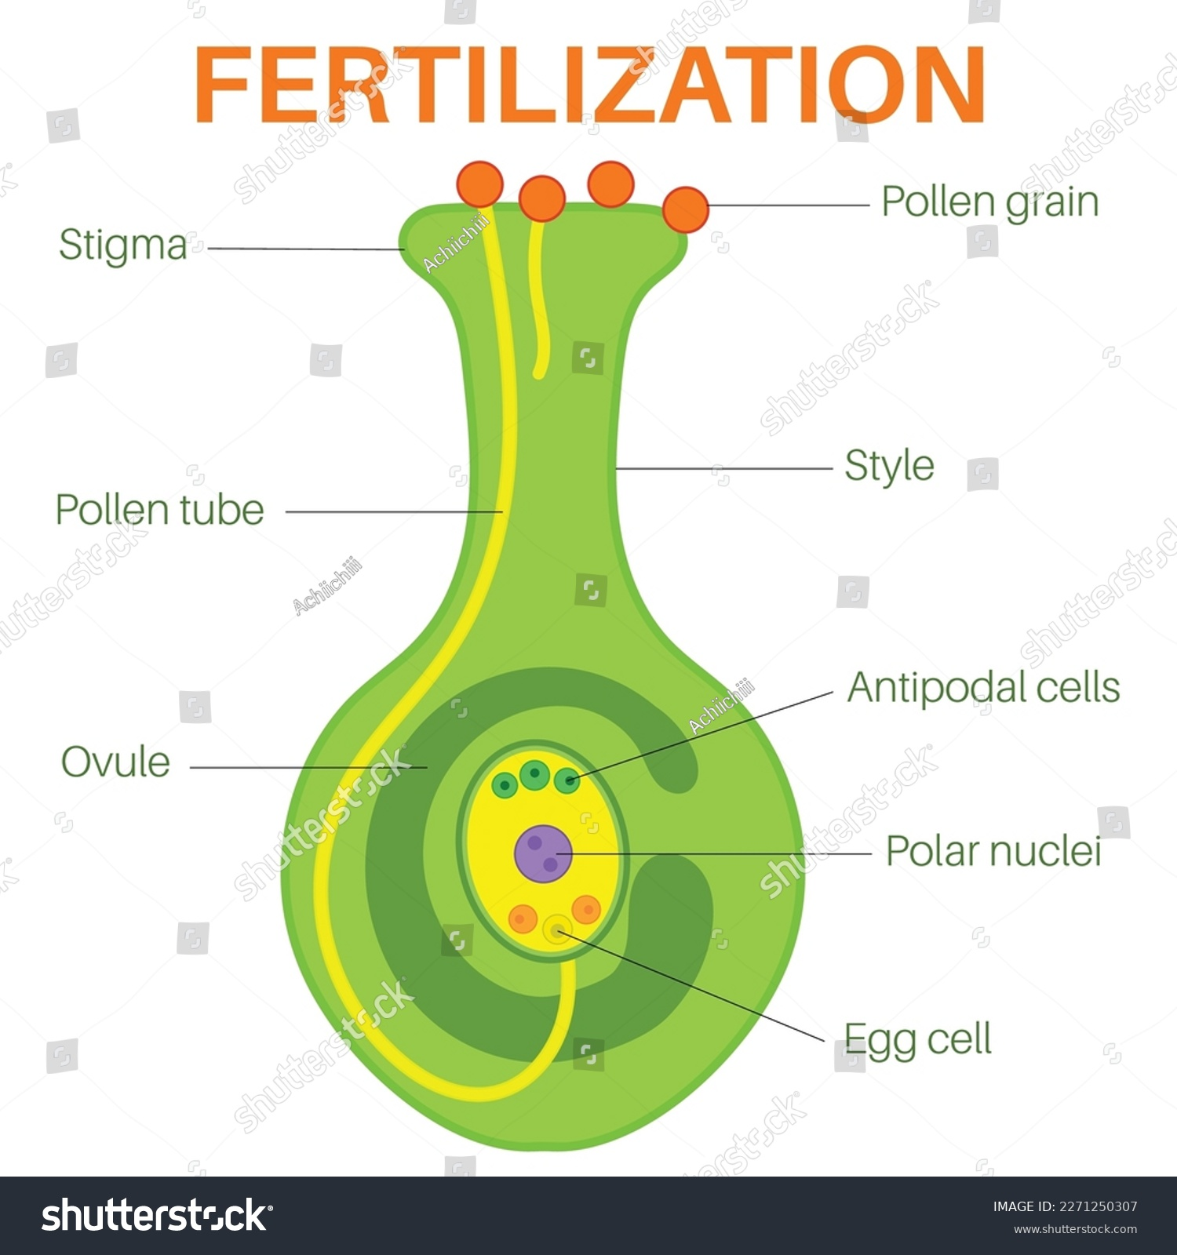
Resources
- YouTube clip “The process of pollination & fertilisation”
- Power point Unit 3 Lesson activities slide18 -19

Activity 1: - Comparing pollination and fertilisation.
- Watch the YouTube clip “The process of pollination & fertilisation”
- In groups students make a list what is involved in pollination and fertilisation.

Lesson 7: - Seed dispersal
Classroom questions
Ask your students: -
- How are seeds spread?
- Why do seeds need to spread?
- What does dispersal mean?
Resources
- Power point “Seed dispersal”
- YouTube video Seed dispersal
- YouTube video Seed dispersal- The amazing way seeds travel
- Helicopter seeds
- How do seeds disperse? - print off enough for class groups
- Seed bombs Make seed bombs for throwing into wasteland or eroded areas. The seeds will germinate to create a wildflower area for bees and other beneficial insects.
- How do seeds travel? Can you find out how plants spread their seeds?
- NZ-Seed-Dispersal (WS)

Activity 1: - Exploring seed dispersal
This activity is best carried out in terms 1 or 4
- Take students outside and find some dandelion seedheads and let them blow them in the wind.
What is special about dandelion seedheads that allows the seeds to fly?
- Make Helicopter seeds. Have a competition to find whose seed can travel the furthest.
- Go through the power point “Seed dispersal” and or watch the YouTube clips. Then using the resource “How do seeds disperse?” ask students to work in groups to predict how the seeds are dispersed?

Activity 2: - Making Seed Bombs
Make Seed bombs for throwing into wasteland or eroded areas. The seeds will germinate to create a wildflower area for bees and other beneficial insects.

Activity 3: - How do seed travel?
Extension lesson How do seeds travel?
- Can you find out how plants spread their seeds?
- How can this knowledge be used to help regrowth of native plant areas and to slow the spread of weeds.

Activity 4: - NZ seed dispersal (WS)

Lesson 8: - Let’s grow plants from seeds.
Have fun growing plants from seeds?
Resources
Seed sowing glossary Understand the words and symbols used on seed packets to help you sow and grow seedlings.
Interpreting seed packets
Power point “Steps involved in sowing seeds”.
Buying Seeds
KINGSSEEDS All schools and early childhood centres throughout New Zealand are eligible for our Seeds of Support discount. This discount provides 20% off our online retail pricing for any home or garden seed products in our range.
This offer supersedes other specials and offers and can only be activated with a verified profile through our website. One account per school.
Email us at info@kingsseeds.co.nz

Growing plants from seed indoors and outdoors
If you have school gardens grow plants by sowing seeds in containers and or directly into the garden. The plants you grow from seed will depend on the time of the year.
The power point “Steps involved in sowing seeds” shows the steps for sowing seeds into container and directly into school gardens.

Activity 1: - Interpreting seed packets.
- Print off the Seed sowing glossary- enough for each group.
- Give each group of students a seed packet.
- Ask the students to
  - use the seed sowing glossary to plan how they would sow the seeds and career for seedlings.
  - use the seed packet terminology to make word finds, cross words.

Activity 2: - Sowing seeds
Using the Power point “Steps involved in sowing seeds”.
- Sow seeds in containers.
- Sow seeds in the garden.
Suggestions
You can explore: -
- The size of the seed and how deep seeds should be sown.
- How far apart seeds should be sown?

