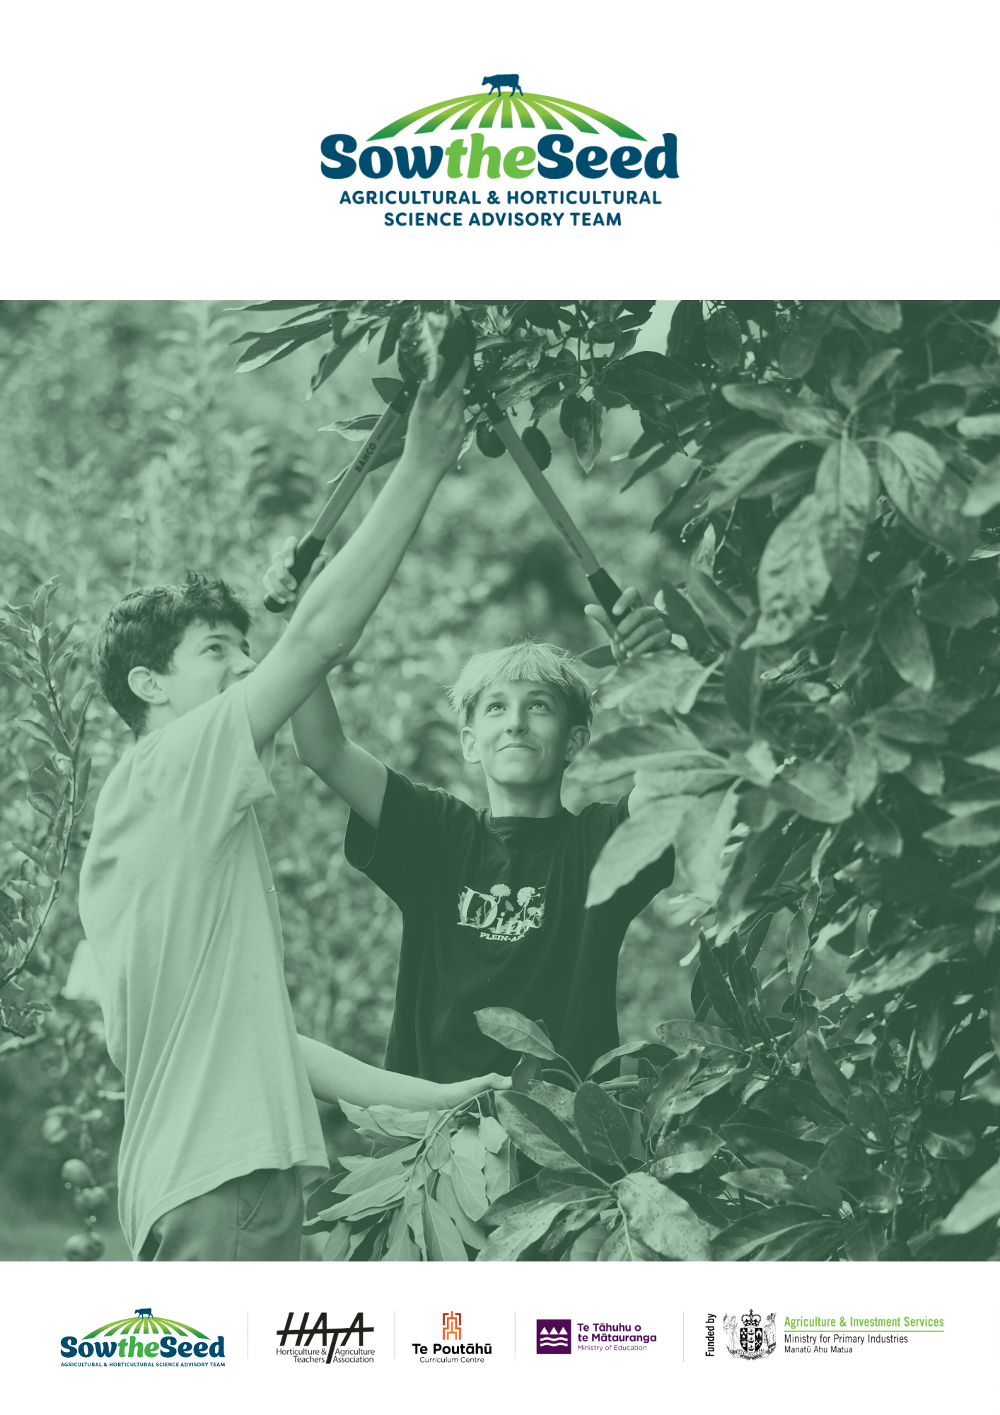
Unit 4
Biodiversity
&
Farming
Teachers Guide

Unit 4
Biodiversity and Farming
Teachers Guide
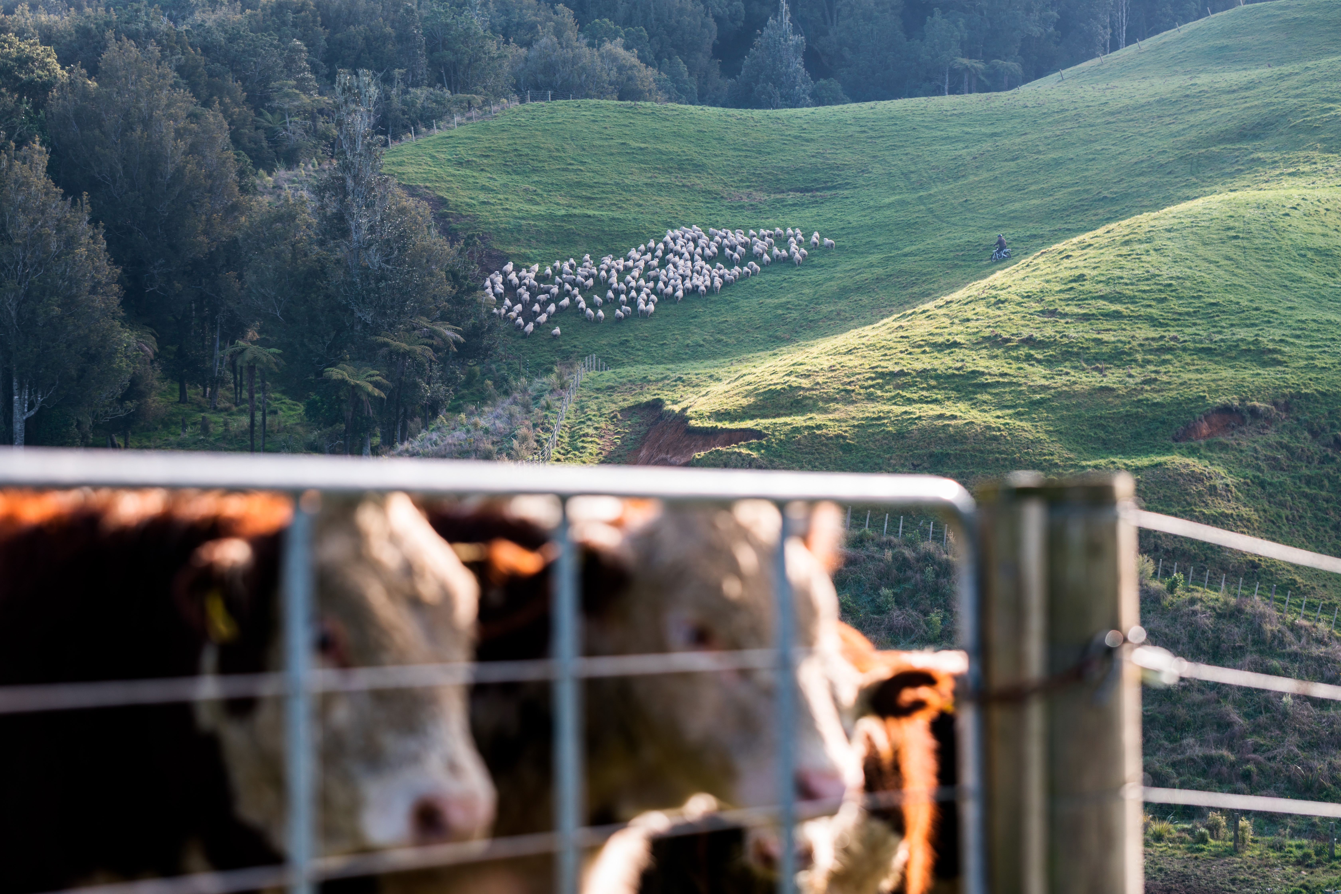

The primary production sector is well established in New Zealand Society and vital to the economy and standard of living. It is sector of opportunities and challenges.
Teaching years 7-10
We invite and encourage you to teach and inspire students about the primary production sector.

We have developed a resource for you.
Included is
- Teacher guide
- Engaging activities
This resource has been developed by Sow the Seed in conjunction with HATA.
For more resources and teaching material for agriculture and horticulture science we invite you to join the Horticulture and Teachers Association HATA

Introduction

Primary Production is a 54 billion+ industry in Aotearoa New Zealand.
In Aotearoa New Zealand, primary production is the process of producing raw materials and products from natural resources, land and water. The main primary industries are agriculture and horticulture, forestry, fishing, and aquaculture, others are turf culture and equine.
A primary production system is a sum of all components, including the growing environment and management practices, that work together in the production of a primary product. Some examples of primary production systems include, dairy farming, sheep and beef farming, orchards such as apple, kiwifruit and cherries.
Primary production is the key driver of New Zealand’s economic, social, and environmental development. The products of primary production are a source of well-being for the present generation and will be so for future generations.

What is agricultural and horticultural science?
The Agricultural and Horticultural Science subject looks at the management practices that occur behind the farm, orchard gate or on boat as well as beyond, to produce a product. This practically orientated subject uses all the primary sector contexts of sheep, beef and cropping, dairying, horticulture, seafood and aquaculture, forestry, equine and sports turf. The application of good production management practices ensures that the primary products demanded by local and world markets are made available in an ecologically and economically sustainable manner. Agricultural and horticultural science deals with contexts, issues, and problem solving drawn from a broad agenda that includes, for example:
- products (for example, pork, poultry, avocados, honey, timber, milk, wool, apples, grapes)
- environments (for example, waterways, erosion, landscape, soil, shelter, glasshouses, effluent, pollution; environmental modification and sustainable management practices)
- solutions for particular management issues (for example, irrigation, cropping, harvesting and milking equipment, data, information and communication digital technologies, shelter and shade construction, and cultivation technologies).

Teacher Guide Notes
This unit of work is designed to increase the knowledge and understanding of biodiversity –What it is? Why it is important and the role the primary industries has, to help improve New Zealand’s biodiversity.
Key Learning Outcomes:
At the end of this unit students will have an understanding of: -
- what Biodiversity is within an Agricultural and Horticultural Science setting
- how to measure biodiversity?
- how plant and animal pests affect biodiversity?
- the solutions primary producers are implementing to reduce loss of biodiversity and improve biodiversity.
- how to protect our unique New Zealand Aotearoa Biodiversity

Supporting resources
- General Farming with Biodiversity Kete
- PPT Unit 4 Biodiversity Lesson Activities
- PPT Primary Production land use
- Biodiversity Monitoring
- DIY-Activity-Sticky-Pest-Traps
- How to do Photo Points
- Native-Biodiversity
- Pollinators-in-New-Zealand-far.org.nz
- Technology and biodiversity

Timeframe
Lessons are generally designed in a one-hour blocks but feel free to modify to suit you and your students. You do not need to complete all the lessons or activities.

Recommendations
Within each lesson there are multiple activities for students to do. We recommend you select the activity or activities that suit your student’s.
Before you start this unit of work on biodiversity, we recommend you have introduced Primary Production to your students by teaching lesson 1-3 in Unit 1 “Primary Production”

Resources to download
Farming with Native Biodiversity and eLearning modules
General Faming with Biodiversity Kete” in English and Te Reo is outstanding resource that you can download and use to introduce biodiversity, what it is and why native biodiversity is important.
There is a series of 9 E modules to select from. These modules can be taught as a class or self-directed depending on your students.
Chapters 1 -3 eLearning modules are recommended as an introduction to biodiversity.
Chapters 4-9 eLearning modules are more advanced and suitable for senior students with more knowledge of agriculture.
This resource include links to native biodiversity Management resources in each region.
This resource is referred to in Lessons 1 and 2. As they provide an excellent introduction to biodiversity which support activities in lessons 3.

Contents
Introduction 3
Primary Production is a 54 billion+ industry in Aotearoa New Zealand. 3
What is agricultural and horticultural science? 3
Teacher Guide Notes 4
Supporting resources 4
Timeframe 4
Recommendations 4
Lesson 1: - Biodiversity 7
Activity 1: - Writing activity. 8
Activity 2: - Mapping Activity. 8
Activity 3: - New Zealand’s Native Taonga 8
Lesson 2: - Pest control and biodiversity monitoring 9
Activity 1: - Predator control 9
Activity 2: - Biodiversity monitoring photo point sight 10
Activity 3: - Guest speaker 10
Activity 4: - Research a biodiversity issue or topic 11
Activity 5: - Monitoring pollinators 12
Lesson 3: - What does biodiversity look like in NZ? 14
Activity 1: - Catchment projects and farming with biodiversity. 15
Activity 2: - Guest speaker 16
Activity 3: - Primary production and biodiversity 16
Activity 4: - Biodiversity Scenarios 16
Activity 5: - Reflection question 21

Lesson 1: - Biodiversity
Class discussion
Ask your students: -
- What is meant by diversity?
- How is the class diverse?
- How is the school diverse?
- What are the great things about diversity?
Now you know what diversity is, what do you think
- biodiversity is?
- native biodiversity is?
Chapter 1 E-Learning module complete as a class, small groups or individually
This module 15-minute module covers
- What biodiverse mean?
- Why biodiversity is important?
- Introduces why biodiversity on farms is important and how biodiversity benefits farms.
Biodiversity refers to both the variety of species in an area and the amount of genetic variation within each species in an area. A higher diversity of ecosystems in an area contributes to higher levels of biodiversity.
Emphasise that New Zealand is known for its unique biodiversity due to its isolation and distinct ecosystems.

Emphasise that New Zealand is known for its unique biodiversity due to itsisolation and distinct ecosystems.

Emphasise that New Zealand is known for its unique biodiversity due to itsisolation and distinct ecosystems.

The resource “Farming with native biodiversity” is aimed at people with knowledge of farming so it needs to be used selectively to suit the level of your class.
Once you have watched the video, we suggest using this resource to discuss with you class the terms ecology, biodiversity and ecosystem and these questions.
- Why do we need biodiversity?
- Why is native biodiversity important on farms?
- Where can farming help biodiversity?

Resources
Native Biodiversity - print as a poster
PPT Unit 4 Biodiversity Lesson Activities slides 3-5

Activity 1: - Writing activity.
Ask your students to answer the questions in your own words.
- What biodiversity is?
- Why you think it is important.
- Why do you think biodiversity important for farming?

Activity 2: - Mapping Activity.
To show the physical isolation of Aotearoa New Zealand
- Use Google to find out the distance from your closest city in New Zealand to major cities around the world.
- Work from your school location as your starting point.
- Find out the distance to New York, Sydney, Paris, Beijing, Singapore, Jakarta, Tokyo and London or any other locations you choose where New Zealand primary products are exported to.

Activity 3: - New Zealand’s Native Taonga
New Zealand's isolation has played a significant role in shaping its unique biodiversity. Separated from other land masses for millions of years, New Zealand developed a distinct assortment of plants (flora) and animals (fauna), with many species found nowhere else on Earth. This biodiversity is a critical component of our natural heritage and is vital for ecological balance and cultural identity.
In groups make a list of: -
- Plants (flora) and animals (fauna)that are only found in Aotearoa New Zealand.
- Pests that are harming our native plants (flora) and animals (fauna).
- What else is and or could negatively affect our native plants (flora) and animals (fauna).

Lesson 2: - Pest control and biodiversity monitoring
Class discussion
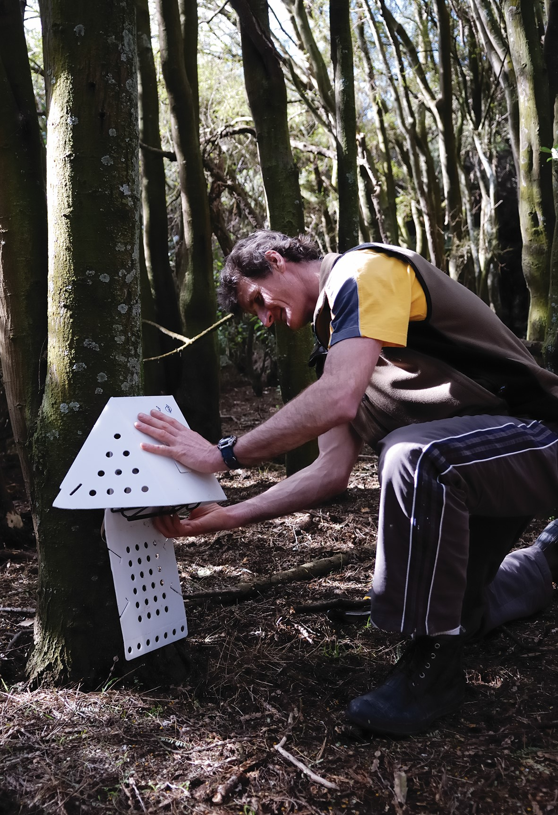

Ask your students: -
- Why is it important to have a mix of primary production systems in Aotearoa New Zealand?
- Name some pests that are harming New Zealand’s biodiversity?
- How are these pests being controlled?
- Whose responsibility is it to control pests?
- New Zealand has a goal to be pest free by 2050. Did you think this is important? What needs to be done to achieve this?

Resources
- Videos
  - Why New Zealand needs predator control
  - This is “impossible”, but New Zealand is trying anyway
- PPT Unit 4 Biodiversity lesson Activities slides 5-9

Activity 1: - Predator control
Watch the video’s below
- Why New Zealand needs predator control
- This is “impossible”, but New Zealand is trying anyway
Ask your students
- Why do we need to control predators?
- To write down questions they have about
  - Biodiversity
  - Controlling predators
- What they think is being done to protect New Zealand biodiversity?
- Write down and discuss ideas they think can be done to help improve biodiversity?

Chapter 2 E-learning module- complete as a class, small group or individually.
Resources- Print as posters
- Biodiversity Monitoring
- How to do Photo- points

Discuss as a class
- Biodiversity monitoring
- Why is biodiversity monitoring important?
- How can biodiversity be monitored?

Activity 2: - Biodiversity monitoring photo point sight
Use the resources Tohu-whakaahua | Photo-points and biodiversity monitoring
If you have an area in the school grounds such as native garden or a native bush area close to the school set up a biodiversity monitoring photo point sight with students.
- Students can monitor the changes in this sight through the seasons during the year.
- Students can set up their own biodiversity monitoring sight at home.
- As a teacher you can create a visual timeline of this sight to show students how the sight has changed over time/years.

Chapter 3 E-learning module complete as a class, small group or as individually
Ask your student to
Look at the list of animal pests that are threatening native biodiversity in lesson 1 activity 3
- Can you add any other pests to this list.
Discuss with your class
- How are animal pests identified?

Activity 3: - Guest speaker
Connect with your regional council or DOC or local community group involved in pest eradication and monitoring to get someone in to talk to students about biodiversity in your area and what they are doing to protect biodiversity.
- As a class make a list of questions you would like to ask the quest speaker.
- Write an article or speech about what you learnt from the guest speaker about biodiversity in your area and what they are doing to protect biodiversity.

Activity 4: - Research a biodiversity issue or topic
There are several research opportunities for students. Provide some research ideas or suggestions that students can select from that interest them.
See suggestions below as starter ideas.
Student’s carryout a research project on a biodiversity as an individual or in a group.
As a group or as an individual prepare a presentation on your biodiversity research project to present to the class. This could be a poster, power point presentation, speech, video, an article for the local paper or another creative way that interesting for the class.
Research suggestions
- Students select a plant or animal pest to research.
Suggestions to help direct student research.
- Find or take a photo of your animal/plant pest.
- Find out why the animal/plant you have selected is a pest.
- Find out how the animal/plant pest is harming biodiversity?
- Find out how this animal/plant pest is being controlled?
- Other interesting facts about you animal/plant pest.
Research topics
- How a pest in your region/area is causing loss of biodiversity and what can be done to stop this?
- How fencing off and planting a waterway or wetland in native plants can improve biodiversity?
- How planting native plants can improve biodiversity?
- Investigate what your school could do to improve biodiversity.
- Design a plan for your, school or local bush area to monitor and control pests.
- New Zealand has a goal to be pest free by 2050. What needs to be done to achieve this?

Activity 5: - Monitoring pollinators
Note: - This monitoring exercise needs to be carried out in term 1 or 4 when trees and shrubs are flowering.
Before starting this activity, you need to discuss what pollination is and what are pollinators? Find out what students know already
Ask your students
- What do you know about pollinators and pollination?

Resources
- Pollinators-in-New Zealand-far.org.nz (print off copies enough for class groups)
Good pollination and pollinators videos
- Pollination explained
This youtube video shows clearly the difference between insect and wind – start at 1.35-5.50
- Honey Bees Make Honey … and Bread
- Bumble bees This Vibrating Bumblebee Unlocks a Flowers Hidden Tresure
- New Zealand native Tui bird feeding on orange nectar from flax bush.

Notes
A pollinator is anything that helps carry pollen from the male part of the flower (stamen) to the female part of the same or another flower (stigma.)
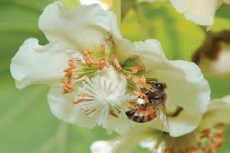

Notes
Pollination. Is the transfer of pollination from male parts of the flower stamen to the female parts of the flower stigma.
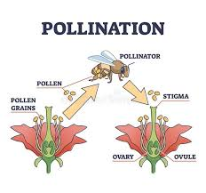

Monitoring Pollinators
Objective:
To study the attraction of pollinators to different flowers, highlighting the importance of different plant species for supporting biodiversity.
Before starting
Look through the “Pollinators in New Zealand” resource to identify common insect and bird pollinators.
How to set this up?
- Choose a spot in the school grounds that has a variety of plants. These could be native trees and flowers such as Kowhai, Manuka, Harakeke or Hebe but any flowering plants will do.
- Set up observation station so you can observe the insects or birds visiting the flowers. Take the handout “Pollinators in New Zealand” to help you identify the pollinators.
- Observe and record the types and number of pollinators (e.g. bees, butterflies, birds) visiting the flowering plants over a specific time period e.g. 3 minutes for 5 days
- Analyse the data to determine which flowers attract the most diverse and abundant pollinator populations.
- Discuss the crucial role of flowering plants in providing food and habitat for pollinators.

Lesson 3: - What does biodiversity look like in NZ?
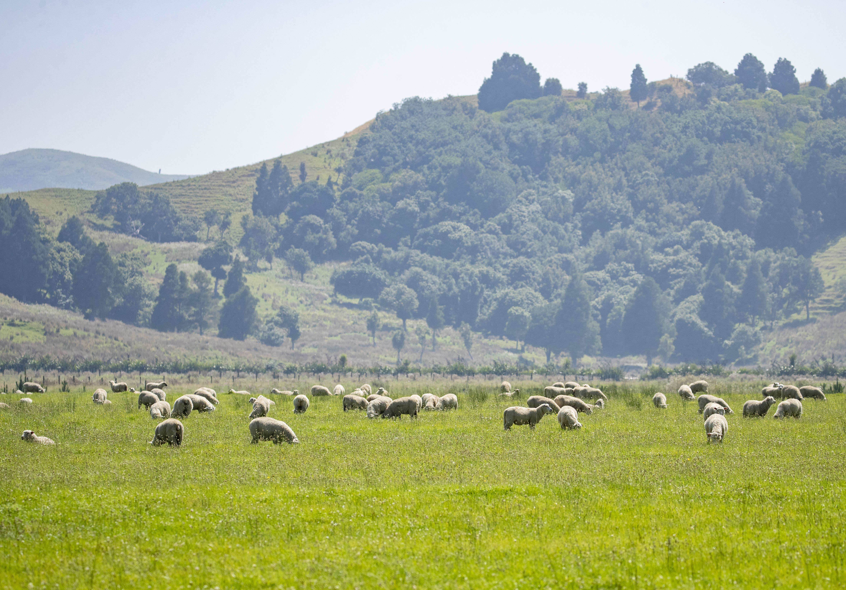

Class discussion
Ask your students
- Name plants and animals that are only found in New Zealand.
- Why are they only found in New Zealand?
Thinking back to unit 1 on Primary Production
- Half of New Zealand land is used to grow primary products. Name different primary production land uses.
- What are the key factors that influence where primary production (farming and horticulture are found in New Zealand?
- Why is it important to have a variety of land uses in horticulture and agriculture in New Zealand?
- How does this diversity benefit both the environment, people and the economy?
Teachers notes
Biodiversity on farm.
Biodiversity on a farm or orchard is a win-win for the farmer or grower and for the ecosystem. Production will improve if pasture and crops are healthy, earthworms are active, and insects and bees are busy.
Most activities that promote biodiversity have other positive spin offs. For instance, planting a shelterbelt – particularly of native varieties – provides a habitat and food for birds and insects, while also keeping stock cool or warm, reducing wind that can damage crops and preventing soil erosion.
Biodiversity is becoming more important for New Zealand’s international customers therefore activities that improve biodiversity contribute to New Zealand’s positive environmental image.
Catchment Area
A catchment area, also known as a drainage basin, refers to the land area from which water drains into a particular river or lake. It is the region that contributes water, usually through rainfall or snowmelt, to a water body via streams, rivers, or other waterways.

Resources
Videos
- Waipoua catchment
- Pokaiwhenua catchment project
- On Farm Story- Bringing Native Bush Back to NZ Farmland
- Rural Delivery Trees and Dairying

Activity 1: - Catchment projects and farming with biodiversity.
These short video’s show what catchment groups and farmers are doing to improves and protect biodiversity.
- Watch: Waipoua catchment
Ask your students
- How has a fence helped biodiversity in the Waipoua catchment?

- Watch: Pokaiwhenua catchment project
Ask your students
- How is planting along the river in the Pokaiwhena catchment help to improve biodiversity?
- What else has is being done to help to increase biodiversity in the Pokaiwhenua catchment?
- Who is doing the work and why?

- Watch: -On Farm Story- Bringing Native Bush Back to NZ Farmland
Ask your students
- What is the farmer doing to improve biodiversity on the farm?
- What are the other benefits of planting native tress on farm?
- What is the farmer doing to protect the native trees and birds?

- Watch. Rural Delivery Trees and Dairying
Ask your students
- To make a list of what this farming family has done and doing to improve biodiversity on the farm.
- To discuss what changes the farming family have observed because of the activities they have and are doing.

Activity 2: - Guest speaker
Contact local iwi, regional council, DOC to ask if there is a catchment or biodiversity project in your region. Visit or get a guest speaker into to discuss the project.

Activity 3: - Primary production and biodiversity.
Resource
PowerPoint “Primary production land use”

Print off land use slides and give one to a group of students. Students discuss
- How the land is being used?
- What can you see that is good or not so good for supporting biodiversity?
Students report back to the whole class on their land use and biodiversity.
Or
Using the PowerPoint select two or three slides. The class discuss the above questions in groups and each group reports what they think back to the whole class.

Activity 4: - Biodiversity Scenarios
Group Activity
- Divide students into small groups.
- Provide each group with a biodiversity scenario.
- Each scenario has a challenge- a question the students need to find the answer to.
Ask students: -
- What is the key biodiversity issue?
- What has caused this issue?
- What are growers and farmers doing to reduce this issue and improve biodiversity
- Can you think of other ways growers and farmers could reduce this issue and improve biodiversity?
Each group keeps track of their scenario and the solutions they have come up with so they can report back to the whole class.
Student presentations guide
- Students plan, develop and present their solutions to the class.
- Students can present in any format; however, all students must participate.
- Students must refer to their specific scenario.
- Presentation must include at least TWO effects on crops and/or animals and
- ONE solution
- And the answer to the challenge.

Scenario 1 The Kiwifruit Challenge
The kiwifruit industry in New Zealand is facing a big challenge because bees, which are crucial for pollination, are declining in numbers. This drop in bee populations has made growers worried about how well their kiwifruit will be pollinated and, ultimately, how much fruit they will produce.
Pollinator
To tackle this issue, New Zealand growers are making important changes. They are using fewer pesticides and focusing on eco-friendly farming practices such as pest monitoring using sticky traps. This shift helps create a healthier environment for bees and other pollinators.
In addition, many growers are working to restore natural habitats around their orchards. This includes planting a variety of flowers and creating wetlands. These actions provide food and nesting places for bees, which also helps improve the overall diversity of the ecosystem.
Raising awareness about the importance of pollinators is another key step. Many initiatives are educating farmers, growers, and the general public about how vital bees are to agriculture and horticulture. This increased understanding is leading to better land management practices that benefit both farming, horticulture and the environment.
With these efforts, New Zealand is working hard to solve the problems caused by declining bee populations. By balancing the health of pollinators with the needs of the kiwifruit industry, the future of this important sector is looking promising.
Pollination
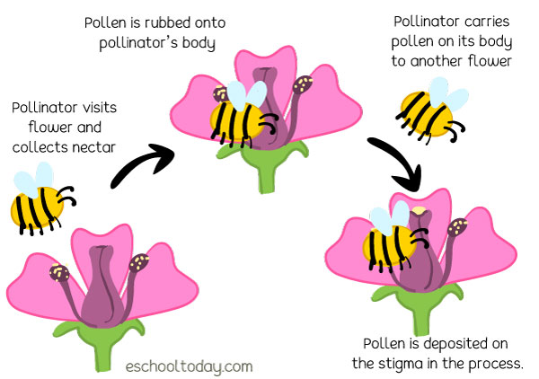
Spraying a pesticide
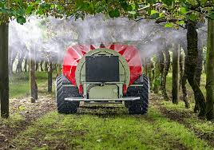

Sticky traps
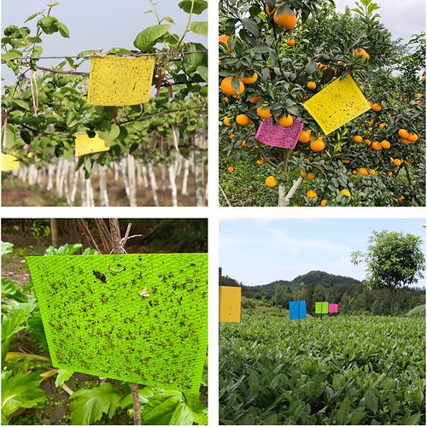
Challenge
- What are sticky traps?
- Why do growers use sticky traps?
Resources
- DIY-Activity-Sticky-Pest-Traps
- Make your own sticky traps to put in the school or your garden
Scenario 2
Habitat Loss: A challenge to New Zealand's Biodiversity
In Aotearoa New Zealand, habitat loss is a serious problem. In the past, large areas of native forests and wetlands were cleared for food production, forestry, and urban development. This ongoing expansion has led to significant loss of habitats. Now, there is a big push to address habitat loss caused by urban sprawl and farming practices. Regulatory measures, community involvement, and sustainable land use practices are all focused on restoring and preserving native habitats to protect New Zealand’s biodiversity.
Many farmers see themselves as guardians of the land. They recognise that healthy biodiversity supports farming by providing pollinators for crops, improving water quality, reducing soil erosion, and offering homes for native species.
More farmers are taking action by controlling plant and animal pests, fencing off areas with native plants, planting riparian strips along waterways, restoring wetlands, and creating patches of native plants on their properties. These efforts help protect endangered species and encourage the return of native birds, insects, and other wildlife.
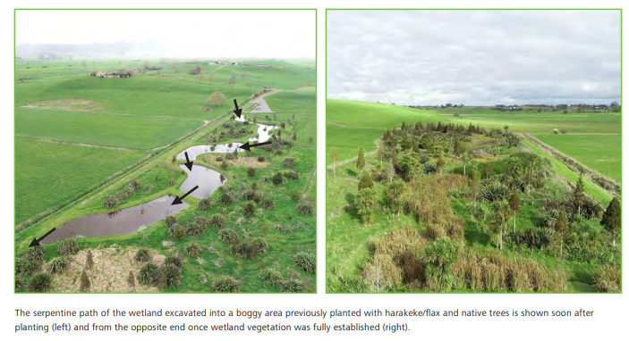
Collaboration between farmers, conservation organisations, and government agencies is crucial for supporting initiatives like predator control programmes and the creation of ecological corridors. These corridors help connect fragmented habitats, allowing species to move freely and enhancing genetic diversity. Together, these actions aim to restore New Zealand’s unique ecosystems and protect its rich biodiversity for future generations.
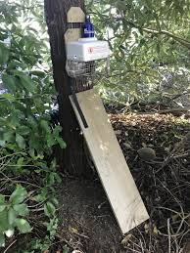
Possum trap
Riparian planting
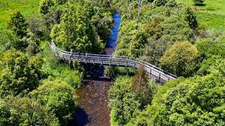
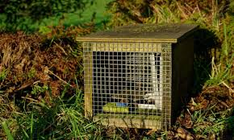
Stoat trap
Challenge
What is an ecological corridor?
Supporting vocab and diagrams.

Scenario 3
Managing our water and biodiversity
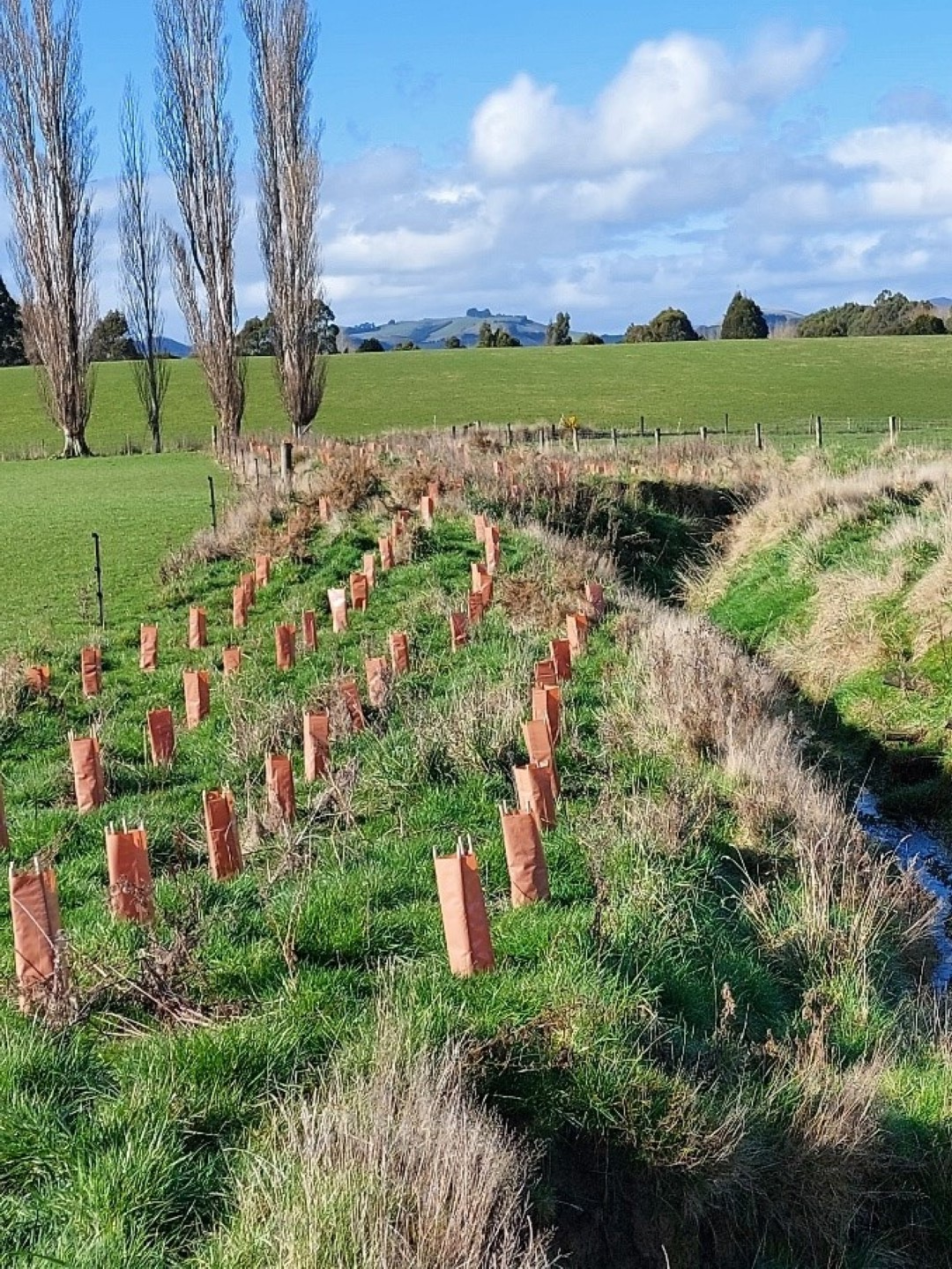
In Aotearoa, New Zealand, there is a strong effort to protect biodiversity while managing water resources on farms and orchards. Local farmers and orchardists are adopting sustainable practices to reduce water pollution and protect native ecosystems. Key initiatives include fencing off waterways to keep livestock away and riparian planting, which involves restoring native plants along waterways. This creates natural buffers that filter runoff and provide habitats for wildlife.
Farmers are also using precision agriculture techniques to make the most of their water. By using tools like soil moisture sensors and remote monitoring systems, they can optimise irrigation, reduce water use, and make informed decisions.
At the national level, the New Zealand government has introduced strict regulations to control nutrient runoff and protect water quality. These rules require farms and orchards to carefully manage their nutrient discharges to avoid harming aquatic ecosystems.
There is also a growing focus on restoring and preserving rivers and wetlands. Restoration projects aim to remove invasive plant species and improve natural habitats, which helps enhance water quality and increase biodiversity.
Together, these local and national efforts demonstrate New Zealand's commitment to balancing agriculture and biodiversity, ensuring its water resources are protected for future generations.
Challenge
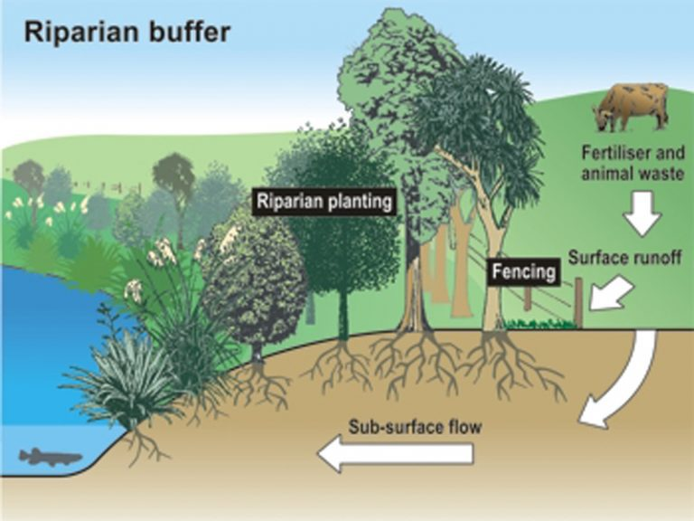
- How do soil moisture meters work?
- How is biodiversity in waterways measured?
Diagrams
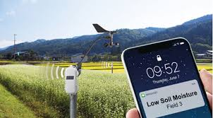
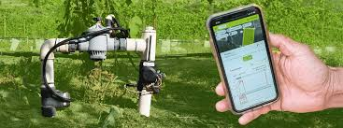
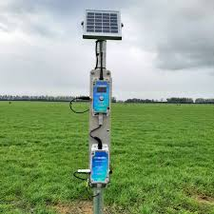
Soil moisture smart system

Activity 5: - Reflection question
Now you know what biodiversity is, why it important, what farmers, growers, iwi and organisations are doing to improve and protect our precious biodiversity.
Make a list or a plan about what you can do to help protect and improve biodiversity where you live?
Other resources and science activities
- House of Science Bi-Lingual Science Resource kits for Year 0-8 students
If your school is registered with House of Science the Science Kits, Plants, Pests & Produce and Soil Secrets provide engaging and relatable science activities that align well with this biodiversity unit.
- Download iNaturalist
The place where you can record what you see in New Zealand nature, meet other nature watchers, and learn about Aotearoa's natural world.
- Conservation activities for children
Find nature activities you can do with children outdoors and at home.
- Science Learning Hub is a perfect resource.
Introduce students to citizen science initiatives, such as bird counts, where they can actively contribute to biodiversity data collection.
Guide students in designing their own Citizen Science projects focused on local biodiversity. Encourage them to collaborate and present their findings.

