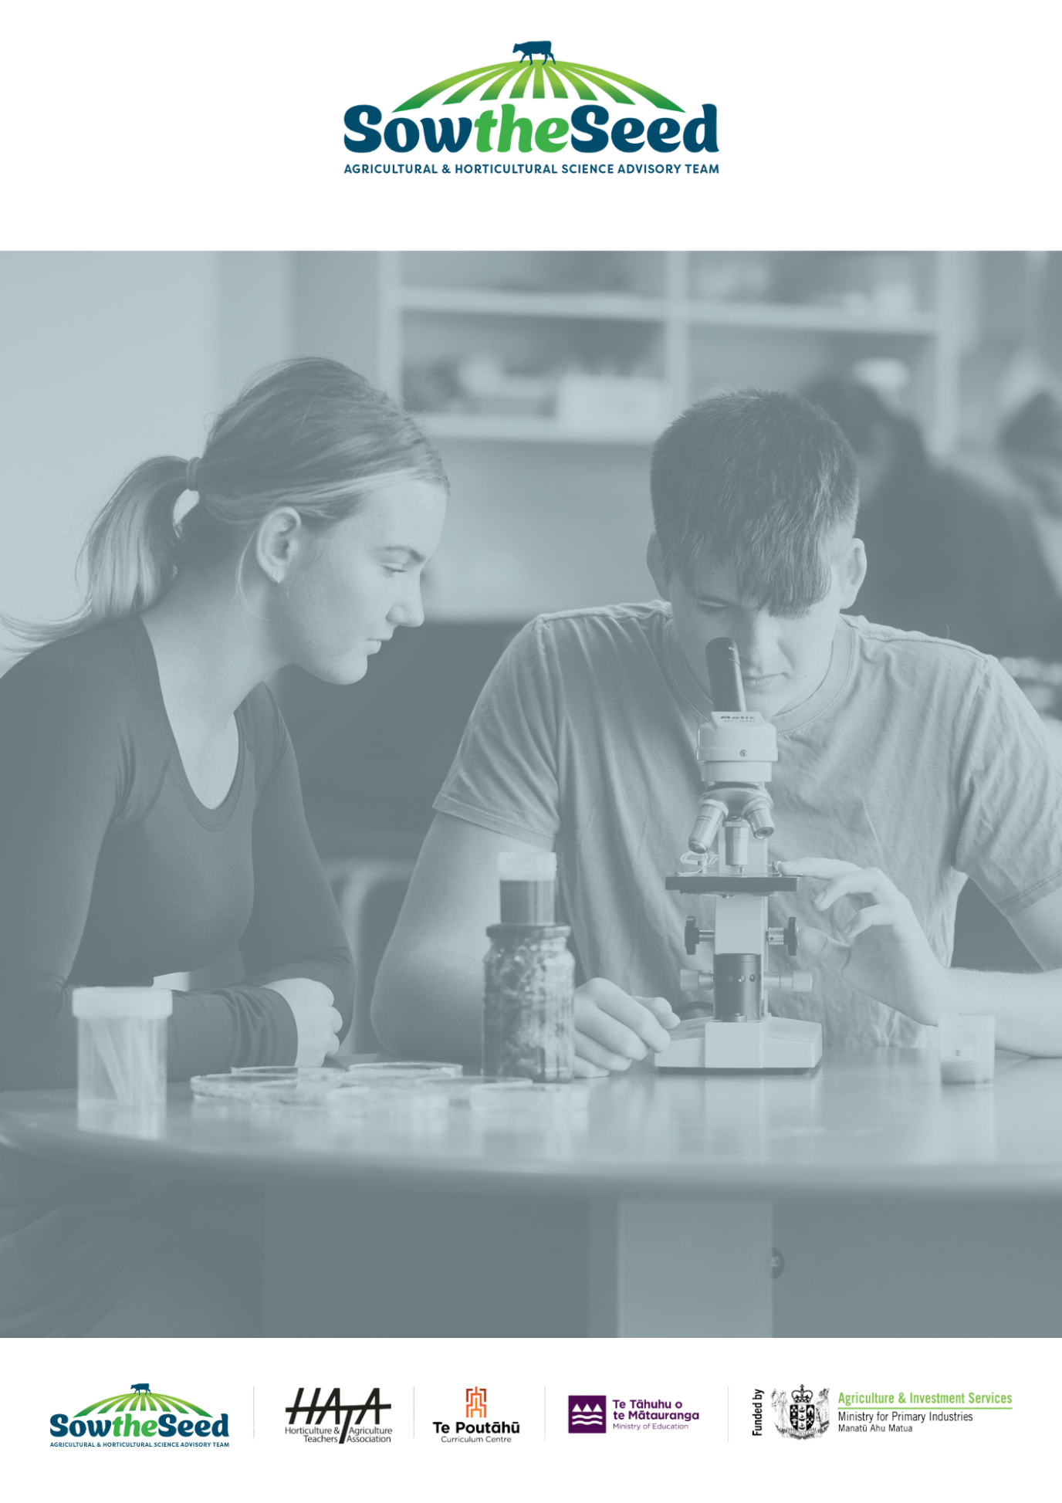
Unit 5
Agri technology in New Zealand’s Primary Industry

Teachers Guide

Unit 5
Agri technology in New Zealand’s Primary Industry
Teachers Guide
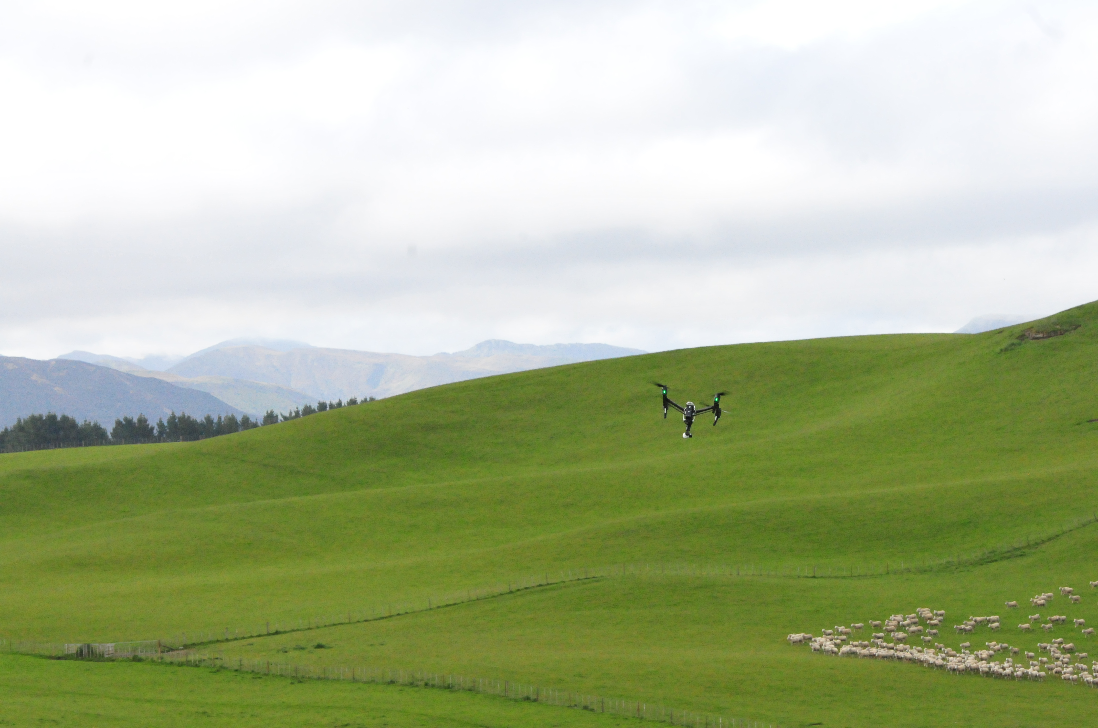

The primary production sector is well established in New Zealand Society and vital to the economy and standard of living. It is sector of opportunities and challenges.
Teaching years 7-10
We invite and encourage you to teach and inspire students about the primary production sector.

We have developed a resource for you.
Included is
- Teacher guide
- Engaging activities

This resource has been developed by Sow the Seed in conjunction with HATA.
For more resources and teaching material for agriculture and horticulture science we invite you to join the Horticulture and Teachers Association HATA

Introduction

Primary Production is a 54 billion+ industry in Aotearoa New Zealand.
In Aotearoa New Zealand, primary production is the process of producing raw materials and products from natural resources, land and water. The main primary industries are agriculture and horticulture, forestry, fishing, and aquaculture, others are turf culture and equine.
A primary production system is a sum of all components, including the growing environment and management practices, that work together in the production of a primary product. Some examples of primary production systems include, dairy farming, sheep and beef farming, orchards such as apple, kiwifruit and cherries.
Primary production is the key driver of New Zealand’s economic, social, and environmental development. The products of primary production are a source of well-being for the present generation and will be so for future generations.

What is agricultural and horticultural science?
The Agricultural and Horticultural Science subject looks at the management practices that occur behind the farm, orchard gate or on boat as well as beyond, to produce a product. This practically orientated subject uses all the primary sector contexts of sheep, beef and cropping, dairying, horticulture, seafood and aquaculture, forestry, equine and sports turf. The application of good production management practices ensures that the primary products demanded by local and world markets are made available in an ecologically and economically sustainable manner. Agricultural and horticultural science deals with contexts, issues, and problem solving drawn from a broad agenda that includes, for example:
- products (for example, pork, poultry, avocados, honey, timber, milk, wool, apples, grapes)
- environments (for example, waterways, erosion, landscape, soil, shelter, glasshouses, effluent, pollution; environmental modification and sustainable management practices)
- solutions for particular management issues (for example, irrigation, cropping, harvesting and milking equipment, data, information and communication digital technologies, shelter and shade construction, and cultivation technologies).

Teacher Guide Notes
This unit of work is designed to increase the knowledge and understanding of the pivotal role technology plays in New Zealand’s primary industry.

Key learning outcomes
At the end of this unit students will have an understanding of: -
- the different types of technology used in farming and other primary industries.
- the benefits and challenges of using technology in agriculture and other primary industries.
- how technology can be used to solve problems in agriculture and other primary industries.
- how to plan, design, and create a solution for a primary industry challenge using technology.
- the types of careers opportunities available in agri technology.

Supporting Resources
- 21st Century skills
- Modern Technology Concepts
- Design Thinking Challenge Guidelines

Timeframe
Lessons are generally designed in a one-hour blocks but feel free to modify to suit you and your students. You do not need to complete all the lessons or activities.

Recommendations
Within each lesson there are multiple activities for students to do. We recommend you select the activity or activities that suit your student’s.

Contents
Introduction 3
Primary Production is a 54 billion+ industry in Aotearoa New Zealand. 3
What is agricultural and horticultural science? 3
Teacher Guide Notes 4
Key learning outcomes 4
Supporting Resources 4
Timeframe 4
Recommendations 4
Lesson 1: - Technology in the primary industry. 6
Activity 1: - Agri technology in the primary industry 6
Activity 2: - Frozen peas - growing to consumer 9
Activity 3: - Technology in primary production systems 10
Lesson 2: - The Future 22
Activity 1: - Careers in Agri technology 23
Activity 2: - Designing a technology solution to a primary industry challenge 24
Activity 3: - Young Enterprise Trust Innovation Challenge 29

Lesson 1: - Technology in the primary industry.
Technology is vital to the primary industry that underpins New Zealand’s economy. It plays a pivotal role in helping our producers to achieve higher productivity and better environmental outcomes and New Zealand to be a global leader in food production.
Note: for more information on the primary industry- refer to Unit 1- Primary Production Systems
Find out what your students know.
Working in groups
Ask your students
- What they think technology is?
- To make a list of the technologies they know about.
- To discuss what these technologies do or are or could be used for?
- To write a list of how they think the technologies they identified are helping primary producers (farmers / growers).
- To write down what they know about technology in the primary sector
- To write a list of questions about what they want to find out about technology in the primary industry

Activity 1: - Agri technology in the primary industry
These videos provide and introduction to technology in the primary industry.
Watch these videos
(1) Discover New Zealand Agritech
(2) Agritech Story, Powered by Place
(3) The importance of agritech and the NZ Story
In this introduction to the importance of Agritech, CEO of Agritech NZ Brendan O’Connell talks about common challenges like labour shortages, the climate crisis and how the New Zealand market has an advantage when it comes to being well-connected and innovative. We explore the advantages of digital adoption, and why it is important for NZ farmers to embrace certain technology to ensure future success.
After watching the videos
Ask your students
- To discuss questions 1-6 again and add to their answers or list of questions.
- To make a list of how technology is helping New Zealand primary producers to produce food more efficiently, sustainably and profitability.

Ideas to get you started
How technology is helping primary producers
- reduces labour
- removes hard and repetitive jobs
- reduce cost of materials/chemicals e.g. herbicides and fertilisers
- maximise the use of water and minimise wastage of water
- reduce chemical use - better for the environment as well as cost savings.
- monitor pest and diseases – selective and targeted spraying
- consistent quality
- more informed decisions
- better animal management, health, reproduction, pasture management

Technology in the primary industry.
Technology is changing the way New Zealand’s primary industries work, making them more efficient, sustainable, and profitable. With the help of technologies like automation, precision farming, data analytics, and sustainable energy, New Zealand can make smarter decisions, use resources better, and reduce environmental impact. These innovations also help farmers, growers, and workers use their time and skills more effectively, focusing on more important tasks. By embracing technology and research, New Zealand's primary industries can and are adapting to changes in the market, climate, and consumer needs. This will ensure that the country’s agriculture, horticulture, and fisheries thrive in the future, making New Zealand a global leader in sustainable production.
How technology is helping primary producers.
- Precision Agriculture: Tools like GPS, drones, and sensors allow farmers to monitor their soil, crops, and water use in greater detail. This helps them use resources more efficiently, reduce waste, and increase crop yield. For example, smart irrigation systems can deliver water exactly where and when it's needed, saving water.
- Automation and Robotics: Robots and machines are making farming tasks more efficient. For example, robotic milkers in dairy farms and fruit-picking robots in orchards save time and reduces labour requirements. These technologies also help solve the problem of not having enough labour in rural areas.
- Data Analytics and Artificial Intelligence (AI): AI and data analytics are helping farmers make better decisions. By looking at things like weather patterns and soil conditions, they can know the best time to plant or harvest crops, predict demand, and avoid risks. This helps them be more productive and reduce their environmental impact.
- Sustainability and Environmental Monitoring: Sensors, satellites, and drones are being used to track the environmental effects of farming. These technologies help monitor soil health, greenhouse gases, and biodiversity, guiding farmers toward more sustainable practices.
- Supply Chain Management and Traceability: Digital technologies like blockchain are making it easier to trace where food comes from. Consumers want to know where their food is from, and blockchain helps track it from the farm to the table, ensuring quality and safety.
- Animal Health and Welfare: Wearable technologies, like smart collars, are used to monitor the health of animals. These devices can alert farmers about early signs of illness, reducing the need for antibiotics and improving animal care. Remote tools also help farmers manage grazing and keep animals healthy.
- Biotechnology and Genetic Improvement: New biotechnology is improving crops and livestock, making them more resistant to pests, diseases, and changing climates. This helps farmers produce more food and improve the quality of their products.
- Fisheries and Aquaculture: In fisheries, technology helps manage fish stocks and monitor water quality. Innovations in aquaculture, like automated feeding systems, are improving fish farming by increasing productivity and protecting the environment.
- Apps for Farmers and Growers: Mobile apps are changing how farmers manage their farms. These apps give real-time data about weather, crops, and soil conditions to help farmers make better decisions. Some apps can also track pests and diseases, giving farmers quick ways to handle problems.
- Augmented Reality (AR): AR is being used to help farmers train and make better decisions on the farm. AR can show farmers how to operate machinery or manage crops by displaying useful information on their devices. It can also help with tasks like planting or checking soil conditions by showing data over the real world through AR glasses or screens.
- 3D Printing: While still new in farming, 3D printing can help with making custom tools and parts. It can quickly create spare parts for farming machines, reducing downtime when something breaks. It can also help design new farming tools or precision equipment, improving efficiency.
Note
For more information on modern technologies refer to the Resource - Modern Technology Concepts

Activity 2: - Frozen peas - growing to consumer
The purpose of activity one is to
- Introduce students to a range of technologies used in the production of a primary product from paddock to plate.
- Get them think about
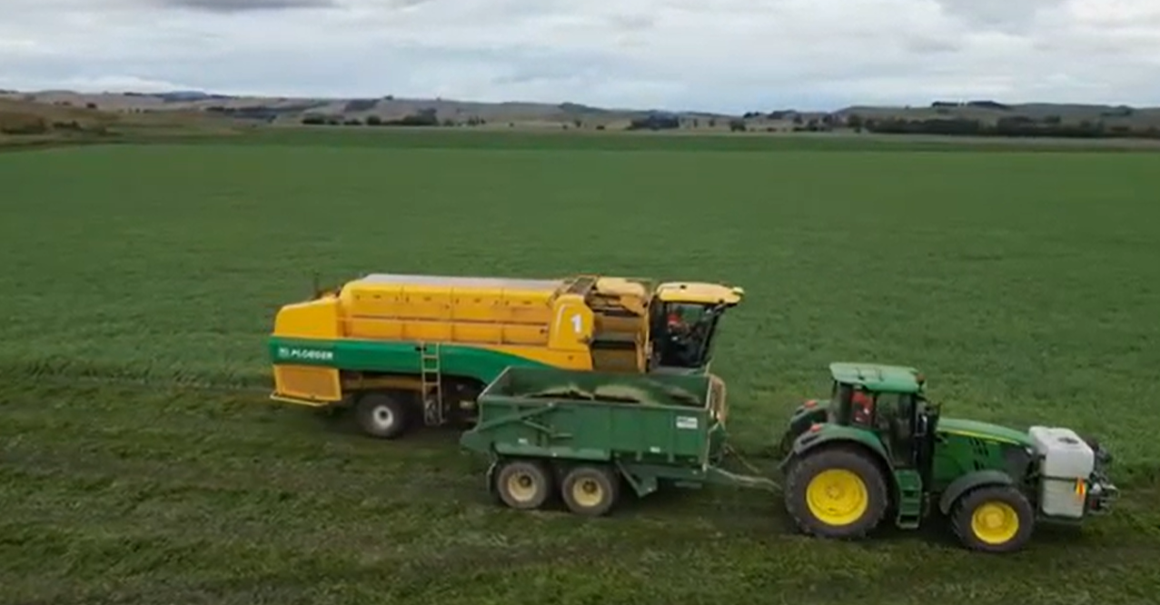
- the role of the technology.
- the advantages and challenges of the technology.
- opportunities for new and or improved technologies to solve a problem or a challenge.
Most households likely have a bag of frozen peas in their freezer. Technology is playing a bigger role in helping New Zealand’s commercial pea growers by making the growing, harvesting, and packaging of frozen peas more efficient and sustainable. From using precision farming techniques in the fields to advanced systems for sorting and packaging, technology is improving every step of the process.
Ask you students to
- Draw a diagram showing how peas get from the paddock to a frozen bag of peas?
- Add to their diagram where they think technology is used and the types of technology used in getting peas from the paddock to being frozen in a bag.
Watch the video’s
- Growing and Freezing Peas in NZ
- Kahotea farming – Pea Harvest- https://drive.google.com/drive/folders/1qQHieodQrnwRwxAbqDJ6rL08o3bsD1jy (No Sound)
While watching the video ask your students to: -
- Look for the technology being used from harvesting peas until they are frozen in bags.
- Make a list of the different types of technology being used.
- Compare what they have seen in the videos with their diagram.
- Discuss what they have learnt.
- Discuss the benefits of the technology being used to produce a consistent quality bag of frozen peas.
- Work in groups and discuss where there may be opportunities to improve or develop new technologies to increase the efficiency, quality and sustainability of growing processing and packaging peas.
- How do you think new and improved technologies could help make New Zealand's vegetable growers be more efficient, productive and environmentally friendly in the future? What kind of new technologies could be used, and how would they work?
- Check their list of questions.
  - Have any of your questions been answered?
  - Write down any more questions you may have about technology in the primary sector.

Activity 3: - Technology in primary production systems
Note: - There are several ways to approach this activity.
- Select one of the following primary products or production systems related to your local community and as class explore the types of technologies used in the production of the product or production system. Use the videos and questions as a guide and a starter.
- Divide your class into groups and allocate each group a primary product or production system. Ask the students to explore the technologies used in the production of the primary product or production system. Each group presents what they have learned to the class.

Primary Production Systems
- Apple Production
Technology plays an important role in supporting New Zealand's apple industry by improving the entire production-to-consumer process. This includes improving orchard management, optimising harvest, processing, packaging, and logistics, and ensuring that apples reach the consumer in top condition.
Ask your students to
- Watch the videos and then discuss the questions.

- Springhill Orchard- is a hi tech- net apple orchard in Hawke’s Bay
- What technologies are being used on this orchard.
- Why is live real time data important to orchard managers.
- What are the advantages of this technology for the grower, staff and the environment.
Automation in harvesting is a game changer for the apple industry.
(2) World-first apple-picking robot boots up in Hawke’s Bay
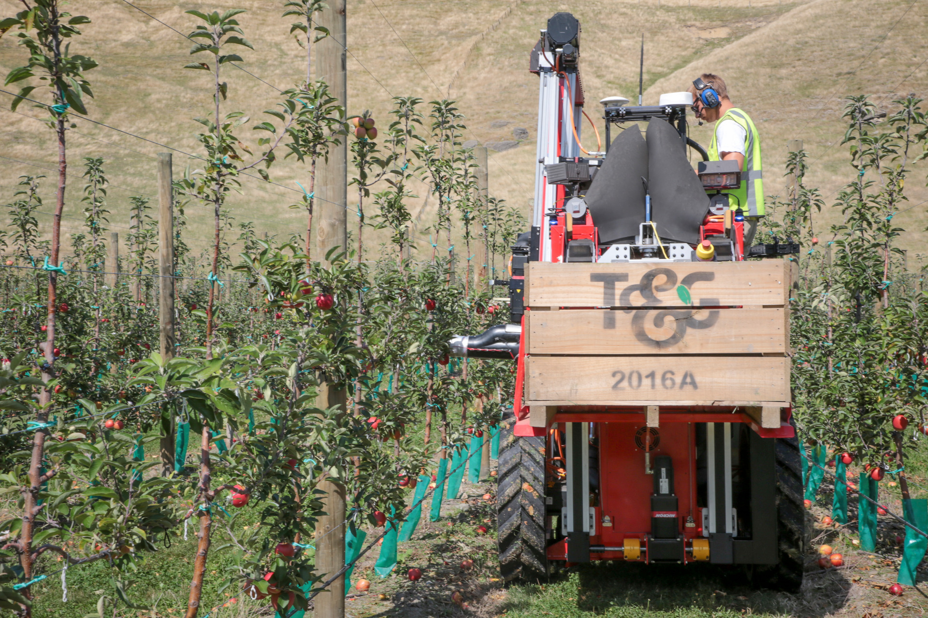
- Why are growers interested in this technology?
- What are the advantages and disadvantages of this technology?
- Would this technology work in all orchards?
- What would the grower need to do to use a robotic harvester?

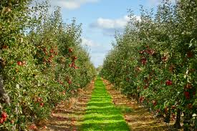

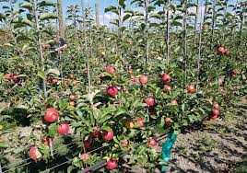

Artificial intelligence (AI) combined with computer vision technology is used to inspect apples for size, colour, ripeness, and defects. This helps ensure that only the highest-quality apples reach consumers and reduces human error in sorting.

(3) Apple sorting and packing @ CAJ - Van der Voort, New Zealand Apples
- What technology is involved in sorting and packaging apples?
- How has this changed the industry?
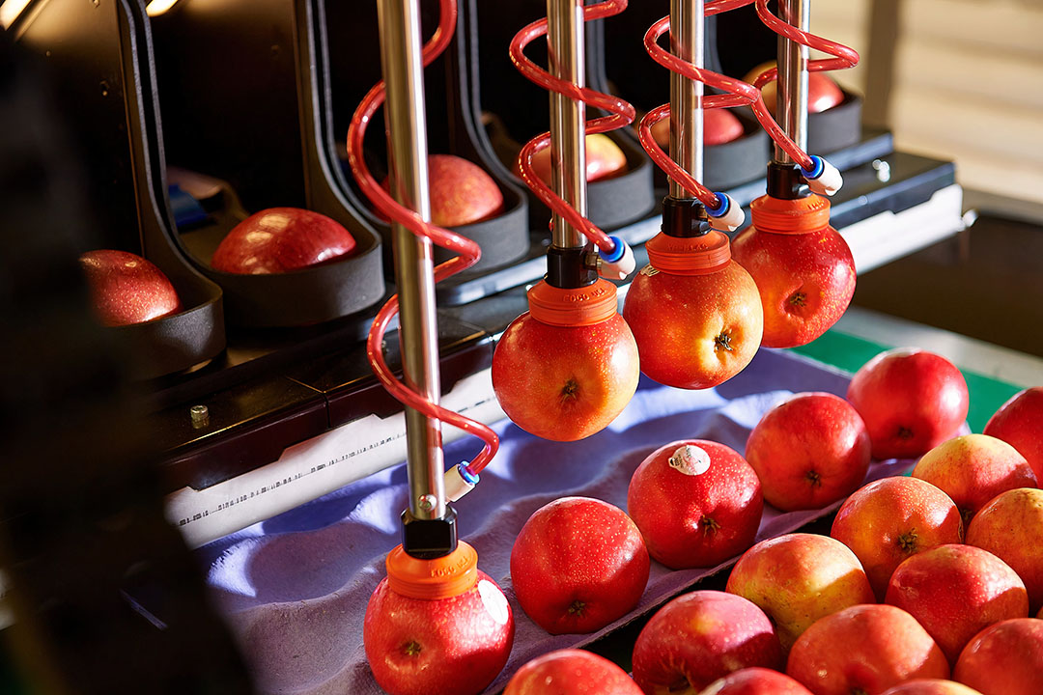
- Research other technologies used in the production of apples from the orchard to the consumer.
- Discuss where you think there are opportunities for new and or improved technologies in growing, harvesting and packaging apples.
- How do you think new and improved technologies could help make New Zealand's apples growers be more efficient, productive and environmentally friendly in the future?
- What kind of new technologies could be used, and how would they work?

- Dairy farming
Technology is playing a key role in helping New Zealand dairy farmers improve efficiency and productivity while being sustainable. From smart farm management to automation and precision agriculture, these innovations are making dairy farming more productive, cost-effective, and environmentally friendly.
Watch the videos
Ask your students: - to explore some of the technologies dairy farmers are using then discuss the questions.

- Wearables- cow collars
Halter is a solar-powered GPS enabled smart collar, which guides cows around a farm using sound and vibrations, allowing farmers to automate herd movements and create virtual fences. The technology can also tell a farmer when a cow is hurt or on heat.
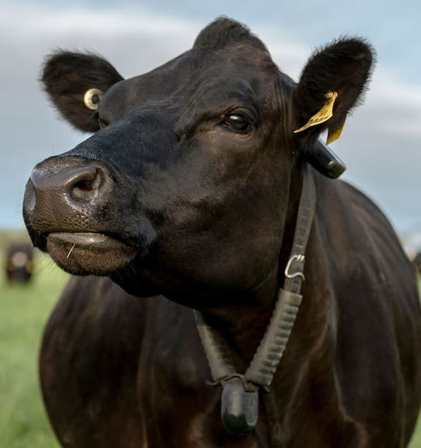
Watch
- Halter's Guidance Cues and System Overview
- Welcome to the Future of Farming
- Meet Connah, New Zealand Dairy Farmer
- Nofence Managed grazing: Matt Turner

Questions.
- In what ways do cow collars help farm staff save time during daily tasks?
- How do cow collars help farmers monitor the health of their cows?
- What benefits do cow collars provide for managing herds more efficiently?
- In what ways do cow collars improve breeding efficiency on dairy farms?
- What are the long-term benefits of using cow collars for farmers and cows?
- Where do you see there can be more improvements or advances in cow wearables.
- What to you think are the limitations or challenges of cow wearables.
- Research other technologies dairy farmers use to help them produce milk efficiently and sustainably.
- How do you think new and improved technologies could help make New Zealand's dairy farmers be more efficient, productive and environmentally friendly in the future?
- What kind of new technologies could be used, and how would they work?

- Robotic milking
Robotic milking systems offer many benefits to New Zealand dairy farmers, including increased efficiency, reduced labour costs, and improved animal welfare. However, challenges like high financial costs, technical difficulties, and changes needed to the farm system and management have limited their widespread use.
Watch
- Lely Astronaut A5 - Rob & Moira Anstis - New Zealand
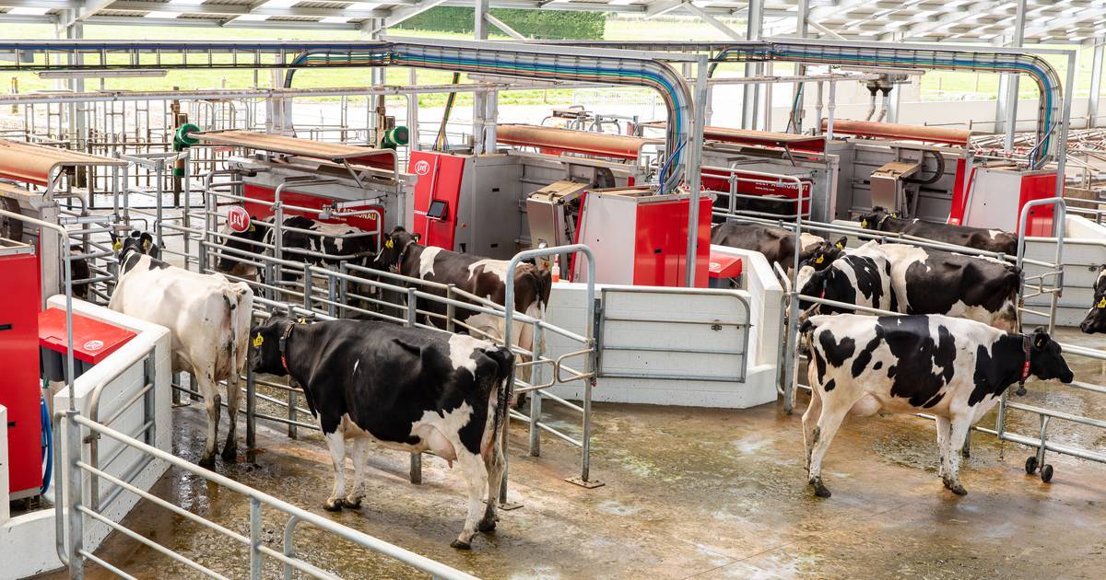
- Large scale robotic grazing system - New Zealand

Questions.
- Discuss the reasons why these New Zealand farmers have put in a robotic milking system.
- Describe the advantages and disadvantages of a robotic milking system.
- Robotic milking systems are more widely used in countries such as the United Kingdom, the Netherlands and Canada. Discuss why you think this is the case.
- Discuss what you think needs to change to improve robotic milking systems to encourage more dairy farms to invest in them.
- Research other technologies dairy farmers use to help them produce milk efficiently and sustainably.
- How do you think new and improved technologies could help make New Zealand's dairy farmers be more efficient, productive and environmentally friendly in the future?
- What kind of new technologies could be used, and how would they work?

- Seafood industry
Technology has greatly influenced New Zealand's seafood industry, enhancing sustainability, efficiency, and product quality.
Ask your students: - to watch the video and then discuss the questions.
Flip Farm- Technology developed by a Marlborough oyster farmer.

- What is the technology the oyster farmer developed
- Why did the oyster farmer develop this technology?
- How has it helped the production of oysters
- What other technology is the oyster farmer using?
- Where do you think there are opportunities to develop new technology in oyster production?
- Research other technologies used in the seafood industry ensure the long-term viability of the industry
- How do you think new and improved technologies could help make New Zealand's seafood industry more competitive and environmentally friendly in the future?
- What kind of new technologies could be used, and how would they work?

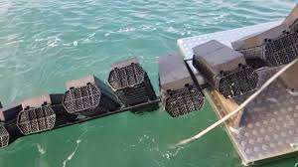
(d) Sports Turf Industry
Sports like football, rugby, cricket, golf, and tennis are multi-billion-dollar industries that attract global fans and feature high-paid athletes. Technology is changing the sports turf industry, helping to improve the quality and appearance of sports fields and stadiums. With better turf management, technology is making fields safer, improving their use, and enhancing their visual appeal. This is important not only for the athletes who play on them but also for the fans who watch these global sports events. Technology helps keep the fields in top shape for high-level games, benefiting both players and viewers.
Ask your students: - to watch the videos and then discuss the questions.
- Turf Management
- List the types of technologies being used in maintaining a high-quality sports turf in New Zealand
- How are ground staff using these technologies help main a high-quality sports turf?
Note: - These video on the retractable grass and retractable roof have no commentary. Before you watch these videos, watch these extra videos. They provide more information but may not be suitable for student. You can select what is appropriate for your students.
Extra videos
- Inside Real Madrid's $1BN Stadium Upgrade
- THIS is how the BERNABÉU PITCH is preserved | Real Madrid (In Spanish with subtitles)

Santiago Bernabéu Stadium is a retractable roof football stadium in Madrid, Spain. It has an amazing pitch removal system. The system, fully automated, moves the trays with the natural grass to an underground warehouse, called Hypogeum, equipped with ventilation, air conditioning, lighting, control and irrigation systems, that can set up ideal ambient conditions to preserve the grass. Access for staff and landscaping materials is also facilitated for ideal continuous maintenance, regardless of the events that may be taking place in the stadium.


- Retractable grass and roof
- Discuss the types of technology they think is being used to grow a natural grass turf?
- Why is this technology groundbreaking?
- What has this groundbreaking technology allowed?
- How does this technology allow the stadium to be used so it makes a profit?
- What would limit other stadiums or countries like New Zealand from using this technology?
- List the types of careers associated with sport turf management in New Zealand and the new Santiago Bernabéu.

- Sheep and Beef Industry
Technology is playing an important role in improving productivity and sustainability on New Zealand's sheep and beef farms. From precision farming tools to better animal health monitoring, these advancements are helping farmers run more efficient and sustainable businesses.

Ask your students to: - Watch the videos to explore some of the technologies sheep & beef farmers are using then discuss the questions.
- Barking drones used on farms instead of sheep dogs
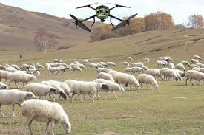
- How is the farmer using drones?
- What are the advantages and disadvantages of using drones?
- What other ways do you think drones could be used to help sheep farmers?

- Using technologies for rapid prediction of livestock performance.
Note - Scanning Technology from 5.11
- Describe the types of technology they think is being used to confirm livestock performance.
- Discuss why this is important to the farmer and other farmers and researchers.

- CT Scanning
- Why are they using this scanning technology?
- What are the advantages and disadvantages of this technology?
- How is this technology helping the meat industry, breeders and other farmers?
- What are the other technologies used in making this technology useful?
- What skills are needed for using this technology?
- Why wouldn’t all livestock farmers use this technology?
- What are the future challenges for developing this technology?

- Viticulture Industry
Technology is transforming every aspect of the viticulture industry, from the vineyard to the bottle. Precision agriculture tools, automation, data analytics, and sustainable practices are helping grape growers produce higher-quality grapes more efficiently and sustainably.
Ask your students to: - Watch the videos to explore some of the technologies being used in the viticulture industry.
- Grape Harvester- vine tech equipment

- VTV Episode 2 of 7 "Harvesting" wine making in Marlborough, New Zealand
- How have harvesters changed the wine industry?

- Smart Apply Pernod Ricard Vineyard New Zealand
- What is the aim of the smart apply technology?
- How does this technology benefit the grower and the environment?

- This Unmanned Agricultural Robot could transform the industry.
- What can this robot do?
- Who helped design it?
- What are the advantages of this technology?
- What are the disadvantages of this technology?
- How do you think new and improved technologies could help make New Zealand's viticulture industry be more efficient, productive and environmentally friendly in the future? What kind of new technologies could be used, and how would they work?
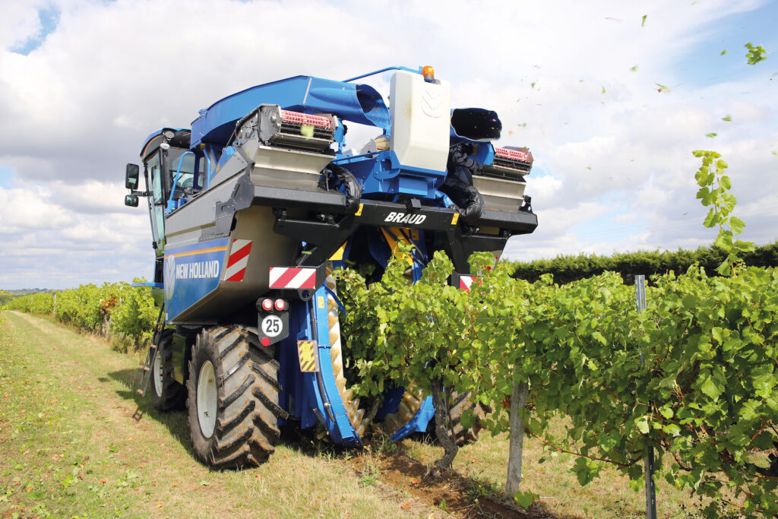

- Kiwifruit Production
Technology is helping New Zealand's kiwifruit orchards become more productive, efficient, and environmentally friendly. By using precision farming techniques, automated harvesting systems, and smarter irrigation and pest control, these innovations are helping growers produce more fruit, use resources wisely, and reduce their impact on the environment.
Ask your students to: - watch the videos to explore some of the technologies kiwifruit growers are using then discuss the questions.
- Kiwifruit robotic harvester (From 02.57)

(2) Robotic hands snatch kiwifruit future.
- Describe the technology used by the robotic kiwifruit harvester?
- How would a robotic harvester transform the kiwifruit industry?
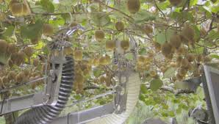

Grading and Packing Kiwifruit
EastPack are the largest post-harvest operator in New Zealand and maintain the largest kiwifruit packing facility in the Southern Hemisphere. They're committed to lean production, continuous improvement and the highest grower returns possible. Partnering with TOMRA has allowed them to improve their operation with increased efficiency and new technology. They're excited about the future and how they can grow and leverage their Compac technology to improve their post-harvest operations.
- EastPack - Integrated Kiwifruit Solution
- What technologies have been introduced into the EastPack Kiwifruit packhouse?
- What do these technologies allow the pack house to do?
- What are the advantages of these technologies?

- Forestry Industry
With the use of advanced machinery, drones, wearable tech, and data analytics, forestry operations are becoming more efficient, environmentally friendly, and safer for workers. These innovations are helping the industry meet growing demand while minimising its environmental impact and ensuring the well-being of its workforce.
Ask your students to: - watch the videos to explore some of the technologies the forestry is using or could be implementing then discuss the questions.

- Customer Spotlight I Wairarapa Forestry Machines
- How is technology improving harvesting efficiency and safety in the forestry industry?

- Forest 4.0 integration into New Zealand forest harvesting- digitisation and automation
- How will this new technology revolutionise the forestry industry?

- Forestry and Wood - Northland, New Zealand
- List the technologies being used in harvesting and processing wood.

- Drones vs Wilding pines
- What role could drone technology help in protecting the environment and New Zealand’s biodiversity?
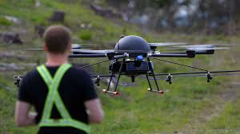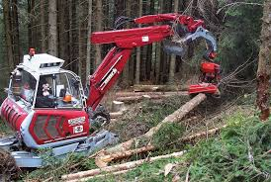

- Arable Industry
New Zealand's arable industry is all about growing crops like wheat, barley, oats, and vegetables. These crops are important for food, animal feed, and products like flour and beer. New Zealand's farmers use advanced technology to help them grow crops more efficiently. This includes using GPS and sensors to track things like soil health, weather, and crop growth. These tools give farmers important information that helps them make better decisions, like when to plant, water, or harvest crops. The technology also helps reduce waste and use fewer resources, making farming more sustainable and profitable for the future.
Ask your students to: - watch the videos to explore some of the technologies the arable industry
- Drones in farming
- Using drones to map and analyse data on the farm
- How do drones work?
- What other technologies are used in drones to improve their use?
- What regulations do drone users need to follow and where are these regulations found?
- How is drone technology helping arable farmers?

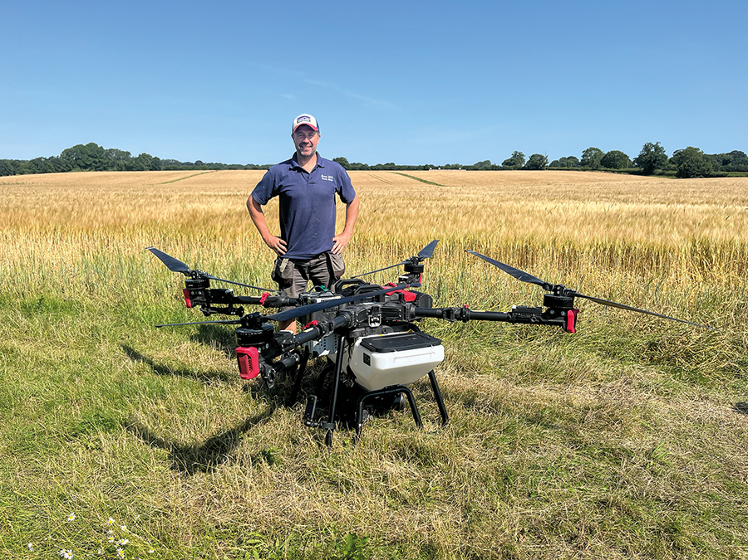

Lesson 2: - The Future
The future of primary production in New Zealand looks exciting with new technologies that will help farmers and growers grow food more efficiently and sustainably. Technologies like drones, robots, and artificial intelligence (AI) are being developed to help farmers monitor their crops, use less water, and reduce chemicals. New tools that can predict weather patterns and help with soil health are also being created. Adopting these new technologies is important because they can make farming more profitable, protect the environment, and help feed more people as the world’s population grows. By using these innovations, New Zealand farmers can stay ahead and keep producing high-quality food for the future.
Ask your students to: - watch the videos on new technologies being developed and the top agriculture robots and discuss the questions.
(1) Advanced Autonomous Tractors and Farming Machines (Modern Agricultural Machinery and Robots)
(2) Revolutionizing Agriculture: Unveiling Autonomous Farming Equipment
- 10 Most Autonomous Farming Robots in the World-Part 2
In this video from Mogoo Tech channel, we're going to show you the top Agricultural Robots that are expected to ease the work of farmers on farmlands soon. These Robots includes weeding robots, seeding robots, harvesting farm robots, Mowing farm robots and more.

Questions.
- Why are these technologies being developed?
- Which of these do you think New Zealand producers would be interested in adopting and why?
- Discuss why some of these technologies may have limited used in New Zealand production systems?
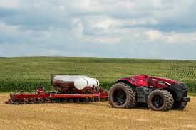
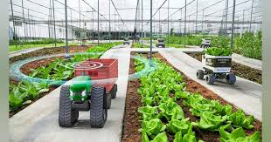

Activity 1: - Careers in Agri technology
There are many exciting career opportunities in agritechnology, where people use new technology to improve farming, food production, and processing. Jobs in this field include roles such as designing robots, developing software to track crops, or working with drones. To succeed in agritechnology, you need skills in science, technology, and problem-solving. It’s also helpful to have knowledge of primary production systems, such as farming, horticulture, forestry, fishing, sports turf management, and the environment. People who enjoy working with computers, data, or machines and want to help make the primary industries better for the future will find great opportunities in agritechnology.
Resource
21st century skills

Ask your students to: - watch this video and discuss the questions
Fruits of Robotics
- How is robotics changing the horticulture industry?
- What are the challenges they are solving?
- What are the career opportunities in the agritech industry?
- What are the 21 skills needed to enter and succeed in an agritech career?

Activity 2: - Designing a technology solution to a primary industry challenge
Technology is changing the way New Zealand’s primary industries work, making them more efficient, sustainable, and profitable. With the help of technologies like automation, precision farming, data analytics, and sustainable energy, New Zealand producers can make smarter decisions, use resources better, and reduce environmental impact. These innovations also help farmers, growers, and workers use their time and skills more effectively, focusing on more important tasks.
Resource
Design Thinking Challenge Guidelines

There are two ways to complete this activity. Students can use Minecraft if they have access to it, or, using basic classroom equipment, they can research, design, and build a technological prototype solution to a challenge faced by a selected industry.
1. Minecraft
Your task is to: -
- Select one of the primary production systems below.
- Research the primary production system and build your own sustainable farm, orchard or market garden.
- Use one of the challenges or describe your own challenge for the primary production system you have selected.
- Research, design and build a technological solution to this challenge.
Or
- Equipment- not an exhaustive list
- Paper
- Ice block stick
- Pipe cleaners
- Post it notes
- Colour pencils / crayons / felt pens
- Glue / cellotape / blue tack
- Scissors
- Cardboard
- Farm animals
Working in groups use the design thinking guidelines design a solution for a challenge a primary sector is facing.
- You can use on of the challenges below or a challenge you think the primary sector you have selected has.
- Present your protype solution to the class.

Challenges
Dairy
- Keeping cows cool in hot weather.
Dairy cows are sensitive to heat, especially in warm weather. When temperatures rise above 23°C and the humidity is high, cows start to feel the heat, and their ability to cool down is reduced. This causes them to eat less and produce less milk. In extreme heat, cows can suffer from heat stress, which can even lead to panting, drooling, and poor health.
Farmers face challenges keeping cows cool because there are few trees for shade, and the cows often don’t have enough ways to stay comfortable in hot weather.
Your challenge is to design a way to keep cows cool during hot and humid weather conditions to help them stay healthy and maintain milk production.
- Measuring pasture growth and availability.
Dairy farmers rely on pasture as a primary food source for their cows. To make sure the cows are well-fed and producing high-quality milk, farmers need to know how much pasture is in each paddock and how quickly it is growing. If there isn’t enough pasture, they may need to provide extra food or move cows to another paddock with more pasture. The challenge is that farmers often don’t have an easy way to get up-to-date, real-time information about their pasture.
Your challenge is to design a technological solution that helps farmers monitor pasture growth and availability in real-time, so they can make smart decisions about feeding their cows’.

Sheep and Beef
- Developing a faster, more accurate way to measure animal body condition.
Just like people, sheep and cattle age at different rates. A younger animal may not always be in the best physical condition, and an older one may be in great health. A healthy animal produces more offspring and is less likely to get sick, which is important for a farm's productivity. To keep track of animal health, farmers use a body condition scoring (BCS) system, which helps them assess how healthy their animals are. Right now, farmers score animals by sight and feel, but this can be slow and sometimes inaccurate.
Your challenge is to create a faster and more accurate way for farmers to measure and record an animal’s body condition to help improve farm productivity and animal health.

- Managing water use and detecting leaks.
Water is essential for farming and growing crops, as well as for animals to drink and keeping equipment clean. However, water systems on farms can have problems, like leaks in pipes, broken pumps, or faulty valves, which can waste water and disrupt the flow. These issues can be hard to detect quickly, causing farmers to lose precious water and time.
Your challenge is to design a new solution that helps farmers and growers quickly find out if there’s a problem with their water system and figure out exactly where it is.

- Creating an affordable and efficient animal traceability system.
In New Zealand, animal traceability is important for keeping track of animals across the value chain, from farms to retailers. It helps ensure food safety, manage diseases, and protect New Zealand’s reputation for high-quality, safe agricultural products. However, tracking animals is difficult, especially for small and medium-sized farms. Current systems are expensive, time-consuming, and complicated to set up and manage. Additionally, different parts of the industry (like farms, transporters, and retailers) often need different information, making it hard to create a smooth system for everyone.
Your challenge is to design a simple, affordable, and accurate animal traceability system that works for farmers of all sizes and is easy to use across the whole agricultural industry.

Horticulture
- Protecting orchards from new diseases or pests.
Orchards are essential for producing fruits that feed people in New Zealand and around the world. However, diseases and pests can spread quickly and damage entire orchards. This can be disastrous for farmers and the industry. Biosecurity measures help protect orchards by preventing new pests or diseases from entering or spreading.
Your challenge is to design and develop an innovative biosecurity defence system to protect an orchard from new diseases or pests.

- Improving irrigation efficiency.
Irrigation is a key part of the horticulture industry, helping crops grow when there is not enough natural rainfall. Water is spread across the land using pipes, sprinklers, and other systems. But if these systems aren’t set up correctly, water can be wasted - some areas get too much, while others do not get enough. Water is precious, and wasting it harms both the environment and crop productivity.
Your challenge is to design an innovative irrigation solution that uses water more efficiently, reduces waste, and helps crops grow better.
- Ensuring kiwifruit pollination without honeybees.
New Zealand’s kiwifruit industry is worth over $3 billion in export earnings, and the country's conditions are perfect for growing kiwifruit. However, honeybees play a vital role in pollinating kiwifruit vines, and their populations are under threat. Pests, diseases, habitat loss, and pollution are causing honeybee numbers to decrease significantly. If honeybees become scarce or disappear entirely, it could impact kiwifruit production.
Your challenge is to design an innovative solution to ensure the successful pollination of kiwifruit vines, regardless of the availability of honeybees.

- Managing weeds in New Zealand’s arable farming industry.
Weeds are a problem because they compete with crops and plants for water, sunlight, and nutrients, which can reduce the amount of food or plants we grow. They can also spread quickly and take over areas where other plants should be. Weed resistance to chemicals makes this worse. When the same herbicides (weed-killing chemicals) are used too often, some weeds can change and become resistant to them. This means the chemicals no longer work as well, making it harder to control weeds.
Your challenge is to design a technological solution that helps farmers to manage weeds without chemicals without harming the environment.
- Managing fertiliser use for sustainable food production.
Fertilisers are vital for plant growth as they provide essential nutrients like nitrogen, phosphorus, and potassium that crops need to thrive. However, overusing fertilisers can lead to runoff or leaching into rivers and lakes, causing pollution and damaging water quality and wildlife. This issue is becoming more significant as New Zealand seeks to balance its food production with environmental sustainability.
Your challenge is to design an innovative solution that ensures plants get the nutrients they need, while preventing fertiliser runoff or leaching into the environment, thereby protecting water quality and wildlife.

Forestry Industry
- Forestry traceability.
Forestry is the fourth largest export earner for NZ, contributing over $5.9 billion to the New Zealand economy each year. Traceability of timber products is especially important with the increasing rate of globalisation & prevention of illegal logging worldwide. Customers want to know which clean green forest their product came from. Traceability is the ability to trace the history, application or location of the wood, or the processing of it by means of recorded identifications. This involves identification of the product and recording of data from the forest where it was grown, through processing and distribution to the customer (the supply chain).
Your challenge is to develop a traceability system for tracking timber product from an overseas market back to the forest where it was grown.

- Making the forestry industry safer for workers.
The forestry industry in New Zealand involves dangerous work, especially during tree felling and logging operations. Workers are at risk from falling trees, heavy machinery, and the difficult environment they work in. Even though safety has improved, there's still a need for better ways to keep workers safe.
Your challenge is to design a technological solution that can help improve worker safety in the forestry industry, preventing accidents and protecting workers.

- Protecting New Zealand's forests from pests and diseases.
New Zealand’s forests are facing a big problem: pests and diseases like kauri dieback and pine caterpillar are threatening the health of both native and commercial forests. These pests and diseases harm the trees, reduce the amount of timber we can use, and hurt the environment.
Your challenge is to design a technology to help protect New Zealand’s forests from pests and diseases by detecting them early and stopping their spread.

Seafood Industry
- Sustainable seafood for the future.
New Zealand’s seafood industry faces a big challenge – how to keep fish stocks healthy while providing enough seafood for everyone to enjoy. Overfishing, illegal fishing, and damage to marine habitats can hurt fish populations and our environment.
Your challenge is to come up with a creative technological solution that helps solve the issue of overfishing and environmental damage, promoting a more ethical and transparent seafood industry, benefiting both the environment and the long-term viability of the sector.

Sports Turf Management
- Water-smart turf management.
The turf management industry in New Zealand faces a big challenge: how to manage water efficiently for maintaining healthy sports fields, golf courses, and public parks. Some areas of New Zealand face droughts, so using too much water can be wasteful and harmful to the environment.
Your challenge is to design a smart solution that helps turf managers use water more efficiently, saving resources while keeping the turf in top condition.

Primary industry
- Attracting more youth to the primary industries.
New Zealand’s primary industries, such as farming, horticulture, forestry, and agri-science, offer a wide variety of career opportunities that are exciting, financially rewarding, and full of potential for growth. However, these industries are struggling to attract enough young people to ensure they continue to grow and remain productive.
Your challenge is to develop a solution for how New Zealand's primary industries can attract more young people to careers in agri-science, farming, and other agricultural industries. How can we get more young people excited about working in these important areas, and help them understand the opportunities available?

Activity 3: - Young Enterprise Trust Innovation Challenge
Register you school to do Innovation Challenge with the Young Enterprise Trust
An Innovation Challenge requires students to apply their subject knowledge to understand a real-life situation, then design and build a prototype solution which they present to an industry expert or other audience.

Contact Young enterprise Trust
support@youngenterprise.org.nz
04 570 0452
PO Box 25 525,
Wellington 6140

