
Unit 6
Rural Safety
Teachers Guide
Unit 6
Rural Safety
Teachers Guide

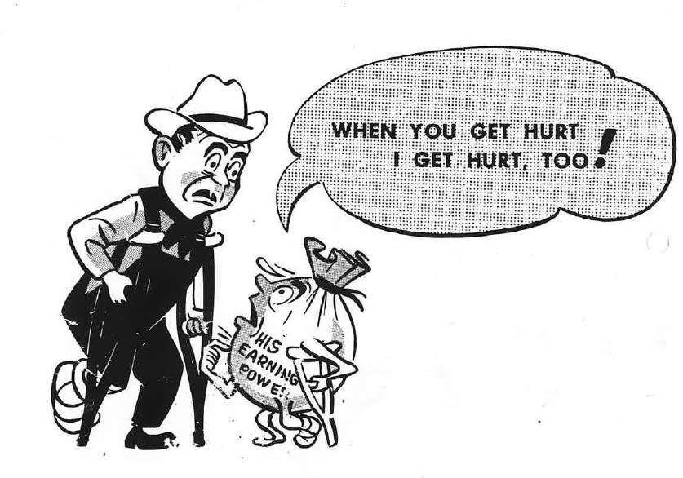

The primary production sector is well established in New Zealand Society and vital to the economy and standard of living. It is sector of opportunities and challenges.
Teaching years 7-10
We invite and encourage you to teach and inspire students about the primary production sector.
We have developed a resource for you.
Included is
- Teacher guide
- Engaging activities
This resource has been developed by Sow the Seed in conjunction with HATA
For more resources and teaching material for agriculture and horticulture science we invite you to join the Horticulture and Teachers Association HATA

Introduction

Primary Production is a 54 billion+ industry in Aotearoa New Zealand.
In Aotearoa New Zealand, primary production is the process of producing raw materials and products from natural resources, land and water. The main primary industries are agriculture and horticulture, forestry, fishing, and aquaculture, others are turf culture and equine.
A primary production system is a sum of all components, including the growing environment and management practices, that work together in the production of a primary product. Some examples of primary production systems include, dairy farming, sheep and beef farming, orchards such as apple, kiwifruit and cherries.
Primary production is the key driver of New Zealand’s economic, social, and environmental development. The products of primary production are a source of well-being for the present generation and will be so for future generations.

What is agricultural and horticultural science?
The Agricultural and Horticultural Science subject looks at the management practices that occur behind the farm, orchard gate or on boat as well as beyond, to produce a product. This practically orientated subject uses all the primary sector contexts of sheep, beef and cropping, dairying, horticulture, seafood and aquaculture, forestry, equine and sports turf. The application of good production management practices ensures that the primary products demanded by local and world markets are made available in an ecologically and economically sustainable manner. Agricultural and horticultural science deals with contexts, issues, and problem solving drawn from a broad agenda that includes, for example:
- products (for example, pork, poultry, avocados, honey, timber, milk, wool, apples, grapes)
- environments (for example, waterways, erosion, landscape, soil, shelter, glasshouses, effluent, pollution; environmental modification and sustainable management practices)
- solutions for particular management issues (for example, irrigation, cropping, harvesting and milking equipment, data, information and communication digital technologies, shelter and shade construction, and cultivation technologies).

Teachers Guide Notes
Each year, a significant number of accidents and fatalities occur in the forestry, agriculture, and horticulture industries, with vehicles and chemicals being the main contributors. In 2024, these sectors accounted for 40% of workplace fatalities. Organisations like WorkSafe, Farm Without Harm, and Safer Farms are actively working to reduce these risks. This unit of work aims to raise awareness of the hazards in rural workplaces and promote safety practices, ensuring workers are equipped with the knowledge, training, and support to minimise injuries and return home safely every day.

Key Learning Outcomes
Students will gain an understanding of: -
- why agricultural and horticultural has high accident statistics.
- the main causes of agricultural, horticultural and forestry accidents and fatalities.
- basic safety procedures and the safe use of other farm equipment.
(tractors, quad bikes, two- wheelers, side-by-side, chainsaws, firearms)
- of animal behaviour and how to handle animals safely.
- how to use and store chemical safely.
- how to minimise risks of noise induce hearing loss, back injuries and slips trips and falls.

Supporting Resources
- Rural Safety Teachers Guide
- PPT Rural Safety
- 10 Commandments for the Safe Handling of Agrichemicals (WS)
- Cattle Balance points (WS)
- Cattle Working distance (WS)
- Cattle, how they see the world (WS)
- GTF-FARMSAFE-RESOURCE – NZ
- Lifting Calves (WS)
- NP-HowLoudIsTooLoudFarm poster
- NP-HowLoudIsTooLoud-Poster508
- SPOT THE DANGERS ON FARM (A)
- SPOT THE DANGERS ON FARM Diagram (A)
- Spot the hazards (A)
- Spot the risks (A)
- Tractor Situations (A)
Information for this unit of work has been sourced from:
- Worksafe
- Safer Farms
- Farm Without Harm

Timeframe
Lessons are generally designed in a one-hour blocks but feel free to modify to suit you and your students. You do not need to complete all the lessons or activities.

Recommendations
Within each lesson there are multiple activities for students to do. We recommend you select the activity or activities that suit your student’s.
Contents
Introduction 3
Primary Production is a 54 billion+ industry in Aotearoa New Zealand. 3
What is agricultural and horticultural science? 3
Teachers Guide Notes 4
Key Learning Outcomes 4
Supporting Resources 4
Timeframe 4
Recommendations 5
Lesson 1: Overview of accidents in agriculture and horticulture 7
Activity 1: Spot the Dangers on farm 9
Activity 2: George the Farmer 9
Lesson 2: Safe use of tractors 10
Activity 1: Tractor situations 11
Activity 2: Tractor safety videos 11
Activity 3: Rules for safe use of tractors 11
Lesson 3: Safe use of quad bikes 12
Activity 1: Videos- Quad bike safety 13
Activity 2: Rules for safe use of quad bikes 13
Activity 3: Safety Alerts 13
Lesson 4: Safe use of two-wheeler motorbikes 14
Activity 1: Videos-motorbike accident 14
Activity 2: Rules for the safe use of two-wheeler motorbikes 14
Activity 3: Safety Alerts 15
Lesson 5: Side-By- Side Vehicles 16
Activity 1: Videos – benefits and safety 16
Activity 2: Rules for safe use of side-by side vehicles. 17
Activity 3: Safety Alerts 17
Activity 4: Farm vehicles safety rules. 17
Lesson 6: Safe handling of large animals 18
Activity 1: Animal behaviour 19
Activity 2: Worksheets 20
Activity 3: Safety Alerts 20
Lesson 7: Safe use of chainsaws. 21
Activity 1: Video - 22
Activity2: True /False 22
Activity3: Guest speaker 23
Activity 4: Do’s and Don’ts 23
Lesson 8: Safe use of firearms 23
Activity 1: Good Practices 24
Activity 2: Video- firearm safety 25
Activity 3: Firearms safety e-learning 25
Activity 4: The don’ts with firearms 25
Lesson 9: Safe use of agrichemicals 26
Activity 1: Safe handling of agrichemicals 26
Activity 2: Pictograms and symbols 27
Activity 3: Safety alert 27
Lesson 10: Noise induced hearing loss (NIHL) 28
Activity1: Video Sound to Brain 28
Activity 2: How much do you know about noise and hearing loss? 29
Activity 3: Harmful noise 29
Activity 4: Sound levels 30
Activity 5: Protect your hearing 30
Lesson 11: Back injuries 31
Activity 1: Lifting safely 32
Activity 2: Sheep and Calf lifting worksheets. 33
Lesson 12: Slips, Trips and Falls 34
Activity 1: Points to discuss 34
Activity 2: Good practices 35
Activity 3: SHED (Safe Home Each Day) 35
Lesson13. Extra activities 36
Safety videos 36
Writing 36
Guest speakers. 36
Rural safety day 36

Lesson 1: Overview of accidents in agriculture and horticulture
Find out what your students know about accidents that have occurred on farm, orchard, forestry or in other primary sectors.
Ask your students?
- Does anyone know someone who has had an accident or an injury on a farm or orchard or in forestry or any other primary sector?
  - As a class make a list of the types of accidents.
  - Discuss what has been the main cause of accidents.
- Is working in agriculture, horticulture or forestry dangerous?
  - What do your students think?
  - Why do you think living and working on rural properties is more dangerous than living and working in an urban area.
- Has anyone heard of SHED (Safe Home Each Day)

Ask your students
- How many children are injured in a farm setting in NZ each yea? Guessing game- Answer Over 1000!!!!
- How many children have been killed on farms between 2011-202 Answer- 20
- How many people are injured in agriculture or horticultural and claim ACC each year?
- On average how many days off work does someone have that has made an ACC claim.
- What is the cost when people are injured?
- How many people have been killed on farm between 2011-2023?
156, 20 were children under 14 years of age
Teacher notes
- People working in agriculture and horticulture, expose themselves to extreme weather, high heat. They also work with large animals, with chemicals, with heavy machinery, at heights and in confined spaces. They work with heavy loads and often they work alone and in remote locations.
- Working and living on a farm or in horticulture or other rural properties is more dangerous than working in an office or living in an urban area.
- The aim for all people working and living rurally is to get Safe Home Every Day (SHED). The same for everyone working.
- However, accidents do happen causing injuries and fatalities.
Refer to PPT Rural Safety slides 3-6 for information on ACC claims for injuries and fatalities data.

Organisations like WorkSafe, Safer Farms, Farm Without Harm and others are working hard to reduce workplace accidents and fatalities and get everyone Safe Home Every Day (SHED).

Discuss these statistics with your students
PPT Rural Safety -slides 3-6
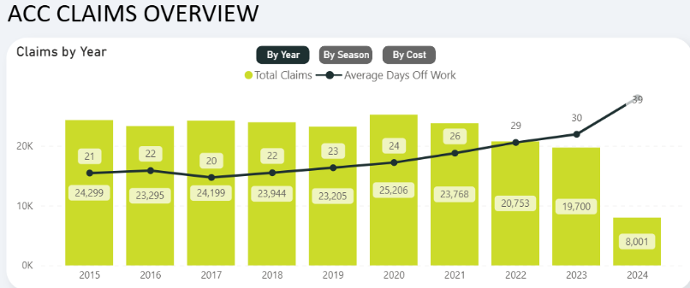

Children Fatalities
Common Agents of Fatality | Statistics on Farm Child (0-14yrs) Fatalities (between 2011-2023) *
Total | 20 fatalities
Water Bodies | 2 fatalities
Quad Bikes | 5 fatalities
Car | 1 fatality
Tractors | 3 fatalities
Motorbikes | 1 fatality
Utes | 3 fatalities
Horses | 0 fatalities
Other Animals | 1 fatality
Others (including firearms, chemicals, machinery, tools, and equipment) | 3 fatalities

Activity 1: Spot the Dangers on farm
There are three resources to select from. Select the most appropriate for your class and ask your students to work in groups to spot the hazards

- SPOT THE DANGERS ON FARM Diagram (A)
- Spot the risks (A)
- Spot the hazards (A)

Activity 2: George the Farmer
Farm Safety Educators Guide New Zealand Edition. This is a great resource with information and a range of curriculum-based activities for students up to year 8.

Videos
The farm Safey Song with George the Farmer
George the Farmer Forestry video (6:43 mins)

Lesson 2: Safe use of tractors
Find out what you students know.
Ask your students
- Who knows someone that has had an accident or close call/near miss on a tractor?
- Why do you think there are a lot of accidents with tractors?
- To brainstorm what makes tractors dangerous?
- What are the main types of accidents involving tractors on farm?
- What age can you drive a tractor in New Zealand?
Teacher Notes
Tractors are useful machinery in agriculture and horticulture, but they also come with several risks due to their size, speed, and power.
On average, six to seven farmers are killed every year in New Zealand, when using farm tractors. Many hundreds have been seriously injured.

The main types of accidents involving farm tractors are:
- tractors rolling over
- people being run over
- people being tangled in implements and machinery.
Other risks are:
- tractor fires
- working under raised loads
- touching overhead power lines
- noise-induced hearing loss
- slips, trips and falls while getting on and off the tractor.

Young people on tractors- New Zealand Regulations
Children under 15 years are normally not able to drive tractors or implements. However, Section 61 of the Health and Safety in Employment Regulations 1995, states that in special cases, children over 12 years old can drive or ride on tractors or implements if they:
- are fully trained in using the tractor and any implements attached to it
- are in a safe position on the tractor or implement
- are the only child on the tractor.

It is important that:
- they only use the tractor for agricultural work, or
- the tractor is only used to train a child to drive the tractor for agricultural work.

However, it is the responsibility of farm owners and managers must keep young people driving tractors safe and make sure they are not put at risk.

Activity 1: Tractor situations
Handout the resource “Tractor Situation” (A)
In groups ask your students to discuss
- What the risk is in each situation.
- How could the risks be avoided.

Activity 2: Tractor safety videos
Watch this video Managing Farm Safety and Health Video Series – This Tractor Safety video is made in Ireland but it is relevant here in NZ.

Activity 3: Rules for safe use of tractors
Resource PPT Rural Safety slides 6-10
- Discuss the key risks with tractors PPT Rural Safety
- Make a list of why you think there are a lot of accidents with tractors then make a list of some simple rules to be safe around tractors?

Suggestions
Reasons for tractor accidents | Rules to be safe around tractors
- Lack of training or experience  - Poor maintenance  - Tired not paying attention  - Steep slopes  - Bad weather conditions  - Going too fast.  - Inexperience with attachments  - Wrong machine for the job | - Always wear seat belts  - Get proper training  - Keep tractor maintenance up to date  - Check surroundings before moving.  - Use roll-over protective structures (ROPS)  - Avoid slopes and unstable terrain  - Stay clear of moving parts  - Work at a safe speed  - Ensure the tractor is stopped before dismounting

- Answer questions and do alert activities and discuss tractor safety key points.

Lesson 3: Safe use of quad bikes
Find out what your students know.
Ask your students:
- Who knows someone that has had an accident or close call/near miss on a quad bike?
- How many people are severely injured in work related quad bike accidents?
- Why do you think there are a lot of quad bikes accidents?
- To brainstorm what makes quad bikes dangerous?
- What are the main types of accidents involving quad bikes on farm?
- What age can you drive a quad bike on farm in New Zealand?
Teachers notes
Quad bikes are invaluable tools on farms when used for the right tasks but pushing them beyond their limits can have disastrous consequences. On average, five people are killed annually in New Zealand farm-related quad bike incidents, with over 100 severe injuries reported each year. The most common accidents include riders falling off, rolling the bikes, or colliding with objects.

The Law: Quad bikes are designed for off-road use and are not meant for public roads due to their light frame and lack of protection in a collision. To ride a quad bike on public roads in New Zealand, you must:
- Register and license the bike
- Hold a valid New Zealand driver’s license
- Wear an approved safety helmet
- Maintain a current warrant of fitness for the bike

Quad bike riding skills should be developed through experience and proper training. Riders unfamiliar with the specific bike or farm terrain, or those lacking active riding skills, face a higher risk of injury.
Quad bikes are not designed to carry passengers. If transporting people around the farm if necessary, consider using a ute, side-by-side, or utility vehicle.
To minimize the hazards associated with quad bike use, always select the right vehicle for the job. For example, a motorbike may be more suitable for certain mustering tasks. Ensuring proper training, safety measures, and appropriate vehicle choice can significantly reduce risks.

How can you reduce the risk involved with quad bikes?

Key points
- Riders must be trained/experienced enough to do the job
- Choose the right vehicle for the job
- Always wear a helmet
- Don't let kids ride adult quad bikes
- Only carry a passenger if there is no reasonable alternative

Activity 1: Videos- Quad bike safety
Watch
- Quad bike safety
- SafeWork Quad Bike Training Program for the dairy industry
- "How To" Quad Bike Operation And Safety: Quad Bike Series
- Sarah Smart’s two cents on quad bike safety
- How CPDs & Speed Limiters help us to fail safely

Activity 2: Rules for safe use of quad bikes
Make list of why you think there are a lot of accidents and injuries with quad bikes then make a list of some simple rules for the safe use of quad bikes.

Suggestions
Reasons for quad bike accidents | Rules for safe use of quad bikes
- Riders lack experience and training  - Carrying more weight than the quad bike is designed  - Riding on steep slopes and rough ground  - Speeding  - Not wearing an approved helmet or protective clothing  - Carrying passengers  - Riding a quad bike under the influence of alcohol or drugs.  - Quad bike in poor condition  - Crashes into obstacles, vehicles, or farm equipment. | - Get formal training to ride a safe quad bike.  - Always wear an approved helmet, boots and protective clothing while riding.  - Don’t carry passengers  - Avoid riding quad bikes on public roads.  - Keep your quad bike in good working condition.  - Don’t speed especially when riding on rough or steep slopes  - Don’t ride in bad weather  - Don’t ride under the influence of alcohol or drugs.  - Be alert and aware of your surroundings watching for hazards

Activity 3: Safety Alerts
Resource PPT Rural Safety slides 11-16
Do questions and safety alert activities

Lesson 4: Safe use of two-wheeler motorbikes
Find out what your students know.
Ask your students:
- Who knows someone that has had an accident or close call/near miss on a two- wheeler motorbike?
- Why do you think there are a lot of accidents with two- wheeler motorbikes?
- To brainstorm what makes two-wheeler motorbike dangerous?
- What are the main types of accidents involving two- wheeler motorbikes on farm?
- What age can you drive a two- wheeler motorbike in New Zealand?
Teacher notes
Two-wheeler motorbikes are invaluable tools on farms and in horticulture, allowing for quick movement across different areas. They are commonly used for checking and moving stock, inspecting crops, and assessing farm infrastructure. Although they are generally safer than quad bikes, the reasons for accidents and injuries are similar. The number of fatalities involving two-wheeler motorbikes is much lower compared to quad bikes.
The Law: NZTA requires anyone riding a motorbike on the road to have a motorcycle licence (eg a Class 6 driver licence) and follow the road rules. You must ride with your light on at all times. Since 1 November 2009, this is a legal requirement. Riders must wear helmets.

Key Points
- Learn to ride two- wheeler motorbike safely
- Choose the right vehicle for the job.
- Always wear a helmet.
- Don’t allow children to ride adult-sized farm bikes

Activity 1: Videos-motorbike accident
Watch this video. Shocking bike accident on farm in New Zealand
- How could this accident have been avoided?

Activity 2: Rules for the safe use of two-wheeler motorbikes
Make a list of why you think accidents on two-wheeler motorbikes occur then make a list of some simple rules for safe use of two-wheeler motorbikes.

Suggestions
Reasons for two-wheeler motor bike accidents | Rules for safe use of two-wheeler motor bikes
- Riders lack experience and training.  - Speeding  - Riding on steep slopes and rough ground.  - In attention/ not concentrating on surrounding  - Carrying more weight than the two-wheeler bike is designed for  - Not wearing an approved helmet or protective clothing  - Carrying passengers  - Riding under the influence of alcohol or drugs.  - Riding in poor weather condition  - Poor bike maintenance  - Carrying things across knees instead of on the from or rear carriers. | - Always wear an approved helmet, boots and protective clothing while riding.  - Don’t carry passengers  - Keep bike in good working condition.  - Don’t speed  - Ride within your ability.  - Stay alert and aware  - Avoid riding in bad weather  - Don’t ride under the influence of alcohol or drugs.  - Don’t carry things across your knees on the motorbike

Activity 3: Safety Alerts
Resource PPT Rural Safety slides17-20
Do safety alert activities

Lesson 5: Side-By- Side Vehicles
Find out what your students know.
Ask your students:
- What is a side-by-side?
- Who knows someone that has had an accident or close call/near miss with a side-by-side?
- Why do you think there are a lot of accidents with side-by-side vehicles?
- To brainstorm what makes side-by-sides dangerous?
- What are the main types of accidents involving side-by-side vehicles on farm?
- What age can you drive a side-by-side in New Zealand?
Teacher notes
A side-by-side vehicle (SSV) is a small, four-wheel drive vehicle designed primarily for off-road use. When equipped with seatbelts and a certified roll-over protective structure (ROPS), and used within the limits for which it was designed, the side-by-side offers better protection in an off-road environment such as a farm or orchard than unenclosed vehicles like quad bikes or two-wheelers.

However, side-by-side vehicles (SSVs) are becoming a significant safety concern on New Zealand farms. While often considered "safer" than quad bikes, recent statistics show an increase in child injuries and fatalities. It’s crucial that children are physically able to grasp the handrails with their feet firmly on the floor of the SSV. They must always wear seatbelts and appropriate personal protective equipment, including helmets. Children should never be carried as passengers in the tray of an SSV, and those under 16 should not operate one.

Key points
- Learn to drive a side-by-side,
- Choose the right vehicle for the job.
- Always wear a helmet.
- Wear a seat belt
- Don’t allow children to drive a side-by-side.
- Don’t overload the SSV
- Keep SSV well-maintained
- Always drive within the limits of the SSV and your skills.
- Keep your arms and legs inside the side-by-side while it’s moving

Activity 1: Videos – benefits and safety
- Benefits of side-by-side vehicles compilation video
- Why are farmers using side by sides more than quad bikes.
- Keeping kids safe on quad bikes
- What should you do to keep kids safe in a SSV?

Activity 2: Rules for safe use of side-by side vehicles.
Make a list of why you think accidents on side- by-side vehicles occur then make a list of some simple rules for safe use of side-by-sides.

Suggestions
Reasons for side-by side vehicles accidents | Rules for safe use of side-by side vehicles
- Overlading the side-by -side.  - Speeding  - Not wearing safety belts and helmet.  - Lack experience and training.  - Driving on steep slopes and rough ground.  - In attention/ not concentrating on surroundings  - driving under the influence of alcohol or drugs.  - Poor vehicle maintenance.  - Carrying passengers in an unsafe way. | - Always wear seat belt and helmet  - Don’t overload  - Don’t carry more passengers that the SSV is designed for.  - Keep SSV in good working condition.  - Don’t speed  - Stay alert and aware  - Don’t ride under the influence of alcohol or drugs.  - Don’t turn to sharply or change direction quickly.

Activity 3: Safety Alerts
PPT Rural Safety Slides 21-24
Do safety alert activities

Activity 4: Farm vehicles safety rules.
The rules for the safe use of vehicles on farms and in horticulture systems have similarities. Write a list of 8 rules that apply to the safe use of all vehicles on farms or in horticulture.

Lesson 6: Safe handling of large animals
Find out what your students know.
Ask your students
- Who thinks farm animals are dangerous? Why? - make list of reasons.
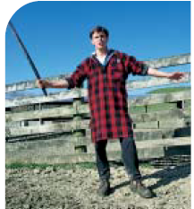
- Has anyone been injured by animal or know anyone who has? What happened?
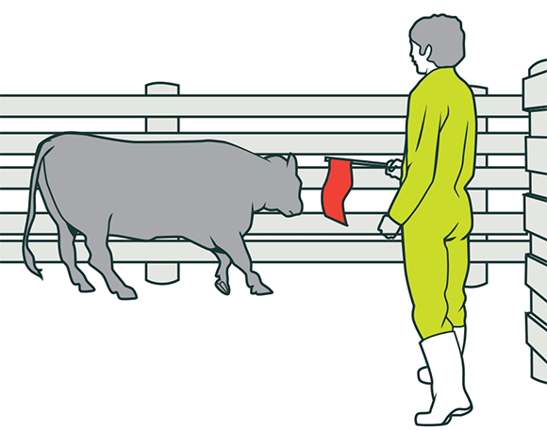
Teacher Notes
Animal handling skills are essential for managing farm animals safely. Good stock managers learn these skills through observation and trial and error.
Good livestock handling
- saves time and effort
- reduces stress for people and animals.
- rough handling of animals can cause financial losses because of bruising, poorer meat quality and lower milk production.
Many farmers sustain minor injuries while working with livestock. Common injuries include cuts, bruises, fractures, sprains and strains. Serious injuries cost farmers in lost time, and financially. ACC has paid out millions in cattle related claims. That’s not counting the minor kicks and bruises considered as part of the job.
Working with livestock can be dangerous. Although this lesson will focus on cattle, other farm animals such as deer, sheep particularly males are equally dangerous.
Five Important tips for managing cattle.
- Keep cattle calm
- Keep an eye on what’s going on around you
- Use your voice
- Make sure they know who’s the boss
- Check the yards before working with them
- Wear appropriate clothing and footwear for the right job
- Stand well back or up close
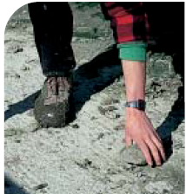

Discuss the components of good livestock handling with your students.
PPT Rural Safety Slides 25-36

The components of good livestock handling
Facilities
- Race and yard design
- Lighting
Animal Factors
- Arousal state
- Unpredictability
- Size
- Speed
- Behaviour
- Experience
- Sex
- Physiological state

Factors to consider when working with livestock
Time
Sufficient time
Environmental Factors
- Shade
- Drinking water
- Weather conditions
Human Factors
- Awareness
- Confidence
- Fitness
- Calmness

Activity 1: Animal behaviour
PPT Rural Safety Slides 25-36
How calm or flighty an animal is ranges from sleep (calm) to mad, frightened and stressed (flighty).
In groups
- Discuss what could cause cattle to be
- flighty
- calm

- PPT Rural Safety Slides 25-36
- Drag and drop the statement in to the table under the correct heading
- Discuss why you have put the statements under the heading.
What can make cattle flighty? | What can calm cattle?

- When you are tired, or hungry or hot or thirsty or all these how do you respond to be asked to do something you don’t want to do?
- If an animal is frightened, hungry or hot or thirsty or all these how do you think they would respond to being moved by people yelling at them or dogs barking at them.
- Discuss how you should move cattle.
- Sheep farmers often move sheep very early in the morning. Why?
- What do you think happens if you are running short of time and rushing around animals to get a job done?
- Farmers often stop for a break and a cuppa after mustering cattle in the yards before they start drafting. How would this help both the farmer and cattle.

Activity 2: Worksheets
- Cattle, how they see the world (WS)
- Cattle Working distance (WS)
- Cattle Balance Points

Activity 3: Safety Alerts
PPT Rural Safety Slides 30-36
- Test your cattle knowledge
- Safety alerts

Lesson 7: Safe use of chainsaws.
Find out what your students know about chainsaws.
Ask your students-
- Who has used a chainsaw?
- Do you think they are dangerous? Why?
- What safety equipment should you wear when using a chainsaw?
Teachers notes
Chainsaws are potentially dangerous machines, which can cause major injury if used by untrained people. Anyone who uses a chainsaw at work must receive adequate training and be competent in using a chainsaw for that type of work.
To operate a chainsaw safely you need-

- Footwear. Boots should have steel toe caps and give firm ankle support. Lace-up types must be securely fastened so that you don't trip on the laces.
- Leg protection. Wear good-quality chainsaw safety trousers or chaps.
- Safety helmet. Wear a helmet to protect your head from falling objects and to minimise the risk of injury to the face in the event of a kickback
- Earmuffs. Wear earmuffs rated Class 5.
- Eye protection. If you are working in very dusty conditions, wear goggles. If there's a danger of flying debris, use a helmet visor.
- General clothing. Clothing should fit fairly closely but be comfortable and allow free movement.
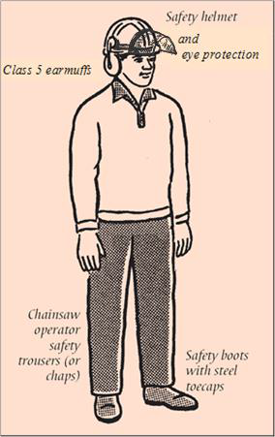

Activity 1: Video - Chainsaw safety
Kick back
Kickback is the leading cause of chainsaw accidents. Kickback occurs when the upper part of the bar nose contacts a solid object or is pinched. This causes a reactive force that may throw the guide bar in an uncontrolled arc towards you and can result in serious injury.
Kickback can occur when:
- The bar nose hits hidden limbs or light material.
- The chainsaw is boring into a log
- The bar nose is pinched while cutting.
- The bar nose makes contact with the end of log or obscured material.
- The chain is loose.
- The depth gauge setting is too low.
How to reduce kickback?
Using proper operating techniques will reduce the likelihood of kickback.
- Use a sharp and well-tensioned chain at full engine speed
- Never use the tip or upper quadrant of the bar to cut
- Be fully alert when using a chainsaw, ensure good visibility, and maintain a strong grip and stance.
- Hold the chainsaw firmly with both hands.
- Do not over-reach or cut above shoulder height
- Cut only one log at a time.
- Correctly maintain your chainsaw
- Use a safety chain (anti-kickback chain)
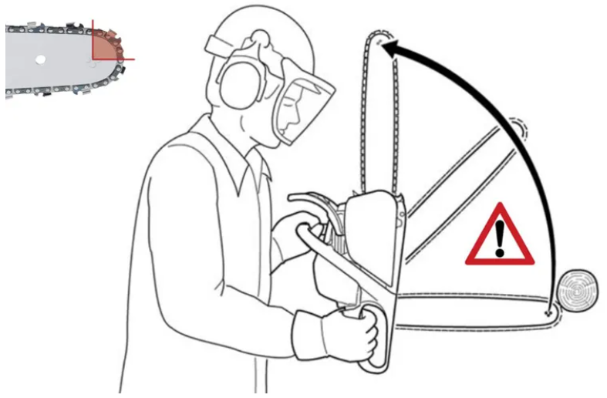

Activity2: True /False
PPT Rural Safety Slides 37- 41
- Do the true and False activity and Safety alert activities

Activity3: Guest speaker
Contact a local store that sells chainsaws and ask them if they know of anyone that can come into your class to talk about the safe use of chainsaws and demonstrate good practice.

Activity 4: Do’s and Don’ts
Make a list of do’s and don’ts when operating a chainsaw.

Lesson 8: Safe use of firearms
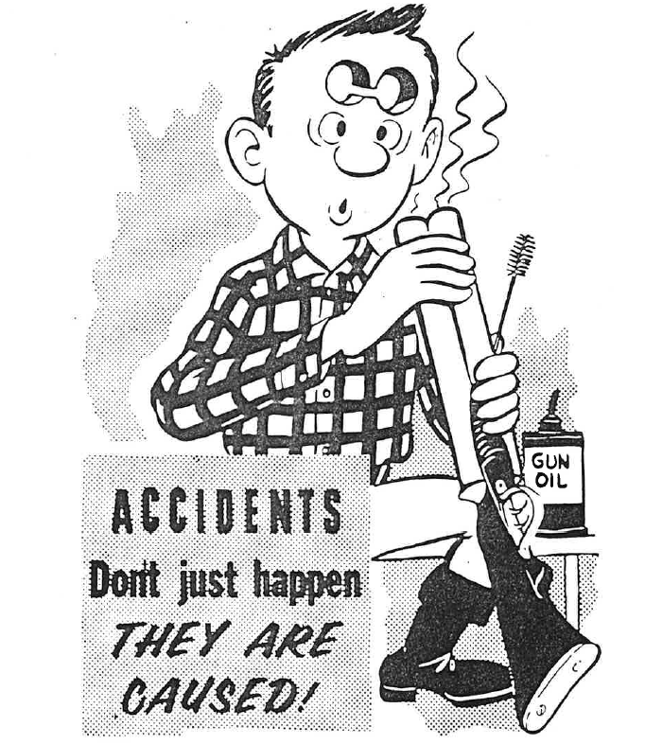

Find out what you students know.
Ask your students.
- Whose family has a firearm at home?
- What are the firearm safety rules?

Teacher notes
Firearms are tools that are used for hunting, sport, and sometimes on farms to control pests. While they are important for many people in New Zealand, it's crucial to handle them safely to avoid accidents. Firearms are not toys, and they can be dangerous if used improperly. Everyone who handles a firearm must follow strict safety rules to protect themselves and others.

In New Zealand, there are laws and rules that help keep people safe when using firearms. These rules are there to make sure that firearms are used responsibly, and that people know how to store and handle them safely. Whether you're using a firearm for hunting or on a farm, understanding and following these safety rules is very important.
Safety always comes first when handling firearms!

To legally own a firearm and apply for a firearms license, you must be at least 16 years old. Children under 16 can use a firearm, but they must be supervised by an adult who holds a valid firearms license

The three most common times when incidents with firearms happen are:
- during initial contact with the firearm, before it’s put to its intended use
- during a hunting trip, when the shooter misidentifies their target, and
- after a shooting or hunting trip, when it’s time to return the firearm to the vehicle or storage.
Firearm rules
- Treat every firearm as being loaded
- Always point firearms in a safe direction
- Chamber a cartridge only when ready to fire
- Identify your target beyond doubt
- Check your firing Zone
- Check every firearm yourself
- Store and transport firearms and ammunition safely
- Avoid alcohol or drugs when handling firearms

Activity 1: Good Practices
PPT Rural Safety Slides 42-44
- Safety alert
- True / False
- Make a list of other good practice when handling or using firearms

Good practices include
- Pass or accept only open and unloaded firearms.
- Make sure there is nothing obstructing the barrel of your firearm before you fire
- Completely unload before you leave the shooting area.
- Get permission before going shooting on any land from the appropriate person.
- Lock the unloaded firearm, the bolt and the ammunition away separately.
- Have your firearm check regularly.

Activity 2: Video- firearm safety
Firearm Safet Rules videos 1-7

Activity 3: Firearms safety e-learning
Do the firearms safety E-learning course
- 7 rules of firearm safety
- Basic types of firearms
- Ammunition
- Being safe when shooting
- Take the firearms safety code quiz

Activity 4: The don’ts with firearms
Now you know the safety rules with firearms write a list of don’t do’s with firearms.
Don’ts
- Do not point a firearm at anyone, yourself included.
- Do not leave firearms loaded.
- Do not load the magazine until you reach your shooting area.
- Do not drink alcohol and do not go shooting with anyone who has been drinking.
- If on medication, be sure the drugs you take do not affect mental and physical reactions.
- Do not shoot when in doubt and
- Never at movement only.
- Never at colour only.
- Never at sound only.
- Never at shape only
- Never at a target on the skyline.
- Never when companions are ahead of you.
- Do not lean firearms against a vehicle or wall where they could accidentally fall.
- Do not close the action on a live round until ready to make a safe shot.
- Do not rely on safety catches.
- Do not cross a fence without unloading the firearm.
- Do not try to jump a stream of cross on slippery rocks when carrying firearms. Walk through the stream.
- Do not daydream. Concentrate on what you are doing when you handle firearms.

Lesson 9: Safe use of agrichemicals
Find out what your students know,
Ask you students
- Name some hazardous chemicals that could be found around
  - Your home
  - On a farm
  - On an orchard or market garden
- Why do we need agrichemicals?
- What are agrichemicals used for?
- Can anyone use agrichemicals?
Teacher notes
Agrichemicals are useful as weedkillers, insecticides and fungicides but they can be dangerous. If used incorrectly some farm chemical can cause illness and death to people and livestock and kill or damage crops and cause harm to the environment.
Toxic agrichemicals can be used without harming people, livestock and crops when the proper precautions are taken.

There are 10 commandments to follow when handling agrichemicals.

Activity 1: Safe handling of agrichemicals
10 Commandments for Safe Handling of Agrichemicals
- Read and complete the worksheet
- PPT Rural Safety Slides 45-53
- Do “Is this safe”-
Teacher notes
What's on the label?
The pesticide label is an important legal document. Always read the label before purchasing the product, and again before and after using it.
The label has information on the type of product, what it contains, what crops it may be used on, the pests it may be used against, how it may be applied, personal protection, information on transport, storage, disposal, environmental concerns, and what to do in emergencies.
The pictograms on labels communicate the most important warnings and advice. The colour bands and pictograms are the same worldwide.

Not everyone can use certain chemicals.
To use toxic chemicals, you need to be trained and accredited. There are raining courses to use agrichemicals run by formal training providers to train people in safe handling of agrichemicals. Two common examples are GROWSAFE™ and FarmSafe™.

Bands
A GREEN band means a LESS TOXIC production, unlikely to be hazardous in normal use.
A BLUE band means CAUTION
A YELLOW band means POISON
A RED band means a DEADLY or Dangerous Poison. It contains the maximum number of advice
and warning pictograms
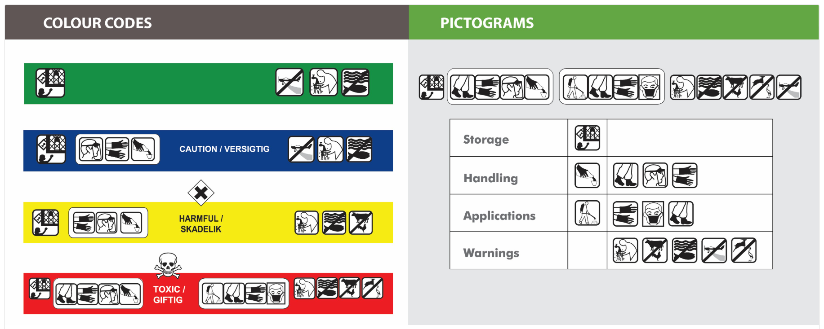

Discuss with you class
- Why are colour and pictograms used together on agrichemicals and why is this labelling universal?
Ideas to consider
- Not everyone can read.
- Some people are colour blind.
- Consistent labelling for the same product in every country.
- Why do you think you need to have special training to use dangerous or toxic chemicals?

Activity 2: Pictograms and symbols
PPT Rural Safety Slides 47-50
1. Drag and drop the pictogram to the correct meaning.
2. Drag and drop the words to match the symbols.

Activity 3: Safety alert
PPT Rural Safety Slides 51-53
  - Do Safety alerts.
  - Make a summary list of the 10 commandments which are quick and easy to read and check.

Lesson 10: Noise induced hearing loss (NIHL)
Find out what your students know.
Ask your students
- Who knows someone that has hearing loss.
- How old are they?
- Do only old people that have hearing loss?
- What do you think can cause hearing loss? Brainstorm ideas.
- Can you protect yourself to reduce the risk of noise induced hearing loss (NIHL).
Teacher Notes
What is noise?
Noise is unwanted sound. It has become a form of pollution and hearing has become the sense most often and easily damaged.

How noise affects us?
Noise affects people both physically and psychologically. The main physical effect of noise is that it can cause deafness.

Inside the ear are some 15-20,000 hearing cells. These cells response and decode different frequencies i.e. low tones through to high tones. Those that respond to higher pitched sounds are the most sensitive.

Without these cells, no message would reach the brain, and no sound would be heard.

Warning signals
Repeated exposure to too much noise can result in the hearing cells becoming tired so that for a short while they are unable to do their job. You may experience this as tinnitus (ringing in the ears) or temporary dulling of hearing. If your ears are allowed 16 hours away from this environment, cells may recover, and normal hearing returns.

Video Journey of Sound to the Brain
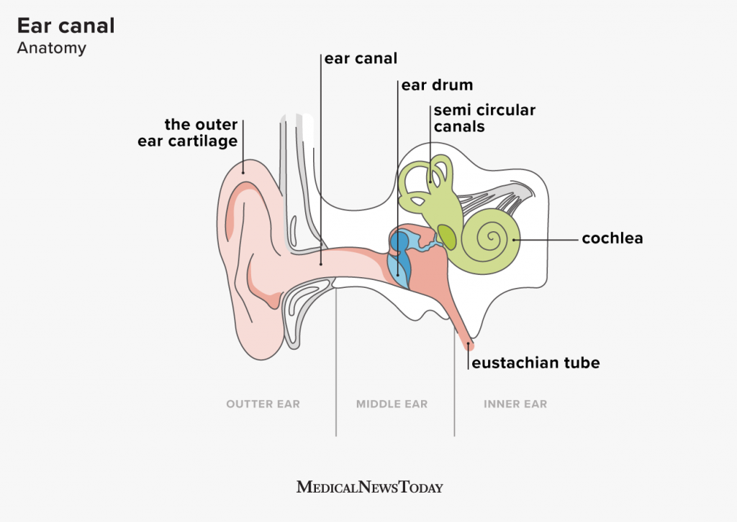

Activity1: Video Sound to Brain

Teacher Notes
Noise-induced hearing loss (NIHL)
If the noise exposure continues day after day, the hearing cells lose their ability to recover. The longer you are exposed to a loud noise, the more damaging it may be. Also, the closer you are to the source of intense noise, the more damaging it is.
Farmers, growers and foresters are often exposed to loud noises from machinery and animals, which can lead to hearing loss over time. They are also exposed to other hearing loss causes, such as:
- hazardous substances
- recreational noise
- aging
- disease
- ototoxic drugs (drugs that harm your hearing)
- trauma.

Hearing loss is expensive. It affects the productivity of farm and horticulture operations and is linked to increased rates of accident and injury. It also affects the social and personal lives of farming families.

Noise induced hearing loss (NIHL) is one of the most common work-related injuries.

Noise induced hearing loss key points
- Noise induced hearing loss (NIHL) is one of the most common work-related injuries.
- Hearing loss is expensive. It affects the productivity of farm operations and is linked to increased rates of accident and injury.
- Keep noise levels below 85dB(A) on average and 140dB at peak.
- If possible, replace machinery that creates noise above these levels.
- If you can’t replace the machinery reduce exposure to it.
- Wear hearing protection if noise levels are still too high.

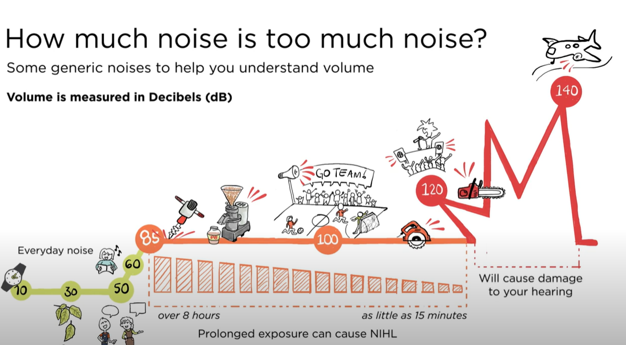

Activity 2: How much do you know about noise and hearing loss?
PPT Rural Safety Slides 54-62
- Do the true True /False

Activity 3: Harmful noise
Noise can be harmful to hearing, but hearing loss is preventable.
- Watch videos
- What is harmful noise-
- Noise exposure
- In groups
- Discuss- “when is it too loud”?
- Make a list of equipment on farm or in an orchard or in a packhouse and the around your home that is noisy and could cause hearing loss.
- How do you know you have hearing loss?
- Make a list of the health and safety concerns with hearing loss?
- Discuss what should you do if you are working with noisy equipment or in a noisy space to reduce the risk of damaging your hearing.

Activity 4: Sound levels
PPT Rural Safety Slides 57-62
- Do the sound level drag and drop

The type of hearing protection needed depends on the equipment being used, the situation and the levels of exposure. Hearing protectors come in a variety of classes, each class appropriate for a different maximum noise level.
- Watch the video Noise exposure again
- Discuss hearing protection classes and protection devices

Activity 5: Protect your hearing
Make a list of what you are going to do to protect your hearing?

Lesson 11: Back injuries
Find out what your students know about back injuries.
Ask your students
- Who know someone who has had or has a back injury? - Hands up
- Discuss what caused the back injury.
- Can you think of activities that might cause you to hurt your back if you’re not careful? - Make a list.
- How do you think carrying a heavy backpack might affect your back over time?
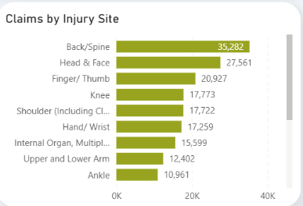
- What happens to your back if you slouch while sitting for a long time?
- Why is it important to stretch before exercising or playing sports?
- Who knows how to lift something off the ground correctly? - Ask a student to demonstrate with a light object.
- What do you think are the most common activities on a farm or orchard that could cause back injuries? - Make a list.
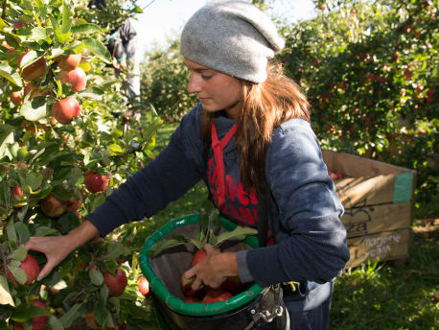
Teacher Notes
People working on farms, orchards, in forestry or other primary industries do a wide variety of manual tasks. These tasks often involve using force, repetitive movements, stooping, awkward postures, and continual bending and twisting at the waist while handling heavy objects. These can cause several problems, including:
- serious back injuries
- musculoskeletal disorders, including occupational overuse syndromes
- acute injuries, like muscle or tendon sprains and strains
- injuries from slips, trips and falls.

In 2023 19.700 working in agriculture and horticulture made an ACC claim. Most of these claims are related to slips, trip and falls, many caused back and spine injuries.

Activities that can cause back injuries
- Milking.
- Lifting sheep.
- Lifting calves
- Shearing and crutching
- Carrying heavy baskets of fruit
- Harvesting vegetable
- Carrying heavy buckets
- Lifting heavy objects
- slips, trips and falls.
  - Discuss and add more

Activity 1: Lifting safely
Tips for lifting objects
- Balance your body’s weight equally over both feet.
- Step close to the load.
- Think about the best place to grip the load and the best type of grip to use. >
- Apply force gradually, after testing the weight.
- Lift smoothly, rather than using sudden exertion.
- Hold the load close to your body.
- To change direction while moving, take a step in the new direction rather than twisting your body.
- Pace the work if it goes on for a long time, take small breaks often
Key points to minimise back injuries
- Get training on the correct techniques for manual handling jobs.
- No one should lift something that is too heavy for them.
- Lift with the legs, not the back.
- (Re)design the workplace to minimise manual handling risks.
- Use mechanical/lifting aids where possible.
- Plan regular breaks and rotate jobs.
- Back Safety: Lifting Safety - Use Your Head - Back Injury Prevention - Safety Video
- Discuss questions
- Why is it important to use your legs instead of your back when you lift something heavy?
- What kind of exercises do you think help strengthen your back to prevent injury?
- Why do you think it’s important to have a good chair and desk setup when working or studying for long periods?
- What do you think could happen to your spine if you spend too much time looking down at your phone or tablet?
- How do you think poor lifting techniques or not asking for help with heavy objects can lead to back injuries?
- Do Rural Safety slides. PPT Rural Safety slides 63-66
(i) Go through slide 64 lifting do’s & don’ts and diagrams to show which lifting technique is correct.
(ii) Make a list of, does and don’ts of how to prevent back injuries.

Suggestions
Do’s | Don’ts
- Lift properly- use your legs, not your back, when lifting heavy objects.  - Exercise regularly-strengthen your core and back muscles.  - Maintain good posture- keep shoulders back, chest forward, and avoid slouching.  - Take breaks  - Wear supportive footwear | - Don’t lift with your back: Avoid bending at the waist when lifting  - Don’t try to lift too much  - Don’t slouch  - Don’t twist while lifting:  - Don’t carry heavy bags on one shoulder  - Don’t ignore pain

Activity 2: Sheep and Calf lifting worksheets.

Lesson 12: Slips, Trips and Falls
Find out what students know about slips, trips and falls.
Ask your students
- Have you ever slipped or tripped while walking? What do you think caused it?
- What kinds of surfaces do you think are most slippery? Why?
- Can you think of any common things people leave on the ground that might cause someone to trip?
- How does rain, ice or snow, make the ground more dangerous to walk on?
- What could happen if you walk too fast or don’t pay attention to where you’re going?
- Why do you think it’s important to keep walkways and paths clear of things like toys, backpacks, or equipment?

Activity 1: Points to discuss
PPT Rural Safety slides 67-68
- Work through the questions and activities
Teacher notes
People working on farms, in horticulture, forestry and fishing do many jobs where there is a risk of slips, trips and falls.
These include:
- working at height
- working on uneven or slippery surfaces
- using ladders
- getting on and off tractors or other equipment
- working in the milking shed, shearing shed, yards,
- not paying attention
- tired

Preventing slips, trips and falls key points
- Keep work areas clean, dry and tidy
- Use footwear with good tread
- Always use three points of contact on ladders, or when mounting/dismounting tractors and mobile plant
- Arrange work areas to minimise slip, trip and fall hazards: e.g. use rubber mats
- Find way to do tasks from the ground rather than at heights.
- Concentrate on what you are doing.

Activity 2: Good practices
PPT Rural Safety slides
- Discuss the good practices in these diagrams that are reducing the risk of slips, trips and falls.
- Make a list of do’s and don’ts to reduce slips, trips and falls on a farm, or orchard or other
primary industry.
Suggestions
Do’s | Don’ts
- Wear proper footwear  - Keep work areas clean and organised  - Use proper ladders and scaffolding  - Clear mud and water from walkways  - Put matts down in slippery areas  - Concentrate on what you are doing. | - Don’t rush  - Don’t ignore wet, icy weather conditions  - Don’t leave tools or equipment in walkways  - Don’t skip safety gear  - Don’t overreach or stretch

Activity 3: SHED (Safe Home Each Day)
PPT Rural Safety Slide 69
- Change wording to suit your class.
If you are working on a farm or in an orchard, what is your responsibility to get SHED.

Lesson13. Extra activities

Safety videos
- Safetree: injury prevention for New Zealand's forestry sector

Writing
- Write a short story describing an accident you almost had on a farm or orchard and how you stayed safe and kept others safe.
This can be a real or imaginary story.
Or
- Make a one-minute video clip that young people can watch to warn them of dangers on a farm or orchard or on a piece of farming equipment.
Or
- Design a safety pamphlet that focuses on one important safety aspect, making it engaging and easy to read for young people. It should be informative and highlight the importance of rural safety.

Guest speakers.
Contact your local Young Farmers Club or Dairy Women’s Network or local Men’s club or other local agribusiness and ask if any of their members or staff members would come and talk to your students and demonstrate some aspect of safety.

Rural safety day
Contact your local Young Farmers Club or Dairy Women’s Network local Men’s club , WorkSafe, Farm Without Harm, Safer Farms, police and or other local agribusiness and ask if any of their members or staff members would be interested in participating in a rural safety day/ morning/ afternoon to discuss and demonstrate safe use of farm vehicles, machinery etc to our students.

 | Potential organisations to ask
Tractors | Forestry or Local dealer
Quad bikes | Forestry or Local dealer
Two-wheeler motorbike | Forestry or Local dealer
Side-by- sides | Forestry or Local dealer
Animals | Farmer or Stock agent
Chainsaw | Forestry or Local dealer
Firearms | Police
Agrichemical | Farmer or Local dealer
Loss of hearing | WorkSafe
Back injuries | WorkSafe

