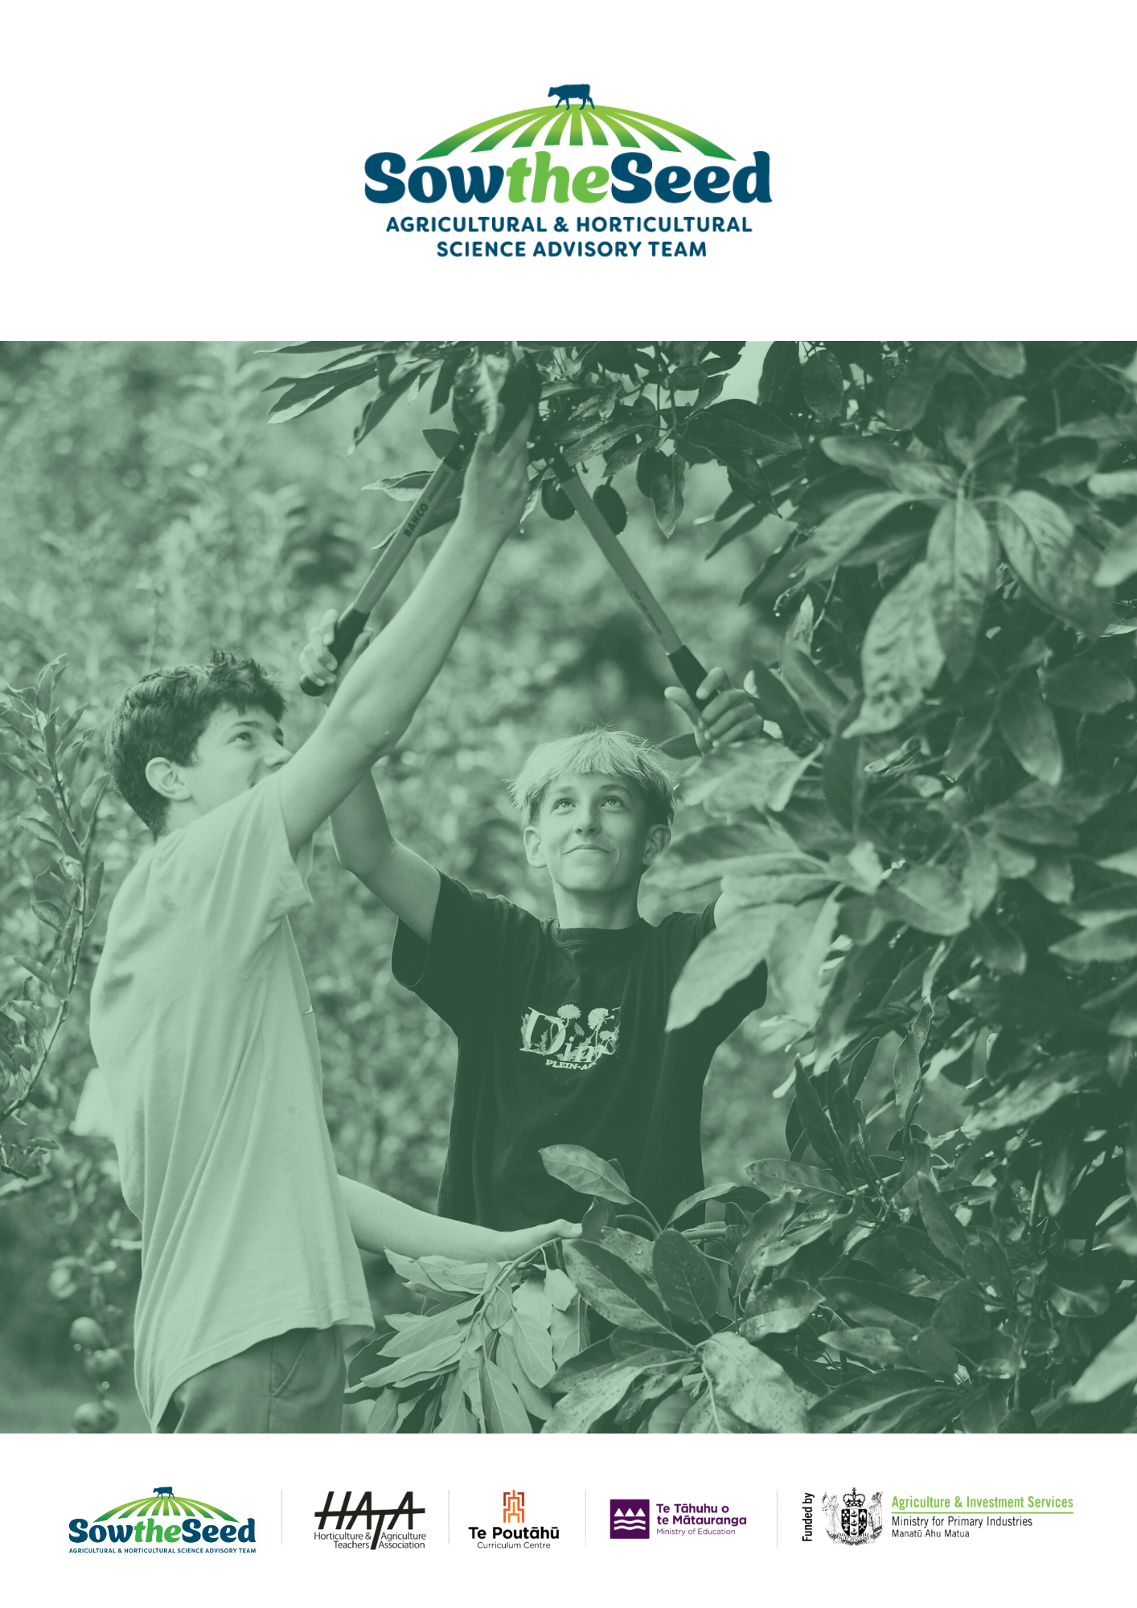
Unit 7
Potatoes
Teachers Guide

Unit 7
Potatoes
An Important Crop in New Zealand and Globally
Teachers Guide
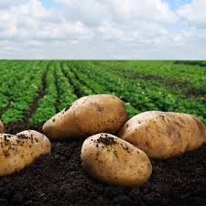

The primary production sector is well established in New Zealand Society and vital to the economy and standard of living. It is sector of opportunities and challenges.
Teaching years 7-10
We invite and encourage you to teach and inspire students about the primary production sector.
We have developed a resource for you.
Included is
- Teacher guide
- Engaging activities
This resource has been developed by Sow the Seed in conjunction with HATA
For more resources and teaching material for agriculture and horticulture science we invite you to join the Horticulture and Teachers Association HATA

Introduction

Primary Production is a 54 billion+ industry in Aotearoa New Zealand.
In Aotearoa New Zealand, primary production is the process of producing raw materials and products from natural resources, land and water. The main primary industries are agriculture and horticulture, forestry, fishing, and aquaculture, others are turf culture and equine.
A primary production system is a sum of all components, including the growing environment and management practices, that work together in the production of a primary product. Some examples of primary production systems include, dairy farming, sheep and beef farming, orchards such as apple, kiwifruit and cherries.
Primary production is the key driver of New Zealand’s economic, social, and environmental development. The products of primary production are a source of well-being for the present generation and will be so for future generations.

What is agricultural and horticultural science?
The Agricultural and Horticultural Science subject looks at the management practices that occur behind the farm, orchard gate or on boat as well as beyond, to produce a product. This practically orientated subject uses all the primary sector contexts of sheep, beef and cropping, dairying, horticulture, seafood and aquaculture, forestry, equine and sports turf. The application of good production management practices ensures that the primary products demanded by local and world markets are made available in an ecologically and economically sustainable manner. Agricultural and horticultural science deals with contexts, issues, and problem solving drawn from a broad agenda that includes, for example:
- products (for example, pork, poultry, avocados, honey, timber, milk, wool, apples, grapes)
- environments (for example, waterways, erosion, landscape, soil, shelter, glasshouses, effluent, pollution; environmental modification and sustainable management practices)
- solutions for particular management issues (for example, irrigation, cropping, harvesting and milking equipment, data, information and communication digital technologies, shelter and shade construction, and cultivation technologies).

Teacher Guide Notes
This unit of work is designed to increase student awareness and understanding of the importance of potatoes in New Zealand and globally, as well as how they are grown.
Key Learning Outcomes:
Students will gain an understanding of:
- why potatoes are an important crop in New Zealand and globally.
- the growth process of potato plants.
- the history of potatoes.
- Māori potatoes.
- the difference between potatoes and sweet potatoes (kūmara).
- where and how potatoes are grown in New Zealand.

Supporting Resources
- Unit 7 Potatoes Teachers Guide
- PPT Potatoes
- PPT Potato Varieties
- PPT Common Potato Pests & Diseases
- Growing Kūmara (WS)
- Kūmara (WS)
- List-of-Varieties (4)
- Māori plants (A)
- Potato Diseases Poster
- Potato Fact Sheet (WS)
- Potato diagram
- Potatoes feeding the world (WS)
- potato-growing-guide
- Potatoes NZ 1.1 Potato Sprouting and Life Cycle Observation
- Potatoes NZ 1.2 Growing Potatoes in a Bag
- Potatoes NZ 1.3 Simple Plant Genetics
- Potatoes NZ 2.1 Potato Weighing and Sorting
- Potatoes NZ 2.2 Volume and surface area calculations with potatoes
- Potatoes NZ 2.3 Estimating and graphing growth of potato plants
- Potatoes NZ 6.1 The Potato’s history and culture impact
- Potatoes NZ 6.2 World potato recipes
- Potatoes NZ 6.3 Potato trade simulation game
- Potato-varieties-2013-poster
- Rabobank Potato Map 2019 D2
- Vocabulary

Timeframe
Lessons are generally designed in a one-hour blocks but feel free to modify to suit you and your students. You do not need to complete all the lessons or activities.

Recommendations
Within each lesson there are multiple activities for students to do. We recommend you select the activity or activities that suit your students.

Content
Introduction 3
Primary Production is a 54 billion+ industry in Aotearoa New Zealand. 3
What is agricultural and horticultural science? 3
Teacher Guide Notes 4
Key Learning Outcomes: 4
Supporting Resources 4
Timeframe 5
Recommendations 5
Content 5
Lesson 1: Potatoes 7
Activity 1: Potato varieties 8
Activity 2: Seed potatoes 9
Activity 3: Potatoes NZ1.1 Potato Sprouting and Life Cycle Observation 9
Activity 4: How light affects sprouting potatoes? 9
Activity 5: Potato Plant 10
Activity 6: Quiz 10
Lesson 2: History of the potato 11
Activity 1: How did Potatoes change the world? 11
Activity 2: Potato facts 11
Activity 3: Potatoes feeding the world. 12
Activity 4: Research the plant family solanaceae 12
Activity 5: More activities 12
Lesson 3: Taewa -Māori potatoes 13
Activity 1: Research 14
Activity 2: Guest Speaker 14
Lesson 4: Potatoes versus Sweet potatoes 15
Activity 1: Compare Potatoes and Kūmara 16
Activity 2: Kūmara worksheets and activity 16
Activity 3: Guest speaker 16
Lesson 5: Where are potatoes grown in New Zealand? 17
Activity 1: Regions growing potatoes 18
Lesson 6: Growing potatoes 19
Activity 1: Growing potatoes flow diagram 20
Activity 2: Fact Sheet - Potatoes 21
Activity 3: Potatoes NZ 1.2 Growing Potatoes in a Bag 21
Lesson 7: Potato pest and diseases 22
Activity 1: Potato pest and disease research 24
Lesson 8: Potatoes varieties grown in New Zealand 25
Activity 1: Research potato varieties. 26
Activity 2: Market survey 26
Activity 3: Reflection 27

Lesson 1: Potatoes
Find out what your students know.
- Tell me what you know about potatoes. Summarise what they know.
- Who has grown potatoes or seen how they are grown?
Based on what students already know
Ask your students
- What is a potato?
- How do you think potatoes grow?
- What are the different types of potatoes you have heard of?
- Do potatoes come in different colours? Why do you think this?
- Do you think potatoes are healthy or unhealthy? Why?
- What are the health benefits of eating potatoes?
- Potatoes are a stable diet in many countries around the world. Why do you think this is?
- Is the potato an important crop?

- Write down, what would you like to learn about potatoes?
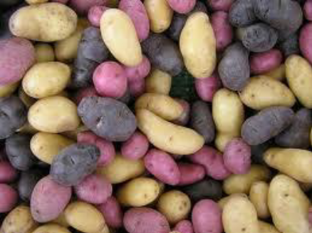
Teacher notes - Resource - Potato poster
1. What is a potato?
A potato is a starchy root vegetable that grows underground. It is the edible tuber of the plant Solanum tuberosum, commonly known for its versatility in cooking and its nutritional value.
2. How do you think potatoes grow?
Potatoes grow underground as part of the root system of the potato plant. The plant produces small tubers, which are the potatoes we eat, and these grow in the soil when the plant's leaves absorb sunlight.
3. What are the different types of potatoes you have heard of?
Some common types of potatoes include Agria, Nadine, Red Rascal. (see the potato poster for more examples).
4. Do potatoes come in different colours? Why do you think this?
Potatoes come in different colours, such as brown, red, yellow, and even purple. Different varieties have different colours. The different colours are due to the presence of different pigments and nutrients in the skin and flesh of the potato.

5. Do you think potatoes are healthy or unhealthy? Why?
Potatoes can be healthy when prepared in nutritious ways, like baking or boiling. They provide vitamins, minerals, and fibre. However, when fried or prepared with lots of butter or salt, they can become less healthy due to the added fats and calories.
6. What are the health benefits of eating potatoes?
Potatoes are a good source of vitamin C, vitamin B6, potassium, and dietary fibre. They also provide energy from carbohydrates. Eating potatoes in moderation can support overall health, including good digestion, immune function, and heart health.
7. Potatoes are a staple diet in many countries around the world. Why do you think this is?
Potatoes are a staple food in many countries because they are cheap to buy, easy to grow, and versatile. They can be stored for long periods, making them a reliable food source. They are also high in calories and nutrients.

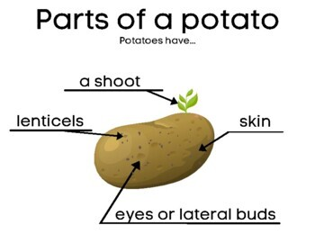
Activity 1: Potato varieties
PPT Potatoes Slide 2
Bring in a range of potato varieties to show students.
(i) In groups students observe
- Skin
- Shape
- Colour
- Size
(i) Find out what potatoes your caregivers buy or grow.
(ii) Ask students to bring in a potato that is growing shoots.
Teacher notes
Most potatoes are grown from potato pieces called "seed potatoes."
Potatoes are grown from seed potatoes because they are special parts of the plant called stem tubers, which store food. When you plant a seed potato, it has small buds on it that grows into new potato plants. This is a form of asexual reproduction, meaning the new plants are genetically the same as the original plant. The tubers store nutrients that help the plant grow, making sure it gets the energy it needs. Using seed potatoes is the best way to grow potatoes that are all the same type and size.

This method of growing potatoes is important because it ensures that all the new plants are genetically the same, which helps produce consistent, high-quality potatoes. By using seed potatoes, farmers can grow crops with predictable size, shape, and taste, making it easier to meet market demands. It also helps maintain the health of the plants, as using certified seed potatoes reduces the risk of diseases and pests spreading through the crop.

Activity 2: Seed potatoes
Q: What has eyes, but cannot see?
A: A potato!

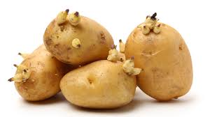
Show the students the eyes on a potato. Explain that each seed potato has an eye. New growth or sprouts grow from the eyes and will grow into potato plants. Potatoes can have more than one eye.
(ii) Discuss what a potato eye is?
(iii) Count the number of eyes on a potato.

Activity 3: Potatoes NZ1.1 Potato Sprouting and Life Cycle Observation
See activity sheet in the resources.

Activity 4: How light affects sprouting potatoes?
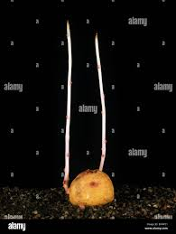
If you have some old potatoes, the "eyes” may have sprouted. You can use a sprouted potato to show students how a plant seeks the light to grow (it is called phototropism -- in Greek "photo" means light and "trope" means turn).
Resources
- A box- like a shoe box- Must have a lid that won’t let light in.
- Sprouted potato
Method
- Poke a hole in one end of the box (approximately 3cm diameter)
- Put the sprouted potato at the opposite end from the hole in the box.
Tip: Take a photo of the sprouted potato and measure the length of the sprout before putting it in the box.
- Put the lid on the box, secure it with duct tape (so that light doesn't "leak" through the lid) and set the box in a sunny spot with the hole facing the light.
- Observe and record what happens over the next 2-3 weeks
Ask students to write down
What I think will happened? | What happened?

Record
- What has happened to the sprouted potato?
- Measure the length of the sprouts.
Teacher Notes
The idea is that the light should be coming in from the hole only. Now you wait. Count how many days until you see the sprout growing out of the hole in the box, in search of light.

Activity 5: Potato Plant
Hand out the Potato Plant Diagram and ask the students to label the diagram using the words flower, leaves, stem, roots, and tubers.

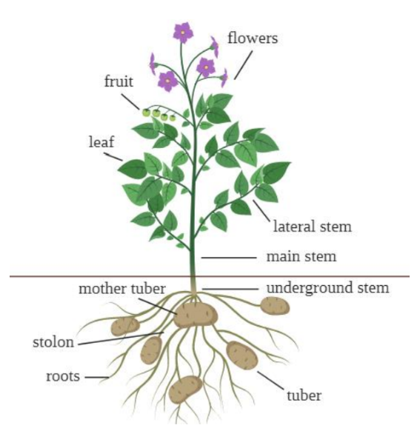
Discuss the function of each potato plant part:
- Flower: location in which pollination takes place and seeds are produced
- Leaves: soaks up the sun's energy and makes food for the plant
- Stem: transports water and food to other parts of the plant
- Roots: anchor the plant and absorb water and nutrients
- Tuber: special part of potato plants (and a few other plants) that stores food; the part of the potato plant that we eat
Additional plant part
- Stolon: plant stems which grow at the soil surface or just below ground that form adventitious roots at the nodes, and new plants from the buds.

Activity 6: Quiz
PPT Potatoes slide 3

Lesson 2: History of the potato
Find out what your students know.
Ask your students
- Are potatoes native to New Zealand?
- Where did the potato come from?
Teachers notes - History of the potato.
The potato originated from the Andes Mountains of South America, mainly in what is now Peru and Bolivia. People there grew potatoes as far back as 8000–5000 BCE. The Inca Empire, one of the ancient civilisations, used potatoes as an important food source. In the late 1400s, Spanish explorers brought potatoes to Europe after they came to the Americas. At first, Europeans were unsure about eating potatoes, but over time, they became very popular, especially in Ireland.
By the 1800s, potatoes were grown all over the world and became a key part of people's diets, helping populations grow. However, potatoes were also connected to a terrible famine in Ireland in the mid-1800s when a plant disease called Late Blight ruined the crops.
Explorer James Cook brought potatoes to New Zealand on his visits between 1769 and 1777, and Māori adopted them as a food source.
Today, potatoes are one of the most important vegetables grown worldwide.

Activity 1: How did Potatoes change the world?
PPT Potatoes Slides 5
Watch the video How Did Potatoes Change the World? or for more detailed information video -How Potatoes Saved The World
Discuss
- how potatoes changed the world.
- the impact on the world population.
- the potato famine in Ireland in the mid 1800
- what do you think would happen if potato crops failed worldwide?

Activity 2: Potato facts
PPT Potatoes Slides 6-7
- True or false - Answers all true
- Use the link to research and make a list of New Zealand potato facts.

Activity 3: Potatoes feeding the world.
- Resource “Potatoes feeding the world” (WS)
- PPT Potatoes slides 8-9
Discuss
- Global potato consumption
- Why New Zealand potato yields are higher than other countries?

Activity 4: Research the plant family solanaceae
PPT Potatoes Slides 10-11
Potatoes belong to the Solanaceae family.
- Research the Solanaceae family and make a list of other crops and plants in this family.
- Discuss why you think
- early European farmers were initially reluctance to grow potatoes
- early Europeans were reluctant to eat them.
Tomato Fruit from Pollinated Flowers
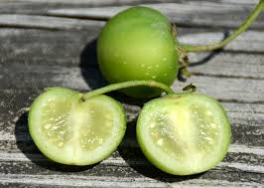
Plant in the Solanaceae family
Crops | Plants
Tomato  Capsicum  Aubergine | Nightshade  Black nightshade  Belladonna  Datura

Activity 5: More activities
For more activities complete the following. These are in the resources.
- 6.1 The potato's history and culture impact
- 6.2 World potato recipes
- 6.3 Potato trade simulation game

Lesson 3: Taewa -Māori potatoes
Find out what your students know.
Ask your students
- Does anyone grow or know someone that grows Māori potatoes?
- Does anyone know the Māori name of potatoes?
- How did the original potatoes come to New Zealand?
- Do you think potatoes were and important crop for Māori?
Teacher notes - PPT Potatoes Slide 12
Māori have been growing taewa (potatoes) in New Zealand for over 200 years. Taewa is the Māori word for potatoes, and it refers to the different types of potatoes (Solanum tuberosum). These potatoes are considered a taonga, or treasure, because they have significant historical and cultural value to Māori.
In the 18th century, European explorers brought potatoes to New Zealand. The Māori quickly learned how to grow them and gave the different varieties Māori names. Potatoes became an important crop in their gardens. Māori liked growing potatoes because they were easy to grow and produced more food than kūmara (sweet potatoes). Potatoes also grew in many parts of New Zealand, while kūmara could only grow in the warmer northern areas.
Over time, Māori developed their own traditional methods of growing and preparing taewa. Potatoes became a key part of their food system. Māori grew different varieties of potatoes, some of which were suited to New Zealand’s climate and soil.
By the mid-19th century, when European settlers arrived in New Zealand, Māori were already growing potatoes extensively. Taewa was not only a crucial food source but also used as a valuable form of currency in trade. Potatoes were important to the settlers as well, and they were even exported to Australia.
Today, Māori continue to grow and preserve traditional potato varieties, some of which have unique colours and flavours. Taewa is still an important part of Māori diet and culture.

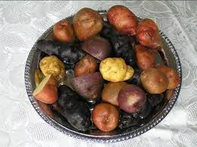

Activity 1: Research
PPT Potatoes Slide 12
Māori Potatoes
(i) Research the different taewa cultivars and their characteristics
Science Learning Hub Taewa (Māori Potatoes)
(ii) Research the benefits of taewa.
(iii) Explore current research on developing novel foods from taewa

Activity 2: Guest Speaker
Contact your local Iwi and ask if anyone is growing taewa and if they would come and talk to the students about this taonga.
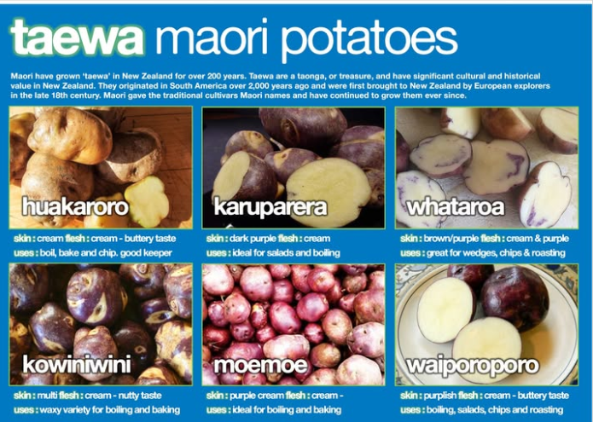

Lesson 4: Potatoes versus Sweet potatoes
Find out what your students know.
Ask your students
- Are potatoes and sweet potatoes the same? - No
- What is the difference between a potato and sweet potato?
- Is kūmara a sweet potato? Yes, kūmara is the Māori name for sweet potato.
- Where are most of New Zealand kūmara grown? In the Kaipara region?
- Why are more potatoes grown than kūmara?
  - Potatoes are easier to grow and produce more food than kūmara and potatoes grow in many parts of New Zealand, while kūmara only grow in the warmer northern areas e.g. the Kaipara region
Teachers notes

There are two general groups of potatoes - Irish potatoes and sweet potatoes.
- The Irish potato is one name for what we typically call a potato. It comes in many varieties, sizes, and colours.
- Sweet potatoes are a distinctly different food. Sweet potatoes are known as kūmara in New Zealand. They come in a range of varieties, colours and shapes. Red kūmara is the most popular variety in New Zealand, with its distinctive red skin and firm white flesh. Orange kūmara is the sweetest and firmest option, whereas purple kūmara is the least sweet. Potatoes and sweet potatoes are both starchy root vegetables, but they come from different plant families and have distinct characteristics. Potatoes are a stem tuber while sweet potatoes are root tubers.
- Origin:
- Potatoes come from the Andes Mountains in South America, specifically Peru and Bolivia. They belong to the Solanaceae family, which also includes tomatoes and peppers.
- Sweet potatoes are native to Central and South America and belong to the Convolvulaceae family, which is the morning glory family.
- Appearance:
- Potatoes typically have a round or oval shape with a brown, yellow, or red skin, and their flesh can be white, yellow, or purple.
- Sweet potatoes usually have a tapered shape with smooth skin that can be beige, purple, or orange. The flesh is often orange, but it can also be white or purple.
- Taste:
- Potatoes have a more neutral, starchy taste, which is why they can be used in a variety of savoury dishes.
- Sweet potatoes are sweeter and have a richer flavour, especially when cooked.
- Nutritional Difference:
- Potatoes are a good source of carbohydrates and provide some vitamins and minerals, but they are lower in vitamins compared to sweet potatoes.
- Sweet potatoes are higher in vitamins A and C, making them a great source of antioxidants and beneficial nutrients.

Activity 1: Compare Potatoes and Kūmara
- Using PPT Potatoes slides 13-16
- True and false
- Test yourself
(ii) Show students a range of kūmara and potato varieties and compare the differences.
- Skin
- Shape
- Colour
- Size

Activity 2: Kūmara worksheets and activity
Select the appropriate worksheet or activity to suit your class.
- Growing Kūmara (WS)
- kūmara (WS)
- Māori plants (A)

Activity 3: Guest speaker
Contact your local Iwi and ask if anyone is growing kūmara and if they would come and talk to the students about kumara are grown traditionally.
Or
If you are in the Kaipara area, contact a local grower and ask them if you do a class visit to show the students how kumara are grown or if they would come into your class to show students different kumara and ask how they are grown.
Or
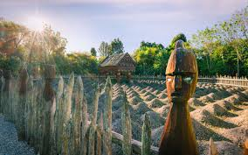
If you are in Hamilton, take you students to visit the Hamilton gardens and ask to have a guided tour that shows how kūmara are traditionally grown.

Lesson 5: Where are potatoes grown in New Zealand?
Find out what your students know.
Ask your students
- Name the regions where potatoes are grown commercially in New Zealand.
- How many hectares of potatoes are grown each year?
Teacher notes
New Zealand uses more land for growing potatoes than any other crop. In 2023/24, over 9,000 hectares were used by 176 commercial potato growers. The majority of potatoes in New Zealand are grown in areas like Canterbury, Auckland, Waikato, Manawatu-Wanganui, and Hawke's Bay. Potatoes are also grown in other regions like Northland, where the soil is suitable.
To grow potatoes commercially, the land needs to have fertile, well-drained soil, plenty of sunlight, and flat or gently rolling land. This allows machines to work easily, and irrigation can be added when needed. Potatoes grow best in temperatures between 18°C and 20°C. They don't grow well if the temperature is below 10°C or above 30°C.
Potatoes grown in NZ | Area (ha) 2023/24
Total area | 9.266
Seed | 961
Table | 4,025
Processed | 4,280

Potatoes are a significantly important crop in New Zealand. They are grown for different purposes. They can be sold as:
- Seed potatoes (used to grow new potato crops)
- Fresh potatoes, often called table (for cooking and eating)
- Processed potatoes (like potato chips and frozen chips)

How are potatoes used in New Zealand?
- 55% of potatoes are used for processing (like making frozen chips).
- 24% of potatoes are used fresh for eating.
- 19% of potatoes are made into potato chips (crisps).
- 2% are used as seed potatoes to grow more crops.

Exports and Local Markets:
Around 25% of New Zealand’s total potato crop is exported to other countries such as Australia. The biggest export for New Zealand potatoes is frozen chips, mainly because we have several large companies that process potatoes into chips.

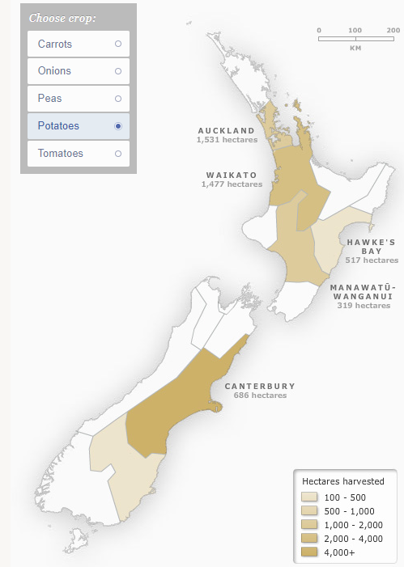

Activity 1: Regions growing potatoes
PPT Potatoes Slides 18-19
- Name the main regions where potatoes are grown.
- For one region explain why it is suitable for growing potatoes. Consider: climatic conditions, soil, topography, access to labour and markets and processing facilities.

Potatoes are a significantly important crop.
- Discuss the purpose of growing potatoes in one of these regions.
Consider:
- The different types of potatoes grown to meet a range of markets – fresh or processing
- Feeding the population - staple versatile food.
- Certified seed potatoes and food security.

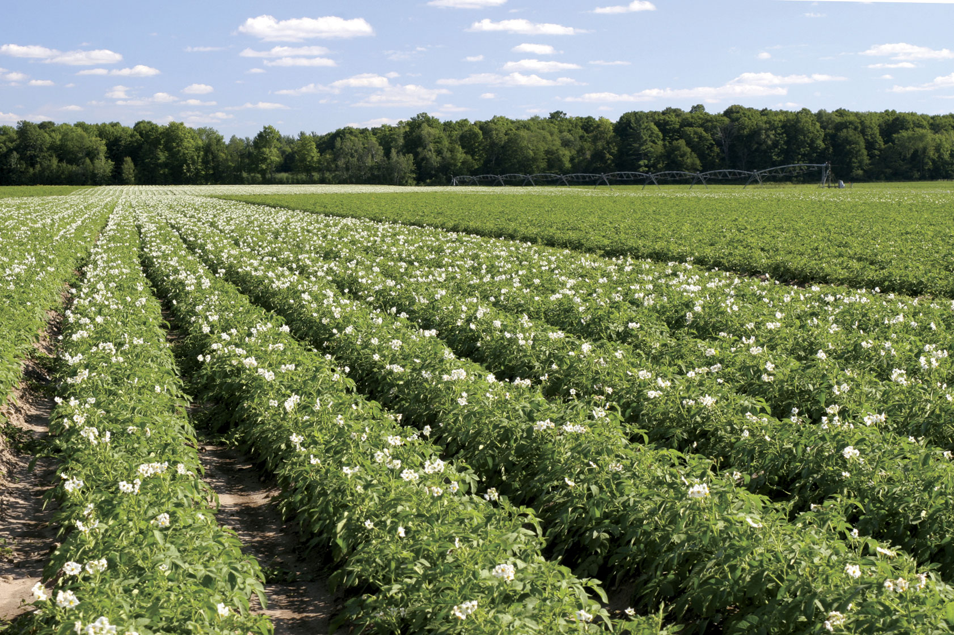

Lesson 6: Growing potatoes
Find out what your students know.
Ask your students
- Who has grown potatoes or knows someone that grows potatoes at home or commercially?
- Brainstorm how potatoes are grown commercially from field or garden to harvesting.
Or
- Brainstorm how to grow potatoes at school or home.
Teacher notes - How to Grow Potatoes
Potatoes grow best on flat or gently rolling land. They like soil that’s deep, easy to dig, and well-drained. If potatoes are planted in sandy soil, they will need to be watered more often to stay healthy and produce a high yield.
Potatoes need lots of sun to grow well, so they should be planted where they will not be shaded during the day. If they don’t get enough sun, the yield won’t be as high. Potatoes also do well in windy conditions. A good breeze helps keep pests and diseases under control.

Pests and Diseases
Potatoes are prone to pests and diseases, but crop rotation can help protect them. This means planting potatoes in a different place each year. Potatoes should not be planted in the same spot for two years in a row. After growing potatoes, it’s best to rest the soil by planting pasture or grass for 3-5 years before planting potatoes again.

Potatoes can also cause nitrogen to leach into the soil, which can harm the environment. To reduce this, crops like cabbage or broccoli (called brassicas) should be planted before or after potatoes. This helps keep the soil healthy. It is also important to test the soil before using fertiliser to avoid adding too much.

Planting Potatoes
Potatoes are usually planted in late winter to late spring. The exact time depends on the temperature of the soil, the weather, and the type of potatoes being planted. In frost-free areas, like the far north, potatoes can be planted in autumn and harvest in early spring for the fresh market as new potatoes.

Potatoes are planted by dropping “seed potatoes” (small potato pieces with eyes) into furrows (small trenches) using a machine. The soil is then ridged over them to form rows. Healthy, certified seed potatoes should be used to avoid diseases, and potatoes shouldn’t be planted in the same spot for two years in a row.
Potatoes take about 120-150 days to grow, depending on the variety and growing conditions. During this time, weeds and pests are controlled using integrated pest management. This involves using different methods, like planting biobanks, cultivation and sprays to prevent and control pests and diseases.

Irrigation
Potatoes have shallow roots, so they can’t handle drought very well. If they don’t get enough water while the potatoes are growing, the yield will be lower. The heavier the crop, the more water it needs.
A typical potato crop needs around 500-700mm of water over the 120-150 days it grows. Soil moisture should be checked regularly, and it should be decided whether irrigation is needed. The cost of watering should be weighed against how much might be lost if the soil gets too dry.
With the right management high yielding crops of potatoes can be grown, ready for harvest in just a few months!

Harvesting Potatoes
Potatoes will be ready to harvest 120-150 days after planting, depending on the variety and weather. They don’t have to be harvested right away. Like carrots, potatoes can be stored in the ground for weeks or even months. It’s possible to wait for the best weather conditions or market demand before harvesting them.
Once harvested, potatoes don’t need to be cured or stored in special conditions. They can be sold fresh, straight from the ground, within hours.

Activity 1: Growing potatoes flow diagram
Work together in groups to draw a flow diagram showing all the steps involved in growing potatoes.
PPT potatoes slide 20 – Provides a starting point for the flow diagram. Slide 21 - completed calendar of operations - more detail could be added to this.
      - Commercially
      - At school or home
Watch the appropriate video and add more information to your flow diagram.
- Growing potatoes at home
  - How to Grow Potatoes | Mitre 10 Easy As Garden
- Growing potatoes commercially
- Growing Potatoes in NZ
- Wilcox Perlas New Season Potatoes: How we grow, harvest and pack them
- Wilcox and Sons on the importance of information - technology

Activity 2: Fact Sheet - Potatoes
Resource Fact Sheet 18 Potatoes (WS)

Activity 3: Potatoes NZ 1.2 Growing Potatoes in a Bag
Use this resource to grow potatoes with your students.
Suggestions
- Use potting mix as the growing media.
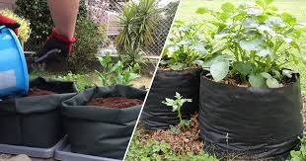
- You can use tyres rather than large bags or pots if you have an area to put them and a supply of tyres.
- Use different varieties of potatoes and do this alongside Potatoes New Zealand 1.3 Simple Plant Genetics to introduce genetics activity.
- After harvesting the potatoes, use one or all, of the below Potatoes New Zealand Maths and Measurement activities.
  - 2.1 Potato Weighing and Sorting
  - 2.2 Volume and surface area calculations with potatoes
  - 2.3 Estimating and graphing growth of potato plants
Tips
As the potato plant grows, add more potting mix to the bag or add another tyre leaving about 5cm of the stem showing.
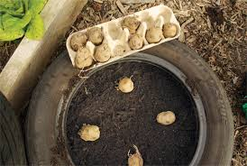
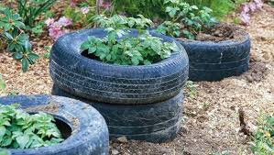

Lesson 7: Potato pest and diseases
Find out what your students know.
Ask your students
- Why do you think it is important to prevent and control pest and diseases in crops like potatoes?
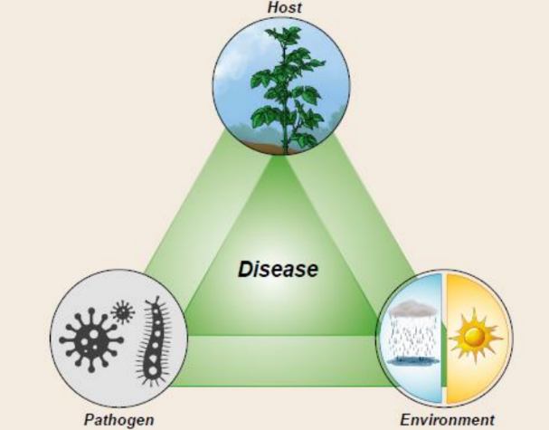
- What management practices do growers use to prevent, reduce or control pests and diseases?
Teacher Notes
Potatoes are an important crop in New Zealand and around the world. However, potato crops are easily affected by pests and diseases, which can reduce the quality of the potatoes and even cause up to 100% yield loss. Controlling pests and diseases is essential for producing high yield crops with consistent quality.
There are three main factors that contribute to pest and disease problems in potatoes, both in the field and in storage:
- A crop that is attacked by pests and diseases
- The pest or pathogen causing damage or disease
- The environmental conditions that favour the pest or pathogen.
To control pests and diseases in potato crops, farmers can use Integrated Pest Management (IPM). This method combines biological, cultural, and chemical strategies from planting to harvest and storage to keep crops healthy and protect them from damage.

Management practices to reduce pests and diseases
Crop Stage | Action | Reason
Pre planting | Crop rotation  Select a paddock that has not been planted in potatoes for at least two years | Reduces the pest and diseases in the soil
Planting | Plant certified seed | Certified seed is grown under strict hygiene regulations and will reduce the risk of introducing seed-borne pests and diseases to the crop
 | Plant in optimum soil conditions | Free draining soils reduce risk of diseases
Moulding | Maintain good soil cover throughout the growing season | Good soil cover acts as a barrier, preventing exposure of tubers to pests and greening
 | Monitor pests and diseases throughout season | Control measures are only required when pest populations reach a critical level
Irrigation | Avoid water stress | Maintaining good crop health makes plants less susceptible to pest and disease attack
Harvesting | Ensure tubers are mature before harvesting | Mature tubers have a protective skin which reduces the risk of infection
 | Handle tubers carefully during harvest | Damage to tubers creates an entry point for disease (e.g. dry rot, soft rot)
Storage | Handle tubers carefully during grading and store them at optimum temperature and humidity
Potato tuber moth – damage
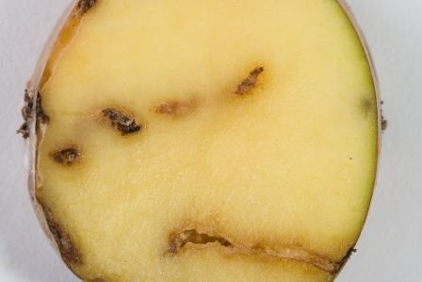
Potato tuber moth
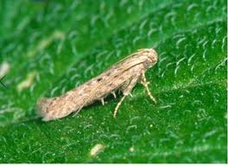

Activity 1: Potato pest and disease research
Show student examples of pest and disease damage
- PPT Common Potato Pests & Diseases
Resources: Potato Disease poster or Potato Pest and Disease Handbook.
Allocate a pest or disease to a group of students or individuals to research.
For a disease
Ask students to describe
- the cause of the disease.
- the symptoms.
- the effect the disease has on the crop.
- methods to prevent and or control the disease.
For a pest
Ask students to describe
- the pest.
- the signs and damage the pest causes.
- the effect the pest has on the crop.
- methods to prevented and or controlled the pest.
Students present their research to the class in a PowerPoint or poster.
Pink rot
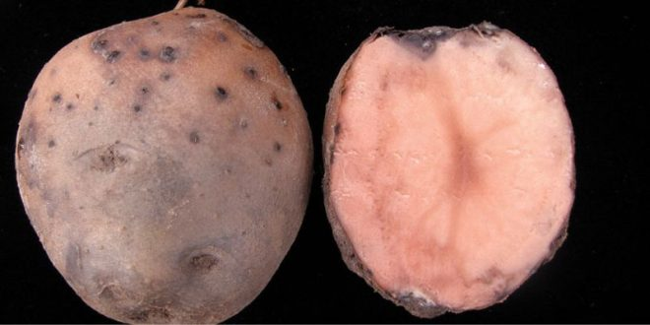
Late Blight
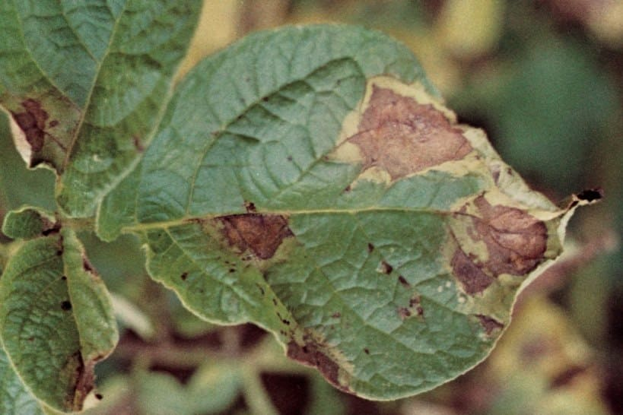

Lesson 8: Potatoes varieties grown in New Zealand
There are about 50 varieties of potatoes grown in New Zealand. Potatoes can be divided into two groups. Table, sometimes referred to as fresh potatoes, and process potatoes.
Domestically consumed processed crisps and frozen/fries potatoes make up 61.3% of the total domestic industry value in 2023/24.
Ask your students
- What are seed, table and process potatoes?
- Why do you think there are more process potatoes grown?
Teacher notes
Table potatoes:
- These are the potatoes grown for cooking and eating by people, and they are what you typically find in supermarkets for cooking, baking, frying, or boiling.
- They come in various varieties, such as Agria, Red potatoes, Perlas, and more, each suited for different way to cook (e.g. boiled, mashed potatoes, baked potatoes, or roasted potatoes).

Processed potatoes:
- These are potatoes that are grown specifically for processing into products like fries, chips, mashed potatoes, and other pre-made potato products.
- The quality of processed potatoes often prioritises traits like size, shape, and ease of harvesting, as well as the ability to withstand processing methods.
- They are usually sold to factories where they are cut, fried, frozen, or turned into other processed items like dehydrated potatoes.

Seed potatoes:
- These are potatoes specifically grown and selected for planting in the next growing season to produce new potato crops.
- They are certified to be disease-free and healthy, ensuring that they produce high-quality crops.
- They are not meant to be eaten directly, rather, they are used to grow new potato plants.
- Typically, they are grown from "seed" pieces of potatoes, which are whole potatoes or parts of potatoes with eyes (buds) that will sprout.

Activity 1: Research potato varieties.
Potato New Zealand Potato Varieties
PPT Potato Varieties
- Using the information from the two seed merchants Eurogrow and Almac make a list of 6 potato varieties grown for the table potatoes and 6 potato varieties grown for the process potatoes. Summarise the main characteristics of each group



Potato Varieties
Table/ Fresh Potatoes | Characteristic | Process Potatoes | Characteristic

Activity 2: Market survey
Carryout a market survey on potatoes sold in a supermarket.
Purpose:
The survey aims to find out which varieties of potatoes are sold in a supermarket, how they are packaged, and the price per kilogram. Your results will help understand consumer demand and shopping habits for potatoes.
Using a supermarket online website, record the different varieties of potatoes that you can find. Use the questions below to help up you. Record your finding in the chart below then answer the questions.
- Name the supermarket.
- Name the varieties of potatoes being sold.
- What are the brands on the potatoes?
- What does the packaging say about the intended use of each potato variety? (For example, best for boiling, best for roasting)
- What types of packing are used to sell the potatoes?
- Loose
- In plastic bags 1kg, 2kg, 5kg
- In boxes

Variety | Brand | Packaging | Weight | $/kg

What have you found out?
- What varieties of potatoes were available in the supermarket?
- Do some varieties have different brands? If so which ones?
- Is there different packing for different types or varieties of potatoes?
- Why do you think there is different packaging for different types of potatoes?
- Who do you think is the target audience for each type of potato and packaging?
- Did the price per kilogram vary for different types of potatoes?
- Which type of potato was the most expensive?
- Which varieties are best for the following uses?
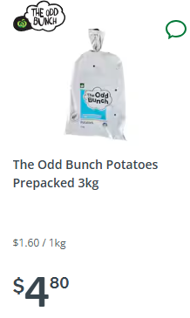
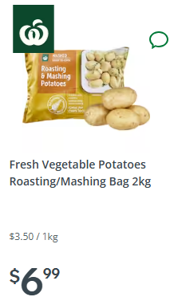
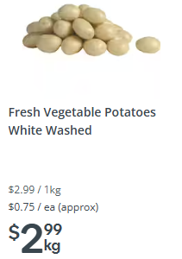
Use | Varieties
Boiling

Baking

Roasting

Chips

All of the above

Activity 3: Reflection
Summarise what you have learnt about potatoes that you did not know.

