Build your own drone http://schools.futureintech.org.nz/what-we-do/default.cfm
Technology ( Digital, Electronics ) | Years 11-13 | South/East Auckland region | July 2014
Two Year 13 Technology students at Pakuranga College are working on a novel entry for this year’s Transpower Neighbourhood Engineers Awards, mentored by Ambassador Antony Burness, a product design engineer at Fisher & Paykel Appliances.
Ali Al-Omari and Rory Buchanan are designing a quadrotor – a small remote-controlled multirotor. Quadrotors use four fixed pitched propellers, two rotating clockwise and two anticlockwise, and altitude, pitch, yaw and roll are controlled by varying the rotational speed of one or more of the rotors.
Their client for the project is a local police officer, as the students hope that their quadrotor could be used as an ‘eye in the sky’ for law enforcement. Using a drone instead of an actual helicopter could be much cheaper, and provide a faster response, when chasing suspects or assessing traffic management around crash sites, for example.
The students have designed a quadrotor that is driven from an Android smartphone or tablet using Wifi, and carries an onboard camera and Raspberry Pi microcomputer that can stream live video back to the user.
“Rory and Ali programmed the phone app and the onboard Raspberry Pi and Arduino controllers by themselves, and are learning about different types of signal transmission and electronics, as well as coding,” Antony explains. “They’ve also built a demonstration quadrotor as proof of concept and to help them to get feedback on their design from their client.”
This high tech project is supported by experienced electronics teacher François du Plessis, and Rory and Ali’s work will count towards a Technology achievement standard.
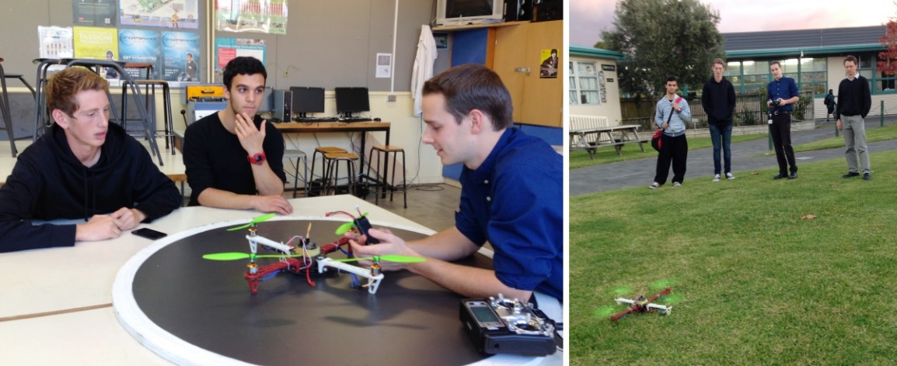
Rory and Ali working on the quadrotor’s electronics with engineer Antony Burness; and (left to right) Ali, Rory, Antony and Francois taking the quadrotor for a test flight.

http://www.learnz.org.nz/highcountry152

