The Samoan Creation Legend
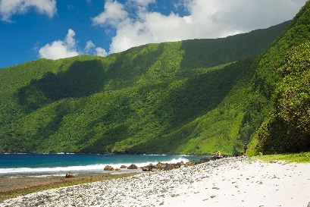Si'u Point, a good place to view the south coast of Ta'u.
NPS
Origins--The Samoan Mythological View
The Samoans explain their islands' colonization differently from anthropologists. The Samoan myth of creation, still passed on from generation to generation, is as follows:
In the beginning, there were only the heavens and the waters covering the earth. The god Tagaloa looked down from his place in the sky and considered creating a place on the earth where he could stand. So he made a resting place by creating the rock called Manu'atele [Greater Manu'a]. Tagaloa was pleased with his work and said, "It would be - well to have still another resting place." He divided the rock Manu'atele so he would have other places in the sea that would serve as stepping stones. From these pieces of rock, he created Savai'i, Upolu, Tonga, Fiji, and the other islands that lie scattered about the wide ocean.

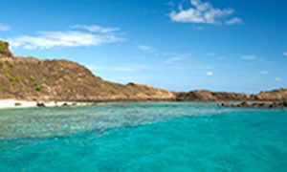Ta'u shoreline
NPS
When Tagaloa had finished fashioning all of these islands, he returned to Samoa. He measured the distance between the islands of Savai'i and Manu'a and found it to be too great. So he placed a rock halfway between and designated it as a place of repose for the chiefs. He called this last island Tutuila.
Tagaloa then sent a sacred vine to spread over the rocks. The leaves of the sacred creeper fell off and decayed and things like worms grew from them. Tagaloa saw that the creeper had given birth to worms that had neither heads, nor legs, nor breath of life. So the god came down and provided these worms with heads, legs, arms, and a beating heart. Thus the worms became men. Tagaloa took a male and a female and placed them on each of the islands that he had created. The man, Sa, and the woman, Vai'i, were placed on one island and the place was called Savai'i. U and Polu were placed on another and it became known as Upolu. The couple Tutu and Ila were the first inhabitants of Tutuila. To and Ga went to a place that Tagaloa named Toga [Tonga], and Fi and Ti were taken to the place to be called Fiti [Fiji].

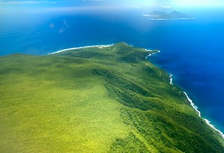The Manu'a Islands -- Ta'u (front) & Ofu and Olosega (back)
NPS
Then, Tagaloa decided that men should be appointed to rule the different islands and so he created the title of Tui [king]. He created the titles Tuiaga'e, Tuita'u, Tuiofu, Tuiolosega, Tuiatua, Tuia'ana, Tuitoga, and Tuifiti, and thus established lords of the islands.
Then, Tagaloa looked upon all he had created and decided that there should be a king greater than all the others and that he should reside in Manu'atele, his first creation. He selected the son of Po [night] and Ao [day] to be the king of kings. When this boy was to be born it was found that his abdomen was firmly attached to his mother's womb. Because of this, he was given the name Satia i Ie Moaatoa [attached by the abdomen], and the whole island group that would be his domain received the name Samoa [sacred abdomen]. When the child was born, he sustained a great wound as he was ripped from his mother's body. From this came the name of the place of his birth, Manu'atele [the great wound]. When this boy grew to manhood, he became king of all the Tui [kings] and carried the title Tuimanu'a Moaatoa.
This "creation story" was first recorded by the anthropologists, Lyell and Ellen Holmes, and is taken from their study, Samoan Village, Then and Now.

https://www.nps.gov/npsa/learn/historyculture/legendpo.htm

