Farming not Maori’s best asset

by BusinessDesk

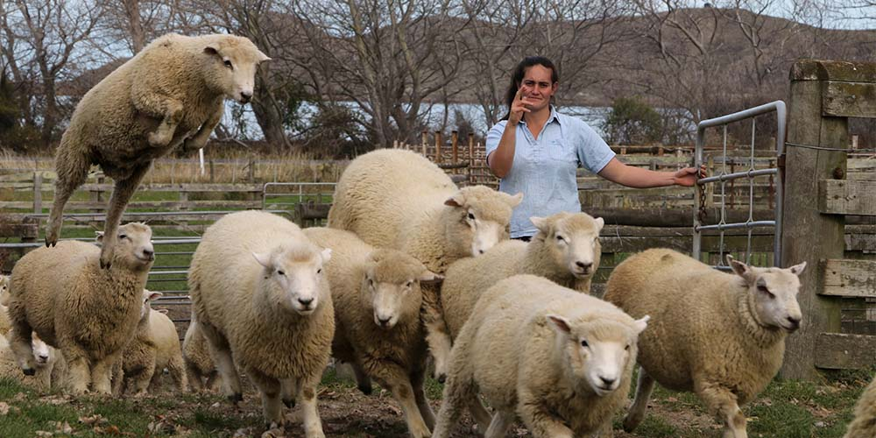
Maori investments take cultural considerations into account rather than just counting returns.

The poorest performing Maori investments are in farming, often favoured for cultural rather than economic considerations, ANZ Bank says.
Its latest annual Iwi Investment Insights report, Te Tirohanga Whanui, said Maori get the best returns from putting their money in managed funds.
ANZ evaluated the asset base of 34 iwi and hapu, finding the commercial assets of the combined group have increased by just over $1 billion or 12% to $5.4b since 2015.
The most common asset in the top quartile for underlying returns is the significant holdings in managed funds that have performed well in recent years.
On the flip side, most iwi and hapu in the lower quartile are actively managing big farms.
“In many cases cultural reasons were an important driver in the investment decision,” ANZ Maori relationships head David Harrison said.
“This highlights non-economic considerations may be impacting financial outcomes.”
Iwi have about a third of their assets in the primary sector, which means they are exposed to commodity cycles as well as new challenges confronting many of the industries.
“Both fishing and farming face increasing sustainability scrutiny and, along with forestry, all three are threatened with disruption from alternatives being developed by science and technology,” the report said.
“However, these assets have largely been returned to iwi through settlements or have been purchased with cultural considerations in mind and are generally considered not for sale.
“This places increased pressure on the rest of the assets to ensure they are allocated or re-allocated to best fit investments that provide greater returns with the right balance between income and growth.”
Three-year average returns varied across the group with the upper quartile for return on assets almost twice that of the lower quartile, it said.
The Maori economy is estimated to encompass $50 billion in assets or about 6% of the nation’s total asset base and represents a rapidly growing segment of the wider New Zealand economy.
Since the first settlement under the Waitangi Tribunal process in 1989 in respect of land at Waitomo Caves, Maori businesses have become economic powerhouses with investments in hotels, farms, forests, bus companies and shopping malls.
“Maori investment has historically been focused in key industries such as farming, forestry and fisheries.
“While strong ties to these industries remain, Maori are strengthening their footprint in other sectors. For example, we’ve seen a number of recent investments in tourism, horticulture and commercial property which is exciting for iwi,” Harrison said.
ANZ found the biggest year-on-year growth from 2015 to 2017 was from transport and infrastructure, up 33%, and tourism, up 30%, both from growth in existing businesses and new acquisitions.
Cash and managed funds grew 19% from treaty settlement receipts and general growth in financial markets while agricultural investments also grew 19% from investment and some treaty negotiated transfers/purchases.
Forestry returned 9% and property 8% from a mix of investment and revaluations.
Harrison said one of the hardest commercial decisions iwi face is whether to distribute or reinvest profits.
“There is pressure to increase returns and distributions, driven by growing populations hungry to see the tangible fruits of their tribe’s treaty settlement.
“Opposing the need for strong financial return is the deep responsibility iwi and hapu carry as kaitiaki, often creating challenges in balancing risk and reward.”
The overall trend for post-settlement iwi has similarities to a start-up business where initially capital growth is modest before it starts to build, he said.
“At one end we see iwi with recent treaty settlements typically benefiting from asset transfers and revaluations and low initial operating costs.
Meanwhile, iwi who settled more than 10 years ago are seeing the advantage of having miles on the clock.
However, some of those four to nine years are showing signs of stalling or consolidating.”
The report found the overall proportions invested in various asset classes remains reasonably stable. - BusinessDesk

