Agribusiness NCEA Resource
Level 3 Achievement Standard 91871

Meeting market needs in China

Student Assessment Task

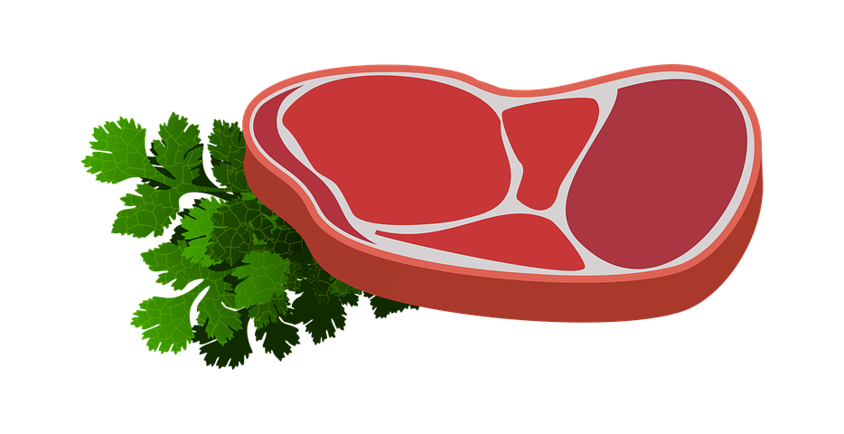

Agribusiness/Business Studies NCEA Resource
Meeting market needs in China

Student task

This is your assessment for Agribusiness 91871 - Analyse how a product meets market needs through innovation in the value chain. It is worth 4 credits.
This task requires you to analyse how a product Silver Fern Farms produces meets the market needs of Chinese consumers through innovation in the value chain.
Due date:___________________

Task 1: Research and design your presentation
Using Silver Fern Farms as your business you are going to create a presentation for the Silver Fern Farm shareholders.
Research information based on the points below and decide on the design by planning the structure, content and format of your presentation.
Your presentation is for a person who works in the red meat industry and is tasked with trying to sell New Zealand's red meat to North Asia.

Task 2: Prepare your presentation
Using Silver Fern Farms and their red meat exports your presentation needs to include the following:
- An explanation of the value chain for the product selected
- An explanation of an innovation that may occur at a stage of the value chain
- Show and evaluate how the innovation adds greater value to the selected product
- Show and evaluate how the innovation meets market needs for the product
- Show and evaluate the impact and consequences of the innovation on the whole value chain
- Show and evaluate the ability for the selected product to meet future needs.

Throughout your presentation, refer to the information you have gathered and include supporting evidence, accurately recording the details of the source(s).
You can use photos, graphs, videos and images in your presentation to support your ideas.
Ask your teacher about the length of your presentation. Quality is more important than quantity.

Assessment schedule

Level 3 Achievement Standard 91871 - Analyse how a product meets market needs through innovation in the value chain (4 credits).

Achievement | Achievement with Merit | Achievement with Excellence
Analyse how a product meets market needs through innovation in the value chain.  The student has:  Analysed how red meat produced by Silver Fern Farms meets market needs through innovation in the value chain.  In their presentation, the student:  · explains the value chain for a selected red meat product  · explains an innovation Silver Fern Farms employ at a stage of the value chain  · explains how the innovation meets the market needs of Chinese consumers. | Analyse, in-depth, how a product meets market needs through innovation in the value chain.  The student has:  Analysed, in depth, how red meat produced by Silver Fern Farms meets market needs through innovation in the value chain.  In their presentation, the student:  · thoroughly explains how a red meat product meets the market needs of Chinese consumers through innovation in the value chain  · examines how the innovation adds greater value to the selected product for Silver Fern Farms. | Comprehensively analyse how a product meets market needs through innovation in the value chain.  The student has:  Comprehensively analysed how a red meat product of Silver Fern Farms meets the market needs of Chinese consumers through innovation in the value chain.  In their presentation, the student:  · evaluates how the innovation meets the market needs in China for red meat products.  · evaluates the impact and consequences of the innovation on the whole value chain  · evaluates the ability for the red meat product to meet future needs.

