The Importance of Plant Classification in Agribusiness

Grouping plants
Imagine you were given a flower of every sort of Fuchsia that exists. You could sort them out according to (for example) flower colour, or inflorescence size and shape.

Then, if a friend brought in an unknown Fuchsia flower, you could compare it with the specimens you had, and identify the new flower as belonging to one of your sorted groups

You would have found out which type of flower it is and what group it belongs to, even though you have used no names so far.

As you have seen, plants are classified according to their botanical features with particular emphasis on floral structure for identification purposes. Knowing and using botanical or Latin names is not just about impressing your friends and family!

Here are four good reasons to learn and use botanical names;

- The botanical name is internationally recognised. Common names for plants vary from place to place, which would be confusing for a German gardener who is talking to a Japanese gardener. One thing they will both talk the same language over is the botanical name, which is always in Latin.

For example, a German gardener calls a carnation Nelke, the English gardener may refer to a gillyflower, but both use the botanical name Dianthus caryophyllus.

- An internationally recognised botanical name prevents plant growers and breeders from giving the same plant many different names. There is an agreed method of naming for both botanical and varietal names. Thus, the continuity of a botanical name is ensured. Once you learn Grevillea rosmarinifolia, you know that name for the rest of your life. There are rare exceptions, when scientific evidence places plants in new genera or families, and their names are sometimes changed to reflect this!

- If we relied on common names alone, there would be a great deal of confusion.
Two gardeners talking about an ake-ake hedge are at total cross purposes; Bill nods at a striking row of purple foliaged Dodonaea viscosa, while Tom is looking around for a white-flowered Olearia.

Another example is the name lily of the valley. It is the common name for the perennial Convallaria majalis and the shrub Pieris japonica.

- Knowing a botanical name opens the door to further botanical knowledge. You may note straight away that the twiggy Melicytus micranthus, which is new to you, is in the same genus as Melicytus ramiflorus mahoe. This may give clues about how to propagate or cultivate the new plant.
A botanical name is easily looked up, as it is unique and can only refer to one plant.

- If propagating vegetatively by grafting, it is important to know or be able to find out one plant’s relationship to another plant. For example because Pyrus and Cydonia are in the same family, the Rosaceae, they may be grafted together.

Weeds closely related to the crop plant can harbour diseases and pests which can build up to spill over and infest that crop. For example, hawthorn is in the Rosaceae, and can be host to diseases and pests of apples, also in the rose family. This is useful to know when you are choosing the best shelter species for a crop, or implementing a pest management plan.

Important features for the identification of specific plant families
Knowing the general features of some important plant families can go a long way towards being able to identify an unknown plant. The features which are most helpful to know are:

- Leaf features, as described in this unit.
- Flower features, as described in this unit.
- Inflorescence type. An inflorescence is the arrangement of individual flowers on the main flower stalk or peduncle.
- Fruit type: as described in this unit.

To remind you of the main different inflorescence types, here is a diagram showing a cyme, umbel, spike, panicle corymb and raceme.
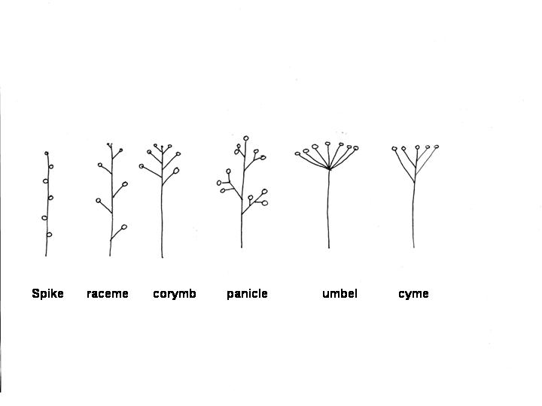

The Poaceae
This is the grass family, also known as the Graminae, or grass family. There are 10,000 species and at least 600 genera. In terms of agriculture the Poaceae is a very important plant family, providing, as it does, the species which animals graze on (the grasses) and the species which are food crops for humans (the cereals).The grasses are thought to be recently evolved, advanced in their adaptations and highly specialised in terms of their flower structure.
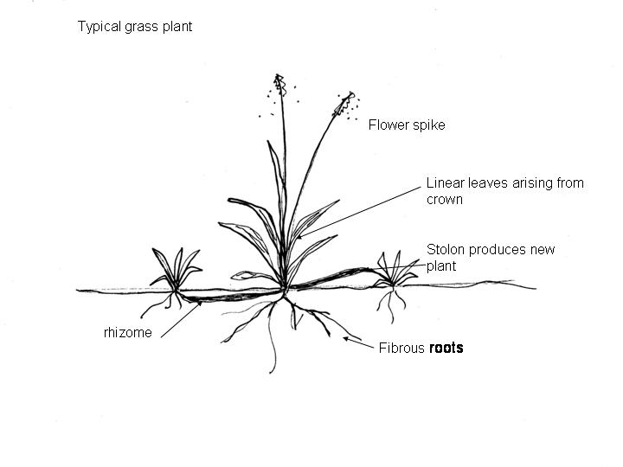

Leaves
The stems are usually hollow, yet very strong. The leaves are alternate or spiral, and have parallel venation. The leaves have a sheath which is wrapped around the stem, and a blade which is separate from the stem. A structure called a ligule separates the sheath and blade.

Flowers
Each individual flower is called a floret. On each side of the floret is a pair of bracts, called the lemma and the palea. The florets are unisexual or bisexual, there are no petals but instead bump-shaped structures called lodicules, where you expect to find petals.

There are three to six stamens and one pistil. Grasses are wind pollinated and the flower structure is adapted to disperse the pollen on the wind. The grass flower produces copious pollen from large anthers which hang outside the floret. The stigmas, to trap the pollen, are feathery and branching, and also extend out of the floret. The inflorescence is held up above the grass plant on a long stalk.

Inflorescence
The florets are arranged in a spikelet, typically consisting of a basal pair of minute sterile bracts called glumes and one or more florets arranged in a zigzag pattern. These spikelets are grouped along a spike, which grows up above the vegetative part of the plant.

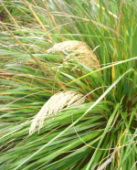
Chionochloa flavicans, NZ native snow tussock showing inflorescence.

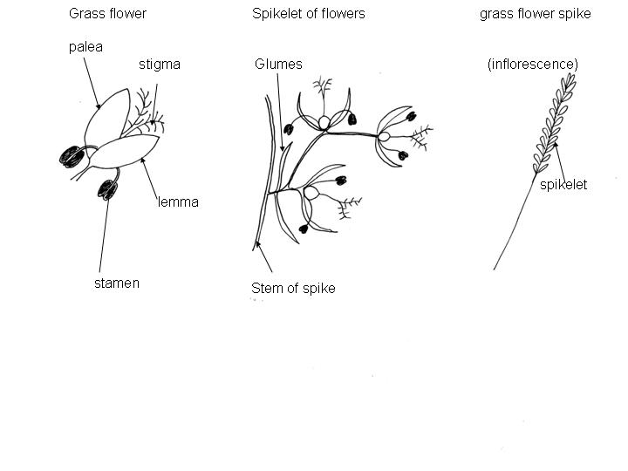

Fruit
The fertilised flower develops into a caryopsis, which is a dry indehiscent fruit.

