FIVE SENSES GRAPHIC ORGANISER – FISTULATED COWS.

LOOK LIKE  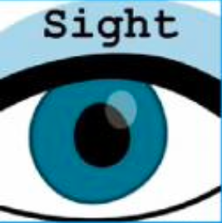 | What did you see?
SOUND LIKE  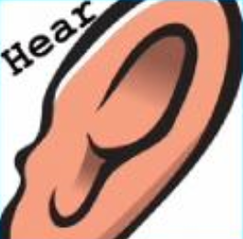 | What did it sound like, what did you hear?
FEEL LIKE | What did it feel like? How did you feel?
TASTE LIKE | What did it taste like? What do you think it might taste like?
SMELL LIKE | What did it smell like? What do you think it might smell like?

