Media Statement Showdown Productions Ltd August 15 2016

Rural Delivery on TV One, Saturdays 7.00am.

Repeat on TV One Sundays 6.00am (at the discretion of TVNZ).

RURAL DELIVERY SERIES 12, EPISODE 25 August 20 2016

A new venture rearing dung beetles for pastoral farms. Fonterra, DOC and farmers working together on the Living Water Partnership. And adding value to green lipped mussels by Maclab and Pharmalink.

Dung Beetle Innovations

https://www.ruraldelivery.net.nz/stories/Dung-Beetle-Innovations

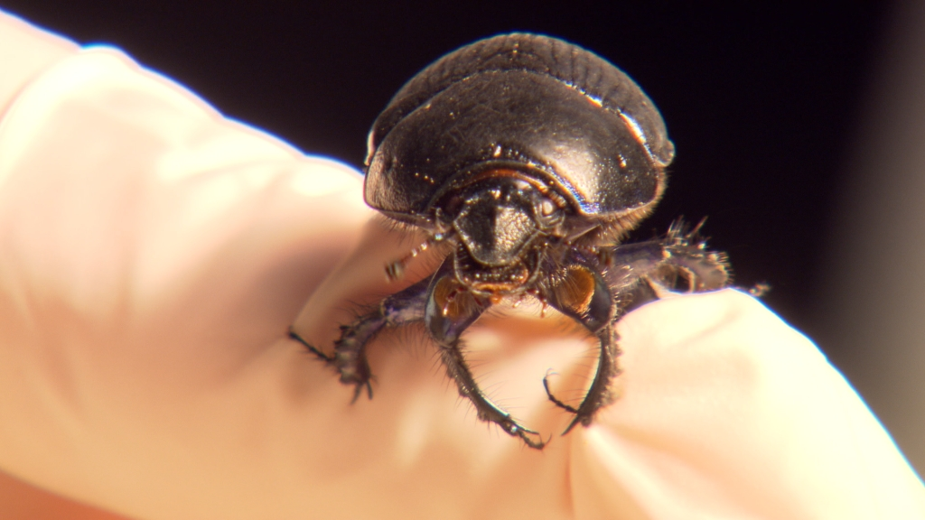

Shaun Forgie began studying dung beetles in the 1990s as a student, and then joined Landcare Research to investigate their potential benefits for pastoral farming in New Zealand. Dung Beetle Innovations has now been set up to rear beetles on a large scale, conduct further research, and advise farmers on the introduction of beetles to their pastoral ecology. Managing Director Andrew Barber says the launch of the company from a government-funded project was a huge leap but that the significant investment and importation and breeding efforts that had already been undertaken could have been a wasted opportunity if it had evolved into a “backyard hobby that a few people dabbled in.” Sean Forgie says the benefits of beetles released in 2013 will probably be seen in about nine years when the population builds up, but research already indicates a number of significant advantages to farms by beetles quickly burying excess faeces on pasture.
____________________________________________________________________________

The Living Water Partnership

https://www.ruraldelivery.net.nz/stories/The-Living-Water-Partnership-in-the-Hikurangi

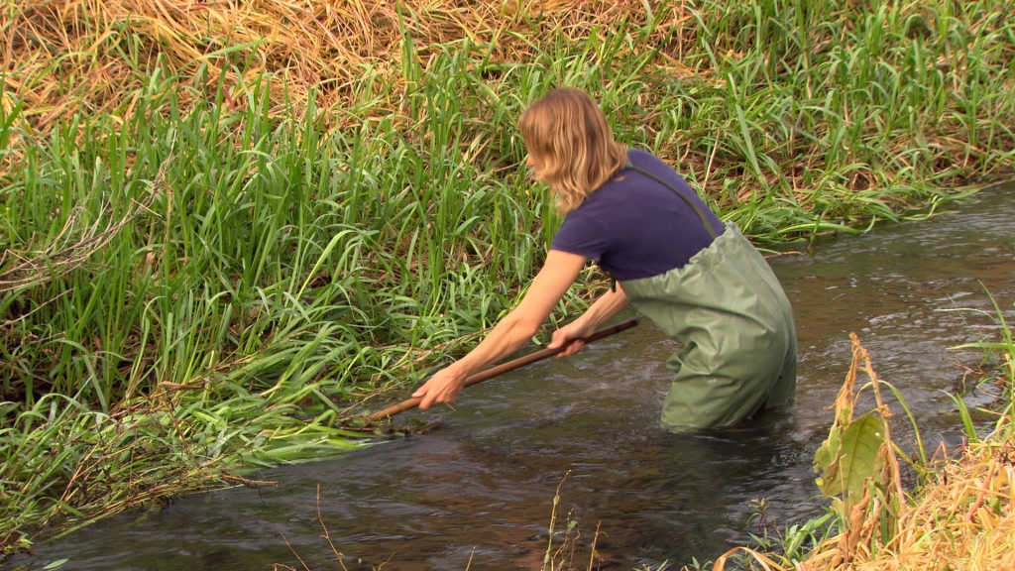

The Hikurangi catchment feeds into the Kaipara Harbour and is one of five special areas in the country that have been identified as needing attention as a result of environmental degradation brought about by years of modification for farming, particularly dairying. A long-term project, called The Living Water Partnership, has been set up by Fonterra, the Department of Conservation and local farmers. It involves a significant investment of time and resources and aims to address the individual needs of each of the five catchments. In the Hikurangi, there are 33 Fonterra farmers, iwi, Landcare Research scientists and members of Fish and Game involved. The partners hope to restore biodiversity and water quality, and through greater community engagement and support, help farmers and landowners develop environmentally sustainable farming systems.
____________________________________________________________________________

Extracting Value from Green Lipped Mussels

https://www.ruraldelivery.net.nz/stories/Clearwater-Mussels

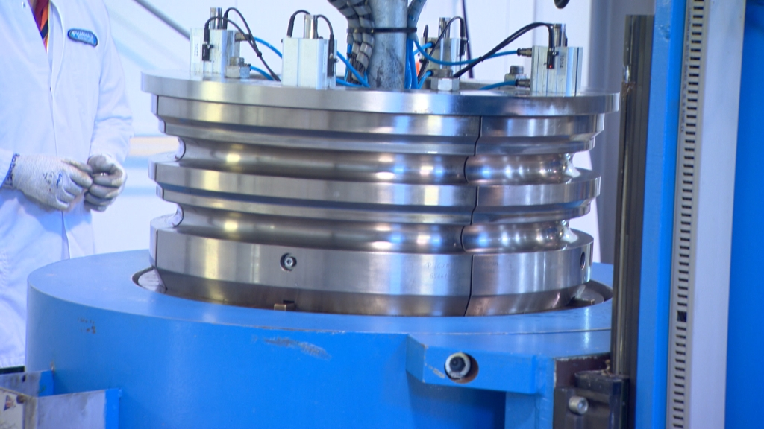
Maclab is a family-owned biotech company, extracting bioactives from New Zealand green lipped mussels for the nutraceutical sector. It is based in Nelson, where it processes carefully selected mussels into a powder, from which oil is extracted at Pharmalink. It is then packaged into products marketed throughout the world as anti-inflammatories. The outcome is the result of many years of research collaborations and development of processes to maximise the quality of their product. Maclab sources mussels from their own farms and also has supply agreements with mussel producers such as Clearwater Mussels and Talleys.

For more information:
Tracy Mika, Producer, Rural Delivery
Showdown Productions Ltd +64 9 360 0140
PO Box 911 227 Victoria St West, 1142, Auckland, NZ
Email tracy@showdown.co.nz

