Dung beetles could play a key role in environmental mitigation
BALA TIKKISETTY
Last updated 11:41, August 31 2017

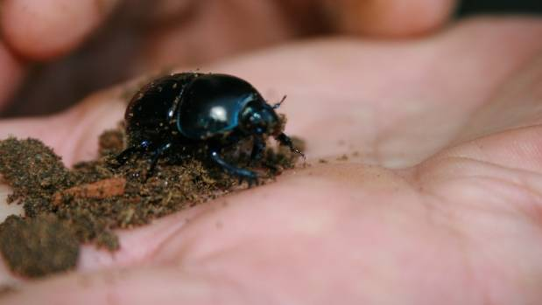
There could be significant environmental benefits to releasing dung beetles in Waikato.

OPINION: Could using exotic dung beetles help address soil health and water quality issues in New Zealand?
It's an option that has real possibilities. Dung beetles provide multiple ecosystem services.
Those services include decreasing the amount of pasture smothered by faeces (pasture fouling), increased pasture growth, nutrient cycling, improved soil structure and control of pests and diseases.
On the basis of these benefits, New Zealand authorities have given permission for importation of dung beetles, which are now being mass reared here.

My feeling is that, if we can successfully introduce and further establish exotic dung beetles in New Zealand, it is possible in the long term there will be millions chewing and burying dung from pastoral animals such as cows and sheep. That could provide significant benefits.
While dung decomposes naturally, intensive farming means large amounts of dung are dropped which can lead to environmental problems such as nutrients and pathogens moving into waterways. Pasture production can also be reduced because of fouling.
However, dung beetles search out the faeces of animals which they use for food and reproduction. Most adult dung beetles make tunnels in the soil beneath the faeces which they then bury to lay eggs in. Other species make balls from the faeces which they roll away and bury deep beneath the soil surface before adding an egg.
As the eggs hatch the grubs feed on the dung so they break it down and eventually turn it into a sawdust-like material that actually adds to the fertility of the soil structure while all the time getting rid of dung sitting on top of the ground.
The first intentional introduction of a pastoral based dung beetle was the Mexican dung beetle in 1956. It was successfully established at Whangarei and later introduced into South Kaipara in 1994.
But, because dung is produced continuously by pastoral livestock throughout the year, one species of dung beetle alone is incapable of achieving suitable control.
As suggested, there is a range of potential environmental and economic benefits from using dung beetles more widely. These include improved soil health and reduced runoff, increased aeration and water penetration into the soil, through beetle tunnels, reduced urine and liquid dung runoff, and reduced microbial contamination, leachate pollution and eutrophication of waterways.
Beetles also help reduce nitrous oxide emissions as some 80 per cent of the nitrogen content of dung is lost by volatilisation when dung remains on the pasture surface, compared to only 10 per cent following burial by dung beetles.
Greater pasture productivity is another benefit, as stock will not graze around dung pats, reducing pasture productivity.
Burial of nutritious material by dung beetles enhances grass growth, reducing reliance on fertiliser inputs.
Nuisance flies breed in dung but are out-competed for resources by fast dung burying beetles.
Introducing beetles could also mean there will be reduced infection by parasitic worms of livestock because dung burial removes the infective stages of parasitic worms of livestock. This would reduce the need and expense of drenching stock.
Some concerns have been raised that tunnels in the soil created by dung beetles could lead to elevated leaching of nutrients and E.coli. The research done in New Zealand showed that this is not the case because while beetles create tunnels they pack these with their brood balls, sealing them off.
Dung beetles spread only slowly after introduction and research is under way to find improved ways to increase their distribution in pasture so that they can help to reduce the effects of grazing animals on the environment.
Bala Tikisetty is a sustainable agriculture adviser at Waikato Regional Council.
- Stuff

