Picking advisors for exact skills your team is missing.
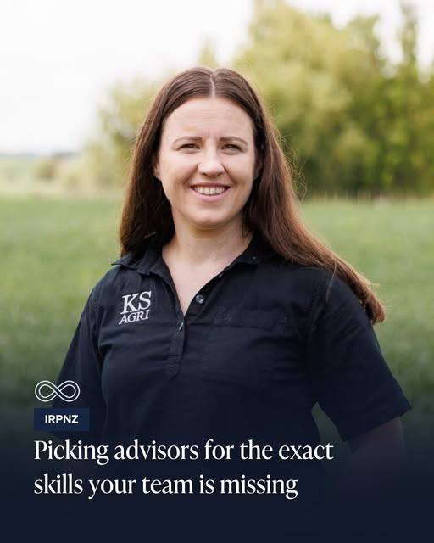
Farm businesses building an advisory board should first take stock of who is already around the table, says Laura Abbiss, chair of the Institute of Rural Professionals.
“You actually might be able to pull some gems out of what you’ve already got there, and then just fill the gaps with what you don’t,” she says.
She says an independent director is administratively heavy, so a looser structure often works better.
“It’s actually probably more important to have the right person than the right structure."
Listen to the interview with Laura starting at 5.26 minutes https://country-wide.co.nz/picking-advisors-for-the-exact-skills-your-team-is-missing/, and the answer the following questions.

Questions
In New Zealand agribusiness, establishing effective governance and advisory bodies—such as formal Boards of Directors or informal Advisory Boards—is a key strategy for driving long-term enterprise growth, risk management, and succession planning.
- What is the difference between a Governance Board (Board of Directors) and an Advisory Board in an agribusiness context?

- Why would an expanding family farm or agribusiness need to look outside its internal team to build an advisory board?

- How does taking a skills audit of the current farm team align an agribusiness structure with its strategic needs?

- Compare how decision-making differs between a Sole Trader / Partnership structure and a Company structure with an Advisory Board.

- Evaluate the short- and long-term implications for a primary industry business that shifts from a sole-owner model to incorporating an independent Advisory Board.

Answers.
- What is the difference between a Governance Board (Board of Directors) and an Advisory Board in an agribusiness context?
- Governance Board (Board of Directors): A formal governing body with fiduciary and legal responsibilities under the Companies Act. Directors hold final decision-making power, sign off on financial statements, and are legally liable for the performance and compliance of the company. A fiduciary is a person or organisation that must legally and ethically manage money or property for someone else. They must put the other person's best interests ahead of their own. Key duties of a fiduciary are:
  - Best interest: Put the client's or business needs first.
  - No conflicts: Avoid choices that help the fiduciary more than the client / business.
  - Careful work: Manage assets with skill and high care.
  - Clear records: Keep good tracking and keep funds separate.
- Advisory Board: An informal, non-fiduciary group created to provide strategic guidance, accountability, and independent perspective. Advisory board members do not hold legal liability or direct voting control over the business; instead, they mentor the owners/managers, who retain full operational and decision-making authority.

- Why would an expanding family farm or agribusiness need to look outside its internal team to build an advisory board?
Family farm operations often excel at daily operations and production management (e.g., agronomy, stock handling). However, as the agribusiness grows or seeks to meet strategic needs like succession planning or land diversification, the internal team may lack specialised expertise. Bringing in external advisors fills specific skill gaps—such as financial restructuring, environmental compliance, human resources, or market access—without adding the overhead of full-time staff.

- How does taking a skills audit of the current farm team align an agribusiness structure with its strategic needs?
A business structure must directly support the enterprise's strategic goals (e.g., capital growth, debt reduction, succession). Taking a stock-take or skills audit of who is already around the table allows the business owners to:
- Identify Critical Blind Spots: Map out existing operational strengths against future strategic goals.
- Avoid Redundancy: Prevent hiring advisors whose skills mirror what family members or existing staff already possess.
- Targeted Advisory Recruitment: Recruits external advisors explicitly to solve high-priority strategic bottlenecks (e.g., hiring a financial strategist if debt restructuring is required to purchase neighbouring land).

- Compare how decision-making differs between a Sole Trader / Partnership structure and a Company structure with an Advisory Board.
- Sole Trader / Partnership: Decision-making is tightly concentrated among the owner(s). While agile, it often leads to "echo chambers," decision fatigue, and emotional conflict in family scenarios.
- Company / Advisory Board Model: Introducing an advisory board imposes structured decision-making. Decisions transition from gut-feel operational reactions to structured strategic evaluations backed by independent expertise. While this adds formal reporting obligations and scheduled meetings, it lowers business risk and improves accountability.

- Evaluate the short- and long-term implications for a primary industry business that shifts from a sole-owner model to incorporating an independent Advisory Board.
- Short-Term Implications:
  - Costs and Time Investment: Preparing financial reports, budgets, and key performance indicators (KPIs) for quarterly advisory board meetings requires an initial investment of time and professional fees.
  - Cultural Shift: Owners must open their financial records and operational methods to external scrutiny, which can initially create friction or discomfort.
  - Immediate Clarity: Rapidly identifies immediate operational risks, cash flow bottlenecks, or compliance gaps.
- Long-Term Implications:
  - Succession and Family Governance: An independent advisory board removes family emotion from succession planning, creating clear pathway frameworks for the next generation.
  - Capital Access and Bank Trust: Banks and equity investors view businesses with formal governance / advisory structures as lower-risk, facilitating better borrowing terms and access to growth capital.
  - Resilience and Strategic Agility: The business is far better positioned to adapt to environmental regulation shifts, market fluctuations, and land-use diversification.

