Meat Co-operatives in New Zealand: Past or Present?
Meat cooperatives were essential in the past and played a major role in building New Zealand’s meat industry. Today, their role is more complex. They face tougher competition, lower stock numbers, and changing farmer attitudes.
The cooperative model is not outdated but, it is under pressure. Whether meat cooperatives remain part of New Zealand’s future will depend on strong leadership, clear purpose, and the willingness of farmers to work together in a rapidly changing global market.
For students studying business and economics, meat cooperatives offer a powerful example of how ownership structure, market conditions, and human behaviour all shape the success or failure of a business.

Co-operatives could be considered obsolete and old fashioned, but they were instrumental in building most of today’s agribusinesses. Recent decisions by shareholders to part of their co-ops into private investors suggests they may not be as valued today as they once were.

Read “Meat Co-operatives in New Zealand: Past or Present?”
Adapted from “Mutual model blamed for bad management”, “Meat co-ops were there when sector needed them” and “Alliance sealed fate of sector co-ops” and answer the questions.

- Discuss how cooperatives were instrumental in building most of today’s New Zealand agribusinesses?

- What are the main issues currently facing meat industry cooperatives in New Zealand?

- Explain why these issues have developed over time?
Consider changes in farming, markets, technology, and farmer behaviour.

- To what extent is the cooperative business model responsible for the problems faced by meat co-ops? Explain your view.

- What do you think the future of cooperatives in the New Zealand meat industry might look like?
- Discuss the statement:
“Recent decisions by shareholders to sell part of their co-ops to private investors suggests they may not be as valued today as they once were.” Do you agree or disagree? Use examples from the article to support your answer.

- If you were a young farmer starting out today, would you choose to join a cooperative or supply a corporation? Justify your choice using at least two advantages and two disadvantages of each option.
Or
- To what extent is the cooperative model still the best option for young farmers in New Zealand today? Support your answer with examples from the meat and dairy industries.

Meat Co-operatives in New Zealand: Past or Present?
Adapted from “Mutual model blamed for bad management”, “Meat co-ops were there when sector needed them” and “Alliance sealed fate of sector co-ops”

For much of New Zealand’s history, meat cooperatives were a cornerstone of the farming industry. Sheep and beef farmers formed co-ops to gain control over meat processing, ensure access to processing space, and share profits beyond the farm gate. However, recent sales of farmer-owned meat co-ops to overseas investors have raised an important question: are meat cooperatives still relevant today, or are they a thing of the past?
Why meat cooperatives were created
In the late 19th and early 20th centuries, New Zealand’s meat industry was largely controlled by foreign-owned companies, mainly from the United Kingdom. Farmers had little power and often struggled to get fair prices or guaranteed processing.
To fix this imbalance, farmers formed cooperatives. By owning processing plants together, they could:
- Guarantee processing capacity when stock was ready
- Share profits made from processing and marketing
- Reduce the power of overseas companies
- Work collectively to strengthen their position in export markets
By the late 1900s, farmer co-ops owned most of New Zealand’s meat processing industry.
Why co-op dominance has declined
Over the past 15 years, the dominance of meat cooperatives has sharply declined. Major changes in the sector have made it harder for co-ops to survive.
One major issue is falling sheep numbers. As land use has shifted toward dairy, forestry, and other uses, fewer animals are available for processing. This has reduced the need for guaranteed processing space, one of the original reasons co-ops existed.
Another challenge is ageing infrastructure. Many meat co-ops operate large, old processing plants that are expensive to maintain and upgrade. At the same time, meat processing is a low-margin, highly competitive industry, making it difficult to earn enough profit to reinvest.
Co-ops also struggled to raise new capital. When debt increased and losses mounted, many farmers were unable or unwilling to invest more money, especially during downturns. This led to major ownership changes:
- Silver Fern Farms sold 50% to Shanghai Maling in 2016
- AFFCO was sold to Talley’s in 2010
- Alliance Group sold a majority stake to Dawn Meats in 2024
Is the cooperative model to blame?
Farmers and industry experts are divided on whether the cooperative model itself is the problem.
Some farmers argue that poor governance and slow decision-making caused problems. Alliance, for example, delayed asking shareholders for capital until prices had fallen, making it difficult for farmers to contribute. Others believe co-ops failed to adapt quickly enough to industry changes.
However, many argue that it was not the co-op structure that failed, but how the businesses were run. Farmers point to successful co-ops like Tatua and the modernised Fonterra, which have clear purpose, lower debt, and disciplined management.
As one farmer noted, “Many failures around co-operatives are really attributable to poor decision-making and poor governance, but the co-operative model gets blamed for it.”
Changing farmer attitudes
Another challenge facing meat cooperatives is changing farmer behaviour. Today, farmers can choose to supply companies without becoming shareholders, which is attractive for younger farmers with limited capital.
Many farmers now act more like traders, selling stock to whoever offers the best price each week rather than committing to a cooperative long-term. This has reduced loyalty and weakened the collective strength that co-ops rely on.
Some farmers even argue that co-ops in the meat industry are no longer relevant, while others believe their value is not fully appreciated until they are gone—especially during events like droughts, when guaranteed processing capacity can be critical.
Are meat cooperatives still relevant?
Despite the challenges, many industry leaders believe meat cooperatives still have a role to play.
Co-ops offer:
- A loyal supply base
- Long-term, intergenerational thinking
- The ability to share risks and keep profits closer to the farm gate
They can also be an effective structure for responding to consumer and market demands around sustainability, animal welfare, and food production standards.
However, to remain relevant, meat cooperatives must:
- Stay financially disciplined
- Keep debt under control
- Communicate their value clearly to shareholders
- Adapt to changing market conditions
- Allow farmers to participate in targeted supply programmes that meet market demand

Answers
- Discuss how cooperatives were instrumental in building most of today’s New Zealand agribusinesses?
Cooperatives were crucial because they allowed farmers to work together to solve problems they could not fix on their own. In the meat industry, farmers formed co-ops to break the control of foreign-owned companies, guarantee access to processing plants, and share profits beyond the farm gate. By pooling resources, farmers have built processing facilities, developed export markets, and gained more control over pricing and marketing. This collective approach helped establish many of today’s major agribusinesses.

- What are the main issues currently facing meat industry cooperatives in New Zealand?
Meat industry cooperatives face several major challenges. These include declining sheep numbers, which reduce the need for guaranteed processing capacity, ageing and expensive processing plants, high debt levels, and strong competition in a low-margin, commodity-based industry. Co-ops also struggle to raise new capital from farmers and face reduced loyalty as farmers can sell stock to multiple processors without being shareholders.

- Explain why these issues have developed over time?
These issues have developed due to long-term changes in the farming and business environment. Land use has shifted away from sheep farming, reducing stock numbers. Market deregulation allowed more processing plants to be built, increasing competition. Globalisation has increased pressure from overseas companies, while economic downturns and price volatility have made farmers cautious about investing more capital. Younger farmers also have less attachment to cooperative ownership and prefer flexibility.

- To what extent is the cooperative business model responsible for the problems faced by meat co-ops?
The cooperative model itself is not the main cause of the problems. Many farmers argue that poor governance, delayed decision-making, and weak financial discipline are more to blame than the ownership structure. Successful cooperatives like Tatua and improved performance at Fonterra show that co-ops can work well when they have clear purpose and strong management. However, the co-op model can make it harder to raise capital quickly, which can increase risk in a fast-changing industry.

- What do you think the future of cooperatives in the New Zealand meat industry might look like?
The future of cooperatives in the meat industry is likely to involve hybrid ownership models, where farmers retain some ownership while private investors provide capital. Fully farmer-owned co-ops may become less common, but cooperatives could still play a role by focusing on niche markets, specialty programmes, and strong farmer engagement. Success will depend on financial discipline, adaptability, and clearly demonstrating value to farmers.

- Discuss the statement:
“Recent decisions by shareholders to sell part of their co-ops to private investors suggests they may not be as valued today as they once were.”
This statement is partly true. High levels of shareholder support for selling suggests many farmers prioritise financial security and immediate returns over long-term ownership. However, it does not mean cooperatives are no longer valued. Instead, it reflects financial pressure, high debt, and changing attitudes among farmers. Some farmers may only realise the value of co-ops, such as guaranteed processing capacity, once that collective ownership is gone.

- If you were a young farmer starting out today, would you choose to join a cooperative or supply a corporation? Justify your choice using at least two advantages and two disadvantages of each option.
If I were a young farmer starting out today, I would likely choose to join a cooperative, because of the long-term benefits and support it can offer, although I would consider the drawbacks carefully.
Advantages of cooperatives:
- Cooperatives pool resources, which allows farmers to access processing facilities, marketing, and buying power that would be difficult alone. For example, Fonterra enables dairy farmers to compete globally.
- Co-ops often reinvest profits for the benefit of members, giving farmers a stake in the overall success and supporting sustainability over generations.

Disadvantages of cooperatives:
- Becoming a co-op member often requires an upfront investment or buying shares, which can be challenging for young farmers with limited capital.
- Large cooperatives may take longer to respond to market changes due to governance structures and the need to balance member interests.

Advantages of supplying a corporation:
- Young farmers can supply a company without becoming a shareholder, allowing them to focus on production without a large investment.
- Corporations can offer new technology, efficient processing, and global market access more quickly than some cooperatives.

Disadvantages of supplying a corporation:
- Farmers usually have no say in corporate decisions, and profits mostly go to shareholders rather than being shared.
- Corporations may change contracts, prices, or sourcing policies, leaving farmers with less security.
While supplying a corporation may offer short-term flexibility, I would choose a cooperative because it provides long-term stability, shared resources, and the chance to benefit from collective decision-making, which is especially valuable in challenging industries like dairy and meat.

- To what extent is the cooperative model still the best option for young farmers in New Zealand today? Support your answer with examples from the meat and dairy industries.
The cooperative model can still be a strong option for young farmers, but its benefits depend on the industry, financial situation, and long-term goals.
Strengths of cooperatives:
- Shared infrastructure and market power: In the dairy industry, Fonterra allows farmers to access global markets, process large volumes, and compete with international companies. Similarly, in the meat industry, co-ops like Alliance historically gave farmers access to processing plants and helped break the control of foreign companies.
- Long-term stability and profit-sharing: Co-ops tend to think intergenerationally. Profits are often reinvested to benefit members rather than distributed to external shareholders, which can help young farmers survive price fluctuations.
Weaknesses or challenges:
- High capital and financial risk: Meat co-ops like Silver Fern Farms and Alliance have sold stakes to private investors because farmers could not supply additional capital during downturns. This shows that co-ops can struggle financially when stock numbers decline or markets are volatile.
- Reduced appeal to younger farmers: Many young farmers prefer flexibility and the ability to sell to the highest bidder rather than committing to co-op membership, reducing loyalty and potentially weakening collective benefits.
The cooperative model remains a valuable option for young farmers who want long-term security, collective support, and a stake in profits. However, in sectors like meat processing, hybrid or flexible arrangements with corporations may also be attractive due to financial constraints and market realities. The best choice depends on each farmer’s goals, risk tolerance, and the specific industry conditions.

Mutual model blamed for bad management
https://www.farmersweekly.co.nz/special-report/co-ops-past-or-present/mutual-model-blamed-for-bad-management/
January 12, 2026
Fans of co-ops and detractors both have plenty of recent examples to back their views.
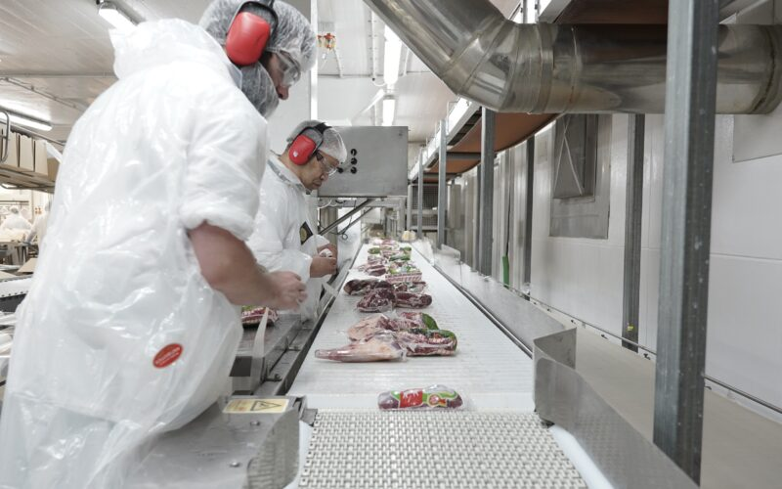
Farmers debate co-op relevance as governance, timing, and hybrid models shape outcomes. File photo
By Neal Wallace, Annette Scott and Richard Rennie.
Too often the primary sector avoids confronting major industry issues until it is too late, says Dean Rabbidge, who farms at Wyndham in Southland.
Alliance delayed asking shareholders for a capital injection and when it eventually did, Rabbidge said, meat prices had fallen and farmers could not afford to contribute.
“It is frustrating the way we wait until things are at the rock bottom before we have a conversation.
“All these big discussions are at exactly the wrong time.”
Alliance subsequently secured outside private investment.
Farmers have the choice to supply companies that do not require becoming a co-op shareholder, a costly expense at a time young farmers have limited capital.
A member of two co-operatives, Rabbidge accepts they act in the best interests of shareholders but believes hybrid ownership will become more common.
Southland farmer Dave Pinckney was instrumental in trying to retain Alliance in co-op ownership and said operational excellence is critical for any ownership model.
“Under the supplier ownership model, suppliers receive a competitive price on the day of supply and benefit from profits generated beyond the farm gate.”
Hawke’s Bay farmer and Alliance shareholder Heath Kingston said meat co-ops face a major challenge from declining stock numbers, which reduces their need for co-op functions such as guaranteed processing capacity.
“It isn’t as relevant today. The relevance of a co-op in the meat industry is zero.”
In contrast, small processors are flexible and nimble.
Kingston joined Alliance not because it was a co-op, but he supported how it functioned and now has about $1 million in shares in Alliance, which he describes as burdensome early in his farming career.
Good decision-making rather than business structure determines success, said Te Aroha farmer Richard Cookson.
Cookson has plenty of his family farming business equity exposed to those decisions, supplying Tatua, Fonterra and the Dairy Goat Co-operative.
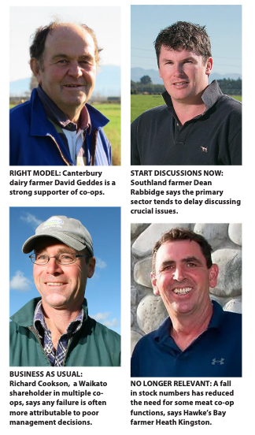
“Many failures around co-operatives are really attributable to poor decision-making and poor governance, but the co-operative model gets blamed for it.”
He said from 2008-2018 Fonterra management was dominated by governance hellbent on growth at all costs.
“Now we have a co-operative that is taking more of a Tatua approach, with greater clarity on why they exist, and what is creating value for its shareholders.
“Tatua has done well thanks to lower gearing and having a clarity about being different. It has more to do with that than about being a co-operative.”
He maintains co-op shareholders tend to prefer taking risks, meaning the co-op entity needs to minimise its own risk, something reflected in Fonterra’s approach today.
Cookson said the risks of trying to process and market perishable products from the bottom of the world are greater now than ever before with geopolitical, climate and business challenges.
“We see Fonterra as really the only entity in NZ with the muscle to push back and hold its own against some of those large corporates like Danone and Nestlé.”
Mid Canterbury dairy farmer David Geddes supports co-ops, saying they are values driven and benefit members by combining resources to achieve economies of scales and market influence.
“It goes back to the NZ Dairy Board days for me.
“I am a firm believer of the co-op model, it is common ground across the globe, we are all in it together, buying into the whole global benefit in marketing and bringing the benefits back to the farm gate.”
He likes their focus on benefiting members, democratic control, community sustainability and offering an alternative by pooling resources, sharing risks and keeping profits local.
“The model is right if it is followed. We have seen at times where governance gets it wrong and the blame goes on the co-op, rather than the leadership’s decision-making.”

Meat co-ops were there when sector needed them
https://www.farmersweekly.co.nz/special-report/co-ops-past-or-present/meat-co-ops-were-there-when-sector-needed-them/
January 9, 2026
Co-op dominance of the meat processing industry has ended after a steep 15-year decline.
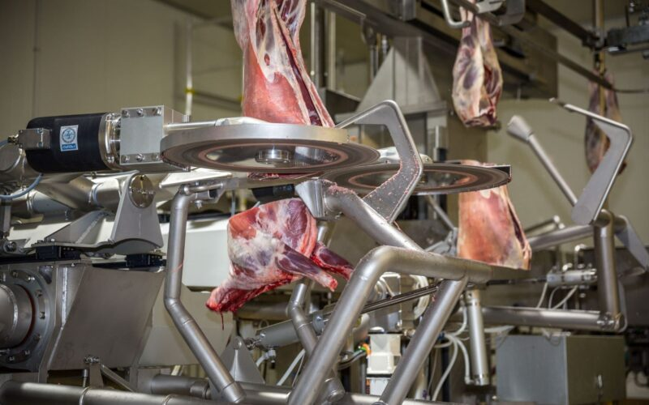
James Lockhart, formerly of Massey University business school, asked whether Alliance shareholders – had they known before voting on the Dawn Meats deal that the co-op was once again profitable – would have voted differently.
Late last century, farmer co-operatives owned most of the meat industry in New Zealand, a 60-year legacy of farmers breaking up the dominance of foreign-owned meat companies.
But it hasn’t lasted.
Falling stock numbers, successive annual losses and rising debt has in the past 15 years seen co-op dominance of the meat sector end with the final nail last year’s sale of a 65% stake in Alliance Group to Ireland-based Dawn Meats for $270 million.
Those same issues forced Silver Fern Farms (SFF) to sell half its business to China-based Shanghai Maling in 2016. In 2010 Talleys Group had bought AFFCO.
Co-ops were formed last century by sheep and beef farmers to compete with the predominantly UK-owned processors, to ensure access to processing space and to share in the profits.
The subsequent lifting of controls on building new processing plants in the 1980s and falling livestock numbers eroded the co-op dominance.
Co-ops also tend to operate ageing, large, multi-chain plants that are expensive to run and to maintain.
As financial pressures grew through the 1990s and 2000s, the co-ops found themselves with growing debt. Requests to shareholders for new capital largely went unheeded, leaving the only option the seeking of outside investment.
“It’s very hard to raise capital when you are on the downward side. Life gets quite tough,” said Mark Wynne, the former chair of Alliance Group and the current chair of the newly formed Alliance Investment Co-operative.
Wynne said every day four large and about 50 smaller meat companies battle for a share of a diminishing number of prime animals.
That creates a contradictory environment in which they have to pay competitive prices while surviving in what is a low-margin, commodity-based industry.
He said the environment allows farmers to become traders, selling to the highest bidder rather than committing to a single processor.
Wynne still believes co-ops are relevant and have the benefit of resilience from a large, loyal shareholder base.
Co-ops tend to think intergenerationally, but he acknowledges younger farmers have selling options and do not need to be a shareholder in a co-op in order to supply their stock.
James Lockhart, formerly of Massey University business school, asked whether Alliance shareholders – had they known before voting on the Dawn Meats deal that the co-op was once again profitable – would have voted differently.
He said the vote was evidence of a loss of shareholder loyalty to Alliance.
“If you go back 20 or 25 years and think of the degree of loyalty behind PPCS [SFF forerunner Primary Producers Co-operative Society] and Alliance at that time, I would have thought Alliance had overwhelmingly more support than PPCS ever did.”
He could understand the reason for the sale but was not convinced of its justification.
“I don’t understand the willingness to simply sell.”
SFF Co-op chair Anna Nelson questions whether farmers understand the benefits of a co-op in accessing processing space when needed, such as in a drought.
Farmers have more investment choices than they have capital, which means co-ops need to promote the benefits they offer.
While understanding the financial pressures on young farmers, Nelson said the co-op structure is the ideal vehicle for food producers to respond to market questions about food production and supply.
She said Shanghai Maling’s 50% stake in SFF allows the company to make investments that were previously impossible.
Rob Hewett, the former chair of SFF and current chair of Farmlands, said co-ops are an extension of a farm business beyond the farm gate.
To stay relevant, Hewett said, processing co-ops need to determine market signals and then allow shareholders to participate in supply programmes to fill those markets.

Alliance sealed fate of sector co-ops
https://www.farmersweekly.co.nz/opinion/alliance-sealed-fate-of-sector-co-ops/
January 9, 2026
Dwindling mutual ownership of the means of production in the meat sector has now come to an end.
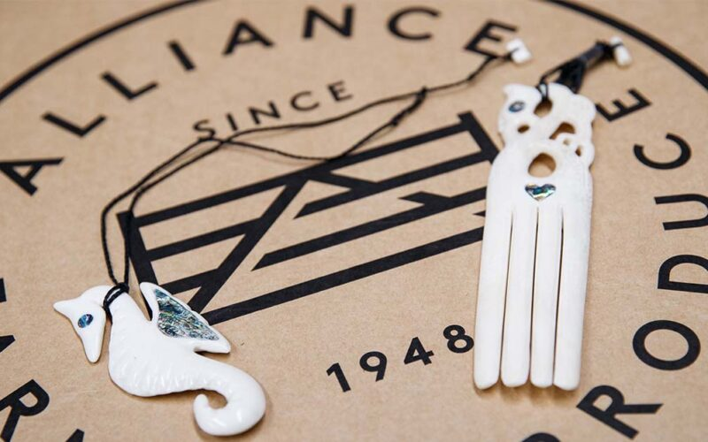
Meat co-op dominance fades as private ownership rises, leaving the sector at a crossroads. File photo
When Alliance Group shareholders voted overwhelmingly last year to sell 65% of the co-operative to Irish-based Dawn Meats, co-operative ownership in the meat industry, the sector’s dominant ownership structure for nearly a century, came to an end.
Fonterra’s size and the necessity for the daily collection and processing of perishable milk, means the dairy industry is still predominantly co-operatively owned.
But as with the meat sector, a plethora of private companies are attracting suppliers who don’t believe in or want to be a member of a co-op.
Dairy and meat co-ops were first established in New Zealand in the early 19th century to create member-owned businesses to compete with foreign-owned entities.
They sought to strengthen the buying and selling positions of members, share the profits and meet their needs, including ensuring access to processing facilities.
Today NZ has nearly 300 co-ops, mutuals, societies and credit unions. Based on 2023-24 revenues, eight of top 15 are agricultural entities.
But the dominance of primary sector processing co-ops appears to be waning, especially in the meat industry.
The 2001 creation of Fonterra from the merger of Kiwi and NZ Dairy Group strengthened the dairy co-op business model but since 2010 the three meat co-ops – PPCS, Alliance and AFFCO – have all passed, in whole or part, into private ownership.
A core of advocates believe co-ops are still relevant in 2026, but others are not so convinced.
For those farmers, many of them early in their careers, having to buy shares in a company to be eligible to sell their meat or milk seems senseless given the alternative of selling to private companies without making a financial contribution.
In recent years dairy has been more profitable than meat and wool, milk production has been increasing, and the sector has largely united behind the dominant Fonterra Co-op.
Contrast that with 40-years of falling numbers of sheep and beef, the inconsistent financial performance of companies and, in the case of Alliance and Silver Fern Farms (SFF), ownership of large, ageing, multi-chain plants that are expensive to maintain.
Alliance also found in the 2022-23 summer that operating for the benefit of shareholders, a role of co-ops, comes at a cost that private businesses do not incur.
Sensing drought was looming, it wore the cost of employing staff and starting chains earlier than normal, only for stock to not arrive when it started raining.
For much of the 1980s and early 2000s, reform of the meat industry was stifled by bloody hard men running a bloody hard industry hellbent on turf protection.
Those attitudes have certainly mellowed, but as SFF and Alliance have discovered, owning shares in a co-op does not translate into shareholders having the willingness or ability to invest new capital when the business is on its knees.
While co-op ownership of the dairy processing industry appears settled, the challenges keep lining up for the meat industry, specifically the issue of excess capacity.
Traditionally the co-ops have worn the cost of closing large-scale plants.
The 2024 closure of Smithfield cost Alliance $50 million.
Overcapacity is an industry-wide issue, but we have something of a Mexican stand-off by processors, and it will be a case of whether the co-ops or private companies blink first.

