Beyond transactions: building trust with Māori agribusiness

Read the article “Beyond transactions: building trust with Māori agribusiness “below and the answer the following questions.

Questions
- What are Māori agribusinesses?

- How are they different to normal agribusinesses?

- What key statistics demonstrate the scale of the Māori agribusiness sector?

- What does the phrase "a journey of a thousand cups of tea" signify in this context?

- How should rural professionals adjust their approach when working with Māori entities?

- How do decision-making timelines differ for Māori entities compared to non-Māori businesses?

Beyond transactions: building trust with Māori agribusiness.
Written by Isabella Beale
August 21, 2026
IRP panel shares ways to connect across the sector, on a ‘journey of a thousand cups of tea’.
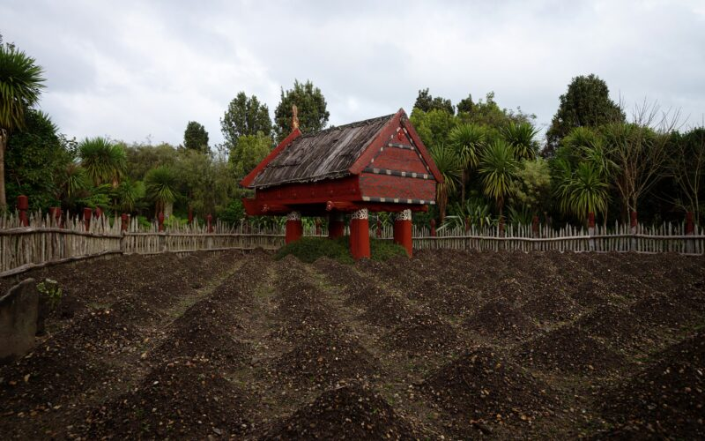
Rural professionals heard that understanding aspirations, whakapapa and long-term goals is key to working with Māori entities.

Building trust with Māori landowners, trusts and incorporations takes time, curiosity and a willingness to listen over kai or a cup of tea, a panel at the Institute of Rural Professionals Conference said.
Those relationships are increasingly important as Māori agribusiness continues to grow as a significant force in New Zealand’s primary sector. Māori freehold land makes up approximately 5% (1.4 million hectares) of New Zealand’s land area, while collectively, Māori owned $39.7 billion in agriculture, forestry and fishing assets as of 2025.
How rural professionals can better engage with this growing part of the sector was explored in the panel Connecting with the Māori Economy. It featured MPI’s Robyn Meehan, Te Tawa Kaiti Lands Trust’s Hinehou Timutimu and Beef + Lamb New Zealand’s Charles Taituha, and was moderated by NZ Institute of Rural Professionals board member Rob Macnab.
At the heart of that engagement is trust. It earns you a seat at the table and is built through repeated, respectful interactions and meetings over time, Timutimu said.
“It happens over the journey of a thousand cups of tea.”
Another perspective offered was that professionals need to understand that Māori entities are not all the same – rather than thinking of the conversation as purely transactional, rural professionals must move beyond that into partnership, Meehan said.
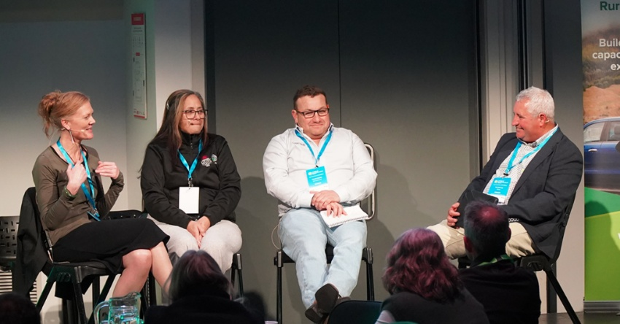
The panel at the Institute of Rural Professionals Conference titled Connecting with the Māori Economy featured, from left, Robyn Meehan, Hinehou Timutimu and Charles Taituha and was moderated by Rob Macnab. Photo: Isabella Beale

“It’s having that flexibility, working with the Māori, their aspirations, and not assuming what they need and what’s going to get them from A to B. It’s helping them reach that goal,” she said.
“How you show up and how you share that information is really important and how you respect the mana of the people that are in the room.”
The conference heard success comes from listening, observing and working alongside others, with respect for mana, whakapapa and governance structures being more important than knowing everything.
That understanding extends to how decisions are made. Māori landowners, trusts and incorporations often view decisions through a longer-term, intergenerational lens, the panel said.
“We’re here for the next generations … intergenerational knowledge is a big part,” Timutimu said.
“It might look like it’s quite tedious to someone that’s non-Māori but just having the patience and the curiosity.”
For rural professionals, that means looking beyond short-term outcomes. Those who align their advice with long-term stewardship can build greater credibility and trust.
But the learning should flow both ways. Taituha said professionals should consider not only what knowledge they leave with clients, but what they carry from each conversation into future relationships.
“It’s not what you leave on the table. It’s what you take away from the conversation that you then take to someone else’s table,” he said.
Answers.
- What are Māori agribusinesses?
Māori agribusinesses are primary sector commercial operations—spanning agriculture, horticulture, forestry, seafood, and farming—that are owned, operated, or collectively governed by Māori people, trusts, and incorporations.

- How are they different to normal agribusinesses?
While they operate as commercial enterprises, they are distinguished by several key characteristics:
- Many Māori agribusinesses manage Māori freehold land or assets governed through collective structures, such as land trusts, incorporations, or iwi (tribe) and hapū (sub-tribe) authorities.
- Decisions are typically guided by a long-term, multi-generational view rather than short-term quarterly gains, prioritising land stewardship (kaitiakitanga) for future generations.
- Business practices are heavily aligned with cultural principles, including whakapapa (connection, lineage, and context) and protecting the mana (integrity and authority) of the land and people.
- They represent a significant driver of New Zealand's economy, accounting for 5% of the national land area and tens of billions of dollars in primary sector assets.

- What key statistics demonstrate the scale of the Māori agribusiness sector?
Māori freehold land accounts for roughly 5% (1.4 million hectares) of New Zealand's land area. Additionally, Māori collectively owned $39.7 billion in agriculture, forestry, and fishing assets as of 2025.

- What does the phrase "a journey of a thousand cups of tea" signify in this context?
Coined by Hinehou Timutimu, the phrase highlights that building trust with Māori landowners, trusts, and incorporations is an ongoing process. It requires time, patience, repeated respectful interactions, and listening over a meal or cup of tea to earn a seat at the table.

- How should rural professionals adjust their approach when working with Māori entities?
Rural professionals should move away from purely transactional interactions toward genuine long-term partnerships. They need to maintain flexibility, respect governance structures, and listen to understand the entity's specific aspirations rather than assuming what solutions are needed.

- How do decision-making timelines differ for Māori entities compared to non-Māori businesses?
Māori landowners and trusts typically make decisions through an intergenerational, long-term lens focused on future generations. Because preserving intergenerational knowledge and stewardship is central, the process may require greater patience and curiosity from non-Māori professionals.

