Food and fibre production
on collectively-owned whenua Māori (Māori land)

New research is under way

New research is under way on the current use of collectively-owned whenua Māori (Māori land) and an assessment of its productivity potential. Provisional highlights from the research are presented below, with the final report from Business and Economic Research Limited (BERL) expected mid-year.
Whenua Māori totals at least 2.4 million hectares, almost 10 percent of New Zealand’s land area. This comprises of more than 800,000 hectares now owned by Māori post-settlement governance entities (PSGE) and 1.6 million hectares of Māori freehold land – this is land that has always been in Māori ownership and is often governed by trusts or incorporations.

Whenua Māori makes a significant contribution to New Zealand’s food and fibre sector economy
Food and fibre production is the most common land use for whenua Māori, accounting for around 1 million hectares of Māori freehold land and 363,500 hectares of PSGE land.
The research identifies the significant contribution that
whenua Māori makes to New Zealand’s food and fibre sector economy, providing an estimated $12 billion in direct output and $5.3 billion in direct GDP annually, supporting the
employment of 33,000 full-time equivalents (FTEs).
Forestry and sheep and beef farming are the largest sectors, each accounting for more than 500,000 hectares of whenua Māori. The research also notes diversification of land use in
the last decade, with growth in dairy farming and horticulture on whenua Māori.

Whenua Māori has unrealised productive potential
The research also demonstrates that whenua Māori has
further economic potential through bringing new land into food and fibre production or increasing the output from land already in food and fibre production.
There are 236,000 hectares of whenua Māori currently
classed as vacant that, given the right conditions, has the potential to be brought into production. The modelling
indicates the potential for an additional $1.01 billion in direct output and $389 million in GDP annually, supporting the
employment of an extra 2,135 FTEs.
The research also models the economic potential of
increasing the productivity of whenua Māori that is already in food and fibre production. This modelling indicates the
potential for an additional $2.9 billion in direct output and $1.2 billion in direct GDP annually, supporting the employment of an extra 7,447 FTEs.

236,000
hectares
of vacant whenua
Māori with
productive potential

Forestry
169,119
hectares

Store livestock
46,819
hectares

Stock finishing
19,174
hectares

Dairy
519
hectares

Market
gardens and orchards
179
hectares

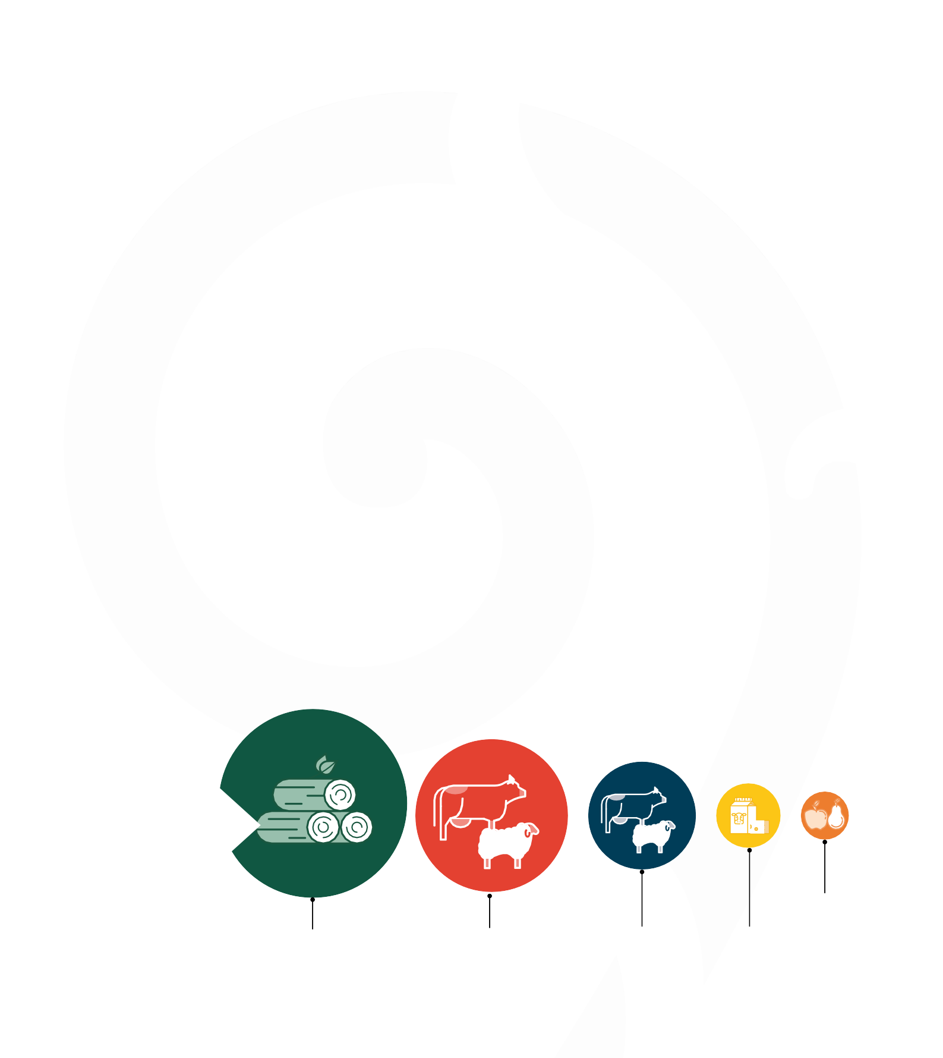

88 Ministry for Primary Industries

Potential additional output from vacant land

$1.01 billion
Direct annual output

$0.389 billion
Direct annual GDP

2,135 FTEs
Direct employment

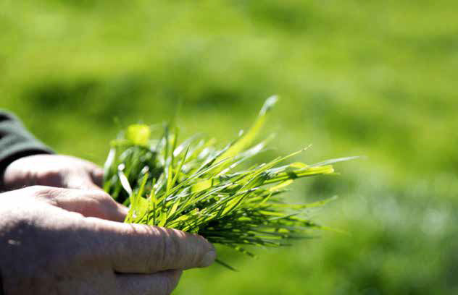
Potential additional output from land already in production

Challenges and opportunities to develop whenua Māori
The research outlines some inherent factors that limit development option on whenua Māori. For example, it estimates that around 21 percent of Māori freehold land is landlocked and difficult to access-almost 200.000 hectares. Nearly half of all vacant Māori freehold land is landlocked

Further, around 670,000 hectares of Māori freehold land has a land use capability rating of 5–8, with limited land use options due to steepness, erosion risk, and other factors.
Despite these limiting factors, there was a 35 percent
increase in the value of the Māori collectives’ food and fibre sector asset base between 2018 and 2023.17 This research
identifies active governance and land use change and
diversification as catalysts to unlock further development on whenua Māori.

$2.9 billion
Direct annual output


$1.2 billion
Direct annual GDP

7,447 FTEs
Direct employme
Case study: Whāngārā Farms’ 100 year vision
Whāngārā Farms is a partnership between three Māori incorporations – Whāngārā B5, Pakarae A, and Tapuwae
Whitiwhiti – representing approximately 2,500 shareholders with whakapapa to Gisborne Tairāwhiti iwi (tribe). A past
Ahuwhenua Trophy winner, the partnership was formed to unlock the value of collectively governed whenua Māori.
Specialising in premium sheep, beef, and wool production,
Whāngārā Farms also leads several diversification initiatives. It integrates animal production, environmental stewardship, and community outcomes into a unified strategy.
This approach is guided by He Rau Ake Ake, a 100-year
intergenerational whenua optimisation plan grounded in te ao Māori and aligned with modern business practices. It informs decision making across farming, biodiversity, forestry, and
innovation, aiming to achieve enduring prosperity – cultural, environmental, social, and economic.
Through He Rau Ake Ake, Whāngārā Farms fosters a
high-performance culture in governance and operations, committed to protecting whenua, upholding whakapapa (genealogy), and delivering long-term impact for whānau (family) and future generations.

