Māori-owned winery first in NZ to be regenerative certified.

Read the article below and the answer the following questions.

Questions
- What does it mean to be Māori owned?

- Explain how Māori-owned agribusinesses like Tiki Wine and Vineyards use values-based practices to access export opportunities in global markets.

- Explain how the adoption of regenerative viticulture reflects core Māori agribusiness principles such as kaitiakitanga, and how businesses can practically transition to these practices.

- Analyse how achieving "first in New Zealand" regenerative certification creates a competitive advantage for Māori agribusinesses in the primary sector.

Māori-owned winery first in NZ to be regenerative certified.
Written by Gerhard Uys
August 20, 2026
Tiki Wine and Vineyards lights a torch for sustainable practices with its standout operation in North Canterbury.
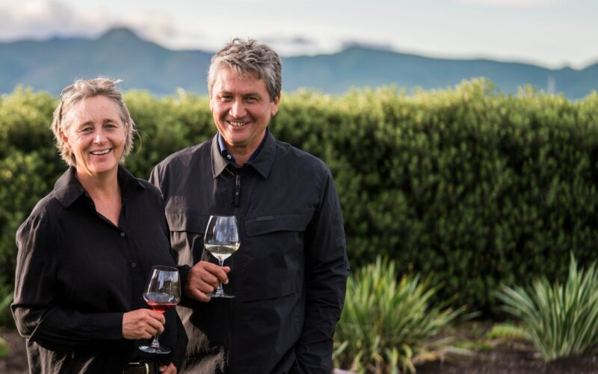
The head of Māori export customers at New Zealand Trade and Enterprise, Jeremy Gardiner, says they are seeing increasing global demand for products that reflect consumers’ values, including sustainability.

Māori-owned Tiki Wine and Vineyards has become New Zealand’s first certified regenerative vineyard.
Founder and managing director of Tiki Wine and Vineyards Royce McKean said the certification is the culmination of years of commitment from the vineyard and winery teams across many growing seasons.
The North Canterbury vineyard is family owned, founded by Royce and Sue McKean.
McKean said they are grateful for growers, researchers and organisations who have openly shared their experience to help others make the transition to regenerative farming.
He said initiatives such as the Regenerative Viticulture Foundation’s One Block Challenge give growers a practical way to trial regenerative practices in a single vineyard block, learn from the results and build from there.
The head of Māori export customers at New Zealand Trade and Enterprise, Jeremy Gardiner, said they are “seeing increasing global demand for products that reflect consumers’ values, including sustainability”.
“Tiki Wine and Vineyards is a great example of an exporter that has responded to this demand, building a brand that stands out in markets where values-led production is increasingly sought after.”
The vineyard was certified by A Greener World (AGW), which identifies, audits, certifies and promotes practical, sustainable farming systems.
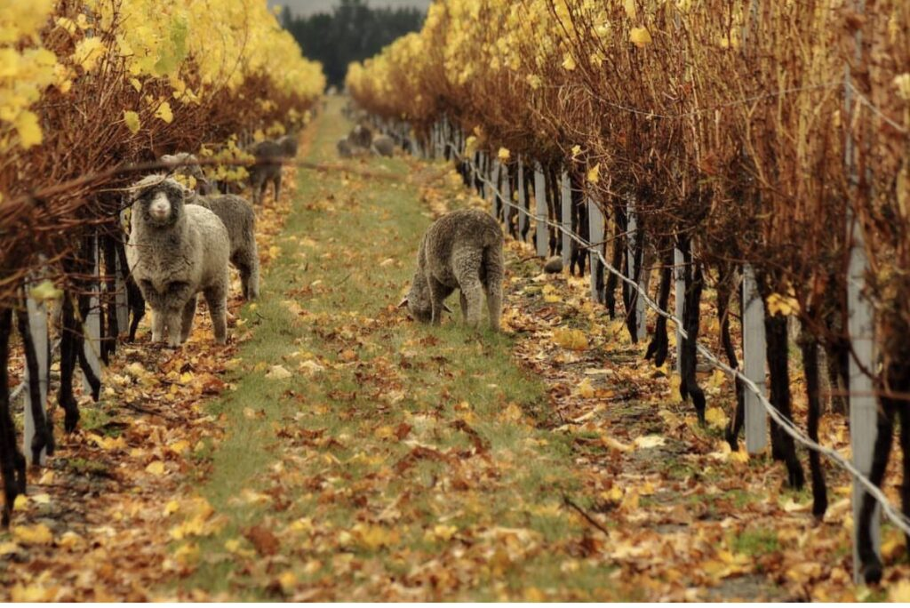
Māori-owned Tiki Wine and Vineyards is New Zealand’s first certified regenerative vineyard.
Certification requires an independently audited regenerative plan, with progress measured and verified over time.
Regional executive director at AGW Wayne Copp said the vineyard has demonstrated a clear commitment to measurable and continuing improvement across its vineyard operation.
The certification will support Tiki Wine and Vineyards in sharing its regenerative journey through its Tiki, Maui and Waiata wine brands in markets around the world.
McKean said global interest in regenerative agriculture continues to grow, with documentaries on regenerative farming, such as Kiss the Ground, and Groundswell, narrated by Woody Harrelson and Demi Moore, bringing the story of regenerative farming to a mainstream audience.

Answers.
- What does it mean to be Māori owned?
Being Māori-owned means a business is owned, controlled, or operated by people of Māori ethnicity or descent (whakapapa Māori). Beyond legal ownership, it fundamentally shapes how an enterprise operates, manages resources, and defines success.
- Under New Zealand government guidelines and procurement standards (such as Stats NZ and Te Puni Kōkiri definitions), a Māori-owned business is generally defined as an enterprise with at least 50% Māori ownership, active shareholding, or directorship, or an entity managed via a Māori Authority (such as iwi/hapū trusts).
- Ownership is tied to ancestral identity. A representative identifies the business as Māori, and its foundation is rooted in heritage and connection to place (whenua).
- Māori businesses traditionally operate around core cultural values rather than profit alone, such as; kaitiakitanga, manaakitanga and whanaungatanga.
- Success is often measured by long-term sustainability and outcomes for future generations rather than short-term financial quarterly reporting.

- Explain how Māori-owned agribusinesses like Tiki Wine and Vineyards use values-based practices to access export opportunities in global markets.
- There is a growing international demand for products that align with consumer values, particularly sustainability and environmental responsibility.
- Tiki Wine and Vineyards leverage its identity and commitment to sustainable production to stand out in values-driven export markets through its brands—Tiki, Maui, and Waiata.
- Obtaining independent, audited certification from organisations like A Greener World (AGW) validates their regenerative claim, providing the transparency required to gain consumer trust internationally.

- Explain how the adoption of regenerative viticulture reflects core Māori agribusiness principles such as kaitiakitanga, and how businesses can practically transition to these practices.
- Regenerative viticulture focuses on measurable, continuous improvement of soil and vineyard health, aligning with the principle of long-term environmental guardianship.
- Transitioning to regenerative systems can be done incrementally using trial initiatives, such as the Regenerative Viticulture Foundation's "One Block Challenge," which allows growers to test practices on a single block before scaling up.
- Success relies on collective learning (whanaungatanga and ako), where growers, researchers, and organisations openly share experiences and data to support broader sector growth.

- Analyse how achieving "first in New Zealand" regenerative certification creates a competitive advantage for Māori agribusinesses in the primary sector.
- Being New Zealand’s first certified regenerative vineyard positions Tiki Wine and Vineyards as an industry leader, generating significant brand story appeal and media visibility.
- Rising public awareness—driven by popular documentaries like Kiss the Ground and Groundswell—creates an expanding market of educated consumers actively seeking regenerative products.
- Aligning authentic cultural and environmental stewardship with audited international standards allows Māori agribusinesses to command premium market positioning over conventional producers.

