Strong growth
in Māori food and fibre sector
A preview of Te Ōhanga Māori – Māori Economy 20231
Since 2010, Te Ōhanga Māori economy reports have tracked the strong growth in the Māori economy and its contribution to the overall New Zealand economy. The Māori food and fibre
sector has made a vital contribution to this ongoing growth. The following is an early preview of Te Ōhanga Māori 2023, presenting provisional data focused on Māori collectives’2 asset
base in agriculture, horticulture, forestry, and fishing industries. Māori collectives are diverse and can include Māori-owned trusts and incorporations, iwi and their commercial arms, and
other Māori authorities.
A more complete analysis of the Māori food and fibre sector, which includes the collectives alongside the over 4,000 privately owned Māori agribusinesses and 40,000 food and fibre workforce of Māori descent, will be presented in the full report.3

In 2023, Māori collectives operating in the food and fibre sector had an asset base worth $19 billion, up from
Significant increase in the Māori collectives’ asset base
$14.1 billion in 2018. This is a 35 percent increase. Māori collectives’ assets in sheep and beef farming increased
by $100 million from $7.1 billion in 2018 to $7.2 billion in 2023. While sheep and beef remained the largest asset
class, the biggest growth in the Māori collectives’ asset base in 2023 was seen in the horticulture, forestry, and dairy industries.
In 2023, Māori collectives’ asset base in the fishing and aquaculture industry was worth $2.3 billion. This asset base includes companies such as Moana New Zealand
(profiled on page 23), fishing quota, and a growing stake in New Zealand’s aquaculture industry.
Overall, this early data demonstrates the strong ongoing growth in the Māori food and fibre sector and in the wider Māori economy. It also suggests a shift towards higher-
value land-use options that generate greater revenue

$6.0

billion

$14.1

billion

$19.0

such as horticulture and dairying and growth in forestry, which is reflective of the wider trend across the country.
billion
2013 2018 2023




Source: BERL.

1 The naming convention is for Te Ōhanga reports to be named after the census date, not the release date.
2 Māori collectives are collectively owned Māori organisations typically involved in the management of commercial assets on behalf of Māori, hapū, and iwi. Māori collectives may take many forms and include trusts, incorporations, post-settlement governance entities (PSGEs), and iwi commercial arms.
3 Te Ōhanga Māori 2023 economy report is due to be released early next year. This will expand on and update previous iterations, presenting the economic value, composition, and growth of the Māori economy in New Zealand.

Māori collectives’ asset base by industry

47%

of assets held by Māori collectives in 2023 were in the food and fibre sector

Sheep and beef
$7.2 billion

Dairy
$4.4 billion

Forestry
$2.9 billion

Māori collectives own food and fibre assets across New Zealand. The proportion,
relative to total assets, varies from region to region. In 2023 in the Kurahaupō
region, 87 percent of assets held by Māori
collectives were in the food and fibre sector.
Conversely, food and fibre sector assets only accounted for 5 percent of Māori
collectives’ assets in Tāmaki Makaurau.

Fishing and aquaculture
$2.3 billion

Kiwifruit growing
$1.2 billion

Other
horticulture
$0.8 billion

Other
agriculture
$0.2 billion

Source: BERL.

Regional spread of Māori collectives’ food and fibre sector asset base, 2023

61%

47%
Te Tai Tokerau Northland

5%
Tāmaki Makaurau Auckland

47%
Waikato

42%
Te Moana ā Toi-Waiariki Bay of Plenty

73%
Tairāwhiti

Te Tai Hauāuru
Taranaki and Manawatū-Whanganui

43%
Te Whanganui ā Tara Wellington

22%
Te Tau Ihu Marlborough, Nelson and Tasman

61%
Tākitimu Hawke’s Bay

87%
Kurahaupō Wairarapa
East Coast



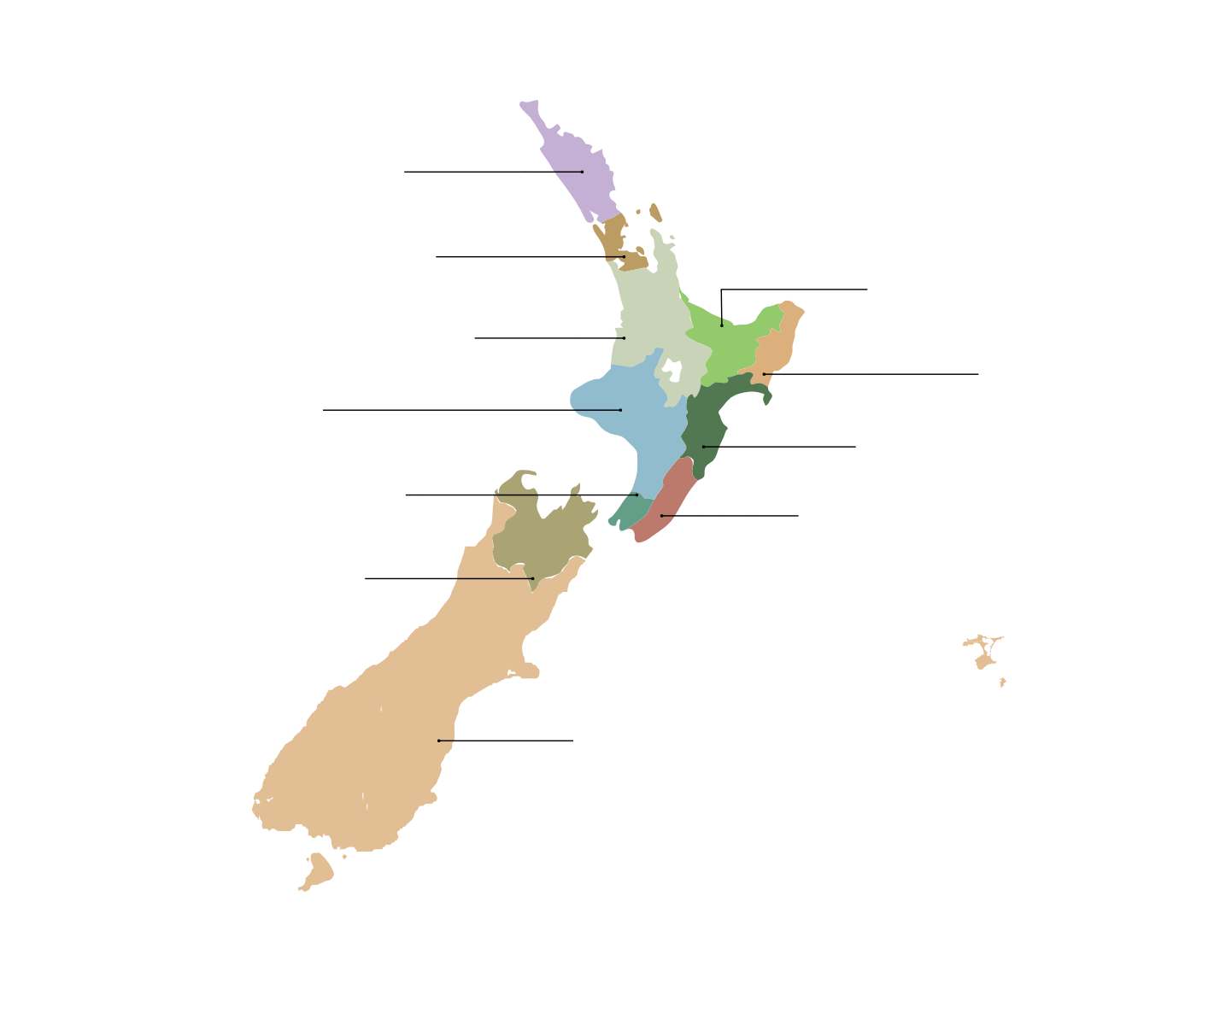


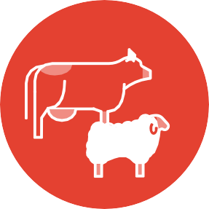

34%
Waitaha Canterbury, West Coast, Otago, Southland and
Chatham Islands

Source: BERL.PI December 2024 21

Wairarapa Moana ki Pouākani win prestigious award
He toa takitini – the power of collective ownership
Almost 1 million New Zealanders were of Māori descent at the time of the 2023 Census, the majority of whom will be a member of one or more Māori collectives. Intergenerational assets owned by Māori collectives provide a range of benefits, including an ongoing sense of connection to whakapapa, whenua, and wai.
The following case studies profile Māori food and fibre producers harnessing the power of collective ownership – he toa takitini – to achieve strong economic growth alongside enhancements to environment and community wellbeing.
Wairarapa Moana ki Pouākani exemplify excellence in Māori farming and won the 2024 Ahuwhenua Trophy for dairying. As well as transforming their farm land in Pouākani near
Mangakino into a highly productive dairy operation over the past 120+ years, they were also a key player in the
establishment of Miraka, a Māori-led dairy company that is exporting milk products produced with geothermal energy directly to offshore markets.

Winning the Ahuwhenua Trophy competition provided
recognition of the ongoing mahi (work) of Wairarapa Moana ki Pouākani to transform this whenua from scrub to dairy farm with average operating profits of $5,500 per hectare.
The award also recognises the contributions that this entity makes to the descendants of Wairarapa Moana ki Pouākani, now numbering around 4,000, and to the wider community. This includes annual distributions to uri (descendants) and support for marae, kura, and educational scholarships.

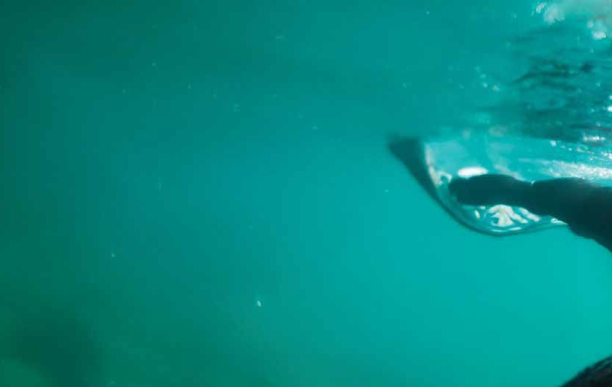
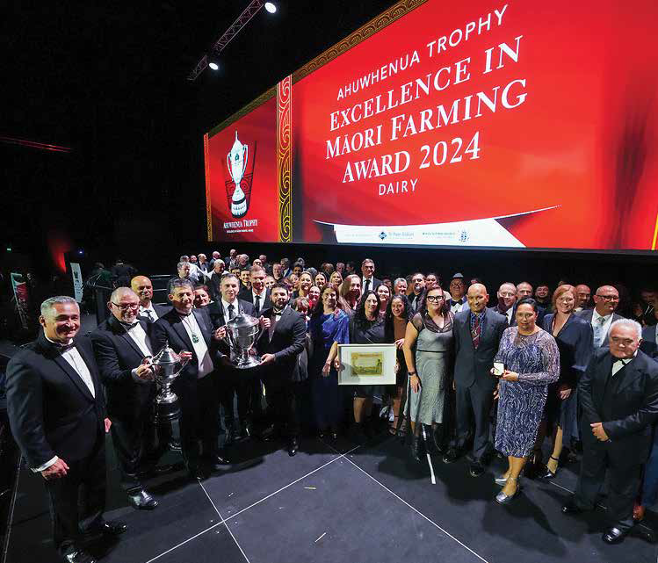

Source: Ahuwhenua Trophy.

22 Ministry for Primary Industries
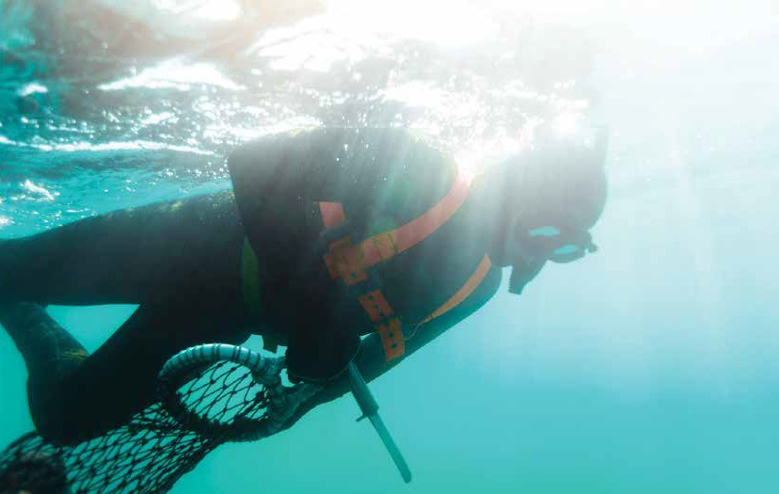
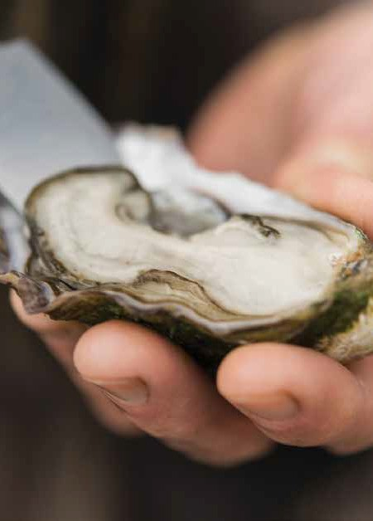
Moana New Zealand to adopt innovative oyster farming technology
Moana New Zealand is the country’s largest
100 percent iwi-owned seafood business. It is an
intergenerational asset created from the Fisheries Settlement with the Crown.
Moana New Zealand operates inshore fisheries,
aquaculture farms, and seafood processing plants, with 50 percent ownership in the Sealord Group and a joint partnership with Port Nicholson Fisheries,
one of the country’s largest exporters of rock lobster. The annual distributions made by Moana New Zealand to its iwi owners provide vital revenue that supports
scholarships, health initiatives, marae upkeep, and community services across the motu (country).
Moana New Zealand is the first fully integrated
oyster company in Aotearoa and demonstrates how Māori are leading the way in the oyster industry.
Moana New Zealand farms Pacific oysters and works with contract growers in sites from Te Tai Tokerau to Te Tau Ihu, with the majority of this kaimoana
destined for high-value export markets. MPI’s He
Taurikura Māori (Māori Partnerships and Investment) unit is supporting Moana New Zealand to increase the output of its oyster farms, by co-funding the uptake
of an innovative technology to be used in its Nelson hatchery that will enable a more consistent supply of oyster spat.
This increased spat supply will enable harvesting
12 months of the year, up from around seven months at present, and contribute to the goal of boosting annual supply to reach 1,650,000 dozen Pacific oysters per annum to market by 2029. This will allow Moana New Zealand to boost exports of kaimoana and to increase benefits to iwi and
regional communities. Source: Moana New Zealand.

SOPI December 2024 23

