
What are Sole Traders and Partnerships All About?

Choosing the correct legal structure for your business is very important as it can affect your liability levels and how much taxation you have to pay. Let’s have a look at two of the more common structures: Sole traders and Partnerships.

Every since losing his battle between good and evil, Darth had been looking for a new career move. He finally decided to set up his own small business.

I sense a weakness in the restaurant industry. I shall set up my own fast food business and go on to dominate the world!


Err right whatever Darth! Let’s see how he goes about starting up in business as a Sole Trader.

SOLE TRADER
A Sole Trader is a one-person business with unlimited liability.

I need to start out by carrying out my own research into who my main competitors are.

Notice that as a Sole Trader, Darth Vadar does not have the money available to pay someone else to do the research for him!
SOLE TRADERS USUALLY HAVE VERY LITTLE MONEY.
Sole traders will have to spend a lot of their own time and money trying to identify a ‘gap in the market’.
Those who do not research the market before setting up their business are much more likely to see their business fail.


So what happens if you do not have a lot of money as a sole trader?


Well sole traders tend to get the money to set up their business through a mixture of sources.
The most common source of finance is their own personal savings and any money that they might have received from leaving their previous job e.g. their redundancy pay.
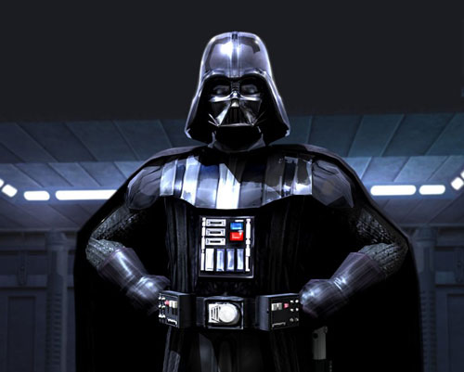
Can I not just get a bank loan?

A new business means HIGH RISK and banks might not be very helpful to you until you become more successful as a business.
You might get a small loan (high interest rate), an overdraft (daily interest charges) and a business bank account but do not expect too much more!
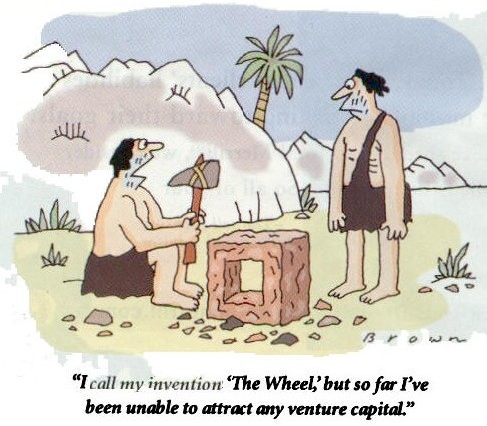
Venture Capital
One of the more common means for new business attracting investment is through venture capitalists.

Venture capitalists are prepared to accept higher levels of risk than high street banks and will invest money in a wide variety of different ‘high risk – high reward’ style new businesses. They will ask for a percentage of your profits and may even help you set up in the market.
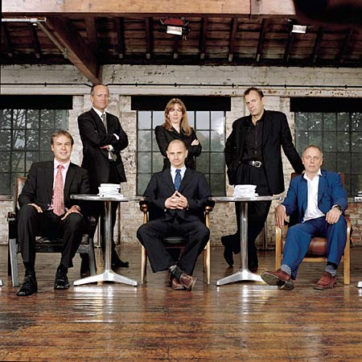
Dragon’s Den is a classic example of venture capitalists.
They risk their own money in new businesses that they see can generate high profits for them in the future.

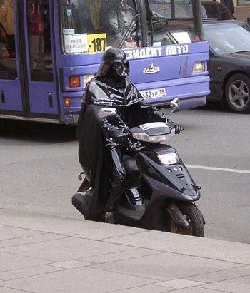
I’m having to work really long hours delivering pizzas!

Just because you are a sole trader does not mean that you cannot employ other people to work for you.

As the owner you are in charge of all key decisions and you also get to keep all of the profits that your business makes after paying out your costs.
PROBLEMS WITH BEING A SOLE TRADER
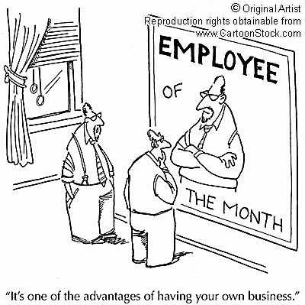
Not having to justify your decisions to anyone else is nice but it also means that you have no-one else to share your ideas with and whose advice and skills you can use.
LIMITED SKILLS & IDEAS!
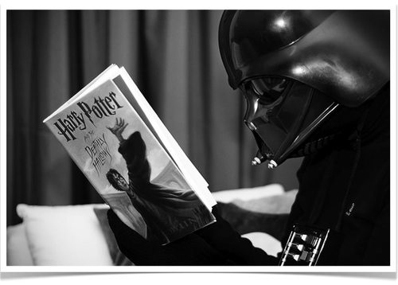
I really need a holiday!

Ahh...as a sole trader you need to be ready to work long hours and to accept very few days off work as there is no-one else to run the business whilst you are away!
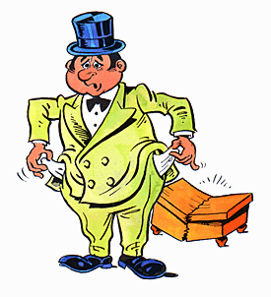
LONG HOURS & LIMITED HOLIDAYS!
As a Sole Trader it means that you have UNLIMITED LIABILITY. This means that the owner and the business are legally considered to be the same thing.
The debts of the business are therefore the debts of the owner as well.

Darth Vadar might lose his own personal possessions e.g. house and car, to help pay off the debts of the business. He can be declared BANKRUPT!

So are there any benefits to being a Sole Trader?

Actually there are plenty of good things about being a sole trader and it is in fact the most common form of business legal structure within the United Kingdom so it can’t be that bad.
Do I need a lot of money to start up?

Well actually NO! It is cheap and easy to set up as a sole trader business. This is why it is so popular as a legal structure.
Who makes all the decisions?

YOU DO! As the owner of the business you also get to keep all of the profits. You don’t even have to publish any of your accounts and so can keep your financial records private.

Question Time

- Name two sources of finance that Sole Traders might be able to use.

- Write down the meaning of Sole Trader.

- Name three benefits of being a Sole Trader.

- What is meant by the term ‘Unlimited Liability’?

What is meant by a Partnership then?
Join with me and we shall rule the world!

Okay, well a partnership offers some important differences. The main is the fact that you are now sharing control of the business with at least one other owner.
PARTNERSHIPS
Partnerships are when two or more (up to 25) people are the owners of a business.

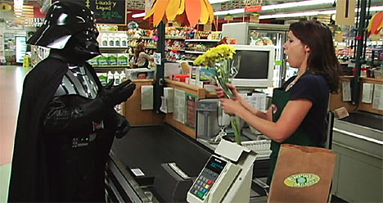
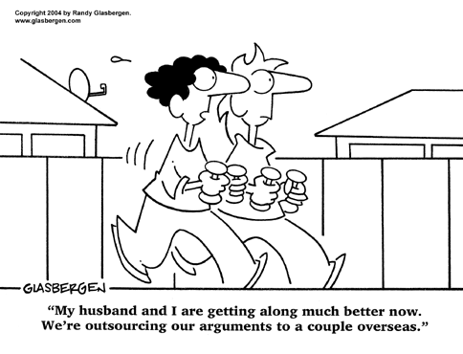
One of the things to remember is that as Sole Trader you made all of the decisions.
As a partnership you have to share these decisions and this might create tension and arguments.

Darth also needs to remember that he will now need to share his profits with his partner(s). Partnerships also have UNLIMITED LIABILITY and so all partners are personally liable for the debts of the business.
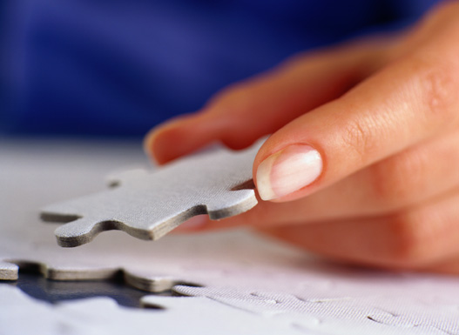
Against these negatives are the big benefits of being a partnership.
You will have owners with skills that you might not have yourself.
Each owner will bring some extra capital (money) into the business and it will also be much easier to provide illness or holiday cover.
A partner might well be the missing piece in your business!
How do you stop arguments then?
Well one thing that many partnerships do is to create a DEED OF PARTNERSHIP. This is not compulsory but when signed is legally binding.
What a Deed of Partnership does is to lay out what each partner is responsible for; how much capital they have invested in the business; how much of the profit they are entitled to have a share of and how much of the debt they are liable for. It will not stop arguments but it helps to resolve disputes between partners.
Complete the following paragraph by filling in the blanks.
Partnership Profit Venture Capitalist
Unlimited Sole Trader Costs Control

A ________ ____________ business only has one owner unlike a _____________________ which has two or more owners. One of the main advantages of being a sole trader is that the owner of the business gets to keep all of the ________ but they also are responsible for paying all of the businesses __________ as well! In a partnership, the ________ of the business is shared between the partners but this can create arguments. Both sole traders and partnerships also have ______________ liability. One of the main sources of finance for a sole trader is to seek out a ___________ _____________ as banks like to avoid risk.
Explain the main differences between a sole trader and a partnership.

Darth Vadar discovers that he lacks the level of finance needed to keep the business running successfully. Explain the options that are open to him to avoid bankruptcy. Make sure that you give at least ONE advantage and ONE disadvantage to each option and reach a conclusion about which is the better decision for Darth Vadar.

