Soil structure scores

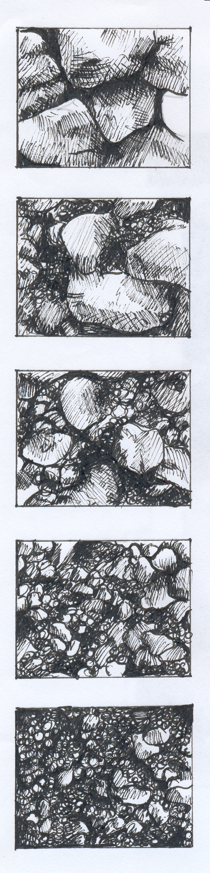
Score 1-2
Soil consists of large (> 5 cm) compact clods with few aggregates of smaller size. Soil breaks with effort into angular blocks with smooth flat sides. Some discoloration (dark blue to black) may be apparent.
Score 3-4
Soil consists of large (> 5 cm) firm clods that break into angular blocks with mostly flat or round smooth sides. Smaller unstable aggregates or loose fine powdery soil may be evident.
Score 5-6
Few large and medium (> 3 cm) firm soil aggregates but mostly smaller (< 3 cm) aggregates in friable mix of loose soil. Some smaller unstable aggregates or loose powdery soil may be evident.
Score 7-8
Friable soil consisting of many distinct soil aggregates (<3 cm) of a rounded or nutty shape. Little loose powdery unaggregated soil.
Score 9-10
Porous loose soil of many distinct stable soil aggregates (<3 cm) of a nutty or rounded shape. Aggregates are prominent with little or no loose powdery unaggregated soil. Roots may be growing in and around aggregates.

