Texture Triangle

The texture triangle can be used to indicate the texture of soil provided that the proportions of sand, silt and clay are known.

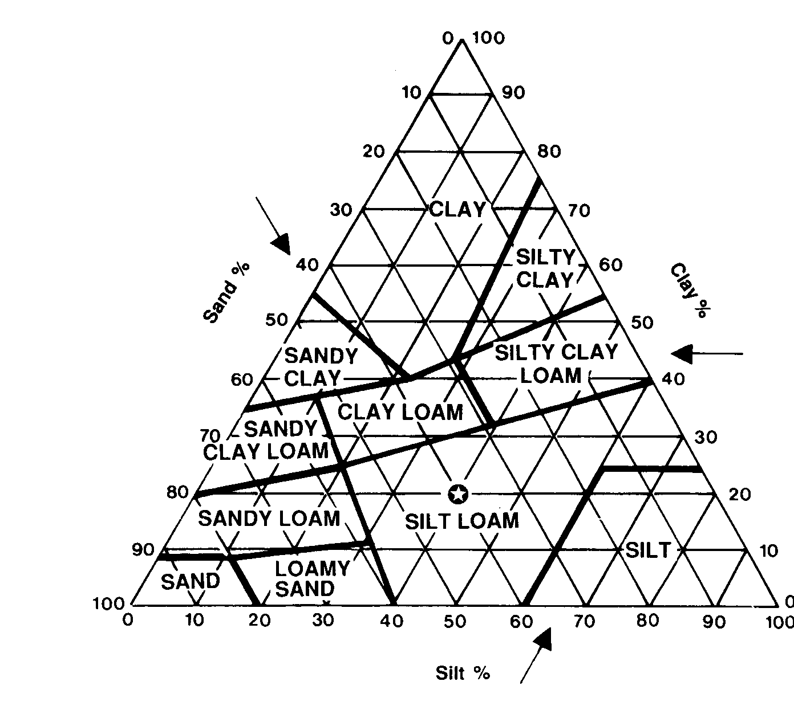
The star in the middle of the silt loam section shows that the soil has 40% sand, 40% silt and 20% clay.

Exercises:
For the following percentages workout the texture of the soil.
1. 30% sand, 10% silt and 60% clay =
2. 70% sand, 10% silt and 20% clay =
3. 30% sand, 50% silt and 20% clay =
4. 55% sand, 25% silt and 15% clay =

5. What is the range of sand, silt and clay that Clay Loam could have?

 | Minimum | Maximum
Sand
Silt
Clay

