STUDENT ACTIVITY: Earthquakes past and future

Activity idea

In this activity, students use data on historical earthquakes to identify when and where they occurred and make predictions about future earthquakes.

By the end of this activity, students should be able to:
- use data to plot a timeline of large earthquakes that have happened in New Zealand over the last 150 years
- look for patterns in earthquake events but learn that it is not possible to predict when an earthquake will occur
- plot the locations of historic earthquakes (using latitude and longitude) and relate them to the positions of known geological faults
- calculate averages and estimate tenths.

This activity was developed for the Earthquake Commission (EQC) and has been kindly provided for use on the Science Learning Hub.

Introduction/background
What you need
What to do
Student instructions
Earthquakes in New Zealand over the last 150 years
Earthquake timeline
Plotting earthquakes using longitude and latitude co-ordinates
Outline map of New Zealand
Main active faults in New Zealand

Introduction/background

This activity looks at some of the possibilities for predicting where and when earthquakes might happen in New Zealand. This activity includes some mathematics, including calculating averages and estimating tenths when plotting latitude and longitude.

It is a useful exercise in investigating how science works, as it highlights some pitfalls of making predictions and of using inappropriate methods of interpreting evidence – it is more practical to suggest where, rather than when, earthquakes might or might not occur in the future.

The best we can do is to be prepared! To find out more about being prepared for earthquakes and other natural disasters, visit www.eq-iq.org.nz.

The data used in this activity is a summary of information from the GeoNet web site, supplied by GNS Science.

For more details about damage, including photos, go to www.geonet.org.nz/earthquake/historic-earthquakes/index.html.

What you need

- Student instructions
- Earthquakes in New Zealand over the last 150 years
- Earthquake timeline
- Plotting earthquakes using longitude and latitude co-ordinates
- Outline map of New Zealand
- Main active faults in New Zealand

What to do

- Hand out copies of earthquakes in New Zealand over the last 150 years and discuss with your students. Explain that the 150 years is a very short time in geological history, but it is the period of human occupation for which we have fairly reliable data. Many large earthquakes happened before this time, some of which have left a partial record of events in the landscape. You could discuss with your students if 150 years is a long enough period to detect patterns in geological events.

Also explain that these earthquakes are only those that had a significant effect on humans or the environment. Other earthquakes of similar magnitudes happened during this period, but did not have the same effects. Thousands of smaller earthquakes happen in New Zealand each year, but most of them are only recorded by instruments and are not even felt by humans.

- Hand out copies of the student instructions and earthquake timeline and have them complete steps 1–4 in the student instructions. Students are asked to make calculations and predict a future earthquake. Their calculations should look like this:
- Intervals between major earthquakes from 1848 to 1968: 7, 13, 20, 31, 0, 2, 3, 8, 0, 26 – the average interval is 11.
- Add 11 to 1968, and the prediction would have been that the next major earthquake would occur in 1979. It didn’t – the next one was 2003, so this was not a reliable prediction.
- If we recalculate and include 2003, we get 7, 13, 20, 31, 0, 2, 3, 8, 0, 26, 35 – the average is 13.
- Add 13 to 2003, and the prediction is that the next major earthquake will be in 2016. How reliable is that?

- Discuss how accurate this method of prediction is. Students should find that making an earthquake prediction in this way is very inaccurate – in fact, most earthquake scientists now believe that it is not possible to accurately predict when earthquakes are going to occur, based on past records. (Remember the prediction for a big earthquake in Parkfield in 1988? It still hasn’t happened.) Too many things affect when earthquakes happen; they are random, unpredictable. Below is an example you might like to use to illustrate this idea.

The Alpine Fault in the South Island is a place where the Australian and Pacific tectonic plates meet on land. The blocks of land on either side of the fault do not slide past each other smoothly. Instead, they build up stress and then slip every now and then, causing large earthquakes.

Major earthquakes have happened on the Alpine Fault in about the years 1100, 1450, 1620 and 1717.

It is tempting to play with numbers to make a prediction:
- The intervals between the earthquakes were 350, 170 and 97 years.
- 170 is roughly half of 350, and 97 is roughly half of 170, so we could expect the next earthquake to be roughly half of 97 years after the last one. That’s in about 1770, but there hasn’t been a major earthquake on the Alpine Fault since 1717 – our prediction was out by at least 240 years.
- If we predicted using the average interval, which is 206 years, the next quake should have been in 1976, but it wasn’t.

Ask your students to suggest what we can say about when the next earthquake on the Alpine Fault will be. In reality, we don’t know – it could be this year, next year, in 50 years or in 100 years. The main message is that we can be fairly sure that there will be another major earthquake on the Alpine Fault, so at least we can get ourselves prepared for it.

- Ask students if we can’t predict when an earthquake might happen, can we predict where? Hand out copies of plotting earthquakes using longitude and latitude co-ordinates and the outline map of New Zealand and have them plot the locations of the earthquakes onto the map. (An example of the finished map is shown here.)
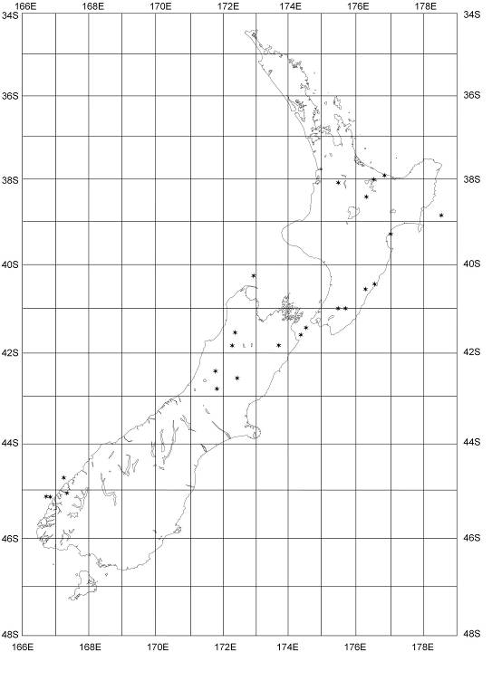
- Look for patterns of earthquake distribution.
- Do earthquakes happen in some parts of New Zealand more than others?
- Why do you think that might be?

- Hand out copies of the main active faults in New Zealand and have students compare the distribution of earthquakes to the active faults.

What are ‘active’ faults?
The rocks that make up New Zealand are broken up into many vast blocks by fractures called faults. Sudden movements along these faults result in earthquakes that can affect the surface above and around them. There are many faults in New Zealand, but only those that are known to have moved in the last 120,000 years, and could move again, are called ‘active’. Movement on these active faults causes shallow earthquakes, which can cause a lot of damage because they are near the surface. Deeper quakes are associated with the movement of tectonic plates deep under New Zealand.

The majority (but certainly not all) of the quakes are close to active faults, so although we can’t say when an earthquake might happen, we can say where they are most likely to occur. However, there are enough exceptions that we cannot be certain earthquakes won’t happen in other places. These may be related to deeper structures in the earth. Students may notice that there have been no large earthquakes along the long fault shown in the South Island. (This is the Alpine Fault, described above.)

Student instructions

You are going to study data from past earthquakes in New Zealand. You will look for patterns, and see if you can work out when and where the next big earthquake might hit.

- Using the data on earthquakes in New Zealand over the last 150 years, plot the earthquake dates and magnitudes on the timeline.

- Mark on the timeline when earthquakes of magnitude 7.1 or higher occurred. Here is an example of the first three:

- Write in the number of years between each event, like this: (If two earthquakes happened in the same year, the interval is 0.)

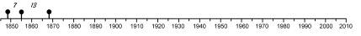

- What patterns can you see in your earthquake timeline? When do you think the next magnitude 7.1 or bigger earthquake will hit New Zealand?

In 1983, some American scientists looked at a timeline of earthquakes centred near the small Californian town of Parkfield, which lies very close to the active San Andreas Fault. Earthquakes of magnitude 6.0 or bigger had happened at Parkfield in 1857, 1881, 1901, 1922, 1934 and 1966. The interval between quakes was 24, 20, 21, 12 and 32 years. The average interval was 22 years. The scientists predicted that the next big quake would hit Parkfield 22 years after the last one – that would make it 1988, give or take a few years.

- Try the same approach with your New Zealand data:
- Pretend it is the year 1970.
- From your timeline, add together the time interval between quakes from 1848 to 1968. Divide this number by the number of intervals (which should be 10).
- This gives you the average interval between the earthquakes on your timeline up until 1968. Add this figure to 1968 and predict when the next earthquake of magnitude 7.1 or higher should have happened. Was there a big earthquake in or close to the predicted year? How reliable do you think the prediction was?

- Now include the 2003 earthquake in your calculation:
- Add the 35-year interval between 1968 and 2003 to your sum of intervals. Divide the total by the number of intervals (which should now be 11). Add your answer to 2003.
- Do you think that the year you get is when the next big earthquake is going to happen? Would you be certain enough about the prediction to try and persuade people to prepare for a big earthquake?

- Add earthquakes of magnitude 5.1–7.00 to your timeline. Mark them in a different colour or symbol to the larger ones you have already plotted.
- What pattern do you observe now?
- Can you make a better prediction for future earthquakes?
Earthquakes in New Zealand over the last 150 years

Date | Location | Co-ordinates | Mag | MMI | Depth | Damage
20.12.2007 | Gisborne | 38.9S 178.5E | 6.8 | 8 | 40km | Buildings collapsed and damaged in central city.1 dead, 11 injured.
16.10.2007 | George Sound | 44.7S 167.2E | 6.7 | 7 | 24km | Landslides in Milford Sound, objects shaken off shelves in buildings in Queenstown/Te Anau area.
18.7.2004 | Lake Rotoetu | 38.0S 176.5E | 5.4 | 8 | 5km | The largest of a swarm of earthquakes in July. Local severe damage to buildings, widespread minor damage. Many landslides.
22.8.2003 | Fiordland | 45.2S 166.8E | 7.2 | 7 | 24km | Little damage to property, but buildings shook in Te Anau. More than 200 landslides in Fiordland, with several local small tsunamis. Seafloor raised offshore.
10.8.1993 | Secretary Island | 45.2S 166.7E | 6.8 | 8 | 5km | Buildings shaken in Te Anau. Many landslides in Fiordland, small tsunami on coast.
13.5.1990 | Weber | 40.4S 176.5E | 6.4 | 9 | 30km | Land damage widespread, varied in amount, relating to soil stability.
10.2.1990 | Lake Tennyson, Nth Canterbury | 42.4S 172.7E | 5.9 | 8 | 13km | Mountain ridges shattered, tree trunks snapped.
4.6.1988 | Te Anau | 45.1S 167.3E | 6.7 | 8 | 73km | Many small landslides in Fiordland.
2.3.1987 | Edgecumbe | 37.9S 176.8E | 6.5 | 9 | 6km | Buildings damaged, chimneys toppled, railway lines buckled, power transformers knocked over, large rifts across paddocks and roads. 25 injured.
14.12.1983 | Waiotapu | 38.4S 176.3E | 5.1 | 8 | 5km | A landslide, roads with loose surface damaged.
5.12.1976 | Korakonui (Waikato) | 38.1S 175.5E | 5.1 | 8 | 12km | Several houses lost chimneys, some other minor damage.
24.5.1968 | Inangahua | 41.8S 172.0E | 7.1 | 10 | 10km | Buildings, roads and bridges destroyed. Railway lines buckled, underground pipes broken, large landslides. 2 dead.
23.4.1966 | Seddon (Cook Strait) | 41.6S 174.4E | 5.8 | 8 | 19km | Seddon, 35km from epicentre, had most chimneys damaged on most houses. Railway lines damaged, water, power and telephone services cut.
2.8.1942 | Wairarapa 2 | 41.0S 175.5E | 6 | 8 | 40km | Buildings damaged from Masterton to Wellington.
24.7.1942 | Wairarapa 1 | 41.0S 175.7E | 7.2 | 8 | 12km | Widespread damage to buildings and land surface. Centred near Masterton, but 20,000 chimneys toppled in Wellington. 1 dead, 2 injured.
5.3.1934 | Horoeka (Pahiatua) | 40.6S 176.3E | 7.6 | 9 | 12km | Widespread damage and collapse of buildings. Landslides on east coast cliffs, ground deformed. 1 injured.
3.2.1931 | Hawke’s Bay | 39.3S 177.0E | 7.8 | 10 | 20km | Buildings destroyed over wide area, especially in cities of Napier and Hastings. Broken gas pipes caused fires. Landslides all over Hawke’s Bay. Fissures across land and roads. Coastline changed (Ahuriri Lagoon raised up). Some land was raised a few metres, some sunk a metre. 256 dead, thousands injured.
17.6.1929 | Buller (Murchison) | 41.6S 172.3E | 7.8 | 10 | 12km | Centred in rural area, but many buildings, roads and bridges destroyed. Landslides and surface fissures over thousands of square kilometres. Some slips blocked rivers and formed new lakes. A fault on Buller River moved 4.5m vertically, 2.5m sideways. 15 dead, 1 injured.
9.3.1929 | Arthur’s Pass | 42.8S 171.8E | 7.1 | 9 | 11km | Isolated houses lost chimneys, house contents damaged.
1.9.1888 | North Canterbury | 42.6S 172.4E | 7.1 | 9 | 15km | Buildings damaged. Many fissures in ground, and widespread landslides. At Glynn Wye, liquefaction of soil caused jets of sandy water to erupt from the ground.
19.10.1868 | Cape Farewell | 40.3S 172.9E | 7.5 | 9 | 25km | Houses and roads damaged in Farewell Spit area.
23.1.1855 | Wairarapa | 41.4S 174.5E | 8.2 | 10 | 25km | Most severe earthquake in NZ since 1840. Severe building and other structural damage from Wellington to Wanganui and Kaikoura. Some land was raised 2.7m. Wellington shoreline changed to where it is now. Many landslides, some liquefaction and possibly a local tsunami. 9 dead, 5 injured.
16.10.1848 | Marlborough | 41.8S 173.7E | 7.8 | 10 | 20km | Widespread damage to buildings, including Wellington and Wairarapa. Many landslides.

Earthquake timeline
Plotting earthquakes using longitude and latitude co-ordinates

Latitude is a measure of how far north or south a place is from the equator. It is measured in degrees (°). The equator is 0°, the North Pole is 90° north (N) and the South Pole is 90° south (S).

Longitude is a measure of how far east or west a place is from the prime meridian. The prime meridian is a line that runs from the North Pole to the South Pole through Greenwich in England. The prime meridian is 0°, and longitude can be up to 180° east (E) or west (W).

Because of where New Zealand is in the southern hemisphere, all its latitude co-ordinates are south and all its longitude co-ordinates are east. Co-ordinates are written as decimal numbers.

This example is for an earthquake in North Canterbury on 10 February 1990. The epicentre had the co-ordinates 42.4S 172.7E.

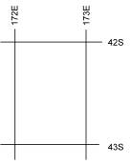 | The parts of the co-ordinates before the decimal place tell us which rectangle on the map the place is in.  42.4S tells us the place is between 42.0S and 43.0S.  172.7E tells us the place is between 172.0E and 173.0E.  The earthquake was in the rectangle formed where these lines cross.
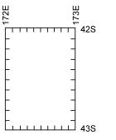 | The number after the decimal point gives us a more accurate place inside the rectangle.  Imagine that each side of the rectangle is divided into 10.  The map doesn’t have tenths marked in the rectangles. (You could use a ruler to start with, but you will soon get the hang of estimating tenths.)
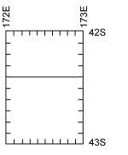 | To find 42.4S, count 4 tenths down from 42S, and draw a line across.
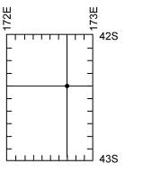 | To find 172.7E, count 7 tenths right from 172E and draw a line down.  Where the two lines intersect is the location of the co-ordinate.
Outline map of New Zealand

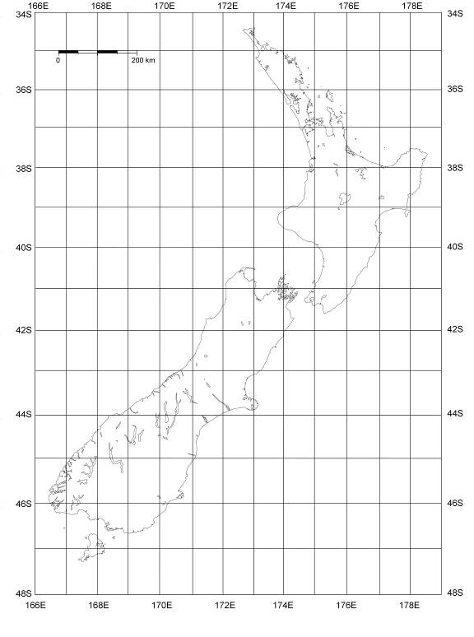
Main active faults in New Zealand

