Weathering and erosion

The process of weathering alters rocks at the earth's surface and breaks them down over time into fine-grained particles of sediment and soil. Weathering is the result of the interactions of air, water, and temperature on exposed rock surfaces and prepares the rock for erosion. Erosion is the movement of the particles by ice, wind, or water. The particles are then transported by that agent until they are deposited to form sedimentary deposits, which can be later eroded again or transformed into sedimentary rocks. The weathering of the sediment grains continues during erosion and transportation. Weathering is generally a long, slow process that is continuously active at the earth's surface.

There are two kinds of weathering: mechanical (physical) and chemical
1) Mechanical weathering is the process by which rocks are broken down into smaller pieces by external conditions, such as the freezing of water in cracks in the rock.
2) The rock is chemically weathered when it reacts with rain, water, and the atmosphere to destroy chemical and mineralogical bonds and form new minerals.

Freeze and Thaw
Water is unique. As it freezes, it expands in volume. In the mountains, snow melts during the day, and the resulting water flows into cracks in rocks. Overnight, as temperatures drop, the water expands and freezes. This expansion provides an incredible wedging force and slowly chips away at the rock face. Most of the local scree or loose rock slopes were formed by the slow action of ice wedging. As water freezes, it expands 9%, providing the sheering force of dropping a shot put 3 m. onto the rock.

Avalanches
As snow accumulates high in the mountains, eventually the excess is released in the form of avalanches. Since these releases will follow the most efficient route, they normally follow the same path year after year. Some years may widen the path if snowfalls are large, other years may allow tree growth to slowly try to reclaim the path. The signs are always evident, and these paths provide opportunities for lush summer growth.

Running Water
Water is the king of erosion. Nothing carves up a landscape like the action of water. Even glaciers are simply another form of this versatile material. As water begins to move, it picks up material in the form of gravel and debris. As these sediments are carried within the water, they provide the abrasive needed to begin carving river channels. As the water continues to move, it picks up increasing amounts of water and sediment, and the process continues.

Slumping
In many situations, a steep hillside will show a spoon-shaped depression within which the material has begun to slide downhill. This slump, as it is known, occurs along a distinct fracture zone, often within materials like clay, that once released, may move quite rapidly downhill. In some cases the slump is caused by water beneath the slope weakening it. In many cases it is simply the result of poor engineering along highways where it is a regular occurrence.

Wind
In the Rockies, wind tends to play a minor erosional role. In areas where the wind constantly blasts, as in the Bow Valley, the wind may add to the effects of other forces.

Biological Action
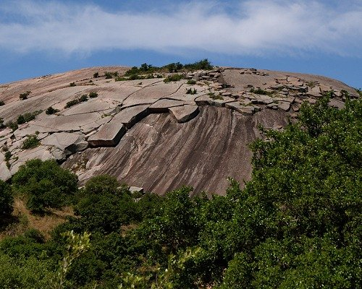
The orange and green lichens that coat many of our rocks are slowly breaking them down. With the ability to slowly break down their limestone home, they begin the lengthy process of soil creation. On a larger scale, the trees that seem able to grab a tenuous roothold on the steepest of slopes, do so by jamming their roots down any available crack. This creates a classic wedging effect which may break off large pieces of rock
Exfoliation
Large daily variations in temperature, especially pronounced in deserts, were also credited with producing exfoliation—expansion from heating during the day followed by contraction from rapid cooling at night is thought to cause the separation of thin slabs from large blocks of rock at the surface.

Activity 1: Weathering and erosion

1. Define Weathering:
_________________________________________________________________________ ___________________________________________________________________________________________________________________________________________________________________________________________________________________________

2. What are the differences between chemical weathering and physical weathering? ____________________________________________________________________________________________________________________________________________________________________________________________________________________________________________________________________________________________________

3. Describe what water does to pavement when it continually freezes and thaws. _____________________________________________________________________________________________________________________________________________________________________________________________________________________________________________________________________________________________________________________________________________________________________________

Tell what type of weathering (physical or chemical) the following are examples of:

__________________________ 4. Particles grind against rock in a process called abrasion

__________________________ 5. Acid rain hits a limestone statue

__________________________ 6. Rust forms on old wheel barrow outside

__________________________ 7. Rocks become smooth and round in shape

__________________________ 8. Roots of a tree grow into the bedrock below

__________________________ 9. Stream rocks dissolving due to carbonic acid present.

__________________________ 10. Changes in temperature cause rock to break apart

Tell how each of the following factors affect rate and type of weathering

11. Exposure:
_________________________________________________________________________ ___________________________________________________________________________________________________________________________________________________________________________________________________________________________

12. Particle Size: _________________________________________________________________________ ___________________________________________________________________________________________________________________________________________________________________________________________________________________________

13. Mineral Composition: _________________________________________________________________________
_________________________________________________________________________
__________________________________________________________________________________________________________________________________________________

14. Climate: _________________________________________________________________________ ___________________________________________________________________________________________________________________________________________________________________________________________________________________________

