Types of Volcanoes & Eruptions

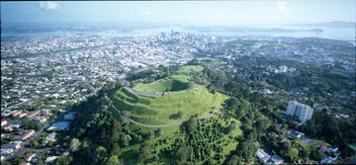
Volcanic Fields
Volcanic fields, such as Auckland and Northland, are where small eruptions occur over a wide geographic area, and are spaced over long periods of time (thousands of years). Each eruption builds a new single new volcano, which does not erupt again. Mount Eden and Rangitoto Island are examples in Auckland.

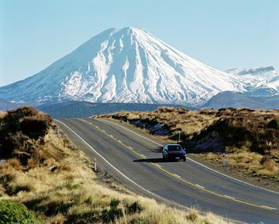
Cone Volcanoes
Cone volcanoes (also called composite cone or stratovolcanoes) such as Ruapehu, Taranaki / Egmont and Ngauruhoe, are characterised by a succession of small-moderate eruptions from one location. The products from the successive eruptions over thousands of years build the cones.

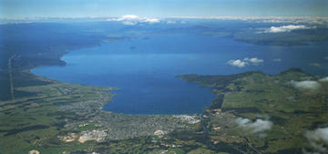
Caldera Volcanoes
Caldera volcanoes, such as Taupo and Okataina (which includes Mt Tarawera), have a history of infrequent but moderate-large eruptions. The caldera forming eruptions create super craters 10-25 km in diameter and deposit cubic kilometres of ash and pumice.
Created: 14/01/2010 10:44 am

