**Plate tectonics overview**

In 1912 German meteorologist, Alfred Wegener, proposed the theory of plate tectonics.

He based his theory on the observation that continents have a jigsaw-like relationship. Fossils, plants and rocks of similar type were found separated by wide expanses of ocean.

However, he couldn’t suggest a plausible mechanism as to how the continents could move around, hence his theory was not accepted by many scientists. His theory was finally accepted in 1960!

Only recently have plate tectonics and continental drift become accepted as geology’s ‘big idea’ that explains why the world looks like it does.

**Current scientific understanding**

* The earth’s crust is broken into 7 or 8 large plates plus a number of smaller ones.
* These plates are continuously moving (up to 10cm per year) due to convection currents in the magma beneath.
* At their edges, the plates bump into one another (collision) or draw apart (spreading). Earthquakes, volcanoes, rift valleys and mountain building occur at the edges of plates.
* Collisions have created huge mountain chains like the Himalayas.
* Rifts (fracture lines) are mostly across ocean floors. New sea floor is pushed up in the rifts from the magma below. This causes sea floor spreading which can result in the formation of the mountains (often sub-marine).

Types of crust

* Continental crust – relatively old, light, high standing, mostly granite rock.
* Oceanic crust – heavier, younger, lower standing, mostly basalt rock.

When crusts collide, the density of the plates determines what happens.

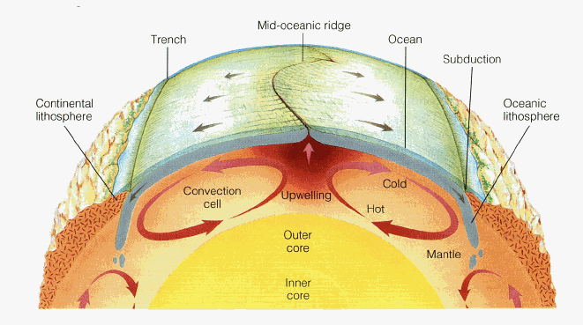

Convection currents

It is reasonable to assume that the heat radiated from the core creates convection currents in the mantle, and the mantle rocks begin to move plastically. Convection movement in the uppermost layers of the mantle may pull on the lithospheric rocks, breaking them into huge plates that move slowly on the more plastic, lubricated surface of the asthenosphere. Another possibility is that the 670-kilometer boundary in the mantle breaks the convection pathways into an upper and lower part; convection in the lower part may induce the convection currents in the upper part (less than 670 kilometers deep) that move the plates. Still others believe that plate motion on the surface creates the underlying mantle convection—that is, when plates diverge, hotter mantle rock rises upward to fill the space between the plates, helping to push them apart; as the plates move away from the spreading center they cool and begin to sink, creating downward currents.

**Activity 1.**

1. What is convection? ________________________________________________________________________________________________________________________________________________________________________________________________
2. Heat transfer by convection is caused by differences of ________________ and ___________ within a fluid.
3. Circle the letter of the sentence that describes what happens to a fluid when its temperature increases.
4. Its particles occupy less space
5. Its density decreases
6. Its particles move more slowly
7. Its particles settle together more closely
8. What happens to convection currents when the liquid or gas is no longer heated?

________________________________________________________________________________________________________________________________________________________________________________________________

5) Is the following sentence true or false? The heat source for the convection currents in the mantle is the sun. _______________________

**Activity 2.**

**What’s happening during convection ?**

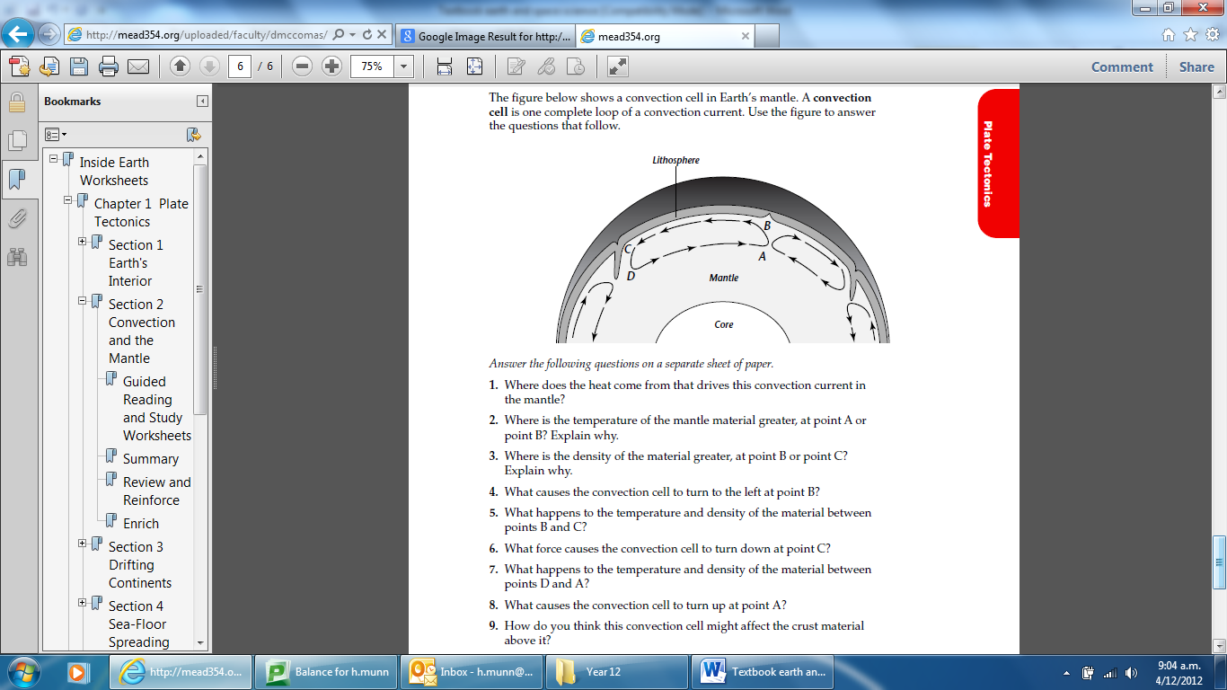

The figure shows a convection cell in Earth’s Mantle. A **convection cell** is one complete loop of a convection current. Use the figure to answer the questions that follow.

1. Where does the heat come from that drives this convection current in the mantle?

_________________________________________________________________________________________________________________________________________________________________________________________________________

2) Where is the temperature of the mantle material greater, at point A or point B? Explain why _________________________________________________________________________________________________________________________________________________________________________________________________________

3) Where is the density of the material greater, at point B or point C? Explain why. _________________________________________________________________________________________________________________________________________________________________________________________________________

4) What causes the convection cell to turn to the left at point B? ______________________________________________________________________________________________________________________________________

5) What happens to the temperature and density of the material between points B and C? _________________________________________________________________________________________________________________________________________________________________________________________________________

6) What force causes the convection cell to turn down at point C? _________________________________________________________________________________________________________________________________________________________________________________________________________

7) What happens to the temperature and density of the material between points D and A? _________________________________________________________________________________________________________________________________________________________________________________________________________

8) How do you think this convection cell might affect the crust material above it?

_________________________________________________________________________________________________________________________________________________________________________________________________________

**Activity 3 World of Quakes activity**

**Part 1 – Seismologist instructions**

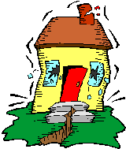

You are a seismologist – earthquake specialists.

Look carefully at the map you have been given.

|  |
| --- |
| What does this map show you? |
|  |
| Describe any patterns that you see in the data (such as groups or lines of dots, concentrations of different colours). |
|  |
| Which parts of the world get the most earthquakes? |
|  |
| Which parts of the world get the deepest earthquakes? |
|  |
| Which parts of the world don’t get earthquakes? |
|  |
| What do you think might cause the patterns of earthquakes? |

**Part 1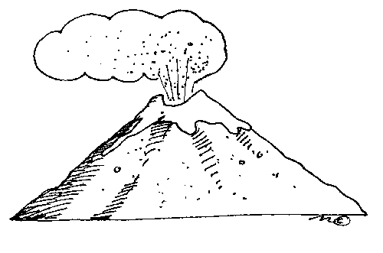 – Vulcanologist instructions**

You are a vulcanologist – volcano specialist.

Look carefully at the map you have been given.

|  |
| --- |
| What does this map show you? |
|  |
| Describe any patterns that you see in the data (such as groups or lines of dots). |
|  |
| Which parts of the world have the most volcanoes? |
|  |
| Which parts of the world don’t have volcanoes? |
|  |
| What do you think might cause the patterns of volcanoes? |

**Part 1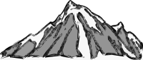– Geographer instructions**

You are a geography specialist.

Look carefully at the map you have been given.

|  |
| --- |
| What does this map show you? |
|  |
| Which parts of the world have the highest land elevations? |
|  |
| The seas on the edges of continents are shallow, but where are other shallow parts of the oceans? |
|  |
| Where are the deepest parts of the oceans? |
|  |
| What do you think might cause this distribution of high and low elevations? |

**Part 2 – Specialists working together instructions**

Your team should have seismologists and vulcanologists.

Look at the new map, showing the world divided up into what are called ‘tectonic plates’.

*Tectonic plates are sections of the outermost layer of the Earth (called the lithosphere) that ‘float’ on a hotter layer beneath (called the asthenosphere). Where plates meet is called the plate boundary. Tectonic plates are moving very, very slowly; some move towards each other, some move away from each other, some slide past each other.*

Where on the plates is the highest land?

Where on the plates is the sea shallowest?

Where on the plates is the sea deepest?

Look at how the plates relate to where earthquakes and volcanoes happen.

* Are earthquakes and volcanoes found in the same parts of the plates?

Where on the plates do most earthquakes and volcanoes happen?

* Discuss whether volcanoes or earthquakes *only* happen on boundaries.
* Discuss whether all boundaries have the same number of earthquakes and volcanoes.

Name a plate boundary where there are more earthquakes than volcanoes.

Name a plate boundary where there are more volcanoes than earthquakes.

Find New Zealand on the data maps.

How does the position of New Zealand account for its earthquakes and volcanoes?

**Activity 4**

|  |  |
| --- | --- |
| titleplatetectonics | **Across**  **3.** The zone below the lithosphere. It is more 'plastic' than the lithosphere so it is easier to bend and move.  **6.** The most outer solid portion of the planet Earth.  **8.** The outer part of the Earth's crust. it is composed of solid rock.  **10.** Places where new seafloor is being created.  **12.** The deepest parts of the oceans.  **14.** The Theory of Continental _____________.  **15.** The Earth's ______________ field reverses from time to time.  **16.** Alfred Wegener noticed that the coast of South America seemed to fit into the coast of this continent, just like a jigsaw puzzle.  **17.** Scientist who first proposed the theory that the continents drifted.  **Down**  **1.** The primary force that causes the seafloor to spread and continents to drift.  **2.** Plate _____________.  **4.** ______________ zones. Places where the seafloor is forced under continental plates.  **5.** Section of the Earth below the crust.  **7.** Paleontologists noticed that these were the same on different continents even though the continents were separated by oceans.  **9.** Source of heat in the mantle.  **11.** Seafloor ______________.  **13.** Scientist who first proposed that thermal convection in the mantle causes continental drift. |