# LEARNZ Field Trips

1. **High Country hi-tech - using drones, mobile maps and other smart tools in remote New Zealand**

<http://rata.learnz.org.nz/summary.php?vft=highcountry152>

Term 2 starting 12 May 2015.

Photo: Fairfax NZ.  
  
Teachers and students, how often do you mention wilderness and technology in the same breath? Well here's a chance. Come on a journey to explore the richness and diversity of the New Zealand High Country and meet people who are using technology in fascinating ways for work and leisure.

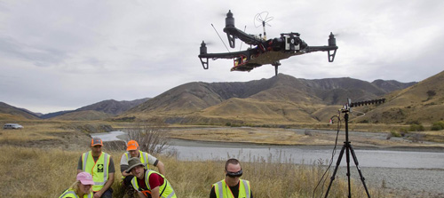

**To prepare for this field trip, LEARNZ content will support inquiry into:**

* New Zealand's high country
* The Mackenzie Country
* drones and their uses
* New Zealand and International Positioning Systems
* maps and other apps on mobile devices
* smart technology
* managing New Zealand's conservation estate
* pastoral lease management
* smart farming
* geocaching

**During this field trip you will:**

* explore remote parts of the iconic Mackenzie Country
* be able to follow the LEARNZ team's location in real time
* meet a drone pilot
* get behind the controls of a drone and fly it
* operate a drone to collect data from a remote place
* follow data gathered in the field and see how it is used
* find your location using GPS on your mobile phone
* explore land-use maps on your mobile phone
* meet a farmer who uses smart technology
* meet a conservation worker who uses smart technology
* investigate the national problem of wilding pines
* visit an archaeological site and map it using mobile digital tools
* use a mobile device to draw land boundaries
* monitor native bird movements
* visit a site where LOTR was filmed
* visit a geocaching site at Mt John and follow their 360 degree live feed
* learn about the process for measuring the new height of Aoraki - Mt Cook
* meet a recreational user, such as a hunter, and find out how they use GPS

**Where you will go**

The Mackenzie Country in central South Island is classic New Zealand high country. Once untouched wilderness, in the last two hundred years or so humans have had an increasing impact. Until recently its most well-known land-use was the many large stations running thousands of sheep. In modern times an increasing variety of human activities have emerged, such as other types of farms, forestry, hunting, fishing, kayaking, rowing, film-making, stargazing, skiing, and heli-skiing. Many of these activities now use a wide array of innovative technologies.