Marketing Mix

The Marketing Mix covers the way a business use product, price, promotion and place to market and sell its product. Also known as the 4Ps'.

Definition: The integration of product, place, promotion and pricing designed to achieve the marketing objectives of the business.

An effective mix....

* achieves marketing objectives
* meets customers' needs
* is balanced and consistent
* creates a competitive advantage
* matches corporate resources

Price: How much the customer is expected to pay for the product.

Product: Refers to the features and functions of the product or service being offered.

Promotion: Communication with the consumers.

Place: Where the purchase can be made by the consumer.

**Product**

Product needs to exist for other elements of the mix to happen.

*Key terms:

* Product development: The process of improving an existing product line to meet the needs of the market.
* Product line: A set of related goods and services
* Product mix: The full range of products offered by a business, also known as product portfolio.

Product development is very important to small and growing businesses because it comes from identifying the needs of customers who should always be the focus of an organisation. It would be dangerous for any business to assume that a successful product will still be successful in a year's time.

The product development process:

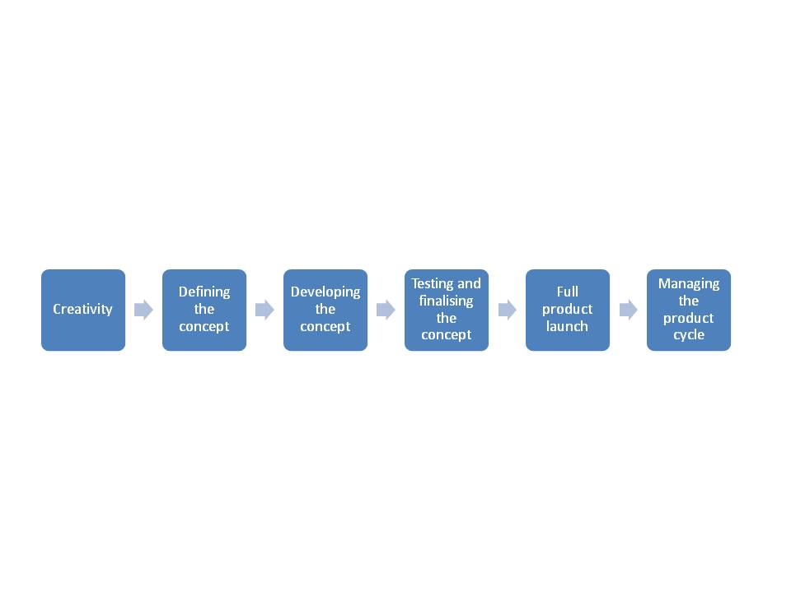

* Ideas stage: Market researchers look for a gap in the market and figure out how a new product can best meet customer needs.
* Screening stage: The business analyses the idea for the new product to see if its easy to market, and to see if it'll make profit. It also finds out what consumers think of the potential new product.
* Product development stage: The prototype (model) is turned into a saleable product.
* Value analysis: The business tries to make the product good value for money by looking at the cost of making, warehousing and distributing the product to make sure the whole process is efficient and give value for money - for both the business and the consumer.
* Testing: Just before launch, the product may be tested. A small batch of pilot products are made, and market research investigates customer reactions.

Product development can create a unique selling point (USP).

USP: a special quality of a product which makes it different from other goods.

Product differentiation: the process of ensuring that a product has some unique features that distinguish it from competing ones.

Brands: Consistent and well-recognised.

* Benefits:
* Inspires customers’ loyalty leading to repeat sales.
* Can charge higher prices, especially if the brand is a market leader.
* Retailers or service sellers would want to stock your brand in their shops.

Product portfolio analysis: Analysing the existing product mix to help develop a balanced range of goods and services.

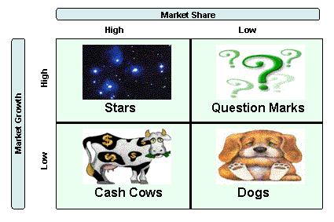The Boston Matrix

The rising star: high market growth, high market share. Marketing resources and effort should be concentrated on this type of product so that market share is maintained. E.g. iPhone, Woodies

The question mark/Problem child: High market growth, low market share. Usually a new product that would need high levels of investment to become a 'rising star'. High failure rate, but huge potential. E.g. iPad, a deli in London

The cash cow: Low market growth, high market share. Basically products that are already well established, with very high profits. E.g. iPod, cigarettes, chocolates, McDonalds

The dog: Low market growth, low market share. In other words, a product that is failing/declining. Can be revived, using Extension Strategies. E.g. Netbook, a hot dog stand in Brighton

The product life cycle: stages in the life of a product in terms of sales and profitability, from its launch to its decline.

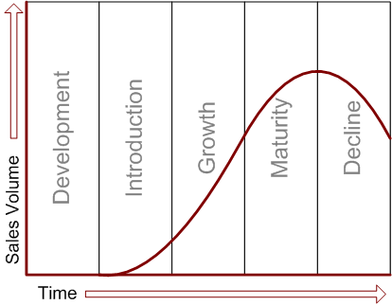Extension Strategies: A marketing strategy aimed at extending the life of a product either by making small changes in it, finding new uses for it, or finding new markets. (Usually used when a product is at the end of the maturity stage and is at the beginning of the decline stage.)

**Promotion**

Definition: Bringing a product or range of products to the attention of existing and potential customers.

* Tapping into our subconscious mind.

*Key terms:

Sales promotion: Offers designed to increase sales.

Promotional activities: The ways in which a business can communicate with its potential/existing customers with the aim of increasing sales.

Direct selling: A way of selling directly to the final customer without another intermediary.

Merchandising: The visual presentation of a product to the consumer at the point of sale.

Advertising: The use of media to communicate with consumers.

Public relations: Communicating with the media to enhance the image of the business and its product, and thereby increase sales.

Branding: Creating an identity for a business and its products to differentiate it from rivals in the market.

Promotional mix: The combination of promotional activities which make up a campaign to communicate with a target market.

Uses of promotion:

* Increase sales
* Attract new customers
* Create an image
* Inform
* Encourage customer loyalty

Promotional activities:

* Advertising – the most expensive form of promotion:

Advantages: Wide area coverage (regional/national), potential customers will be forced to watch/listen as they’re watching TV/listening to radio,

Disadvantages: Not all types of media are available to small businesses, competitors advertisement may be more successful, the law have a say on where and how they can advertise,

* Direct selling:

Advantages: Orders can be collected and delivered, features and functions of product can be fully explained, feedback can be gathered directly,

Disadvantages: Expensive to maintain a sales team, some customers dislike “cold callers”, there are legal issues to protect consumers from being intimidated by forceful people.

* Merchandising:

Advantages: Often target impulse buyers, attracts customers psychologically,

Disadvantages: Costly to make high quality display materials,

* Public Relations (PR):

Advantages: Gives a business good publicity in the media

Disadvantages: Mistakes the business make will be known to public

* Branding:

Advantages: Customers’ can see it is an established business, customers pay a premium price for branded products, creates customer loyalty, helps distinguish the products.

Disadvantages: High number of competitions as brand becomes well-known

* Sales Promotion:

Advantages: Effective at achieving a quick boost to sales, encourages customer to trial a product,

Disadvantages: Sales effect is short-term, customers expect further promotion,

**Price**

*Key terms:

Pricing strategies: Long-term pricing plans which take into account the objectives of the business and the value associated with the product.

Price skimming: Entering a market with a high price to attract early adopters and recoup high development costs.

Penetration pricing: Setting prices lower than market prices to get a grip in an established and competitive market.

Price leader: A product that has a significant market share and can influence the market price.

Price taker: A firm which sets its prices at the same or similar level to price leaders in the industry.

Pricing tactics: The manipulation of price to achieve a specific short-term objective.

Loss leaders: Products sold at less than cost to attract customers to a product range.

Psychological pricing: The use of odd number pricing to increase the value-for-money appeal of a product.

Price elasticity of demand (PED): The sensitivity of demand to the change in a product’s price.

Price inelastic demand: The demand for a product changes relatively less than the change in price.

Price elastic demand: The demand for a product changes relatively more than the change in price.

Pricing strategies for new products:

* Price skimming
* Penetration pricing.

Pricing strategies for existing products:

* Price leaders
* Price takers

Pricing tactics:

* Loss leaders
* Psychological pricing

Influences on pricing decisions:

* Costs: Loss leader available on short-term basis, the business needs to make sure costs are covered by other products.
* Competitors: Price wars, a business needs to be aware of prices of their competitors.
* The market: Number of customers and competitors and conditions of the life cycle of their products need to be taken into consideration.
* The target market: A business needs to make sure it matches the potential customer’s income.
* The objectives of the business: Depends on what the business wants to achieve.
* The other elements of the marketing mix: The other elements must be fully integrated for the mix to be effective.
* Sensitivity of demand to price changes: If price increases, demand decreases. However, it depends on the product and the business.

Formula to calculate PED:

PED = % change in demand

% change in price

* When PED is more than 1, demand is price elastic.
* When PED is less than 1, demand is price inelastic.

**Place**

This element of the marketing mix is concerned with the distribution of the product to the purchaser.

*Key terms:

Distribution channel: Method by which a product is sold to the customer.

Direct sale: Where no intermediaries are used.

Intermediaries: Organisations involved in the distribution of goods and services on behalf of other businesses.

Business to business markets: Companies meeting the needs of other businesses in the market place.

Business to consumer markets: Companies meeting the needs of final consumers of goods and services.

Main types of intermediaries:

* Retailer

Advantages: Convenient for customers, Often UK wide, retailer chooses the final price, handles the financial transaction, holds the stock, after-sales support

* Wholesaler

Advantages: Reduce the producer transport costs, retailers can order in small amounts from wholesalers

* Distributor
* Agent

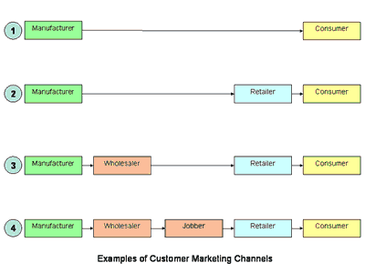

Factors influencing place decisions:

* Costs
* Competitors
* Market coverage
* Control
* The marketing mix
* Volume of sales