First Synergizer calves welcomed on Pāmu farm
Adding value along the value chain
Pāmu, the brand name for Landcorp Farming Limited, is a state-owned farming business in New Zealand focused on sustainable, innovative, and research-driven agriculture. Managing over 100 farms and forestry operations, it spans dairy, livestock, horticulture, and forestry, using its scale to trial new ideas, conduct research, and lead positive change while caring for land, water, animals, and communities for future generations.
Dairy farmers in New Zealand are facing increasing pressure to address both the issue of bobby calves and rising scrutiny around methane emissions. Traditionally, large numbers of non-replacement (bobby) calves have had low economic value, creating ethical concerns and inefficiencies in the dairy system. At the same time, farmers are under growing regulatory and market pressure to reduce greenhouse gas emissions, particularly methane produced by livestock. Balancing profitability with sustainability is becoming more challenging, as farmers look for solutions that improve the value of surplus calves while also adopting breeding and management practices that can lower emissions and meet evolving environmental expectations.
Read “First Synergizer calves welcomed on Pāmu farm” and discuss the questions below

Discussion questions
- Who is Pāmu, and what role does it play in driving innovation and progress within New Zealand’s primary sector?
- What key challenges and needs are currently facing dairy farmers, particularly in relation to bobby calves, profitability, and environmental pressures?
- How does the research and breeding programme at Pāmu’s Waikite Farm aim to address these challenges?
- What is meant by the “value chain” in the context of the dairy-beef industry?
- In what ways could the Synergizer breed add value at different stages of the value chain, from farm to consumer?
- Why is it important to develop a purpose-bred dairy-beef animal rather than relying on traditional beef breeds?
- How might innovations like the Synergizer breed contribute to both economic and environmental sustainability in the farming sector?
- What role does collaboration between organisations like Pāmu and LIC play in advancing agricultural research and innovation?
First Synergizer calves welcomed on Pāmu farm
https://www.farmersweekly.co.nz/news/sheep-and-beef/first-synergizer-calves-welcomed-on-pamu-farm/
April 24, 2026
First of breed tailored to dairy-beef needs are born on Waikite Farm ahead of commercial launch next year.
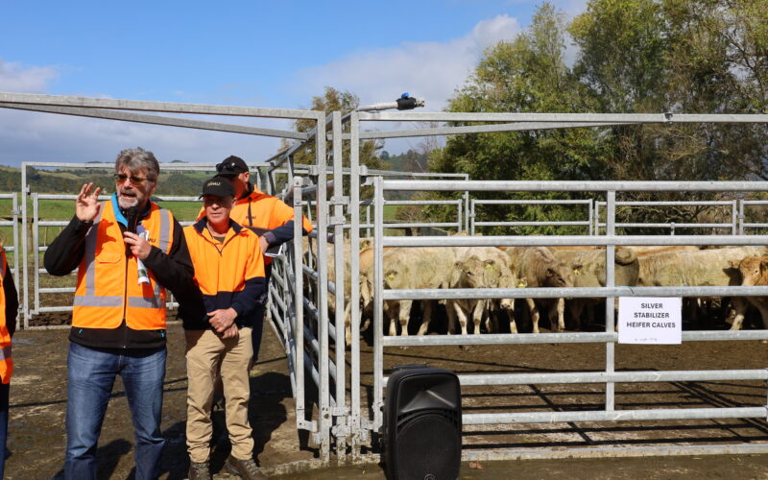LIC research leader Ric Sherlock and Waikite Farm manager Peter Strawbridge, right, speak to farmers at the farm’s open day. In the pen are Stabilizer heifer calves that are part of Pāmu’s beef herd.

The first Synergizer calves have been born at Pāmu-owned Waikite Farm ahead of the new dairy-beef breed’s commercial launch in 2027.
The heifer calves are being grown at the farm south of Rotorua, while the bulls are being monitored by LIC at its methane research barn. They were weaned at 264kg at 150 days.
The breed has been developed by LIC in partnership with Pāmu on the 992-hectare effective sheep and beef farm with staff from both companies updating farmers on progress at a recent open day held on the farm.
The farm is a key genetics engine room for Pāmu’s sheep and dairy beef genetics programmes.
The Synergizer breed is a Charolais crossed with a Stabilizer composite breed and is designed to be mated with dairy cows calving a farmer’s non-replacement calves, LIC research leader Ric Sherlock said.
Charolais was chosen because of its growth rates, and the resulting calf is easy to spot because of its distinct colour, he said.
“The key thing from a dairy farmers’ point of view is that when you see that calf hit the ground that it’s actually a non-replacement calf and it’s not one of the replacements.”
He is aiming to build a 350-cow closed Synergizer herd on the farm to provide the scale to make good genetic progress for the new breed.
The programme’s first progeny are eight months of age and will be processed before their second winter so the breed’s meat quality attributes can be assessed.
LIC’s head of genetics, Izzy Willison, said they developed the breed so farmers would have confidence that they have a product that adds value all the way along the value chain.
“We are starting to see a real opportunity with dairy farmers starting to selectively breed their cows. They are putting their bottom BW cows to a beef product.”
LIC sees that growing at around 20%. The dairy genetics company wants it released on the commercial market as a “proven” product.
Around 2000 straws will be used this spring on Pāmu dairy farms and the data collected from that animal’s life cycle will help shape the final product ahead of its commercial launch in 2027 as a liquid product.
Silver Fern Farms recently inspected the Synergizer bulls and was impressed with the potential of the breed’s feed-conversion efficiency and growth rates, she said.
“They have customers now who are really rewarding that dairy-beef offering.”
Most dairy farmers are sourcing their beef genetics for their non-replacement cows from beef breeders. However, these breeders are often breeding their animals with slightly different aims to what dairy farmers want, Willison said.
“We need to make sure the whole value chain is balanced and this is why this has been a purpose-bred breed.”

Answers
- Who is Pāmu, and what role does it play in driving innovation and progress within New Zealand’s primary sector?
Pāmu is a state-owned farming enterprise that manages more than 100 farms and forestry operations across New Zealand. Its scale allows it to act as a testing ground for new farming systems, technologies, and genetics. Rather than focusing only on production, Pāmu plays a leadership role by researching, trialling, and demonstrating more sustainable and efficient farming practices. These insights are then shared with the wider industry, helping lift performance across the primary sector while balancing environmental, economic, and social outcomes.

- What key challenges and needs are currently facing dairy farmers, particularly in relation to bobby calves, profitability, and environmental pressures?
Dairy farmers face several interconnected challenges. Bobby calves, non-replacement calves have traditionally had low value, raising both ethical concerns and lost economic opportunities. Farmers need solutions that turn these calves into profitable animals rather than waste. At the same time, there is increasing pressure to reduce greenhouse gas emissions, particularly methane, as part of climate change commitments. Farmers must also remain profitable despite rising costs and market expectations. This creates a need for animals and systems that are efficient, environmentally sustainable, and capable of producing higher-value products.

- How does the research and breeding programme at Pāmu’s Waikite Farm aim to address these challenges?
The Waikite Farm programme focuses on developing the Synergizer breed specifically for dairy-beef systems. By breeding animals that grow quickly, convert feed efficiently, and produce high-quality meat, the programme aims to increase the value of non-replacement calves. The farm acts as a research hub, where data is collected across the animals’ lifecycle from birth to processing to assess performance, meat quality, and environmental impacts such as methane emissions. This evidence-based approach ensures that the final product is practical, profitable, and aligned with sustainability goals.

- What is meant by the “value chain” in the context of the dairy-beef industry?
The value chain refers to all stages involved in producing and delivering a product, from initial breeding and farming through to processing, distribution, and final sale to consumers. In the dairy-beef industry, this includes the dairy farmer breeding the calf, the grower raising it, processors turning it into meat products, and retailers selling it. Each stage adds value, and the goal is to ensure that the product meets the needs of all participants along the chain.

- In what ways could the Synergizer breed add value at different stages of the value chain, from farm to consumer?
At the farm level, Synergizer calves are easily identifiable and designed to grow efficiently, improving profitability for dairy farmers. For beef finishers, the breed offers better growth rates and feed conversion, reducing costs and increasing returns. Processors benefit from more consistent carcass quality and better meat characteristics. At the consumer level, the result is a reliable, high-quality beef product. Overall, the breed is designed to align the needs of each stage, ensuring value is created and retained throughout the entire system.

- Why is it important to develop a purpose-bred dairy-beef animal rather than relying on traditional beef breeds?
Traditional beef breeds are typically selected for traits that suit beef farming systems, which may not align with dairy farmers’ needs. For example, dairy farmers require easy calving, clear identification of non-replacement calves, and compatibility with dairy herd management. A purpose-bred animal like the Synergizer is specifically designed to meet these requirements while still delivering strong beef performance. This targeted approach improves efficiency and ensures better outcomes for both dairy and beef sectors.

- How might innovations like the Synergizer breed contribute to both economic and environmental sustainability in the farming sector?
Economically, the breed increases the value of calves that would otherwise generate little return, improving farm profitability. Environmentally, more efficient animals those that grow faster and convert feed better can reduce emissions per unit of meat produced. Ongoing research into traits like methane emissions can help farmers select animals that have a lower environmental impact. Together, these improvements support a more sustainable and resilient farming system.

- What role does collaboration between organisations like Pāmu and LIC play in advancing agricultural research and innovation?
Collaboration allows organisations to combine expertise, resources, and data. Pāmu provides large-scale farm environments for real-world testing, while LIC contributes advanced genetics research and breeding technology. This partnership accelerates innovation by ensuring that new ideas are both scientifically sound and practically applicable. It also increases confidence among farmers, as the resulting products are well-tested and backed by credible organisations, making adoption more likely across the industry.

