Foot and Mouth Disease  DairyNZ’s Farm Biosecurity Response Plan | Site: Lye Farm, Scott Farm
 | Page: 1 of 10
 | Last Reviewed: June 2017
Persons Implementing:
Farm Staff/Technicians
 | Printed Version:

Immediate Action Plan - summary:
ACTION: COMPLETE: INITIALS:
- Secure farm entrances Yes ____________
- Install Entry Prohibited sign on main gate Yes ____________
- Notify staff and arrange a team meeting Yes ____________
- Move animals away from boundaries Yes ____________

Background:
In the event of an outbreak of an exotic disease that affects cattle in NZ, the Ministry for Primary Industries (MPI) would lead the response plan, and control response activities. For the first 72 hours the country will effectively be in ‘lock-down’ and farms will need to be prepared to implement reasonable biosecurity precautions and to be self-sufficient for this time.

Foot and Mouth Disease (FMD) is a viral disease of cloven hoofed animals (cattle, pigs, sheep, goats and deer, as well as many other species). Animals with FMD develop a high fever, get blisters in their mouths, on their tongues, between the claws of the feet, and on other hairless parts of the body such as the udder. Lactating cows have a significant drop in milk production and may even be dry for a period of time. The disease is not normally fatal in adult animals, but can cause sudden death in calves. FMD is such a concern because it is highly infectious, with infected animal producing large amounts of virus, so it spreads very quickly in animal populations. If NZ had confirmed FMD the countries we export our milk and meat to would no longer accept our products, until we had cleared the infection from NZ, and were sure no infection remained. This would have a big impact on our economy and every sector of our communities.

NOTE: FMD does not affect humans. Hand, Foot and Mouth Disease which affects children is a completely different disease which is not transferable to animals and should not be confused with FMD.

The first action that MPI will take if Foot and Mouth Disease (FMD) is confirmed in NZ will be to stop the movement of all susceptible animals over the entire country.

Farms that have infected animals will be treated as Infected Places. MPI appointed Infected Place (IP) Managers will be allocated to these farms and work with the farmer to control all activities on farm.

Personal Protective Equipment (PPE):
 |  | 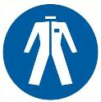 | 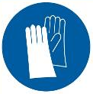
High Vis  Worn at all times | Safety Boots  Worn at all times | Overalls  Recommended | Gloves  Recommended when handling Virkon

Preparation for a NZ Foot and Mouth Disease Outbreak:
By DairyNZ Farms

- Lye and Scott Farm each have enough chains and padlocks available on site to lock all boundary gates  - Except main entrance  - Refer to maps at end of document  - Both ends of gates need to be padlocked  - Unless hinges are such that gate cannot be lifted off hinges | 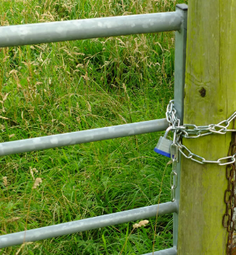
- Lye and Scott Farm main entrances are able to be shut

- Entrance prohibited sign prepared and available
- “Entry is strictly prohibited unless prior approval given by Farm Manager”
- Sign includes Farm Managers contact details

- Signs stored in Farm Manager’s office

- Designated garden sprayer and disinfectant readily available at each farm  - Suggested disinfectants are virkon or alternatively citric acid  - Scrubbing brushes and fish bins should be available  - Gear should be cleaned prior to disinfecting |  | 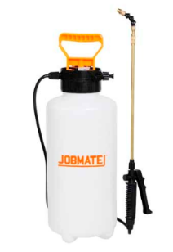
- A stock of disposable overalls and boot covers for essential visitors is available at each farm

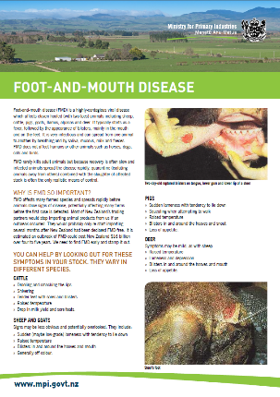
- Resource material to help with identification of FMD lesions is available at each farm
- Ministry for Primary Industries (MPI) poster
- Guidelines for veterinarians
- DairyNZ FMD resources

- Check staff emergency text alert system has up to date lists of all Lye and Scott Staff (including casuals)

- Have a conference call number available that can be used to set up a teleconference for all staff at short notice

- Develop a site plan for managing staff on the farm for the first 72 hours of a response
- This must include
  - Which staff have contact with susceptible animals at home
  - Which staff would require family support if they can’t go home

- Develop a site plan for managing all animals on site for 72 hours if no feed or other support can be brought onto farm in this time

- Ensure vehicles used for farm visits carry
- Disinfectant
- Scrubbing brush
- Plastic bags for samples and PPE

Confirmed NZ Outbreak of Foot and Mouth Disease:
Required DairyNZ On-Farm Actions

- Secure farm boundaries and entry points
- Ensure there is NO stock movement on or off the farm at this time  - Minimises the chance of inadvertently spreading disease | 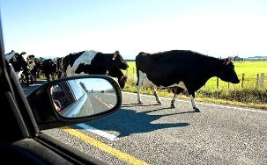
- No visitors are allowed on farm
- Minimises the chance of inadvertently spreading disease

- Lock the main entrance gate/s or close tape gate
- Display signage
  - “No Entry is Permitted – Unless Permission is Obtained from Farm Manager”
  - Include Farm Manager contact details
- Ensure entrance way is secure from wandering stock, especially at night

- Visitors should leave their vehicles outside the farm gate

- Ensure machinery and visitors that have been on other farms do not enter the farm
- These visitors are VERY high risk

- Lock non-essential boundary gates
- Check any gates that are normally locked to ensure they are still securely locked

- Close of any public walkways bordering the farm
- i.e. the Newstead walkway bordering Scott Farm
- Use tape and No Public access signage

- Ensure facilities are available for visitors to clean and disinfect footwear
- A garden sprayer with a disinfectant effective against FMD should be available
- Suggested disinfectants are virkon or citric acid
  - Ensure there are adequate supplies provided at all times

- Disposable overalls and boot covers should be used for essential visitors
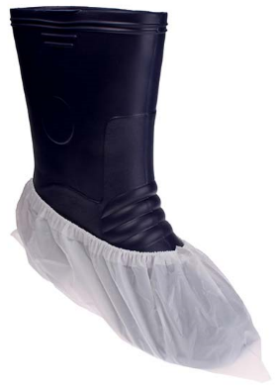
- Check all stock for any signs of disease
- Check ALL animals on farm for any signs of FMD at regular intervals
- Use supplied FMD resources

- Most obvious signs of FMD
  - Depression
  - Lethargy
  - Drooling
  - Possible lameness

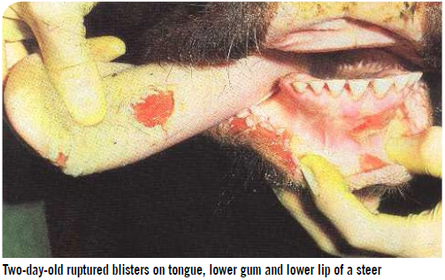
- Closer examination
  - Blisters or erosions
    - Inside the lips
    - Dental pad
    - Tongue
    - Inside the mouth
    - Muzzle (possible)
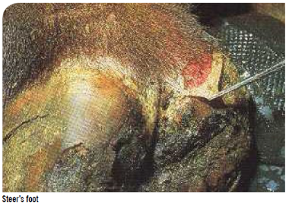
    - Foot lesions (resembling foot rot)
    - Lesions in the teats (possible)

- Milking cows
  - Sudden and significant drop in milk production
  - Some produce very little in early stages of infection

- Check any animals that have arrived on farm in the last 14 days
- Keep animals isolated from other stock if they have not yet been mixed
  - 14 days is the maximum incubation period for FMD

- Notifiy MPI as soon as possible if you suspect FMD may be present
- This will normally be done by the farm vet
- The MPI number is 0800 80 99 66

- It is also essential to notify DairyNZ management, in the first instance a call should be made to Chris Morley (021 309 563) or Nita Harding (021 225 9138)

- Bring stock to the centre of the farm
- Minimises the opportunities for stock contact over boundary fences

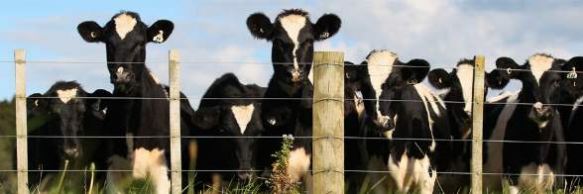

- Increases the distance from other stock, reducing the risk of infection being spread by air movement such as on the wind

- Set up staff management plan
- MPI’s first priority will be to understand where the disease is in NZ and set up high risk control zones around infected sites
- The whole country will be considered high risk initially
- There will be a lot of uncertainty in the initial stages of a response

- All Lye and Scott Staff (including casuals), whether at work or not, need to be notified as soon as possible via the DairyNZ emergency text alert system
- Initial instructions will be for staff to remain where they are (at work or at home) until further notice
- A staff meeting for all staff on site will follow, as soon as possible
  - Staff off site should dial in
  - Staff will be sent dial in instructions by text

- Lye and Scott staff (including casuals) who have contact with susceptible animals at home
- If not at work when the FMD announcement is made
  - Staff should NOT come into work until they have contacted their manager

- If at work when FMD announcement is made
  - Staff should not go home unless they can
    - Shower
    - Change into a completely clean set of clothes
    - Stay away from susceptible animals for 48 hours when they go home

    - Any work clothing must go through a hot (>60⁰C) machine wash as soon as possible

- Staff at work on the farms are likely to need to stay at work initially
- Meals, medication, clothing and sleeping bags etc. will need to be delivered to the farm gate
- Off-site support for farm worker’s families may also be needed
  - E.g. child care

- Review animal management and feeding plans
- For some weeks (likely months),
- It will not be possible to move stock off farm
- There may be limits around what sort of supplementary feed can be brought onto farm

- A plan needs to be developed that will enable all animals to be fed and managed on farm for at least 72 hours
- Without relying on incoming feed or support
- Without compromising animal welfare

- DairyNZ research staff / technicians on non-DairyNZ farms when FMD announcement made
- If the farm is deemed an Infected Place by MPI,
- DairyNZ staff will need to follow all directions given by MPI on site
  - May mean a delayed departure from the site
  - A restriction on the removal of samples from the farm
  - Requirements for disinfecting equipment and clothing

- If the farm is deemed NOT an Infected Place by MPI,
- DairyNZ staff will need to be sensitive to the farmer needs in terms of closing off the farm

- Staff may leave the farm but
  - All equipment and PPE should be cleaned and disinfected prior to leaving
  - If no disinfectant is available, then wash in hot water (>60⁰C) and detergent
  - Items that are difficult to wash (eg. Overalls) should be left on the farm or double bagged for removal
  - Vehicles that have been driven on the farm should have wheels, wheel arches and undercarriage hosed to remove all obvious dirt
  - If samples such as blood samples have been collected these will need to be left on farm until further notice. It may be possible to retrieve these samples at a later date, however this will depend on MPI requirements.

- Staff should not visit any other farm, or contact any susceptible animals until
- Fully showered, including hair washed
- Completely changed clothes
- A stand-down of 48 hours has passed

- Keep up-to-date with MPI announcements and DairyNZ staff notices
- MPI public announcements will be available on
- MPI website (most up-to-date)
- TV and radio
- Social media
- Newspapers including main newspapers and rural newspapers
- DairyNZ will be providing regular updates for staff
- Likely to be specific messages for the DairyNZ farm staff which will communicated directly to key farm staff

- DairyNZ will be repeating MPI information and providing updates for farmers
- Website
- Social media
- Email

DairyNZ Farm Maps
Lye Farm
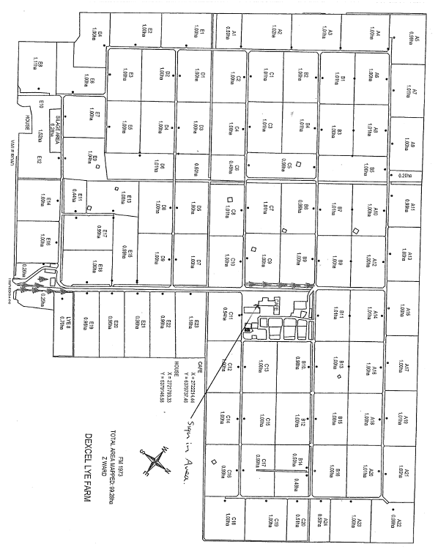

Scott Farm
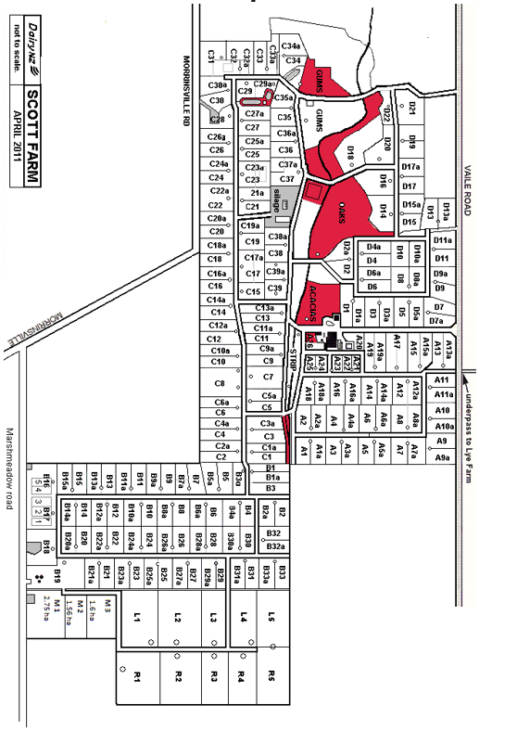

Emergency Procedure:
Virkon – Eye Contact
- Rinse eye immediately with plenty of water
- Remove contact lenses
- Rinse under eyelids
- Rinse for at least 15 minutes

- Call physician immediately

Virkon – Ingestion
- Do NOT induce vomiting

- If person vomits when lying on their back, place in recovery position

- Drink 1 -2 glasses of water
- Never give anything by mouth to an unconscious person

- Call a physician immediately

Virkon – Skin Contact
- Wash off immediately with plenty of water

- Remove contaminated clothing and shoes
- Wash before reuse

- Consult a physician

Virkon - Inhalation
- Remove from exposure, lie patient down

- If patient has stopped breathing,
- Start CPR
- Send for AED

- Call for an ambulance
- 111 (mobiles)
- 1- 111 (office phones)

Activity | Person | Date
Created | Nita Harding - Technical Policy Advisor (Veterinary) | June 2017
Reviewed | Kirsty Schmidt – SOP Developer  Bruce Sugar – Lye Farm Manager  Ben Fisher – Scott Farm Manager  Stu Morgan – Science Support Manager | June 2017
Approved

