NCEA Resource

North Asia Region
Meeting market needs in China

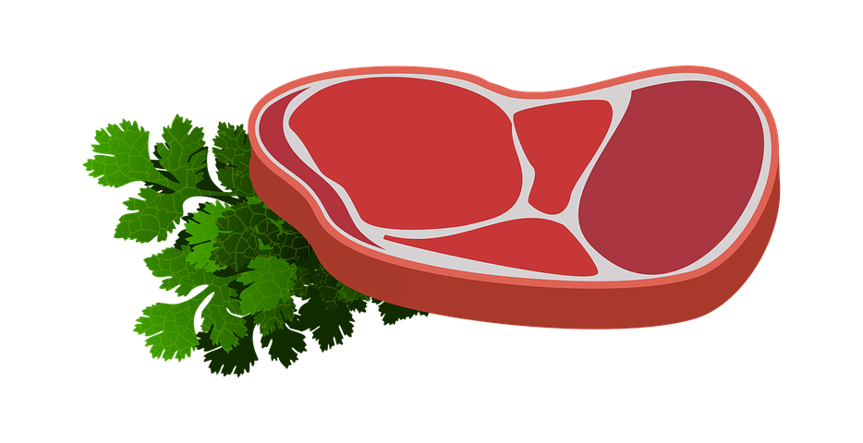
Teacher Guidance

This resource focuses on the demand for protein (red meat) in China. New Zealand companies must ensure they add value to their product both from the Chinese consumer point of view and being able to differentiate themselves from competitors around the globe.

Agribusiness/Business Studies Level 3 Achievement Standard 91871 - Analyse how a product meets market needs through innovation in the value chain

Agribusiness/Business Studies NCEA Resource
Meeting market needs in China

CAPE Region: North Asia
Country: China

This resource:
- Should be subjected to the school’s usual assessment quality assurance processes
- Should be modified to make the context relevant to students in their school/kura environment and ensure that submitted evidence is authentic
- Teachers need to satisfy themselves that the resource meets the requirements of the standard and develop any further material or details that may be required if used for moderation purposes.

Theme
Students will be able to identify and explain the market needs of the Chinese consumer and explain how innovation in the New Zealand red meat industry is designed to meet these market needs and capture a greater share of the market value of the product.
NCEA Assessment – Agribusiness/Business Studies
Level three Agribusiness - AS91871
Analyse how a product meets market needs through innovation in the value chain.
Links to global competence
- Examine local, global and intercultural issues
- Understand and appreciate the perspectives and worldviews of others
- Take action for collective well-being and sustainable development.
New Zealand Curriculum
- Understand how the nature and size of the New Zealand economy is influenced by interacting internal and external factors
- Demonstrate understanding of how a business that operates in a global context responds strategically to external factors
- Discuss a complex problem(s) in a given global business and apply business knowledge to provide possible solutions and recommendations to address issues
- Investigate the exporting potential of a New Zealand business.
To achieve these objectives specific factors of the red meat industry business need to be examined including:
- societal expectations on the business (environmental, economic, social, cultural)
- cultural intelligence and responsiveness (importance of protocols, relationships, flexibility)
- changes in the global marketplace (consumer behaviour)
- innovation (risks and opportunities of innovation, including intellectual property management, product and process innovation, corporate cultures and strategies encouraging innovation).
Key Competencies:
Participating and Contributing | How to contribute to the business, industry and national economic interest through participating in a global context to meet the needs of consumers
Thinking | Critically analyse the development of goods and services to identify areas of opportunity
Relating to Others | Share experiences to understand the culture of other countries and their people to develop an understanding of the goods and services that they desire
Using Language, Symbols & Texts | Understand the power of messaging and how this can have an impact on the perception and value of a good or service
Managing Self | Using a range of resources to form an independent opinion about the opportunities of a business in selling to an overseas market

Values
Integrity - Using the information that you are provided with in a responsible and ethical manner
Innovation, inquiry and curiosity - Analysing a current situation to identify and explain possible innovation opportunities for Silver Fern Farms.
Possible links to other curriculum areas
Science
Food technology
Social sciences
Key concepts/big ideas
- How does Silver Fern Farms add value to the red meat products they export to China to increase profitability of the business?
- How can the New Zealand red meat industry (RMI) add value to the products that they produce for the Chinese market?
- How Chinese consumers differ from New Zealand consumers and the impact this has on the production of red meat in New Zealand?
- How can innovation separate New Zealand from other red meat exporting countries to capture a larger share of the Chinese market?
Resources
AgriBusiness Resources
Great resources to establish value chain terminology and the significance of the value chain for New Zealand.

Silver Fern Farms
Background information on the company and the products that they produce.

Beef and Lamb NZ meat export tool
- Tool to look at the trend in value and volume of NZ Meat Exports
- Can isolate different areas of the world and exports for trends
- Trends over the past 5 years

NZ Herald article – China's appetite for red meat grows
Rural news - China will be hungry for NZ meat
Export and Trade - Red meat sector must pursue ‘value and volume’ into China

Learning sequence

Cover:
- What is ‘growing value’ and why is it important for a company and a nation to grow the value of their products?
- How does Silver Fern Farms add value to their products being exported to China currently?
- How does a supply chain differ from a value chain?
- What is the difference between the supply chain of Silver Fern Farms and the value chain of Silver Fern Farms?
- What are the characteristics of a market (China) and why are they important to understand?
- What does the consumer in China want? How does it fit with their
  - Culture
  - Behaviour
  - Brand recognition?
- Define and explain product innovation and how Silver Fern Farms add value to their products
- How will capturing more value for Silver Fern Farms impact the business and New Zealand?
The student assessment task for this resource is found here.

