Apples in short supply across country

LAURA WALTERS
Last updated 20:47, January 17 2017

http://www.stuff.co.nz/business/farming/88514563/apples-in-short-supply-across-country
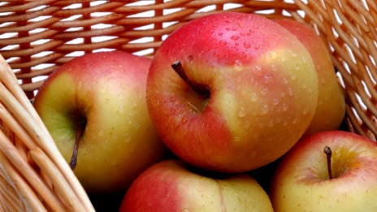
FAIRFAX NZ

Bad timing of seasons means New Zealand's experiencing an apple shortage.
Apples are in short supply due to a slow start to the New Zealand season.

The popular fruit is usually available year-round but this week shoppers were shocked to see empty shelves where the granny smiths and royal gala would usually sit.

A Countdown spokeswoman said there were apples in their stores at the moment but they were not New Zealand apples.

"We're in between seasons at the moment," she said. "Apples are very popular with our customers so we have imported a range of apples to make sure Kiwis can still enjoy an apple mid-season."

The strong export market last year meant apples were in short supply until the new season New Zealand apples started rolling in.

But there is good news for all the apple-lovers out there: New season royal gala New Zealand apples will be available in Countdown stores for next weekend.
Apples are a popular choice for those looking to buy economically priced, locally sourced fruit.

Luckily, the shortage falls at a time when summer fruits, like nectarines and plums, are in abundance.

And the prices on these stonefruit are finally starting to drop.

A spokeswoman for Foodstuffs, the co-operative that owns New World and Pak 'n Save, said Kiwis embraced fresh, seasonal New Zealand produce.

"So while our stores have apples available, technically the New Zealand apple season has not yet kicked off," she said. "Ahead of apple season we try and make as much room as possible for delicious berries and stone-fruit which are in season and very much in shopper demand."

Once the stone-fruit and berry season tailed off, Kiwis could look forward to the new season of crisp, fresh New Zealand apples which would be hitting New World and Pak 'n Save stores in a week or so.
- Stuff

