Kiwi ingenuity saves the day amid Chinese New Year cherry rush

http://www.stuff.co.nz/business/better-business/88559722/kiwi-ingenuity-saves-the-day-amid-chinese-new-year-cherry-rush

CHARLOTTE GREENFIELD
Last updated 09:36, January 19 2017

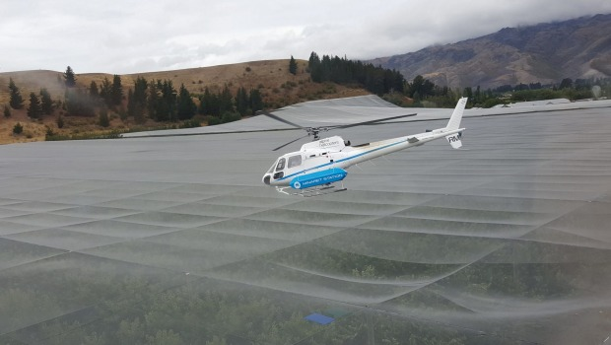

A helicopter is used to dry cherries at New Zealand Cherry Corp's orchard in Cromwell.

New Zealand cherry producers are flying helicopters low over their orchards to dry off raindrops and protect thousands of tonnes of their product headed to Asia to feed rapidly growing demand from Chinese New Year revellers.

China has grown to become the second largest destination for New Zealand cherries after Taiwan in the past seven years. Together they take about 60 per cent of cherry exports, which were worth about $43 million last year.

Last week New Zealand exported 900 tonnes of cherries, the largest amount recorded in a one-week period. Exports are expected to grow to around $50 million this season, according to Tim Jones, chairman of Summerfruit NZ, which represents growers.

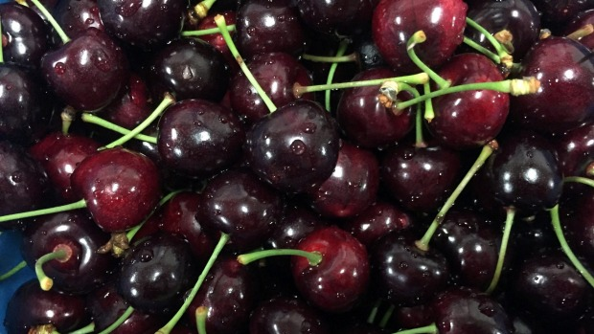
JO MCKENZIE-MCLEAN
Cherries are extremely popular in China.

"The demand is phenomenal," said Tracey Burns, who handles international cherry sales at produce exporter Freshmax.

Singapore Airlines said it is re-directing four cargo flights from Auckland to Christchurch to pick up 300 tonnes of cherries to be shipped on to cities in mainland China, Hong Kong and Taipei by Thursday.

JASON LEE/REUTERS

China is set to mark the year of the rooster this Chinese New Year.

Exporters and growers said they received constant requests for as much as fruit they could grow during Chinese New Year.

"I had a woman recently calling me up from China wanting 500 tonnes. We only do probably 50 tonnes in our orchard maximum, so I think she was dreaming a little bit," said Martin Milne, a grower in Cromwell.

All harvesting and sales take place in a two-and-a-half-month season starting in December, but the timeframe for Chinese New Year is even tighter: growers have to deliver fruit by January 23, the deadline set by Asian distributors.

Growers in Central Otago are paying thousands of dollars an hour to fly helicopters over trees to stop rainfall from cracking fruit.

To ensure the good quality sought by Asian buyers, the choppers have been flying just one metre above the trees, operating like fans to blow away moisture left by recent rain.

"It's a high-value, fast-moving crop which means it gets a lot less room for glitches like rain," said Marie Dawkins, Chief Executive Officer of Summerfruit NZ.

Growers were racing on Wednesday against the incoming weather bomb low.
"It's a bit of a worry but at the end of the day the weather is what it is and you can't do much about it except getting helicopters out," said Milne.

- Reuters

