**Level 2 Future proofing influences: Economic and Political.**

**NZ Hothouse**

Market leaders in hothouse produce. NZ Hothouse has grown, packed and marketed New Zealand's freshest and most flavoursome produce for over 30 years.

For more information visit [NZ Hothouse](https://nzhothouse.co.nz/about) it includes a short video.

Founder and Executive Chairman Brett Wharfe started growing tomatoes in 1984.

**Teacher Note:**This worksheet provides an example of **economic and political influences**. The shorter article, *“Gas Crisis Threatens Tomato Growers and Jobs,”* has been adapted from the article *“The Industry-Killing Crisis: Indoor Food Production,”* which is also included in this worksheet.

The **Future Proofing Influences Questions** focus on **economic and political influences**.  
Note: Questions 6–8 can be repeated using other future proofing influences. Alternatively, you could split the class into groups, assigning each group a different influence to explore using the same questions. Afterwards, bring the class back together to discuss and compare findings.

This worksheet can be used as **prior learning** for a Level 3 **Future Proofing Strategy**. A separate worksheet, also based on *“The Industry-Killing Crisis: Indoor Food Production,”* has been developed for Level 3.

**Gas Crisis Threatens Tomato Growers and Jobs**

Simon Watson, managing director of NZ Hothouse, says a growing natural gas shortage could destroy parts of New Zealand’s hothouse industry, cost thousands of jobs, and make food more expensive.

NZ Hothouse, based in South Auckland, has been growing tomatoes in large greenhouses for 25 years. When it started, it used natural gas from the Maui pipeline, a cleaner and cheaper option than coal. The gas was used to heat the greenhouses and feed the plants carbon dioxide, helping them grow.

But now, gas supplies are running out, and prices are rising fast. Watson says they are now paying three times more than they did in the past, and it's still going up.

“Gas was cheap, and we were told it would last forever,” Watson says. “Now we’re facing the biggest challenge in over 30 years.”

His 10-hectare greenhouse in Drury produces nearly half a million tomatoes a year and employs many workers. But the future is uncertain. Watson only recently realised how serious the gas crisis is. At a meeting with business leaders, he learned that many industries, including meat, dairy, drinks, sugar, alcohol, building, and even schools and hospitals depend on natural gas.

“Around 80 to 90% of the products in a supermarket have some gas connection,” he says.

The company first noticed gas supply problems three years ago, but the situation has gotten much worse. A government report says gas reserves have halved in just four years, and supply is falling faster than expected.

NZ Hothouse is now looking at moving to a new location, possibly near Taupō, where it could use geothermal energy instead. Watson thought they had 5–10 years left at the current site, now he says it may be just three years.

He warns that many growers using similar gas systems won’t survive if prices keep rising. The government and energy companies have nine months to come up with a solution before next winter.

*Adapted from “****The industry-killing crisis- Indoor food production”*** *article included in this worksheet.*

**The industry-killing crisis- Indoor food production**

26 August 2025

[**Sharon Brettkelly**](https://www.rnz.co.nz/authors/sharon-brettkelly), for The Detail

https://www.rnz.co.nz/news/thedetail/571148/the-industry-killing-crisis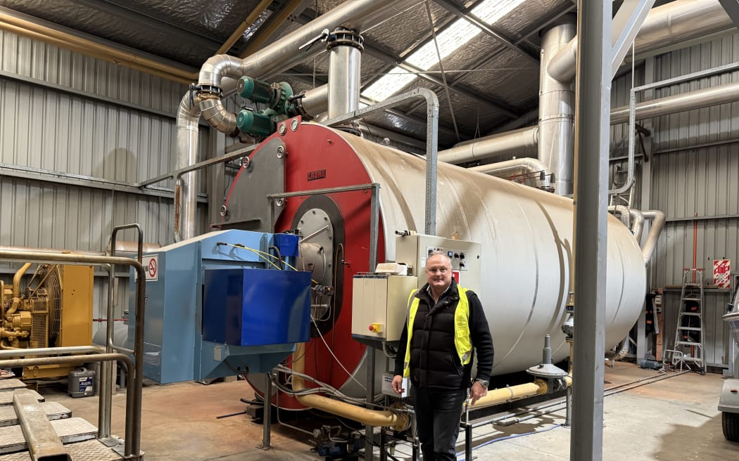

NZ Hothouse managing director Simon Watson at one of two giant gas boilers that help fuel and feed thousands of tomato plants. Photo: Sharon Brettkelly

**Tomato grower warns the gas supply crisis could threaten the hothouse industry, end thousands of jobs and send consumer prices even higher.**

When NZ Hothouse built its tomato growing operation 25 years ago in South Auckland, hooking up to the nearby Maui pipeline was a key factor.

In an area where most growers were using the dirtier, less efficient coal, natural gas was cutting edge and the company brought in the latest technology from The Netherlands.

"It was the best in show in the world at the time," said managing director Simon Watson.

The gas was abundant and inexpensive, and they were told it would last forever.

"Gas was incredibly cheap. Probably about a third of what we're currently paying and obviously a fraction of what we're going to be paying when the price goes up," said Watson.

But the very lifeblood of the operation - the thing that keeps the plants warm through winter and feeds them much-needed carbon dioxide - is dying.

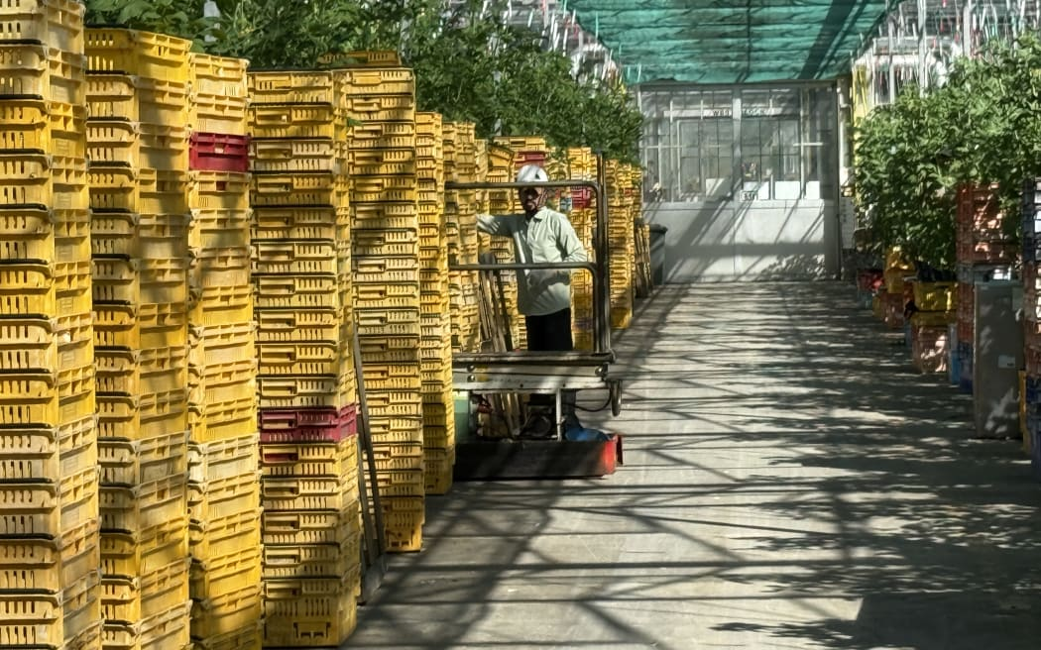NZ Hothouse managing director Simon Watson says the gas supply crisis could end thousands of jobs. Photo: Sharon Brettkelly

Natural gas supplies are running out and as the shortage bites, the rising cost of it is threatening the future of some businesses.

It is likely to uproot NZ Hothouse's operation and disrupt hundreds of workers.

Watson said it is the toughest problem he's faced in his 31-year career there. But he had no idea of the widespread impact of it until a business leaders' meeting a couple of weeks ago.

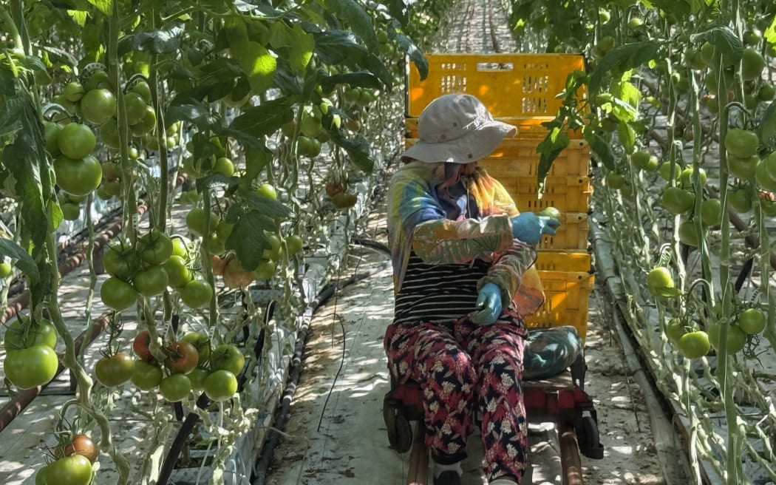"Until we started looking into the depth of this crisis, we had no idea how extensive this is and how far reaching it is. It's going to have a massive effect on our society unless we can make some changes pretty quick," he says.

He thinks most people are unaware of how many different industries depend on natural gas as their energy source.

"If New Zealanders walk through a supermarket and all the regular things that they buy, basically 80, maybe 90 percent of that product in a supermarket has some gas content.

NZ Hothouse’s 10-hectare hothouse in Drury grows nearly half a million tomatoes every year. Photo: Sharon Brettkelly

"Your meat industry, your dairy industry, your drinks industry, anything with sugar in it, your liquor industry, the breweries utilise a lot of gas. And then you look to the building industry, the glass industry, the aluminium industry, the timber industry and then you look beyond that to old people's residential homes, schools, hospitals, local bodies, heating swimming pools."

Today, Watson takes *The Detail* on a tour of its 10-hectare hothouse packing and distribution operation in Drury, where it grows nearly half a million tomatoes every year.

His company first got an inkling of a shortage about three years ago when the gas producers said the supply had become more unstable.

"At that time, it was a short-term issue which they fixed. But it was a bit of a heads up as to what was going on," he said.

But this year it was revealed that gas reserves had more than halved in just four years. And the news keeps getting worse. Just last week the Ministry of Business, Innovation and Employment (MBIE) warned that gas supply may be falling faster than previously expected.

Watson said it has forced his company to look urgently at alternative energy sources, and it will probably relocate to a site where it can tap into geothermal energy, such as Taupō.

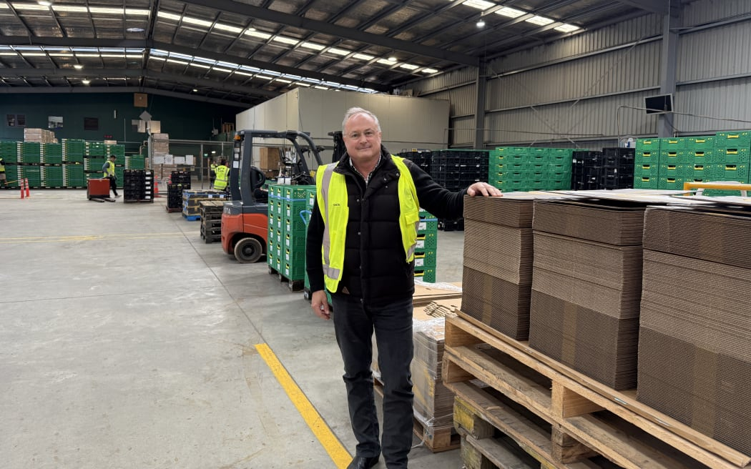NZ Hothouse managing director Simon Watson Photo: Sharon Brettkelly

He thought the company would have five to 10 years more at the current site, now he thinks it will be three years.

But much of the industry is in the same boat, with glasshouses or covered crop operations all around 25 years old, he said. NZ Hothouse's two plants make up 19 hectares of the 200-hectare covered crop sector in the upper North Island, and he predicts that many will have to cut back or close down because they can't afford to pay for the gas.

Watson said the government and the energy industry have nine months to come up with a solution, before the high energy demands of next winter.

**Questions**

1. NZ Hothouse is facing several future-proofing influences that will impact its viability. These are in the box below. Match the statements below with the future proofing influence.

* Planning for workforce impacts including potential job losses or relocation.
* Preparing for higher operating costs due to rising energy prices.
* Investing in new heating and CO₂ supply technologies independent of fossil fuels.
* Transitioning from natural gas to renewable energy sources like geothermal.
* Engaging with government and industry groups to influence energy policy.
* Managing potential financial risks associated with relocation or downsizing.
* Advocating for urgent solutions to the gas supply crisis within the next 9 months.
* Maintaining community and employee relations during transition.
* Anticipating supply chain and market disruptions affecting revenue.
* Investing in energy-efficient technologies to reduce carbon footprint.
* Upgrading infrastructure to support alternative energy sources.
* Changing physical infrastructure to accommodate new energy systems and growing methods.
* Reducing dependency on fossil fuels to align with sustainability goals.
* Considering relocation to areas with better access to renewable energy (e.g., Taupō).
* Navigating regulatory requirements related to energy use and relocation.
* Innovating growing techniques to be more energy efficient.
* Addressing social responsibility in the face of industry-wide challenges.

|  |  |
| --- | --- |
| **Future proofing Influence** | **Match statement with influence** |
| **Economic** |  |
| **Environmental** |  |
| **Political** |  |
| **Technological** |  |
| **Social** |  |

1. What challenges is NZ Hothouse facing with its current energy supply?
2. Why did NZ Hothouse originally choose to use natural gas for their tomato growing operation?
3. Why is using natural gas becoming an issue for NZ Hothouse?
4. What is the impact on NZ Hothouse if they cannot get gas?
5. Using the economic and political influences identified in question 1, explain the impact beyond NZ Hothouse e.g., on the local community?
6. What are the consequences of these impacts on NZ Hothouse?
7. Using the consequences for each of the economic and political influences, explain how each consequence might affect the viability of the business?

**Teachers Note**

**Note:** Questions 6-8 can be repeated using other future proofing influences or you could spit the class into groups and give each group a different influence to answer the above questions. Then come back together to discuss as a class.

**Answers**

1. NZ Hothouse is facing several future-proofing influences that will impact its viability. Match the statements below with the future proofing influence.

|  |  |
| --- | --- |
| **Future proofing Influence** |  |
| **Economic** | * Preparing for higher operating costs due to rising energy prices. * Managing potential financial risks associated with relocation or downsizing. * Anticipating supply chain and market disruptions affecting revenue. * Considering relocation to areas with better access to renewable energy (e.g., Taupō). * Changing physical infrastructure to accommodate new energy systems and growing methods. |
| **Environmental** | * Transitioning from natural gas to renewable energy sources like geothermal. * Investing in energy-efficient technologies to reduce carbon footprint. * Reducing dependency on fossil fuels to align with sustainability goals. |
| **Political** | * Engaging with government and industry groups to influence energy policy. * Advocating for urgent solutions to the gas supply crisis within the next 9 months. * Navigating regulatory requirements related to energy use and relocation. |
| **Technological** | * Investing in new heating and CO₂ supply technologies independent of fossil fuels. * Upgrading infrastructure to support alternative energy sources. * Innovating growing techniques to be more energy efficient. |
| **Social** | * Planning for workforce impacts including potential job losses or relocation. * Maintaining community and employee relations during transition. * Addressing social responsibility in the face of industry-wide challenges. |

1. What challenges is NZ Hothouse facing with its current energy supply?

* NZ Hothouse is facing a natural gas supply crisis because the gas reserves are rapidly depleting and have more than halved in four years.
* The cost of natural gas has risen significantly compared to the past, increasing their operational expenses.
* The gas supply has become unstable and unreliable, threatening the consistent energy needed to keep their tomato plants warm and provide necessary carbon dioxide.
* Due to these issues, NZ Hothouse is considering relocating to a site with alternative energy sources, like geothermal energy, and believes they only have about three years left at the current location.
* The crisis threatens to disrupt hundreds of jobs and potentially force the company and other growers in the industry to downscale or close.

1. Why did NZ Hothouse originally choose to use natural gas for their tomato growing operation?

* When NZ Hothouse was established 25 years ago, connecting to the nearby Maui pipeline offered abundant and inexpensive natural gas, making it a key factor in site selection.
* Natural gas was considered cutting edge technology at the time, being cleaner and more efficient than the commonly used coal.
* Gas was very cheap, costing about a third of what it costs today, making it a highly cost-effective energy source for the operation.
* Natural gas provided two essential benefits for growing tomatoes; it kept the plants warm during winter and supplied carbon dioxide necessary for plant growth.
* They imported the latest technology from the Netherlands to utilise this gas efficiently.

1. Why is using natural gas becoming an issue for NZ Hothouse?

* Gas is now more expensive and in short supply.
* Prices have tripled, and the government has warned that gas reserves are running out faster than expected. NZ Hothouse can no longer rely on gas to power its greenhouses in the long term.

1. What is the impact on NZ Hothouse if they can’t get gas?

Without gas, NZ Hothouse can't heat its greenhouses or supply carbon dioxide, both of which are essential for growing tomatoes. This could force the company to shut down or relocate, leading to the loss of hundreds of jobs and disrupting tomato production in New Zealand.

1. Using the economic and political influences identified in question 1, explain the impact beyond NZ Hothouse (e.g., on the local community).

Economic

* Rising energy costs affect many local businesses and industries beyond NZ Hothouse, like meat, dairy, sugar, alcohol, building, and healthcare. This will increase their operating expenses and potentially leading to higher prices for goods and services in the community.
* As NZ Hothouse considers relocation or downsizing, there may be job losses or reduced employment opportunities for local workers, and therefore less stability for workers impacting household incomes and local spending power.
* Supply chain disruptions from changes in production or relocation can affect local suppliers, distributors, and retailers, possibly leading to economic slowdowns in related sectors in the wider community.
* Investment in new infrastructure or renewable energy in the region (e.g., Taupō) could create new economic opportunities but may also shift economic activity away from the current local area, affecting regional economic balance.

Political

* If there is no clear plan or support for alternative energy, many businesses may close or move, weakening the local economy and putting pressure on public services like schools and hospitals that also rely on gas.
* The community may experience increased political advocacy and engagement as local businesses and residents urge government action to address energy security and affordability.
* Local government and policymakers will be pressured to respond quickly with solutions to avoid widespread economic and social disruption, affecting policy priorities and resource allocation.
* Public concern over job security, energy costs, and environmental sustainability may increase political activism, shaping local elections and community engagement.

1. What are the consequences of these impacts on NZ Hothouse?

Economic

* Increased operating costs from rising energy prices mean higher expenses for heating and CO₂ supply, squeezing profit margins. NZ Hothouse may need to raise product prices, which could reduce competitiveness and sales.
* Higher production costs could disrupt production reducing supply of tomatoes which could lead to failure to meet customer demand. This might damage their brand and relationships with buyers and reduce market share making them less competitive which would negatively impact their long-term viability.
* The costs associated with moving to a new location with alternative energy like Taupō will require significant capital investment. If this capital investment is not available, NZ Hothouse may need to downsize. However, downsizing to reduce energy use could decrease production capacity and revenue.
* Potential layoffs or reduced hours and or loss of experienced workers may harm employee morale and affect operational efficiency and product quality.

Political

* New government policies on energy use, emissions, or relocation may impose additional compliance costs and increase administrative burdens for the business.
* The unstable energy situation creates uncertainty, making it hard to plan long-term investments or expansion. This could hinder innovation and limit the company’s ability to adapt quickly.
* If the company is forced to reduce production or lay off workers, it may face negative public perception. This could affect customer loyalty and community support.

1. Using the consequences for each on the economic and political influences, explain how each consequence might affect the viability of the business.

Economic

* Higher gas prices

Will increase production costs, reducing profit margins. If the company cannot pass these costs onto customers without losing sales, profitability will decline, threatening financial sustainability. Prolonged cost pressures could force the business to downsize or close.

* Relocation and infrastructure

Relocating requires significant investment in new infrastructure and logistics, straining capital resources. Downsizing reduces revenue and economies of scale, making the business less competitive. If the company cannot secure funding or manage costs, its survival is at risk.

* Supply chain disruptions

Interruptions in production and staff layoffs can reduce NZ Hothouse’s ability to fill orders, lower productivity, and compromise product quality, leading to lost customers, reduced revenue, and a weakened competitive position. This damages brand reputation and customer trust, ultimately affecting the company's operational resilience and long-term viability.

Political

* Regulatory and compliance

New government regulations on energy use or emissions could impose additional costs or operational restrictions. Complying with complex policies consumes resources and could delay projects, reduce flexibility and increasing expenses, which threatens profitability**.**

* Uncertainty and planning difficulties

Uncertainty about energy availability and costs hinders strategic planning and investment decisions. Without clear direction, NZ Hothouse may miss growth opportunities or fail to innovate, risking long-term competitiveness and survival.

* Political pressure

Political pressure from the community or government to protect jobs may increase operational constraints or costs, complicating management decisions. This pressure could strain resources putting NZ Hothouse under pressure which may force them to downsize or close.

* If nothing changes to source reliable heating before winter, NZ Hothouse may not be able produce enough tomatoes to cover operating cost therefore the business may not survive through another winter.