Risk management a key skill for farmers
https://www.farmersweekly.co.nz/farm-management/risk-management-a-key-skill-for-farmers/
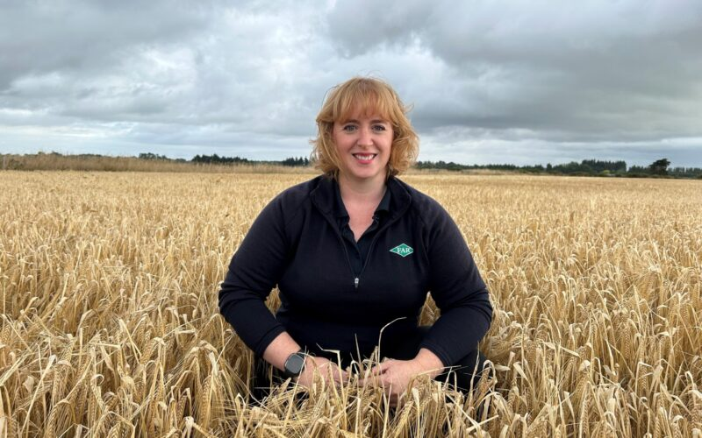
November 3, 2023
Strategy must aim to maximise results and minimise consequences, Lincoln forum hears.
Building resilience into high-value export and domestic cropping systems is a juggling act for farmers, Foundation for Arable Research senior researcher Jo Drummond says.
Farmers are having to keep a lot of balls in the air when making production system decisions, but it is important to identify risk and manage it.
This was the message from speakers at a recent agri-industry science forum.
The New Zealand Institute of Agricultural and Horticultural Science forum at Lincoln University focused on building resilient production systems. In his address to the forum, Jon Manhire of The Agribusiness Group said planning for resilience is about risk management.
“Focusing on risk is a really good way of building resilience and risk can create opportunities. Risk management is not a new concept; it aims to maximise results and minimise consequences. Resilience is the capacity to bear risk. It is important to identify risk and manage it or you won’t be around in the future,” he said.
Natural hazards are relatively low on the list of reasons businesses fail. Manhire presented figures showing key reasons for failure are economic factors, 47%; financial troubles such as excessive debt, operating expenses and insufficient capital, 38%; inexperience, 7%; owner neglect, including business conflicts, family problems and poor work habits, 4%; and other, including natural disasters, 3%.
“We are in a world where farmers really have to manage their own risk as best as possible in their own business, as farming is so variable across sectors and within sectors. Individual businesses and farm systems are driven by any number of reasons, but strategic response is key, rather than proactive response.”
Risks can be identified, evaluated and prioritised at a farm or sector scale. When preparing a situational analysis consider the PESTE framework – political, economic, social, technological and environmental dimensions – and rank potential strategic risks.
“It needs to be an input into a strategic planning process and updated regularly to ensure that it is responsive to changing conditions with active monitoring, evaluation and management for predicting future risks.”
There is a need for the development and promotion of case studies, tools and specialist skills, as well as chief risk officers to help agribusiness identify and manage risks.
“Chief risk officers in global businesses have taken the science of risk management to another level. There’s a gap there in relation to New Zealand’s capability,” Manhire said.
Institute of Geological and Nuclear Sciences Limited (GNS) principal social scientist Nick Craddock-Henry said building resilience in rural communities and the industries they support is about choice. At some point, he said, current practice will no longer be sufficient.
“Resilience is driven by complex interconnected factors, many of which are driven by factors beyond New Zealand shores. A systems perspective is needed. We need to choose to invest in resilience, identify thresholds and tipping points, account for interactions and have flexibility in planning, and be able to anticipate uncertain or novel change. There are options but no silver bullets. We can use the past as a guide to the future and challenge the way of our own thinking, but what resilience means to individuals for what end is what will drive investment.”
Building resilience into high-value export and domestic cropping systems is a juggling act for farmers, Foundation for Arable Research senior researcher Jo Drummond said.
“Farmers are increasingly being asked to grow more with fewer tools. We can already grow more on less land. We can also grow more with less chemistry.”
But is it enough?
“Our system in New Zealand is very much dominated by the stick, not the carrot. Our growers are not incentivised with grants and subsidies. This makes it harder for our exporters, so the impetus is to only change when you have no other choices, which is a difficult road as opposed to voluntary change, which requires more thought, but allows for greater readiness and flexibility.”
The challenge is with the breeders and plant-breeding technologies.
“To reduce our footprint, we need to rationalise each application, conserve, protect and support. We need effective use of plant genetics, cultivar selection, integrating new crop protection technologies, rationalising chemical pesticides programmes – genetic diversity in a mix, but also in a monoculture. Some time we need to take the plunge and take all our growers on the agroecology systems journey. It needs some big thinking and some big support,” Drummond said.
Discussion Questions
- Why is managing risk key to the future?

- What is resilience?

- How can risks to an agribusiness be identified?

- How does risk management contribute to the long-term success and sustainability of a farming business?

- In what ways can ignoring risk lead to business failure, even in good economic times?

- How can building resilience help a farm not only survive but grow through uncertainty?

- How can learning from past challenges help farmers make better decisions about future risks?

Activity
- Imagine you are a farmer. What steps would you take to identify and prepare for potential risks in the next growing season?

- How would you use the PESTE framework to assess the risks to your farm business?

Answers
- Why is managing risk key to the future?
Managing risk is key to the future because it helps maximise results while minimising
negative consequences. Without actively managing risks, farm businesses may not survive in a highly variable and uncertain environment. According to Jon Manhire, resilience, the capacity to bear risk depends on identifying and managing those risks effectively. Failure to do so can lead to business collapse, especially since most failures are due to economic, financial, or management-related risks, not natural disasters.

- What is resilience?
Resilience is the ability of a farm or agribusiness to withstand and adapt to risk, uncertainty, and change. It is not just about surviving tough times but being prepared for them and able to bounce back or even grow stronger after disruptions. As Nick Craddock-Henry emphasised, resilience involves making deliberate choices, understanding complex systems, and being able to respond flexibly to uncertain or novel challenges.

- How can risks to an agribusiness be identified?
Risks can be identified by conducting a situational analysis using the PESTE framework, which considers:
- Political
- Economic
- Social
- Technological
- Environmental factors.
These risks should be evaluated, ranked, and prioritised regularly at both the farm and sector levels. This process must be part of strategic planning, with ongoing monitoring and evaluation to adapt to changing conditions. The development of tools, case studies, and potentially Chief Risk Officers in agribusiness can also support more effective risk management.

- How does risk management contribute to the long-term success and sustainability of a farming business?
Risk management allows farmers to anticipate problems, plan ahead, and reduce the impact of unexpected events (e.g., weather, pests, market prices). By managing risks well, farmers can make better decisions, protect their income, and stay in business even during tough times. This builds a more resilient and sustainable farm operation over the long term.

- In what ways can ignoring risk lead to business failure, even in good economic times?
Even when prices are high or yields are good, ignoring risks like debt, changing regulations, or climate variability can lead to disaster. For example, a farm might take on too much debt during a good season, but if a drought hits the next year, they may not be able to recover. As the article notes, economic and financial issues are much more common causes of business failure than natural disasters.
- How can building resilience help a farm not only survive but grow through uncertainty?
Building resilience means a farm is prepared for change and can adapt quickly. This might include diversifying crops, improving soil health, or using better data to guide decisions. Resilient farms do not just survive hard times—they can take advantage of new opportunities (e.g., switching to a high-demand crop) and come out stronger.

- How can learning from past challenges help farmers make better decisions about future risks?
Past experiences, like dealing with a flood, crop disease, or market crash, teach valuable lessons. Farmers can look at what worked and what did not, helping them develop better strategies, avoid repeating mistakes, and become more confident in handling future risks. This is part of building both knowledge and resilience.

Activity Questions
Sample Responses
- Imagine you are a farmer. What steps would you take to identify and prepare for potential risks in the next growing season?
Sample steps:
- Review past seasons: What went wrong and why?
- Check weather forecasts: Prepare for drought or heavy rain.
- Monitor market trends: Will the price of my crop go up or down?
- Check regulations: Are there any new environmental or export rules?
- Diversify: Grow more than one crop or add livestock to spread risk.
- Build savings: Set aside money in case of low yields or equipment failure.
- Talk to advisors: Get expert advice on financial and agronomic planning.

- How would you use the PESTE framework to assess the risks to your farm business?
The farmer would use the PESTE framework - political, economic, social, technological and environmental dimensions, to find out are the risks that could affect the business and then rank these potential strategic risks to the ease of mitigation. If they can be easily mitigated, then they should be, the harder to mitigate ones should be worked towards.

