Level 2: Future Proofing Worksheet.
Political Future Proofing Influence
Teacher Note:
This worksheet provides an example of a political future proofing influence based on outdated road rules for agriculture vehicles
Resource
- Rural road rules for agricultural vehicles 'null and void- contains a TV One video News reports
https://www.1news.co.nz/2025/08/22/rural-road-rules-for-agricultural-vehicles-null-and-void/

Rural road rules for agricultural vehicles 'null and void
https://www.1news.co.nz/2025/08/22/rural-road-rules-for-agricultural-vehicles-null-and-void/
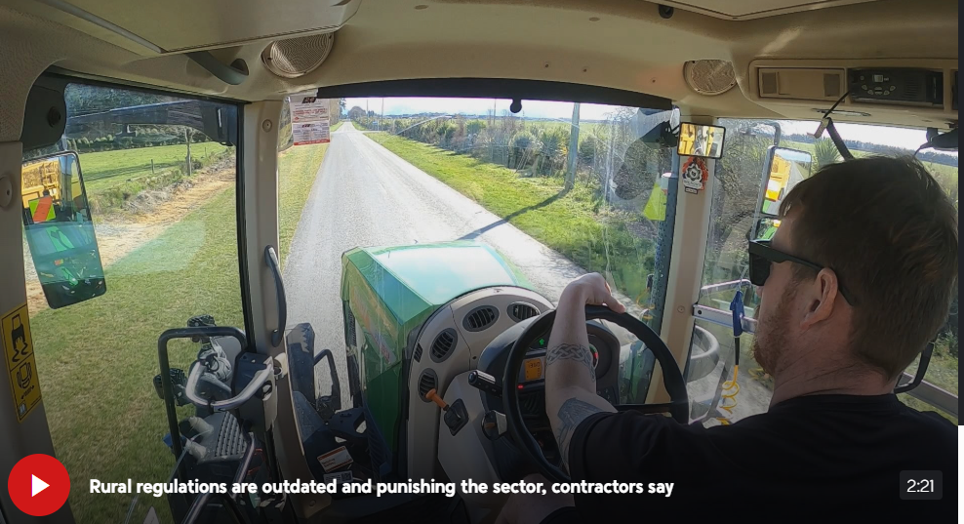
A Canterbury contractor fined more than $12,000 for an overweight agricultural vehicle is just the latest hit by rules the industry says are crippling some operators.
Rural contractors say current regulations are decades out of date and don't reflect the size of modern machinery now being used.
The requirements are under review but there's concerns about what will happen in the meantime.
A tractor and trailer with cattle feed in tow enroute to a local farm in Mid Canterbury last month resulted in a $12,150 fine for the contracting firm operating it.
Jacob Holdaway of Jacob Holdaway Contracting told 1News the unit and its contents – "about 39 tonne as a gross combination" - was deemed overweight.
He said the laws for weight limits on New Zealand roads date back to the 1970s to late 1990s.
"They just simply null and void and we need to have a change so we can keep operating this machinery on the road," Holdaway said.
He said the current weight regulations didn't reflect the size of agricultural machinery now being used.
"We picked up a new tractor the other day from the dealership. We bought it back here and weighed it. It's already overweight."
The industry body Rural Contractors New Zealand said it was an issue plaguing its members across the country.
"[The] government have said that it needs tidying up and it needs to be addressed," Rural Contractors NZ vice president Daryl Thompson said. "But in the meantime, coming into spring, contractors, farmers are getting slapped with very, very heavy fines [and] being stopped from moving between farms."
But, with the government review set to take months, the organisation is calling for discretion in the interim, adding that fines were disproportionate and urgent action was needed now.
Transport Minister Chris Bishop said there would be a draft plan out by October, with the Government hoping to have the new rules out by the middle of next year.
"[We] fully acknowledge and appreciate the problem. We are going to make the changes that are required — it's just going to take a few months. In the meantime, they should be talking to the officials about discretion and how that might be applied."
Thompson said some contractors were "very, very fearful of driving out of their yard" while the current laws were in place.
Holdaway added that they wanted to be able to operate efficiently.
"But at the end of the day, the law's the law, and we need to see a change to that law," he said.

Questions
- Describe the legal influence.

- Explain the short- and long-term impacts on a contracting agribusiness.

- Describe the consequences of these impacts outside the agribusiness contracting business?

- Using these consequences, explain how each consequence might affect the viability of a contracting agribusiness?

Answers
- Describe the legal influence.
- The laws governing vehicle weights on New Zealand roads date back to the 1970s to late 1990s, meaning they were designed for smaller, older machinery.
- These outdated regulations are legally enforceable and result in heavy fines for operators who exceed current weight limits, even when using modern, standard agricultural equipment.
- While the government is reviewing these rules and plans to release a draft by October, current legal standards remain in place, and discretionary enforcement is not yet formalised.

- Explain the short- and long-term impact on a contracting agribusiness.
Short-term impacts:
- Financial strain from large fines (e.g., over $12,000 per incident).
- Fear and uncertainty around operating machinery, especially during busy seasons like spring.
- Delays in job completion, as contractors are hesitant to move between farms.
- Increased costs due to needing to find alternative (possibly legal but less efficient) transport options.
Long-term impacts:
- Loss of income or clients if services are delayed or unavailable.
- Reduced operational efficiency, lowering competitiveness.
- Pressure to under-invest in modern equipment for fear it cannot be legally used.
- Risk of business closure if fines continue and no relief is provided before the new regulations are implemented.

- Describe the consequences of these impacts outside the agribusiness contracting business.
Consequences include:
- Delays for farmers, who rely on contractors for tasks like soil preparation, spraying, harvesting, or transporting feed could disrupt farm operations, especially during peak seasons like spring which could reduce productivity and financial returns.
- Legal fines and compliance efforts raise operational costs for contractors, which are often passed on to farmers, increasing the cost of production.
- Strain on rural communities, where contractors are a key part of the local economy and support network.
- Adds stress and uncertainty across the agricultural sector, reducing its ability to adapt or grow under pressure.
- Using these consequences, explain how each consequence might affect the viability of a contracting agribusiness.
- Contractors who cannot deliver services on time may lose clients to competitors. Missed or delayed jobs (e.g. harvesting, spraying) can damage their reputation, leading to fewer future contracts. Reduced trust and reliability can result in lost income during the most profitable times of the year. This reduces short-term cash flow and long-term client loyalty, threatening the overall survival of the business.
- Farmers may seek the services of other contractors, such as smaller operators or those who bend the rules. The loss of clients would reduce cash flow and place the contracting business under financial pressure. If the contractor absorbs some of the cost of fines to retain clients, this will decrease profit margins. Over time, this could make the business financially unsustainable.
- The contractor often relies on local networks and word-of-mouth for ongoing work. If the rural economy weakens due to delays or high costs, demand for their services may fall. Community trust and support may decline if the contractor is seen as unreliable or expensive. Weaker community demand and reduced local support directly impact the contractor’s client base and income stability affecting the long-term viability of the business.
- The contractor may hesitate to invest in equipment due to unclear legal rules. The constant fear of fines creates a high-stress business environment, negatively affecting decision-making. The contracting business may avoid taking on jobs that carry legal risk, limiting their income opportunities. This inability to plan and grow puts long-term business viability at serious risk.

