Everything you need to know about chocolate
12 Feb, 2020 7:00pm
19 minutes to read
New York Times

By: Melissa Clark
The beloved bar has come a long way in quality and complexity. Here's a primer on how it's made, and how to choose the best and most ethically produced.
For instance: The higher the percentage of cacao, the more bitter the chocolate, right? The term "single origin" on the label indicates that the chocolate expresses a particular terroir. And wasn't the whole bean-to-bar movement started by a couple of bearded guys in Brooklyn?
Wrong; not necessarily; and definitely not.
Americans spend US$21 billion on chocolate every year, but just because we eat a lot of it doesn't mean we know what we're eating. And misunderstandings at the store can make it especially hard for chocolate lovers to figure out which of the myriad, jauntily wrapped bars crowding the shelves are the best to buy, in terms of both taste and ethics.
One thing that's clear is that there are more varieties of handcrafted chocolates on offer than ever before, at prices that soar as high as US$55 ($85) a bar.

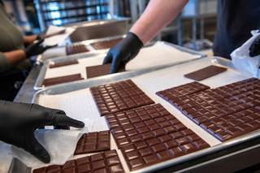
Dandelion is known for single origin, bean-to-bar chocolates, all made at its factory in San Francisco. Before being wrapped, each bar is inspected by hand.

According to the Fine Chocolate Industry Association, sales of premium chocolates grew 19 per cent in 2018, compared with 0.6 per cent for mainstream chocolate like the classic Hershey bar. Over the past decade, the number of small American bean-to-bar chocolate producers — the kind with cacao percentages and places of origin printed on those hyper-chic labels — has jumped from about five to more than 250.
But while creativity and technical acuity in chocolate making have blossomed, ethical and environmental concerns still plague the supply chain. Despite a 20-year effort to battle the systemic poverty, child labor and deforestation endemic to the industry, those problems may actually be getting worse.
It might seem a lot to think about as you choose your Valentine's Day chocolates, but here are answers to some basic questions you may not even know you had.
All chocolate, even white chocolate, starts with the fruit of the cacao tree, an equatorial, Seussian-looking plant with plump, bumpy, ovoid pods that grow directly from the trunk.

The cacao beans (also called cocoa beans) are the seeds that grow inside the pod, surrounded by fleshy, juicy fruit that tastes a little like a mango crossed with a pear that was carrying a lychee. After harvesting, the beans are fermented for up to a week to develop their flavours, and dried.

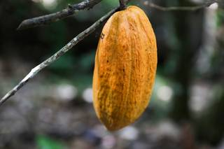
There are more than a dozen different cultivars of cacao used to make chocolate, each with its own distinct flavor and aroma.
To make chocolate, the dried beans are roasted, then cracked to separate the outer husks from the inner nibs, which have a nutty, earthy flavour and crunchy texture — and are excellent added to baked goods. The nibs are about half cocoa solids and half cocoa butter.
Chocolate makers grind the nibs into what's called chocolate liquor, or chocolate paste. This liquor is ground again, along with sugar and other ingredients that might include milk powder to make milk chocolate, lecithin to smooth the texture, or vanilla for flavour. Sometimes extra cocoa butter is mixed in to give creaminess to dark chocolate or to mellow the flavour of extra-bittersweet chocolates without much added sugar.

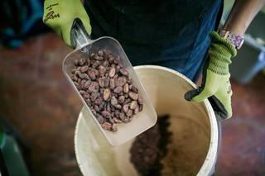
Carol Morse, the owner of Acalli Chocolate in New Orleans, buys her beans directly from cacao growers in Peru and Mexico.
(Industrial chocolates may include other ingredients, like vegetable oil, corn syrup or glucose, or vanillin, an artificial vanilla. Always read the label.)
The goal of this second grinding, called conching, is to reduce the size of the sugar and cacao particles until they feel like satin on the tongue, a process that can take anywhere from 24 to 72 hours. Then the chocolate is tempered (heated and cooled to specific temperatures) so that it sets with that characteristic glossy look and snappy texture. After that, it's ready to savour.
Strictly speaking, all chocolate is bean-to-bar, just as all meals are essentially farm-to-table. But just like the chef who fanatically seeks out all her ingredients, down to the flakes of salt garnishing her sustainable line-caught crudo, bean-to-bar chocolate makers obsess over the character and ethical origins of their beans.
This is in marked contrast to mainstream industrial chocolate, in which the beans are a commodity product, bought in bulk for price, not quality.

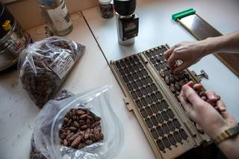
Emily Stone, a founder of Uncommon Cacao, imports raw cacao beans to supply small bean-to-bar chocolate makers in the United States.
"If there are infested, moldy, terrible-looking beans mixed in with the good ones" large chocolate companies will buy them anyway, said John Scharffenberger, a founder of Scharffen Berger Chocolate Maker in San Francisco. That's because big companies often mix in so many other ingredients that the consumer won't taste any bad beans in the final product.
The best bean-to-bar chocolate makers (also called craft or micro chocolate makers) choose beans the way chefs choose tomatoes — obsessively, often visiting the farms where the beans are grown. They roast and grind the beans themselves before making them into chocolate bars.
Pastry chef and author David Lebovitz, who wrote "The Great Book of Chocolate," compares bean-to-bar chocolate to natural wine. "It's exciting and alive in a way that even really great regular chocolate isn't," he said. "It can surprise you."
The new wave of craft chocolate began with Scharffen Berger, founded in 1996 by Scharffenberger, a winemaker, and Robert Steinberg, who had studied at the famous chocolate shop Bernachon, in Lyon, France.
"When we started, there were only nine companies grinding their own cacao in the United States and they were all huge, except for Guittard," Scharffenberger said, referring to Guittard Chocolate Co., also in the San Francisco area. "We were the first new chocolate maker on the scene in 150 years."

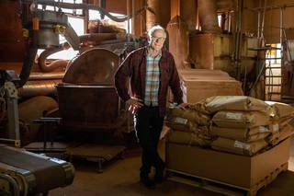
Gary Guittard is the fourth-generation owner of the Guittard Chocolate Company, which was founded by his great-grandfather in San Francisco in 1868.
When Gary Guittard, the company's fourth-generation owner, sampled some of Scharffen Berger's chocolate, it spurred him to revamp his own production, in some cases going back to the way his great-grandfather made chocolate when he started the company in 1868.
"Scharffen Berger was the disrupter," Guittard said. "Trying their chocolate was just terrible for me. It opened my eyes to a world of flavours that had been present in our chocolates 50 years ago but that were lost. We had to change everything to get them back."
Scharffen Berger was sold in 2005 to the Hershey Co., which moved the operation to Illinois. But other small bean-to-bar makers quickly followed Scharffen Berger's lead. There are now more than 250 in the United States. And even though Brooklyn, contrary to popular belief, didn't invent the bean-to-bar craze, it has several producers, including Kahkow, Cacao Prieto, Jacques Torres, Raaka and Fine & Raw.
No. A bean-to-bar maker makes chocolate from cacao beans. A chocolatier buys premade chocolate, then melts it and combines it with other ingredients to make confections like truffles or pralines. And this isn't at all a bad thing: The best chocolatiers buy superb bean-to-bar chocolate as a starting point. (Many professional chocolatiers buy from Valrhona.) It's just that making chocolate and making chocolate confections are two different skill sets.
To return to the wine analogy, many people think that single-origin cacao beans are like grapes from one vineyard, producing chocolate that expresses nuances from that particular soil and vintage in the same way a wine might.
And sometimes that's true. But just as often, beans labeled as having a single origin in, say, Peru or Trinidad can come from small farms in different parts of that region, each farm with a distinct terroir, variety of cacao bean and fermentation process.
"Single-origin is a flexible term," said Maricel Presilla, author of "The New Taste of Chocolate, Revised: A Cultural and Natural History of Cacao with Recipes." "It could refer to a specific farm known for a particular cultivar of fine cacao. Or it could mean a larger region where they grow a mix of cultivars, some of which are high-quality and some of which are not. Just saying that a cacao comes from Ecuador opens a can of worms because there are so many genetic varieties. You can't be sure what you're getting."

Dr. Maricel Presilla, a culinary historian in New Jersey, comes from a family of Cuban cacao growers. She now runs the International Chocolate Awards.
That said, knowing a chocolate's origin can tell you something general about its flavour. I've found that chocolates made from fine Latin American beans tend to be complex. Some might be bright and fruity, with notes of dried apricots, fresh berries and dark fruit, while others taste of nuts or fresh herbs. West African chocolates are often more straightforwardly fudgy, sometimes tinged with flavours of coconut, raisins and coffee.
When you're buying single-origin chocolate, Presilla's advice is to look for as much detail on the label as possible, including country and region, farm or estate, and the genetic variety of the cacao. "It's a lot for the consumer to understand," she said, "but if the chocolate maker is transparent about it, it's a sign that they are putting thought and care into the bar."
Cacao percentage is the amount of cacao mass (ground-up beans) present in the bar.
In order for something to be labeled chocolate in the United States, it must be at least 10 per cent cacao mass. Most milk chocolate is 10 per cent to 30 per cent cacao; most bittersweet chocolates, 35 per cent to 55 per cent. (For white chocolate, only the cocoa butter is used, and it must constitute at least 20 per cent of the bar.)
Historically, the cacao percentage was printed on the back of the package in tiny type, if it was listed at all. But this had changed by 1986, when Valrhona introduced its Guanaja chocolate, the first bar with a 70 per cent cacao content. And it said so right smack on the front of the label, indicating a more intensely bittersweet flavour. Other chocolate makers quickly followed suit.
Here's the confusing part. While most people assume that the higher the cacao percentage, the more bitter the chocolate, that's not always true. In some cases, a chocolate maker's 68% might taste more bitter than its 74 per cent.

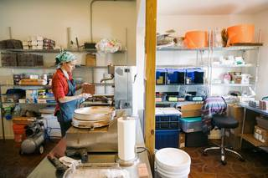
Like many small bean-to-bar chocolate makers, Carol Morse uses repurposed equipment.
That's because the percentage includes both cacao solids and cocoa butter. The solids are bitter, while the butter is smooth and creamy. If a chocolate maker adds extra cocoa butter to produce a smoother texture, the overall cacao percentage will increase, but the bitterness will not.
Carol Morse, who owns Acalli Chocolate in New Orleans, adds a small amount of cocoa butter to her Teapa Dulce 64 per cent dark bar to round out the inherent toasty flavours of cacao and make the chocolate slightly creamier on the palate.
"I'm working with so few ingredients, so it's all about balancing them," she told me in her workshop just outside New Orleans, where she was wrapping the latest batch of glossy brown bars by hand in gold foil. Piled in a corner, burlap bags of raw cacao beans from Peru were waiting to be sorted, then roasted in a repurposed rotisserie oven once used at a Walmart store. "A small amount of added cocoa butter can make a huge difference."
One of the biggest ethical concerns about chocolate-making is the cacao supply chain. In the current system, the vast majority of cacao beans are sold as a commodity crop without regard to quality. Because farmers aren't paid more for better beans, there's no incentive for them to plant finer-flavoured cultivars. Nor would they have the money to do so. In West Africa, which grows 60 per cent to 70 per cent of the world's beans, many cacao farmers live below the poverty line, making less than US$1.90 a day.
Direct trade refers to beans that are bought outside this system, most often directly from farmers or farmers' cooperatives. These beans are usually higher quality, and the farmers are paid anywhere from 50 per cent to 300 per cent more than the market price of commodity cacao. Currently, though, direct trade accounts for less than 1 per cent of the cacao beans on the market.
While some chocolate makers buy directly from farmers, most of the micro, bean-to-bar makers in the United States get beans from one of two direct-trade cacao importers, Uncommon Cacao and Meridian Cacao. Both have strong social goals that include living wages for the farmers.
"Ninety percent of the world's cocoa is grown on 6 million small farms, and most of the farmers can't survive on what they're paid," said Emily Stone, a founder of Uncommon Cacao. "Our mission is building a more equitable and transparent supply chain."
The past two decades have brought reporting about the use of child labor, sometimes under hazardous conditions, on cacao farms in Ivory Coast and Ghana, and of widespread destruction of forests in cacao-growing regions worldwide.
By 2001, consumer outrage had prompted the major chocolate companies to pledge to end the worst forms of child labor in the cacao industry. But no laws were ever passed in America to require this (those same companies lobbied against the legislation and quashed it). Reports have surfaced that little has changed.
It's a similar story with environmental impact. In 2017, 34 chocolate companies agreed to end deforestation by their industry. But according to a 2018 report by the environmental group Mighty Earth, cacao production was still ravishing forests, and the animals living within them, at an alarming rate.

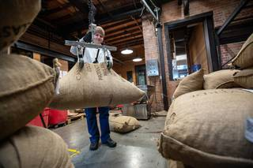
Dandelion gets all of its beans directly from cacao farmers or from a trusted importer who works with the growers, ensuring a transparent supply chain.
Even when the industry does act, efforts from the top down can fail to take root. Both child labor and deforestation are part of the daily realities of the systemic poverty afflicting West Africa, said Kristy Leissle, a founder of the Cocoapreneurship Institute of Ghana and author of the 2018 book Cocoa.
To truly improve the lives of farmers and their families, Leissle said, the farmers need to be included in the conversation. "The current initiatives have been imposed on Africa from European and North American people who are not engaged in the daily labor of cocoa farming," she said. "The solutions need to come from within the cocoa industry in Africa. That's where the expertise is."
Cacao, a shade-tolerant plant, can be grown under the forest canopy without drastic clearing. And when grown in a sustainable manner, it can have a low carbon footprint.
Consumers looking for chocolate that is sustainably and ethically grown should parse a lot of labels and ask a lot of questions. A good start is looking for Fair Trade, Rainforest Alliance and organic certifications. These independent, third-party audits can be an important part of the process, even if they are only partly effective.
Many craft-chocolate makers don't seek certification. Instead, companies like Dandelion Chocolate in San Francisco publish detailed sourcing reports on their websites, telling where they buy their beans and for how much. "It's transparency that goes deeper than what you can fit on a label," said Greg D'Alesandre, an owner of Dandelion.
"Everyone wants to be able to buy chocolate and go to heaven," Presilla said, "but the issues are complicated."

