**Level 2: Future Proofing Influences**

**The Rise of the Conscious Consumer Worksheet**

**Teacher Note:**

This worksheet provides students the opportunity to understand what a conscious consumer is then carry out and activity: **"Conscious Consumer Challenge"**

**Recommended resources**

[The rise of the conscious consumer](https://impactbuying.com/the-rise-of-the-conscious-consumer/)

Watch The rise of the [climate conscious consumer](https://www.youtube.com/watch?v=l5h_uGjaIZQ)

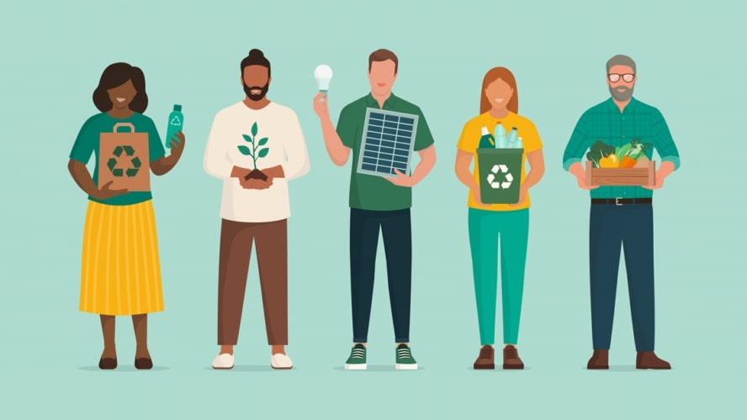

**The rise of the conscious consumer**

Consumers are more critical than ever. They want to know where products come from, how they are made, and their impact on people and the planet.

The conscious consumer is changing the game. People no longer buy blindly. They want to know where products come from, how they’re made and what impact they have on people and planet. Sustainability, ethics and transparency are no longer bonuses – they’re expectations. companies that don’t adapt risk falling behind.

**Why the conscious consumer is growing**

Several forces drive this shift. Climate change, social inequality and supply chain scandals have raised awareness. On top of that, social media and stricter regulations have made business practices more visible than ever.  
  
As a result, a new generation of conscious consumers is speaking up. They actively choose sustainable, ethical products and hold brand accountable when they don’t meet expectations.

**What do consumers expect?**

* **Transparency**  
  People want clarity. Where do your materials come from? Who made the product? Brands that share this openly earn trust.
* **Sustainability**  
  Reducing environmental impact is key. Think: low-waste packaging, clean production and circular design.
* **Fair working conditions**  
  Exploitative labour practices can damage your brand fast. Today’s consumers demand fairness across the supply chain
* **Ethical business**  
  From fair trade to inclusive hiring, consumers want brand that do good – not just sell products.

**How can businesses respond to this trend?**

1. **Communicate openly and honestly**: be open about sourcing, production and sustainability. Honest builds credibility.
2. **Make progress visible:** set measurable targets – like CO2 reductions or fair wage benchmarks and share updates.
3. **Innovate sustainably**: Invest in circular models, renewable materials and ethical designs.
4. **Involve consumers**: encourage conscious through recycling programs, incentives or community initiatives.
5. **Be consistent**: avoid greenwashing. Make sustainability part of your strategy – not just a campaign.

**This is not a trend – It’s a shift**

The conscious consumer isn’t going anywhere. What began as a niche movement is now a major force in the market. Brands that take ethics seriously build stronger relationships, future-proof their business and stand out in a crowded landscape.  
  
Ready to align your brand with the values of the conscious consumer?

**Activity: "Conscious Consumer Challenge"**

**Objective:**  
Students will summarise key ideas about conscious consumers and apply these to evaluate or redesign a business’s practices to meet modern ethical and sustainability expectations.

**Activity 1:** Group discussion & summary (15-20 mins):

* In small groups, students read the article
* Each group identifies the 4 key consumer expectations
  + transparency
  + sustainability
  + fair working conditions
  + ethical business practices
* Groups summarise why conscious consumers matter and what companies must do.

**Activity 2:** Business case study or creation (25-30 mins):

**Option A:**

* Assign each group a real or fictional business (e.g., Open Country, Halter, Merino NZ, Zespri, farming or growing business, DairyNZ, Beef ++ Lamb NZ, A meat processing company, Rabobank).
* Ask students to research and analyse the business’s current practices i.e. **how does your business currently meet conscious consumer expectations?**
  + Transparency:
  + Sustainability:
  + Fair working conditions:
  + Ethical business practices:
* Ask groups to list what the business does well and what needs improvement to meet conscious consumer demands.

**Option B:**

* Groups create their own business idea (product or service).
* They design a strategy showing how their business will meet the expectations of conscious consumers (focus on transparency, sustainability, fair labour, and ethics).

**Activity 3:** Presentation & reflection (15 mins):

* Each group presents their summary and business application.

**Prepare to share:**

* + Your summary of what conscious consumers expect
  + How your business is responding or will respond to these expectations
  + Why this is important for the business’s future success
* Class discusses how these changes could impact consumer trust and business success.