Level 2: Future Proofing Influence
Legal influence
Trademarks
Teacher Note:
This worksheet provides an example of legal or social future proofing influence.
Discussion Questions: These are designed to stimulate discussion and deepen understanding of trademarks and the impacts they have on an agribusiness.
Questions:

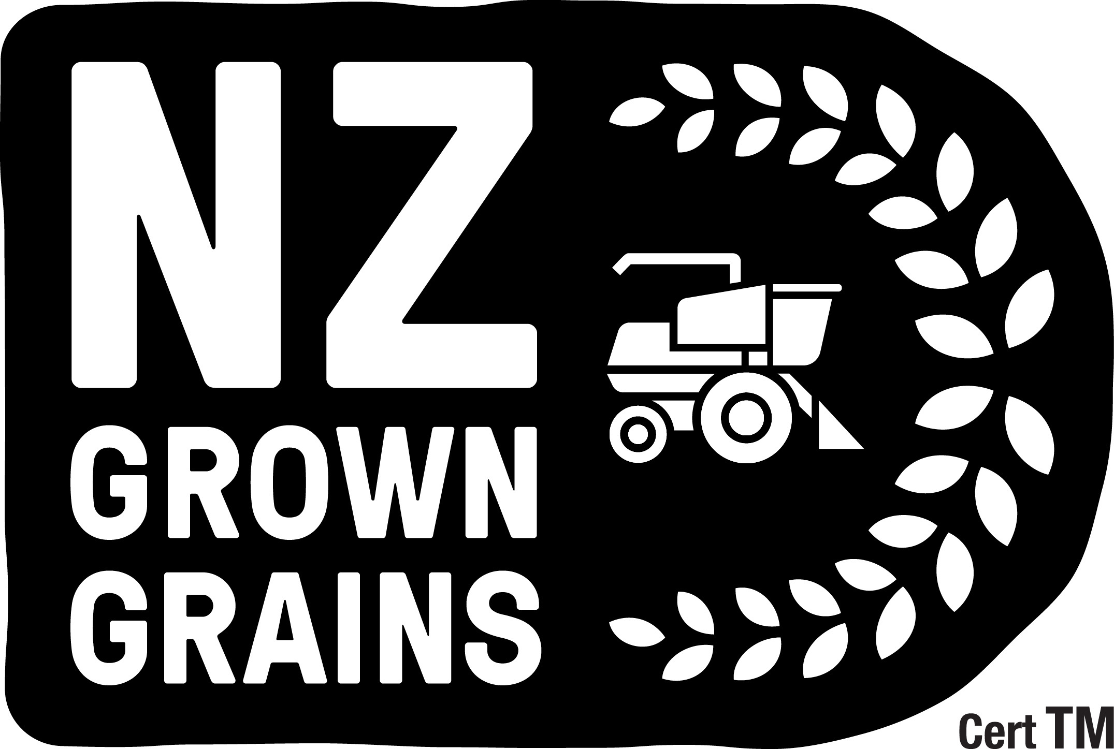

Choosing a local loaf soon to get much easier
https://www.agribusinessmagazine.co.nz/blog/choosing-a-local-loaf-soon-to-get-much-easier
Bakers, breakfast cereal makers and plant-based milk manufacturers are already eyeing up the arable industry’s new home-grown logo to help consumers choose products made from local grain.

Ivan Lawrie.
That is according to Ivan Lawrie, general manager of business operations for the Foundation for Arable Research. FAR has collaborated with Eat NZ to introduce the ‘NZ Grown Grains’ trademark, for milling wheat, oats and barley. It is part of a wider industry campaign underway for about five years, to make New Zealand more self-sufficient in growing of milling wheat.
Ivan Lawrie says despite the arable industry’s reputation for quality product, at least three-quarters of the bread sold in New Zealand is made from imported grain, primarily from Australia.
Most consumers do not realise this when they buy bread from the supermarket. Market research has shown 50 per cent of bread buyers are prepared to pay up to 20 cents extra a loaf and some up to 50 cents for a loaf guaranteed to be made from New Zealand grown grain.
Eat NZ chief executive Angela Clifford says the new campaign is a unique opportunity for farmers to join with bakers, chefs and consumers using their grains and seeds, and tell a compelling story about what makes New Zealand grown arable foods so wonderful.
“From the quality to the connection to our land, from food security to social license, we all win when our farmers and those eating the food they grow, work together."
Growers want to expand production and maintain a strong industry, but infrastructure remains a major hurdle. Most cereal is grown in the South Island but is expensive to transport to where most consumers live, in the North Island.
“It costs less to transport grain from Australia to the North Island than across Cook Strait from the main growing region of Canterbury,” Ivan Lawrie notes. “Although the grain component may represent only a small share of a final product’s total cost, even a modest rise in demand can have significant long-term effects, encouraging investment by plant breeders, traders and processors and helping to maintain a diverse and resilient portfolio of cropping options for New Zealand growers.”
Research commissioned by FAR and Eat NZ has debunked some industry myths which questioned the suitability of New Zealand grown wheat for baking. An independent analysis compared the performance of Australian wheat grades most often imported into New Zealand with domestically grown wheat in terms of the baking properties of the flour.
“This highlighted the superior performance of New Zealand milling wheat compared with imported Australian grain. It is not only better than the Australian product, but as good as Canadian, which is rated as the international standard.”
Local grain growers are already certified through a United Wheatgrowers’ QAgrainz quality assurance and traceability programme. In terms of greenhouse gas emissions, an analysis showed that one kilogram of flour, milled in New Zealand from local wheat has a lower carbon footprint than one kilogram of flour milled using Australian wheat at the same mill.
New Zealand grown grain not only has lower transport emissions, but it is much higher yields result in lower emissions per tonne of grain, Ivan Lawrie says.
FAR owns the trademark which became available under license from July 1 for companies that meet its specifications.
More publicity around the trademark is planned in spring as food and beverage makers are signed up.

Discussion questions
- What is a trademark, and why do companies use them?
(Hint: Think about how the 'NZ Grown Grains' logo helps consumers.)

- Why do you think the arable industry in New Zealand created the ‘NZ Grown Grains’ trademark? (What are they trying to achieve with it?)

- How can a trademark help both producers (like farmers) and consumers?
(Think about trust, transparency, and buying decisions.)

- What makes the ‘NZ Grown Grains’ trademark different from other marketing logos you might see on food products? (Is it just advertising, or is there more to it?)

- Can a trademark influence what people are willing to pay for a product? Why or why not? (Use the bread example where people would pay more for New Zealand grown grain.)

- What does the article suggest about how trademarks can help support local industries and reduce environmental impact? (Think about transport emissions, food miles, and local jobs.)

- What might happen if a company used the ‘NZ Grown Grains’ trademark without actually meeting the required standards? (Why are quality assurance and traceability important here?)

Answers
- What is a trademark, and why do companies use them?
A trademark is a special symbol, logo, or name that identifies a product or company and shows that it meets certain standards. Companies use trademarks to help customers recognize their products and to build trust.

- Why do you think the arable industry in New Zealand created the ‘NZ Grown Grains’ trademark?
They created it to help consumers easily identify products made from New Zealand grown grains and to support local farmers. It also promotes trust in the quality and origin of the grain.

- How can a trademark help both producers like farmers and consumers?
For producers, it can increase demand for their products and help them sell at better prices. For consumers, it provides clear information and confidence that they are buying authentic, local, or ethically produced goods.

- What makes the ‘NZ Grown Grains’ trademark different from other marketing logos you might see on food products?
It is backed by strict standards and quality checks like the QAgrainz programme to guarantee the product actually comes from New Zealand grown grain, not just advertising.

- Can a trademark influence what people are willing to pay for a product? Why or why not?
Yes, it can. For example, some people are willing to pay extra for bread made with New Zealand grown grain because they trust the quality and want to support local farmers.

- What does the article suggest about how trademarks can help support local industries and reduce environmental impact?
Using the trademark encourages buying local grain, which reduces transport emissions, supports local jobs, and promotes sustainability.

- What might happen if a company used the ‘NZ Grown Grains’ trademark without actually meeting the required standards?
It would be misleading to consumers and could damage trust in the trademark. That is why quality assurance and traceability are important to make sure only products meeting the standards can use the trademark.

Questions
- Explain the short- and long-term impact of a trademark on an arable business.

- Explain the impacts of a trademark beyond the business.

- What are the consequences of these impacts on an arable business.

- Explain how each consequence might affect the viability of an arable business.

Answers
- Explain the short-term and long-term impacts of a trademark on an arable business.
- Short-term impacts: A trademark like "NZ Grown Grains" helps the business attract customers who want local, high-quality products. This can increase sales and allow the business to charge a higher price because consumers trust the brand. It also helps the business stand out from competitors selling imported grain.
- Long-term impacts: Over time, the trademark builds the business’s reputation for quality and sustainability. This can lead to stronger customer loyalty, more stable demand, and opportunities to expand. It also encourages investment in better farming and processing methods because the market values the trademarked product.

- Explain the impacts of a trademark beyond the business.
- Support local farmers by creating more demand for locally grown grain.
- Encourage sustainable farming practices that reduce environmental harm.
- Build consumer awareness about the benefits of buying local, including reducing carbon emissions from transport.
- Strengthen the local economy by keeping money within the community and supporting jobs in farming, milling, and baking.
- Improve the overall image of the industry and country’s agricultural products internationally.

- What are the consequences of these impacts on an arable business?
- Increased sales and potentially higher profits due to consumer trust and preference for trademarked products.
- Greater pressure to maintain high standards to protect the trademark’s reputation.
- More competition as other businesses try to join the trademark program or create similar certifications.
- Opportunities for partnerships with other local food producers, retailers, and brands.
- Possible costs associated with meeting trademark standards, including quality assurance and traceability programs.

- Explain how each consequence might affect the viability of an arable business.
- Increased sales improve the business’s financial profits and allows reinvestment in equipment, technology, or expansion, making it more viable.
- Pressure to maintain standards can increase operational costs. However, maintaining high quality is necessary to keep consumer trust and market share, which supports long-term success.
- Increased competition might reduce market share or force businesses to innovate, which can be challenging but also drives improvements and growth.
- Partnership opportunities can open new markets and share resources, helping the business grow and become more resilient.
- Costs for compliance might reduce short-term profits but are an investment in reputation and long-term viability by protecting the trademark’s value.

