Level 2: Future Proofing Influences
Environmental Influence Worksheet
Teacher Note:

This worksheet provides an example of the impact of an extreme event on an agribusiness.
This article “Kumara Growers Bounce Back After Cyclone Disaster” is a
shortened version of “Bumper harvest brings relief for Kaipara kumara growers” also included in this worksheet.
Discussion questions - Stimulate discussion and understanding of the impact of an extreme weather event. These questions and supporting answers are based on the full article “Bumper harvest brings relief for Kaipara kumara growers”
Future Proofing Influences Questions: Exercise based on future proofing influence on a kumara business. Either the shortened version or full article could be used.

Recommended resources:
Cyclone-hit kumara growers grateful for support
https://www.anz.com.au/newsroom/new-zealand/2024/05/james-krista-franklin-dargaville-kumara-cyclone-gabrielle/
This article of another kumara grower impacted by cyclone Gabrielle includes a video which shows the flooding damage and the personal impact on the growers.
Kūmara prices tipped to drop as supply improves
This worksheet could be used as prior learning for the level 3 Future Proofing Strategy worksheet “Bumper harvest brings relief to Kaipara kumara growers”

Kumara Growers Bounce Back After Cyclone Disaster
One year ago, the future of kumara in New Zealand looked uncertain. Cyclone Gabrielle flooded much of Kaipara, the region where 95% of the country’s kumara are grown, destroying crops that were nearly ready to harvest.
Doug Nilsson, a kumara grower from Dargaville, lost 99% of his crop in 2023. He was only able to sell a tiny amount, and his workers' accommodation was also flooded. Many growers, including Nilsson, couldn't even plant a full crop that season due to the record wet winter and back-to-back storms.
The disaster had a big impact on the local economy. Without kumara to harvest, workers lost jobs, trucking companies had nothing to transport, and even local businesses like bin builders were affected. The whole community felt the loss.
But 2024 has brought a huge turnaround. Nilsson has now filled 2,900 bins of kumara, 100 times more than last year. While the yield wasn’t his biggest ever, the harvest conditions were the best he’s seen in 20 years. The kumara are high quality, and his staff, including both locals and seasonal workers from Vanuatu, worked hard to bring in the crop.
Kaipara Kumara director Anthony Blundell said the cyclone damage in 2023 was worse than Cyclone Bola in 1988. His company processed 73% less kumara that year and had to let go of 24 workers. Some found temporary jobs elsewhere, but now the business is back to normal.
Even though this year’s harvest was successful, Nilsson said it will take years to recover financially. After losing money in previous seasons, he had to borrow heavily to plant this year’s crop. He hopes good prices for the 2024 kumara will help him start paying off debt.
Still, he remains positive: “I'm upbeat because I’ve got sheds full of kumara again. Kumara is part of New Zealand’s history: it’s like the All Blacks. No dinner is complete without one.”
Shortened version of “Bumper harvest brings relief for Kaipara kumara growers”

Bumper harvest brings relief for Kaipara kūmara growers
6:07 am on 6 May 2024
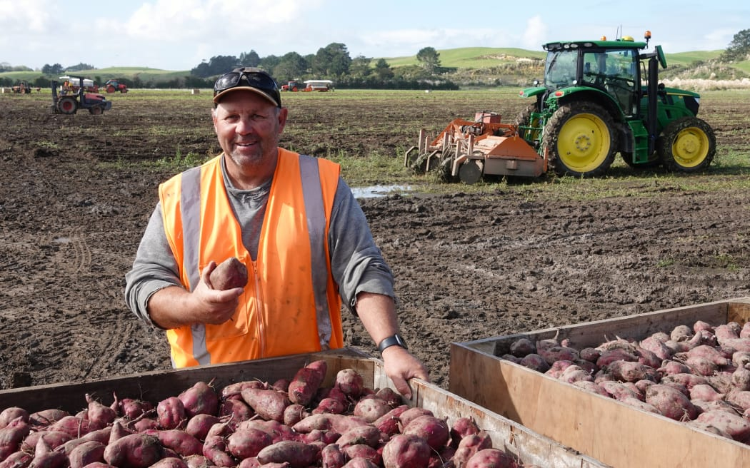
https://www.rnz.co.nz/news/country/516054/bumper-harvest-brings-relief-for-kaipara-kūmara-growers
Peter de Graaf, Northland reporter
One year ago, the future for New Zealand's favourite root vegetable looked bleak.
After a dismal spring and summer, Cyclone Gabrielle turned large swathes of the Kaipara - where virtually all New Zealand's kūmara are grown - into a vast inland sea, causing the harvest-ready crop to rot in the ground.
Dargaville kumara grower Doug Nilsson checks the seed kumara that will form the basis of next year's crop. Photo: Peter de Graaf.
Grower Doug Nilsson, of Dunsmore Gardens on the outskirts of Dargaville, lost 99 percent of his crop, managing to salvage and sell fewer than 30 bins of kūmara.
But the 2024 season has been very different. Last week, Nilsson filled the last of 2900 bins, each containing about 750kg of kūmara - 100 times more than the year before.
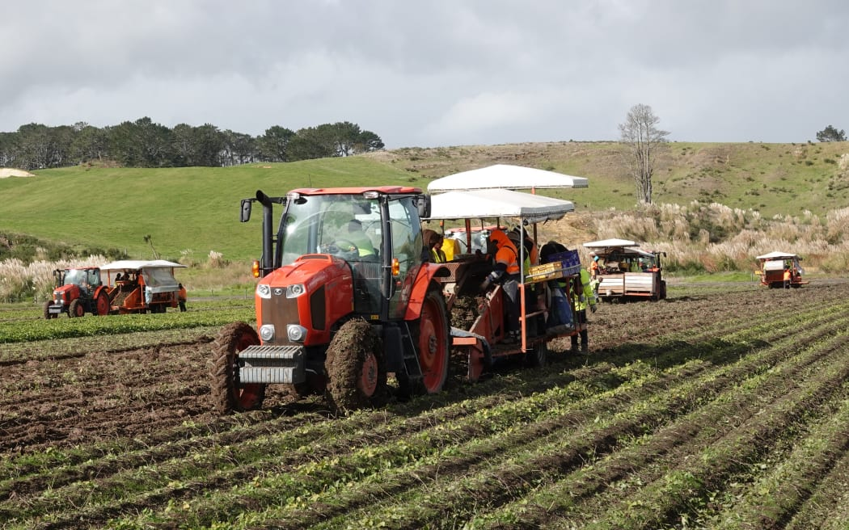
While the yield was not his biggest ever, harvest conditions were the best he had experienced in 20 years.
"Last season was a shocker. Cyclone Gabrielle was just the last straw in a bad growing year. It came off the back of a record wet winter, a really wet difficult planting season, in which most growers, us included, were lucky to get 60 percent of their normal crop planted. And then a wet summer, Cyclone Hale and Cyclone Gabrielle," Nilsson said.
Harvesting crews gather the last of Doug Nilsson's 2024 crop at his farm on the outskirts of Dargaville. Photo: Peter de Graaf

It was not just his crop that was affected - housing for his workers was also submerged.
"The accommodation had about a metre of water through it. It took until Christmas time to get the workers back into here. That's been the one bugbear, the time it takes before you can do anything, waiting for insurance. We still haven't been fully paid out."

The loss rippled across Northern Wairoa, where kūmara growing vied with dairy for the title of the area's biggest earner.
Dargaville kumara grower Doug Nilsson reflects on a roller-coaster couple of years. Photo: Peter de Graaf

"It affects everybody because we're at the start of the chain. If we've got no kūmara to harvest, there's no work - that corresponds to less money spent in town. It also affects our trucking firms that carry the kūmara - nothing to cart. Even our local bin builder, he had a terrible year last year because no one needed bins. It's a snowball effect."
The 2024 season, however, had been the "complete opposite".
Kaipara's Kaihu River north of Dargaville in flood during Cyclone Gabrielle in 2023. Photo: Kaipara District Council / Supplied
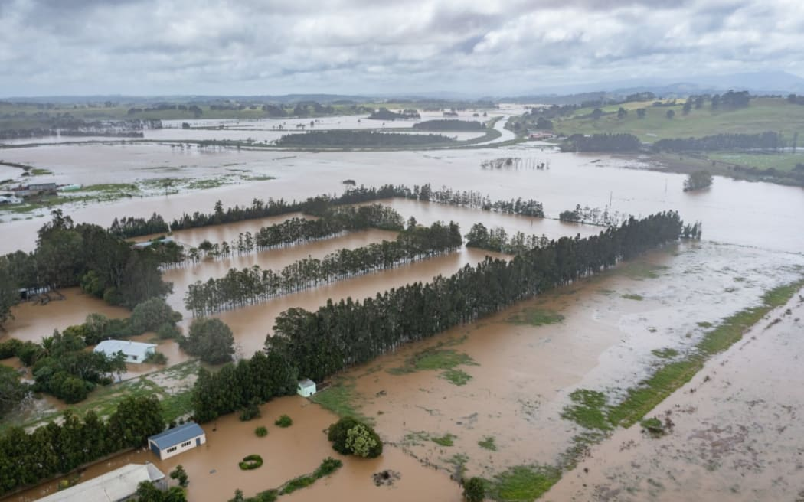
"The yields are a bit lighter than average, but we've had tremendously good weather and good digging conditions for harvest. The shed's full of nice kūmara, really good quality this year. It's probably the best harvest I've had in 20 years."
Nilsson said he had also been lucky with reliable staff this year, a 50-50 mix of locals from Kaipara, Kaikohe and Whangārei, and overseas workers employed through the RSE (recognised seasonal employer) scheme.

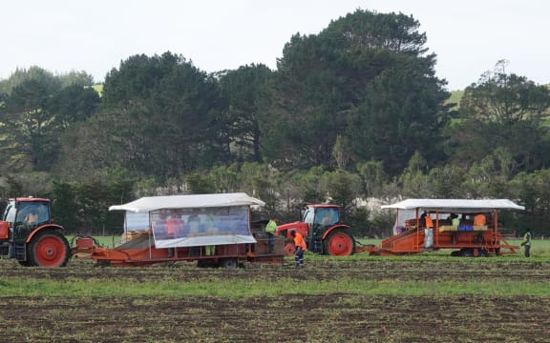
Harvesting crews gather the last of Doug Nilsson's 2024 crop at his farm on the outskirts of Dargaville. Photo: Peter de Graaf

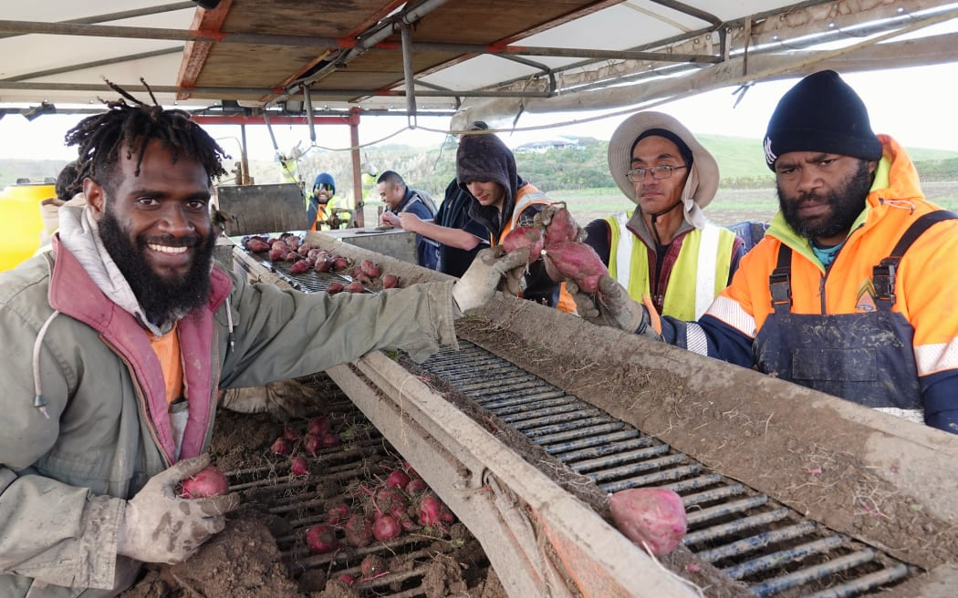
Many of those sorting the kūmara pulled from the clay soil were, like Mansen Makito, from Vanuatu.
Makito was among those evacuated last year as floodwaters swamped their living quarters.
"Every part of here was flooded. It was very difficult last season, but this season was really, really, really good," he said.
Mansen Makito, left, of Vanuatu, says the 2024 kumara crop is much better than last year's. Photo: Peter de Graaf

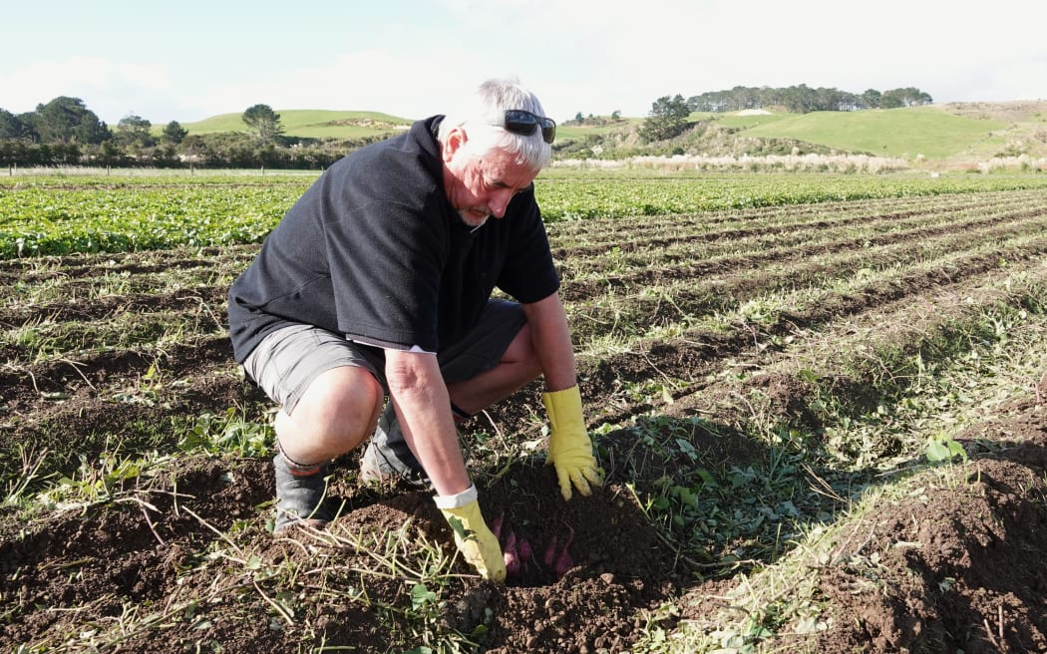
Kaipara Kūmara managing director Anthony Blundell said the "once-in-a-lifetime" 250mm of rain dumped by Cyclone Gabrielle was even more than 1988's Cyclone Bola - and it came on the back of a wet spring and summer.
"So that 250mm of rain had nowhere to go but look for a place to make its way out to sea. It flowed over Doug's four or five hundred acres, which included about 200 acres of kūmara, so it wiped out the whole lot. It was up to the top of the fence posts. It was all just a lake."
Kaipara Kumara managing director Anthony Blundell checks soon-to-be-harvested kumara. Photo: Peter de Graaf.

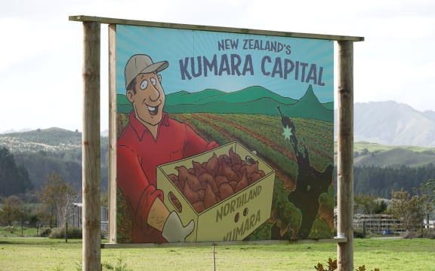
Overall, the district's kūmara crop dropped by 65 percent, while the volume processed at Kaipara Kūmara was down 73 percent.
That meant the packing season finished four months early and 24 staff had to be laid off.
Some were able to work for Nilsson, who switched to courgettes so he could keep paying his staff, while others were offered part-time work at Countdown.
An estimated 95 percent of New Zealand's kumara are grown in the Kaipara region. Photo: Peter de Graaf.

"But now we're pretty much back in business as usual. It means we've all got work for four, five days a week, and we've got a lot of kūmara to sell, which is great news for consumers. It couldn't be more the opposite to 2023."
Like Nilsson, Blundell said he was grateful to Kiwi shoppers who kept supporting growers during last year's tough times, when kūmara were scarce and prices were high.
Even with the success of the 2024 crop, Nilsson said it would take years to recover from the ravages of 2023.
"It's going to take a fair while. Prior to this disaster last year, the year before we lost money on our crop, and the year before that was barely break-even prices.
"Financially, our resilience had ebbed away for two years. We've had to borrow heavily this last year to put a crop in the ground, and it's not just going to be paid off in a year or two. Depending on the returns it could be five years, it could be 10."
He was, however, optimistic about the future.
"I'm upbeat because I've got sheds full of kūmara again. It's just a question of what the price will be, if we can start paying back some debt."
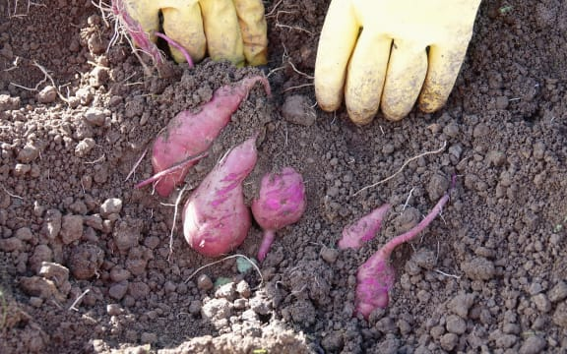
Nilsson said kūmara and New Zealand belonged together.
"It's a bit like the All Blacks. It's part of New Zealand's history, isn't it? They're treated as a taonga.
"It's always been part of your diet. If you've got meat and veggies on your plate and there's not a kūmara amongst them, it's not finished, is it? You send the cook back to get a kūmara," he said.
Kumara grow just below the surface of the Kaipara's clay-rich soils. Photo: Peter de Graaf

The last of Nilsson's 2024 crop was harvested on Thursday. His overseas workers are due to fly home today.

Discussion Questions
Understanding the issue: Extreme Weather Event on a Primary Production Crop.
- What environmental events affected Doug Nilsson’s kūmara crops in 2023?

- How did Cyclone Gabrielle affect the kūmara harvest across the Kaipara region?

- How did the weather in 2024 compare to the weather in 2023, and how did it affect the kūmara crop?

- What kind of soil do kūmara grow in, and why might this be important during heavy rain or flooding?

- Why was it difficult to plant kūmara in the 2023 season? What environmental conditions made it hard?

- What short-term effects did the 2023 floods have on Doug Nilsson’s business?

- What long-term financial challenges is Nilsson still facing because of the 2023 disaster?

- How long does Nilsson think it might take to recover financially from the past few years?

- Why do you think the 2024 harvest made Nilsson feel more hopeful about the future?

- How did the flooding affect the workers who lived on Doug Nilsson’s farm?

- Why is reliable staff important during a harvest season? What challenges might there be without them?

- What impact did the kūmara shortage have on the local community and other businesses?

- What impact did the kūmara shortage have on price to consumers?

- How does Nilsson describe kūmara in New Zealand culture? Why do you think this matters for the future of the crop?

Discussion Question Answers
- What environmental events affected Doug Nilsson’s kūmara crops in 2023?
Doug Nilsson’s crops were affected by a record wet winter, a wet and difficult planting season, Cyclone Hale, and Cyclone Gabrielle, which caused major flooding.

- How did Cyclone Gabrielle affect the kūmara harvest across the Kaipara region?
Cyclone Gabrielle caused massive flooding that turned farms into lakes, destroying crops just before harvest. The kūmara rotted in the ground, and overall production dropped by 65%.

- How did the weather in 2024 compare to the weather in 2023, and how did it affect the kūmara crop?
The 2024 weather was much better, with good growing and harvesting conditions. While the yield was a bit lower than average, the quality was excellent, and Doug has able to harvest the kūmara.

- What kind of soil do kūmara grow in, and why might this be important during heavy rain or flooding?
Kūmara grow in clay-rich soils. This type of soil doesn’t drain well, so during heavy rain or flooding, water can’t escape easily, which causes the crops to rot.

- Why was it difficult to plant kūmara in the 2023 season? What environmental conditions made it hard?
Planting was difficult due to constant wet weather and a record wet winter, making the soil too muddy and wet for machinery or planting.

- What short-term effects did the 2023 floods have on Doug Nilsson’s business?
Doug lost 99% of his crop, only managing to sell fewer than 30 bins. His worker accommodation was flooded, and he had delays with insurance payouts, which made rebuilding slow.

- What long-term financial challenges is Nilsson still facing because of the 2023 disaster?
Doug had to borrow heavily to replant in 2024, as the insurance had not been paid out. He said it could take 5 to 10 years to recover financially. His business had already been struggling with low returns in the years before the flood.

- How long does Nilsson think it might take to recover financially from the past few years?
Doug believes it could take five to ten years, depending on how good future harvests are and what prices he gets for his kūmara.

- Why do you think the 2024 harvest made Nilsson feel more hopeful about the future?
Because he had a full shed of high-quality kūmara, good weather, reliable workers, and finally had something to sell again, which gave him hope that things could slowly improve.
- How did the flooding affect the workers who lived on Doug Nilsson’s farm?
Their accommodation was flooded with a metre of water. It took until Christmas to fix the housing so they could return. Some workers were evacuated during the flooding.

- Why is reliable staff important during a harvest season? What challenges might there be without them?
Reliable staff are needed to pick, sort, and pack the kūmara quickly before it spoils. Without them, crops might be lost, and the business could fall behind or fail to deliver to markets.

- What impact did the kūmara shortage have on the local community and other businesses?
It caused a ripple effect:
- No harvesting work meant no employment and therefore less or no income for families.
- Trucking companies had no kūmara to transport.
- Bin builders had no orders.
- The whole local economy slowed down.

- What impact did the kūmara shortage have on price to consumers?
Because kūmara were scarce in 2023, prices went up. Despite this, many consumers kept buying them, helping growers survive a tough year.

- How does Nilsson describe kūmara in New Zealand culture? Why do you think this matters for the future of the crop?
Nilsson says kūmara are like the All Blacks – a taonga (treasure) and a special part of New Zealand’s history and diet. This matters because when people see kūmara as part of their identity and culture, they are more likely to support local growers, protect the crop, and keep growing traditions alive for future generations.

Level 2 Future Proofing Influences Questions
- What are the influences impacting this kūmara business?

- Using the environmental influence, outline some of the impacts, separating the impacts out into short and long-term on the kūmara business.

- Using the environmental influence, explain the impact beyond the business e.g. on the local community?

- What are the consequences of these impacts on the kūmara business?

- Using these consequences, explain how each consequence might affect the viability of the kūmara business?

- The environmental influence has economic flow on effects, discuss these linking back to the business and the community.

Answers
- What are the influences impacting this kūmara business?
Environmental:
- Cyclone Hale and Gabrielle (2023).
- Record wet winters and summers (2022–2023).
- Flooding (housing and fields submerged).
- Soil conditions - clay-rich soil have a high-water holding capacity which affects drainage, sowing and harvesting of kūmara.
- Favourable dry weather conditions in 2024 for harvesting.
Social:
- Impact on RSE (Recognised Seasonal Employer) workers and their housing.
- Reliance on overseas labour (e.g. RSE workers from Vanuatu).
- Community support from consumers.
- Local employment availability (e.g., packing sheds, harvesting crews).
- Historical resilience already low from previous poor seasons.
- Cultural significance of kūmara in New Zealand.
Economic:
- 99% crop loss in 2023.
- Decreased kūmara supply led to higher prices.
- Loss of income and delays in insurance payouts.
- Borrowing heavily to replant kūmara crop.
- Full sheds and improved kūmara yield in 2024.
- Layoffs and reduced business for other local suppliers (e.g., local bin builder and trucking firms that transport kūmara).
- Switching crops (e.g., to courgettes) to sustain business during poor seasons.
Political:
- Government and insurance responses delayed (slow payouts).

- Using the environmental influence, outline some of the impacts, separating the impacts out into short and long-term on the kūmara business.
Environmental: Cyclone Gabrielle
Short-term impacts:
- 99% loss of 2023 kūmara crop therefore no income for the business to pay on-going costs.
- Flooded worker housing, delaying labour return until Christmas.
- Local and RSE employees were laid off as there were no kūmara to harvest or pack.
- No revenue but continued overhead costs (e.g., wages, maintenance).
Long-term impacts:
- Significant debt from borrowing to replant in 2024.
- Loss of financial reserves and resilience.
- Delay in insurance compensation.
- Long recovery period projected (5–10 years).
- Reputational risk if consistency of supply is affected.
- Potential barriers to attracting or retaining seasonal workers.

- Using the environmental influence, explain the impact beyond the kūmara business (e.g., on the local community).
- When kūmara crops failed, there was loss of employment as there was no work for harvest crews, packing shed staff, and support businesses (e.g., trucking firms, bin makers).
- With lower wages circulating in the community, there was an economic downturn due to less spending in local businesses.
- Flooded worker accommodation put a strain on local housing which highlighted the need for resilient infrastructure.
- Flooding disrupted the supply of kūmara. The low supply of kūmara made them expensive across New Zealand, affecting consumers ability to buy kūmara.
- Some workers had to find temporary jobs elsewhere in the community (e.g., at Countdown), which disrupted their livelihoods and the local labour supply for local growers.

- What are the consequences of these impacts on the kūmara business?
- Reduced revenue and cashflow increasing debt and financial stress.
- Delayed business recovery.
- Loss of staff during and after the disaster.
- Weakened operational capacity.

- Using these consequences, explain how each might affect the viability of the business.
- Reduced revenue and cash flow: A reduction in revenue and cashflow means the business may not be able to cover operational costs or reinvest in the next season’s crop. This could result in increased debt, putting the business under financial stress. If recovery from the cyclone is delayed, market opportunities could be lost, decreasing the business’ competitiveness and further reducing revenue. Higher financial risk and long-term repayment obligations could also affect the future profitability of the business.

- Loss of staff during and after the disaster: The loss of staff could make it more difficult to find the permanent and casual workers required during the busy planting and harvesting seasons, as many may have found other employment in the community or moved away. If reliable staff cannot be sourced, this could disrupt the harvesting and processing supply chain, which may affect customer confidence in securing a timely supply of kūmara. As a result, customers may seek alternative sources of kūmara, further impacting revenue and cashflow and negatively affecting the business’s long-term viability.

- Weakened operational capacity: The loss of housing for staff could make it more difficult to attract the labour needed for planting and harvesting. If cashflow is limited, the business may struggle to cover operational costs, including replanting the next season’s crop, rebuilding infrastructure, replacing machinery, or scaling operations. This reduced capacity could leave the business more vulnerable to future adverse events, ultimately putting its viability at risk.

- For the agribusiness to be viable, how could current or future needs be met?
- Invest in flood-resilient infrastructure (e.g., elevated worker housing, improved drainage).
- Diversify crops grown to spread risk (e.g., including courgettes, as Nilsson did).
- Invest in and use data and technology for weather prediction, soil monitoring, and crop planning.
- Adopt more efficient planting and harvesting tools that can handle the clay soils to reduce manual labour reliance.

Article 2
Cyclone-hit kūmara growers grateful for support - Has a video
Published on 5 June 2024
https://www.anz.com.au/newsroom/new-zealand/2024/05/james-krista-franklin-dargaville-kūmara-cyclone-gabrielle/
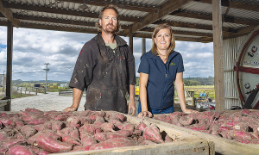
With Northland’s kūmara industry back on track after the devastation of Cyclone Gabrielle, one Kaipara farming couple have a simple message for those who helped: “thank you”. Like many growers in the region, James and Krista Franklin’s property near Dargaville was hit hard by Gabrielle, after the Kaihu River burst its banks in February last year.
“We were warned about a storm coming, but never did we expect the devastation that Cyclone Gabrielle dealt to us,” Krista said.
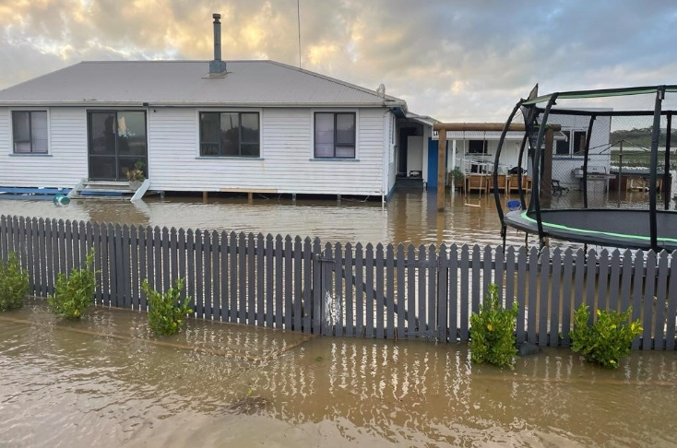
After a night of very heavy rain, the couple woke to find the field across the road had turned into a lake and knew they were in trouble. They took their two young girls to James’ parent’s home and after driving his family to safety, James returned to the farm to try to save what he could. While the couple’s home was fortunately spared due to being built up on piles, hectares of kūmara were completely underwater. In the days that followed, the pair endured a nervous wait. The longer the water sat on their fields, the greater the damage was likely to be. Some exploratory digs confirmed their worst fears - most of the kūmara had started to rot, and in the end, they were only able to harvest 16 per cent of their total crop. The most agonising part was that the cyclone hit only a few days before when they had planned to harvest.
“We had, like many other growers, decided to leave it a couple of weeks to size the crop up,” Krista said. “Hindsight’s a wonderful thing – it was probably the worst mistake we’ve made in our lives.”
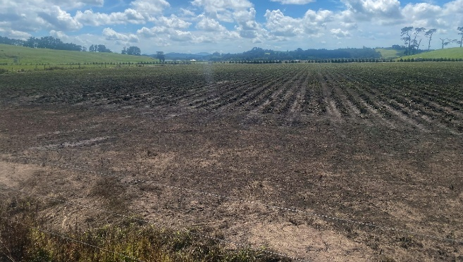
The physical and financial damage was so bad that the couple seriously considered leaving the business.
“But in the end, we decided that we’d kick ourselves if we didn’t try again,” Krista said.
HARD GOING – BUT EASIER WITH SOMEONE TO TALK TO
As James and Krista faced the daunting task of cleaning up and starting over, Krista said they realised, more than ever, the importance of mental wellbeing, including taking time to get off the farm to unwind.
“It’s a very lonely place when you’re not sure where to turn,” she said. “But there were amazing events run by Rural Support Trust Northland, as well as the Northern Wairoa Vegetable Growers Association – they hosted lots of dinners and lunches where we could all get together as growers.”
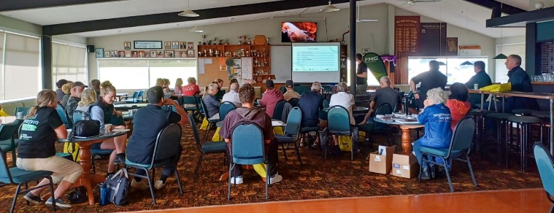
Rural Support Trust Northland Chair Michelle Ruddell said, in the aftermath of Gabrielle, the trust organised a wide variety of support initiatives to help farmers like James and Krista.
“The initial impact on farmers was incredibly stressful,” Michelle said. “Kūmara growers had lost upward of 70 per cent of their crops - but initially no one knew just what the damage was - people were shell shocked. The ongoing rain had a more insidious impact on people - the weather ground people down. Rural Support is here to create opportunities for our farmers and growers to get off-farm, connect with other farmers and growers, to realise they are not alone.”
Michelle said Rural Support Trust Northland organised 100 events supporting farmers in 2023, with 5500 people attending, and facilitated the clean-up of 135 farms. The number of one-on-one support clients being helped by the trust increased from 45 before Gabrielle, to 145 afterwards. Care packages were sent out to 960 farmers, which included $1000 Countdown vouchers to enable them to hold end-of-harvest events with their teams. For Krista and James, it made an incredible difference.
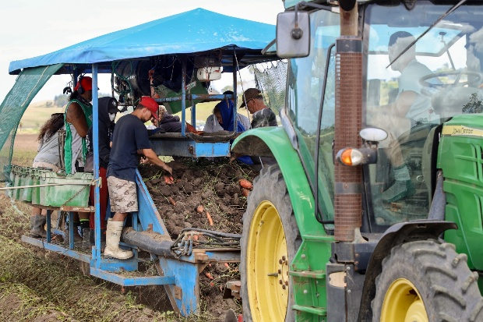
“There were information-sharing evenings, or spokespeople would come through from different organisations to offer support,” Krista said.
The trust receives funding from a range of sources, including the Ministry for Primary Industries, private donations, and from corporates. ANZ New Zealand was one such company, donating $100,000 to the trust’s Cyclone Gabrielle relief effort. Michelle said the funding went towards care packages for farmers and training trust staff and agri-sector professionals to better support the community and recognise signs of distress.
“ANZ's contribution made a genuine difference for our farmers and growers,” Michelle said.
HELP OTHERS, HELP YOURSELF
Krista realised the impact Rural Support Trust had at times like these, and soon after Gabrielle hit, she decided to get involved herself.
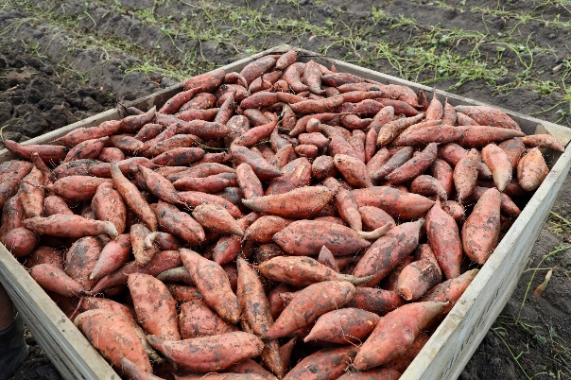
“It was such a welcome opportunity at that point in time,” Krista said. “Being able to work with fellow kūmara growers experiencing something similar to us, and other farmers who were going through the difficult season, it was just really rewarding. When you’re going through a time of devastation and difficulty, it’s just awesome to have someone rurally who can help guide you to the different supports that are available.”
Krista Franklin - Kūmara grower and Rural Support Trust Northland Facilitator
A year later, with this season’s kūmara harvest well underway, James says things seem to be back on track, both for the Franklin’s farm, and others in the region.
“We’re looking forward to getting our product out to market, hopefully at a good price,” he said. “Maybe there’ll be a bit of built-up demand in the market, since a lot of people might have missed out last year. But yeah – the quality is looking really good.”

Article 3
Kūmara prices tipped to drop as supply improves
7:11 pm on 1 March 2024
https://www.rnz.co.nz/news/business/510624/kūmara-prices-tipped-to-drop-as-supply-improves
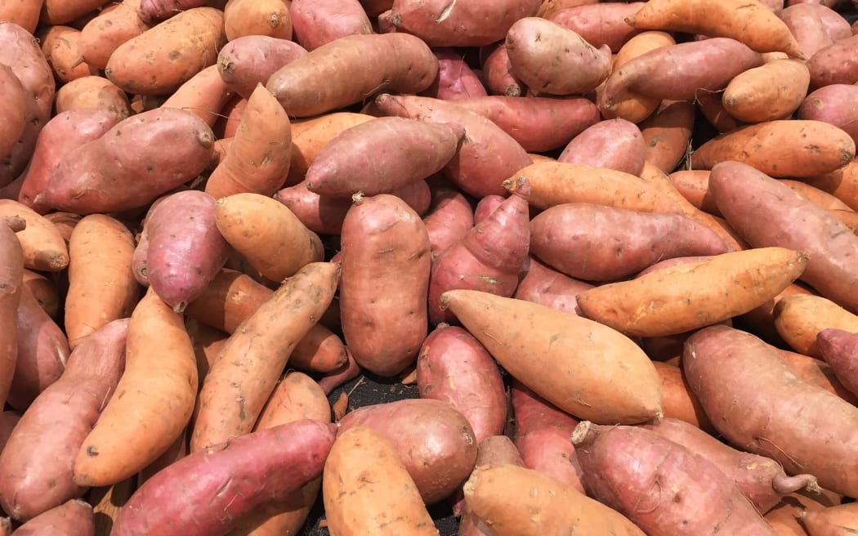
Kūmara is back in abundance after many crops were devastated by Cyclone Gabrielle. About 97 percent of Aotearoa's kūmara is grown in Northland due to its warm climate and good soil, but much of it was left rotting in the ground because of storm damage. At its scarcest, some kūmara prices topped out at $14/kg. But the new season's orange, gold and reds are back on supermarket shelves. Foodstuffs Produce and Butchery North Island head Brigit Corson said red was about $7/kg. Orange and gold are only just being harvested, but they are expected to halve in price to $7/kg in the next few weeks. Corson told Checkpoint that as supply improved, those prices would come down.
"Kūmara is an amazing crop, so we use all of it. The big ones normally go to processing, the small scrappier ones, they get steam peeled and popped into kūmara hash, and then the ones that are just right end up in Pak'nSave, New World and Four Square for our customers. But over the last year, because of the shortage - big, small, medium and everything in between - we've been trying to get on our shelves and so that's why there's been a bit of a size variation for our customers."

Kūmara prices up to $14 a kg
She said in 2023, about 60 percent of the crop was wiped out. This year the crop is expected to return to almost normal levels.
"Kūmara is a once-a-year crop. So, what happens is it gets harvested, and then it gets cold stored and just kind of released to the market. So, we're expecting with a normal crop that we will be able to have kūmara until the new season, which kind of starts in February each year."
According to Stats NZ, average kūmara prices in January 2023 were $4.37/kg, and shot up in September 2023 to $12.98/kg.

