Level 2: Future Proofing Influences

Environmental Influence Worksheet

New wood fibre technology set to futureproof
local horticulture and agriculture industries.
Teacher Note:
This worksheet provides an example of an environmental future proofing influence based on the media release” New wood fibre technology set to futureproof Local hort & agri industries”

Discussion Questions: These are designed to stimulate discussion and deepen understanding of Daltons.

Future Proofing Influences Questions: This exercise focuses on environmental influences but can be adapted to explore other future proofing influences as needed

Daltons

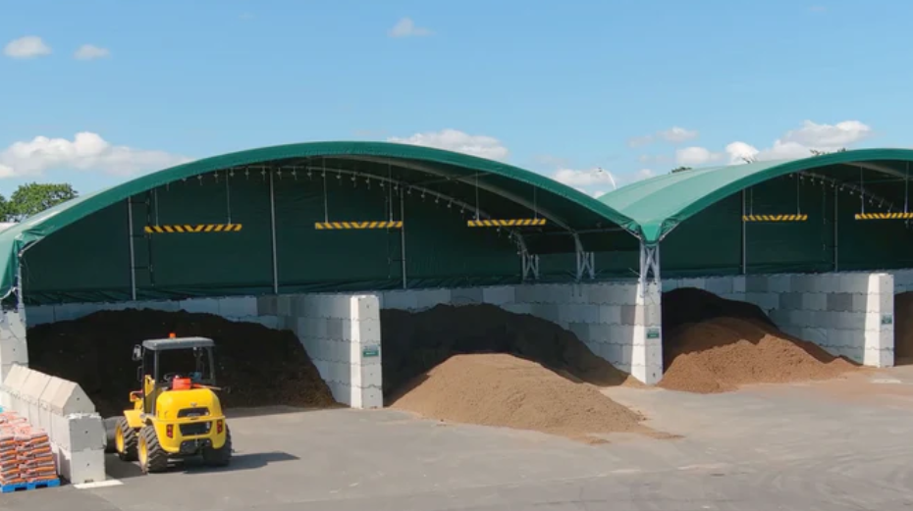
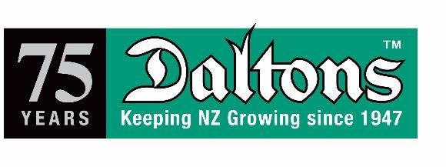
01 August 2022

MEDIA RELEASE

NEW WOOD FIBRE TECHNOLOGY SET TO FUTUREPROOF LOCAL HORT & AGRI INDUSTRIES
When you purchase locally grown fruit, vegetables, or plants from your favourite retailer they will have been grown in compost or potting mix which usually contains a highly sought-after ingredient called peat which boosts production, retains nutrients, and holds water.
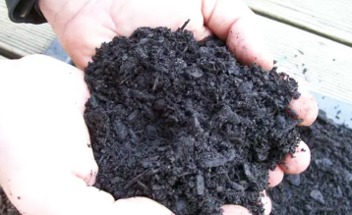
An estimated 60,000 cubic metres of growing media (compost, garden/potting mixes etc) is used each year within the horticultural and agricultural industries in New Zealand and much of it contains peat.
There is a small amount of peat extracted here in New Zealand but as peat bogs are regulated in the same way as the likes of coal mines their days are numbered.
Most of the peat contained in compost and other growing media used by New Zealand growers is imported from Canada or Eastern Europe.
Ireland has recently banned peat extraction because of the high levels of carbon emitted when it is intensively harvested.
Add to that, New Zealand’s ambitious goal of having one billion trees planted (triple current
numbers) by 2035 and the need to find a viable, locally sourced alternative to peat becomes urgent.
A global expert in horticultural substrates, Dr Brian Jackson from North Carolina State University, has been researching alternatives to peat and educating horticulturalists and others worldwide for close to two decades. He is currently in New Zealand for a short visit to educate and share his environmental passion with growers and talk specifically about the potential for using processed wood fibre products in lieu of peat.
Processed wood fibre products are not new but up until now there has been no technology here to manufacture a product suitable for local horticultural use.
The Chief Executive of the NZPPI, (New Zealand Plant Producers Incorporated), Matthew Dolan is hailing 2022 as the start of a new, exciting era of innovation for horticulture. He says that Dr Jackson’s visit could not be better timed for the industry as it coincides with the arrival of new wood fibre processing technology which Dolan cites as a crucial part of the puzzle towards future proofing the industry.
Being able to access locally produced wood fibre products means that New Zealand growers will reduce their reliance on imported material which cuts down freight costs and makes for a gentler environmental footprint.
Dr Jackson says, “This is a really exciting time for New Zealand’s horticultural industry. Because of the high quality of the Pinus radiata wood chips being used in New Zealand, there’s huge potential to export processed wood fibre overseas to meet global demand.
Daltons, a family-owned Kiwi business in Matamata has been supplying growing media (potting mix etc) to both home gardeners and commercial growers of plants and food for 75 years. About 20 years ago they started substituting bark fibre and coco fibre for peat in some of their compost mixes but that is not suitable for all applications. Because of the acidity levels required for growing some crops it is not currently possible to totally replace peat, but it is certainly possible to immediately, significantly reduce our reliance on peat.
Daltons General Manager, Colin Parker said of Dr Jackson’s visit; “We identified Dr Jackson as being the leading global expert in wood fibre processing and connected with him about three years ago. His knowledge, experience and guidance have been invaluable to us over the last few years as we researched numerous options before purchasing the industry’s first wood fibre processing machine. We are thrilled that the machine has finally arrived here, and that Dr Jackson has agreed to come to New Zealand to share his knowledge and passion for sustainability with others in our industry.”
Daltons will use wood chips from Pinus radiata trees (many of which will then be replanted using growing media with the processed wood fibre as an ingredient), making the process both sustainable and renewable.

Discussion Questions

- Who are Daltons, and what do they do?

- How long has Daltons been operating in New Zealand?

- What products does Daltons’ supply, and who uses them?

- Discuss what you think futureproofing is to Daltons?

- What changes did Daltons start making to their compost mixes about 20 years ago? Why?

- Why did Daltons connect with Dr Brian Jackson, and how has he helped them?

- Why is peat being phased out as an ingredient in potting mixes and compost?

- What environmental problems are linked to peat extraction?

- Why is it important for New Zealand to find alternatives to imported peat?

- What role do wood fibre products play in reducing reliance on peat?

- What is the new technology Daltons has invested in, and why is it important?

- What type of wood will Daltons use in their new wood fibre products, and why is it a sustainable choice?

- How might this innovation help New Zealand reach its goal of planting one billion trees by 2035?

- Do you think Daltons made a smart move by investing in wood fibre technology? Why or why not?

Discussion Question Answers.

- Who are Daltons, and what do they do?
Daltons is a family-owned Kiwi business based in Matamata. They supply growing media such as potting mix and compost to both home gardeners and commercial plant and food growers.

- How long has Daltons been operating in New Zealand?
Daltons has been operating for 75 years.

- What products does Daltons’ supply, and who uses them?
Daltons supplies growing media, including compost, potting mixes, and garden mixes. These are used by home gardeners and commercial growers of plants and food.

- Discuss what you think futureproofing is to Daltons?
To Daltons, futureproofing means reducing reliance on unsustainable or imported materials like peat, investing in sustainable, locally sourced alternatives like processed wood fibre, and adopting new technologies that ensure their products remain viable, environmentally friendly, and economical in the future.

- What changes did Daltons start making to their compost mixes about 20 years ago? Why?
About 20 years ago, Daltons began substituting bark fibre and coco fibre for peat in some compost mixes. They did this to reduce their use of peat due to environmental concerns and the need for more sustainable alternatives.

- Why did Daltons connect with Dr Brian Jackson, and how has he helped them?
Daltons connected with Dr Brian Jackson because he is a leading global expert in wood fibre processing. Over the past three years, he has provided knowledge, experience, and guidance to help Dalton’s research options and choose the right technology for producing high-quality wood fibre growing media.

- Why is peat being phased out as an ingredient in potting mixes and compost?
Peat is being phased out due to its environmental impact especially due to the high levels of carbon emissions caused by intensive harvesting. Additionally, peat bogs are heavily regulated, and extraction is no longer seen as sustainable.

- What environmental problems are linked to peat extraction?
Peat extraction leads to high carbon emissions, destruction of natural peat bogs, and contributes to climate change. Peatlands are important carbon sinks and disturbing them releases stored carbon into the atmosphere.

- Why is it important for New Zealand to find alternatives to imported peat?
- To reduce the destruction of natural peat bogs.
- To reduce carbon emissions.
- To reduce environmental impact from long-distance freight.
- To be less dependent on international supply chains.
- To support local industry and sustainability.
- To help meet environmental and planting goals, like the one billion trees by 2035 initiative.

- What role do wood fibre products play in reducing reliance on peat?
Wood fibre products can partially or significantly replace peat in growing media. They are renewable, locally sourced, and more environmentally friendly, helping to reduce both carbon footprint and peat dependency.

- What is the new technology Daltons has invested in, and why is it important?
Daltons has invested in New Zealand’s first wood fibre processing machine. This is important because it enables local production of high-quality wood fibre for growing media, making the industry more self-sufficient and sustainable.

- What type of wood will Daltons use in their new wood fibre products, and why is it a sustainable choice?
Daltons will use Pinus radiata wood chips. This is a sustainable choice because the trees are locally grown, and many of them will be replanted, creating a renewable cycle.

- How might this innovation help New Zealand reach its goal of planting one billion trees by 2035?
By creating a sustainable, local supply of growing media using wood fibre, it will support the production and planting of trees at scale, making it easier and more environmentally friendly to achieve the one billion trees target.

- Do you think Daltons made a smart move by investing in wood fibre technology? Why or why not?
Yes, Daltons made a smart move because:
- It positions them as industry leaders in sustainability.
- They are reducing their reliance on imported and unsustainable resources.
- It helps meet national environmental goals.
- It aligns with global trends toward low-carbon agriculture.
- It opens the potential for exporting processed wood fibre.
- It meets the environmental needs of their consumers.

Future Proofing Influence Questions.

- What is the name of the agribusiness?

- What are the future proofing influences impacting Daltons?

- Using one of the influences, outline the short- and long-term impacts on Daltons.

- Using the influence you have discussed, explain the impact it could have beyond Dalton’s e.g. on the environment.

- From the impacts above what are the consequences and explain how they might affect the viability of the Daltons.

Future Proofing Influence Answers

- What is the name of Agribusiness?
Daltons

- What are the future proofing influences impacting Daltons?
Daltons is influenced by several future-proofing factors, including:
- Environmental:
  - Regulations limiting extraction of peat in New Zealand and globally.
  - Carbon emissions concerns related to harvesting peat.
  - Consumer pressure to reduce reliance on imported peat.
  - New Zealand’s goal to plant one billion trees by 2035.
- Technological:
  - Wood fibre processing technology makes it possible to locally produce an alternative to peat.
- Economic:
  - Heavy reliance on imported peat from Canada and Eastern Europe presents risks in terms of cost and availability.
- Social:
  - Consumers demanding a sustainable produce product with a lower carbon footprint.

- Using one of the influences, outline the short- and long-term impacts on Daltons.
Environmental: regulations around peat harvesting and use.
Short-term impacts.
- Daltons’ investment in new technology such as a wood fibre processing machine to produce a wood fibre product to replace peat requires significant capital investment.
- Increase in research and development costs and time required to trial and adjust new growing media.
- Increased time and cost of training staff and educating growers about new products.
Long-term impacts.
- Stronger market position as a sustainable, innovative supplier.
- Reduced costs from lower reliance on imported peat and using locally sourced wood fibre alternative.
- Possible market opportunity to export wood fibre to meet global demand for a peat replacement could generate another income stream.
- Enhanced brand reputation as an environmentally responsible company increases customer loyalty.

- Using the influence you have discussed, explain the impact it could have beyond Daltons’.
Environmental: By reducing reliance on peat, the move to wood fibre-based growing media will:
- Lower carbon emissions, since peat harvesting is a big emitter of CO₂.
- Preserve natural peatlands, which are vital carbon sinks and habitats.
- Support reforestation efforts by providing sustainable growing media for planting.
- Inspire other businesses in horticulture to adopt greener practices.
- Decrease the environmental impact of global freight, by sourcing materials locally.

- From the impacts above, what are the consequences, and explain how they might affect the viability of Daltons.
- Daltons is a leader in sustainable horticulture, which will attract more environmentally conscious customers. This could increase Dalton’s brand reputation and market share leading to increased growth and revenue, which would strengthen the viability of Daltons.
- By sourcing alternative local peat replacement will lower costs long-term which will make the business more resilient.
- New export opportunities for peat alternatives could open a new revenue stream for Daltons, strengthening their viability.
- High initial investment in technology and research and development may take time to recoup and put a short-term financial strain on Daltons.
- Market education is needed to introduce the new wood fibre products, and it may take some growers time to adopt new products, however the use of a more environmentally sustainable alternative will retain current customers and attract new ones making their business more resilient and competitive in the face of global environmental and economic challenges.

Teacher Notes: Daltons BACKGROUND

Keeping it local – why it matters
Eating food that has been grown locally using local growing media is becoming more important to Kiwis (and their global counterparts) not just because they want to support local businesses but because they know it is better for the environment and their own carbon footprint. Demand for growing media to enable efficient food and plant production is predicted to double globally in the next decade as consumer demand scales new heights.

About Dr Brian Jackson and why his visit is such a big deal
Brian is a Professor and Director of the Horticultural Substrates Laboratory at North Carolina State University. He has studied and researched growing media for the professional and hobby markets since 2003. His primary research interest and experience is in developing and characterizing engineered wood fibers, understanding soilless substrate hydrology and wettability, and developing substrates for edible crops in soilless systems. He has worked very closely with growing media suppliers and manufacturers around the world over the past decade and he frequently writes articles and gives presentations on various growing media topics, trends, and research around the world.
He believes that engineered wood fibre processing offers a golden opportunity for New Zealand to differentiate itself and reaffirm our clean, green positioning on the global stage. If the industry can work together to embrace the use of processed wood fibre technology for horticulture, then it also has the potential to export this material.

Why Peat is so sought after
There’s no question that peat is highly effective as an additive to soil because of its ability to hold water and retain nutrients. When introduced in the early 1900’s it was hailed as revolutionary.

What is peat?
Peat is formed in moss over many years and if left untouched is harmless. However, when it is extracted out of the ground it releases high amounts of carbon dioxide and other greenhouse gasses into the atmosphere, contributing to climate change. Scientists say that the 3% of the world's peat moss bogs that are currently being harvested intensively have the potential to hold 30% of all the stored carbon on earth.

Key advantages of substituting wood fibre products for peat include;
- Food and plant producers will more confidently be able to move more of their production indoors. They will no longer be at the mercy of fickle mother nature. The consistency of processed wood fibres substrate as an ingredient will ensure greater consistency of products, less freight costs due to the lighter weight of the fibrous product (no importing) and ultimately reduce pressure on growers’ production costs which hopefully may trickle down and ease the burden on consumers’ pockets.
- The wood chip being used is from logged pine trees, many of which will be grown using compost containing the wood fibre substrate so it will have come full circle adding to Dr Jackson’s scientific evidence that wood fibre processing and use is a viable option for utilizing local and renewable natural resources.

- The finished product being launched by Daltons is called Pinegro. It has been shown to have good physical and structural properties and that it will not break down rapidly in the soil. Pinegro is not a standalone growing media product but rather one ingredient within a mix that is customised for each growing activity.
- Less reliance on imported peat which can impact local production if supply is threatened, or delivery delayed
- Being lightweight due to the fibrous nature of the product it is cheaper and easier to handle and freight. This also assists with crop management.

About the technology
The technology involved includes a mechanical extrusion process to form a lightweight fiberised material. The fiberisation occurs when the fibres within the woodchip are teased apart by a rolling and twisting action. A mechanical heat of 140-160c is achieved which is combined with high pressure. It can then be used for blending other growing media bulk materials.
Other New Zealand industries are already using wood fibre processing, but the technology and application is different to the opportunities now available to the horticultural industry.
Wood fibre processing has been used successfully in horticulture overseas but has not previously been available for local New Zealand use.

