Level 2:
Environmental Influence Worksheet
Teacher Note:
Greenhouse gas emissions are increasingly shaping the future of agribusiness, as global markets, regulators, and consumers demand more sustainable food production. Reducing emissions is not only critical for meeting climate targets but also essential for maintaining market access, securing investor confidence, and ensuring long-term viability in a low-emissions economy.

Activity: Read the article and summarise the key points on environmental influences.

Less emission from hill country farms
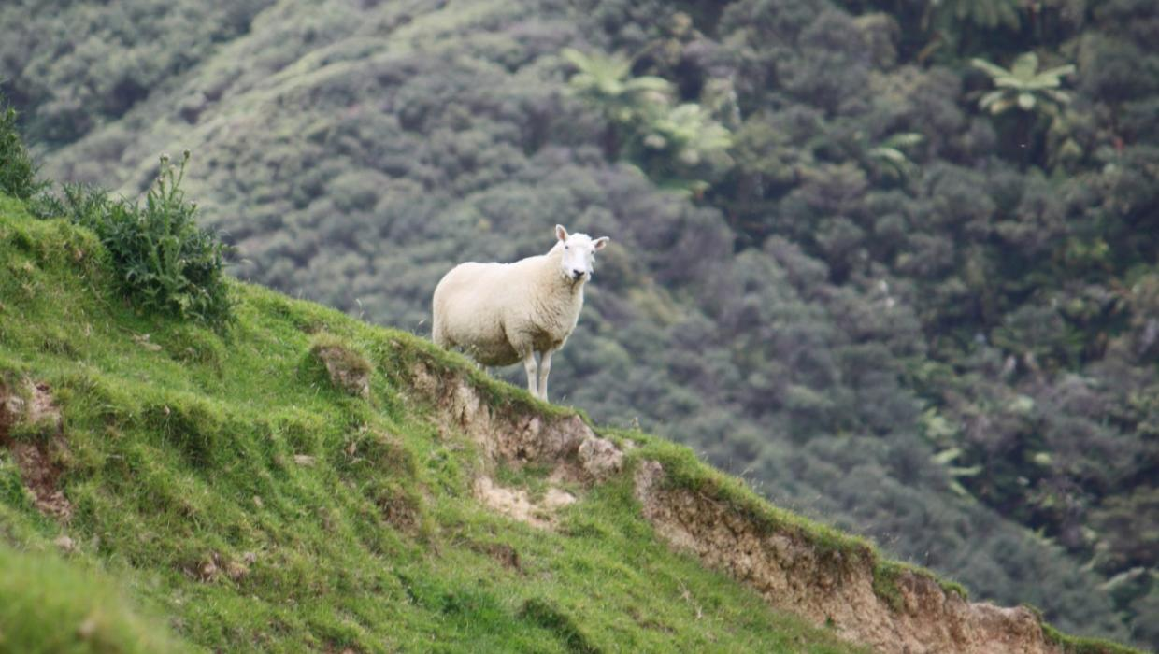
New research shows that New Zealand hill country farming may be producing fewer greenhouse gas (GHG) emissions that previously thought.
Work by AgResearch and Landcare Research has determined that the amount of nitrous oxide emitted from urine patches is driven by a farm's steepness.
For medium and steep slopes, current data suggests the emission factor is less than half when compared to flat areas, senior soil scientist Tony van der Weerden said.
Livestock on steep hill country emit half as much of the greenhouse gas nitrous oxide as those farmed on flatland.

Speaking at a field day at Onetai Station north of Awakino, he said it was an exciting discovery.
The lower emissions were probably due to lower soil biological activity and fertility on the sloping land compared to the soil on flat land, because stock will transfer nutrients from slopes to flat land through urine and dung.
"There is much tighter nitrogen cycling going on in medium slopes and sloping land, it's not so rich in activity and we think that's having an influence on the emission factors," he said.
The urine patch from livestock on a hill country slope is distributed over a larger area compared to flat land, which potentially increased the affected soil's nitrogen use efficiency. Urine patches on slopes can often be seen as long lines of darker green growth.
Nitrous oxide is a greenhouse gas, mainly coming from urine patches in the soil. A portion of the nitrogen in the urine patch is converted into the gas, which is the second most important greenhouse gas after methane.
Much of the research in the past 15 years had been carried out on dairying in lowland areas, where scientists have determined that New Zealand has a country-specific emission factor of 1 per cent along with 0.25 per cent for dung. These agricultural emissions are currently seen to be evenly split between 50% dairy and 50% from sheep, beef and deer.
However, the lower emission factors measured on medium and steep sloping hill country would reduce the total nitrous oxide emissions from the sheep, beef and deer sector.
New Zealand had an obligation to report its greenhouse gas inventory to the United Nations, and the Ministry for Primary Industries is funding field trials to confirm the lower values.
He stressed it was not a mitigation strategy; it did not include methane emissions and real agricultural emission levels had not changed.
A reduction in the calculated emissions was potentially a powerful marketing tool for Beef+LambNZ where consumers were increasingly demanding food that was produced with a lower emissions profile, AgResearch senior scientist Robyn Dynes said.
"It could potentially deliver a huge plus for sheep and beef farmers when we think about global consumers. It is important to New Zealand's future; it is important to how discerning consumers view our product."
New Zealand also had to be seen to be making a fair contribution to reducing GHG emissions, and the country relied on global consumers to buy its products, she said. "They are looking at footprints, so our GHG footprint from hill country could potentially, because of the science, be seen as reduced."
Scientists are able to measure the emissions by collecting gas samples from covers placed over fresh urine patches. Urine is collected from sheep or cattle, analysed for the nitrogen content and then poured onto the soil, where it is covered periodically for an hour and gas samples are taken at 30-minute intervals. Once analysed, the change in concentration of nitrous oxide over that time is used to calculate emissions from the urine-affected soil.
Those emissions are measured for three months following the urine application. The emissions are the heaviest in the first month before tailing off over the remaining two.
Emission factors, which is the percentage of nitrogen that is lost as nitrous oxide, are also calculated, and these have been found to be lower on slopes than on flat land.
Dynes said work was continuing on testing inhibitors and vaccines as solutions to methane emissions. Summer rape crops were also looking promising after tests showed there was a 20 per cent emission reduction when consumed.
AgResearch was also looking into livestock genetics and had flocks of low emission sheep that were producing less methane.
"The ideal of course is that if we could capture that methane, turn it into something where you capture a productive gain - that's the holy grail."

Answer:
- Summarise the key points on environmental influence on hill country farms
New research shows that hill country farms in New Zealand emit less nitrous oxide, a key greenhouse gas than previously estimated, largely due to environmental factors such as topography and soil characteristics. These conditions lead to lower emission factors for sheep, beef, and deer farming in hill country areas, which could help reduce New Zealand’s reported agricultural emissions and strengthen its sustainability story in global markets.
Key Environmental Influences:
- Slope of the land:
  - Steeper slopes have significantly lower nitrous oxide emissions than flat land.
  - Emission factors are less than half on medium and steep slopes compared to flat areas.
- Soil fertility and biological activity:
  - Hill soils are generally less fertile and have lower microbial activity, reducing the conversion of nitrogen into nitrous oxide.
- Urine distribution:
  - On slopes, livestock urine is spread over a larger area, increasing nitrogen use efficiency and reducing emissions per unit of nitrogen.
- Nitrogen cycling:
  - Tighter nitrogen cycling occurs on hill slopes due to lower nutrient levels, which limits greenhouse gas formation.
- Nutrient Transfer by Livestock:
  - Animals tend to move nutrients (via dung and urine) from slopes to flatter areas, leading to less nutrient buildup on slopes.

