Knewe offers shares in new prebiotic for cows

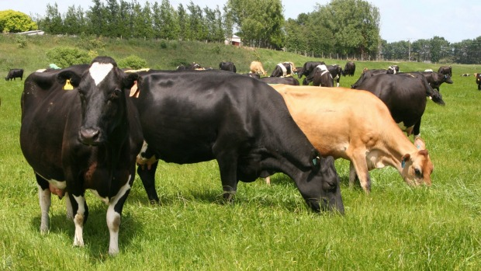
Sonita Chandar
Knewe Biosystems Ltd are using crowdfunding to raise the funds to upscale a new prebiotic product for dairy cows.
Knewe Biosystems is hoping crowdfunding will raise the working capital needed to upscale its new prebiotic product Knewe-Mg across New Zealand.
Knewe has developed a scientifically proven patented prebiotic that ensures cows and other ruminants are more productive and healthier while producing less waste.
The Canterbury-registered company claims the product provides direct economic returns of two to three times the cost of the product, which promotes good intestine health.
In autumn, cows trialled in Southland gave a 15 per cent increase in milksolids while in spring on pasture, there was an increase of 23 per cent. Based on a dairy farm with 400 cows that is an estimated NZ$250,000 of extra profit a year said Knewe technical director Graeme Coles.
"That's up to $1.70 profit per cow, per day," he said.
The venture will be launched on September 25 with Knewe equity crowdfunding through PledgeMe to give interested parties the opportunity to buy shares at $10 each. Pledges close on October 23.
Based on five-year projections the valuation of the company is being estimated at $4.5 million.

