**Level 2:**

**Science Influence Worksheet**

**Teacher Note:**Science and innovation are crucial to the future of New Zealand’s primary industries, but outdated regulatory systems are blocking progress. Enabling faster, science-aligned access to modern animal and plant health products is essential for global competitiveness, sustainability, and the long-term prosperity of New Zealand's agricultural economy.

**Activity:** Read the article and summarise the key points on the science influence on primary production.

**Clear the Regulatory Runway.**

https://www.agribusinessmagazine.co.nz/blog/clear-the-regulatory-runway

**Words:** Animal and Plant Health NZ

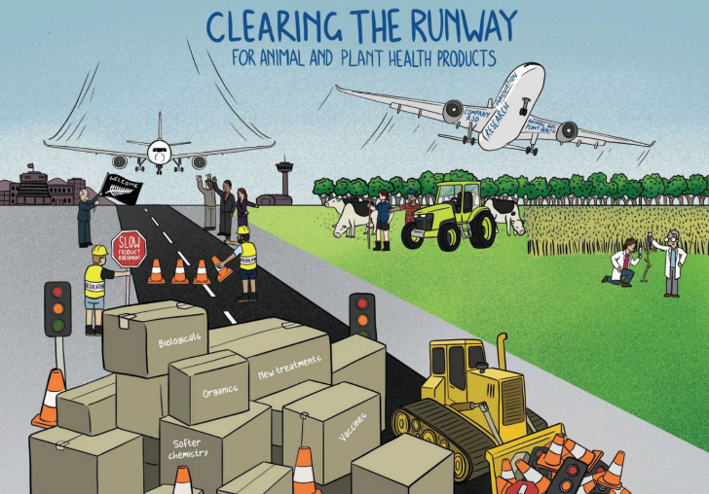If agriculture and horticulture are the engines of New Zealand’s economy, innovation is the fuel, and regulation is the runway that enables it to take flight.

Global research and development companies, the ones developing new tools to power the primary sector, are circling overhead, waiting to land innovation.

But there is a blockage on the runway for New Zealand’s primary sector ambitions – access to new animal and plant health products.

These products underpin every primary sector goal, doubling export value, trade agreements, emissions targets, resistance management, animal welfare, sustainability, and replacing old chemistry that is a trade and environmental risk.

These mission critical tools also support the delivery of many primary sector leaders’ key performance indicators.

Companies say the regulatory approval process for agricultural and horticultural products under the Agricultural Compounds and Veterinary Medicines (ACVM) and Hazardous Substances and New Organisms (HSNO) Acts remains unpredictable and is not keeping pace with global innovation and harmonisation trends.

New Zealand used to be world leading in bringing innovation to market, but no more.

If a market cannot provide regulatory efficiency and certainty, farmers and growers miss out on tools needed to manage pests and fight diseases. And veterinarians go without new options for drench resistance, preventative medicines, and vaccines to strengthen animal health and reduce reliance on antibiotics.

A broad toolkit with new solutions is needed, to replace older chemicals, to compete globally, address resistance and meet growth expectations set by government. While these tools sit within reach on the runway, primary industry is waiting at the baggage claim station for the latest pipeline of animal health and crop protection products to come through.

The Ministry for Regulation’s review¹ of the regulatory process for agricultural and horticultural products calls for improved proportionality, efficiency, transparency and certainty of the approval path.

The review inspected the runway and estimated a 5.6 to 8.3-year timeframe to clear new products to land. Cabinet greenlighted the plan and Ministers set targets for regulators to crack on to clear the runway. Air traffic controllers in the control tower are working on amendments to the ACVM and HSNO Acts, but legislative reform will take time.

The good news is there are operational levers that can be pulled right now.

Animal and Plant Health New Zealand (APHANZ) have been working with regulators, bringing forward-looking solutions, prior to this review. Developed from the Ministry for Regulation review report recommendations, APHANZ has a shovel-ready blueprint for change.

The actions in this blueprint do not need legislative changes and propose three areas to deliver results on the ground, while legislative reform runs its course.

1. Specialist taskforce to clear applications for products with new active ingredients.
2. Use available tools (international harmonisation, trusted regulator data) to enable more efficient processing.
3. Meaningful engagement for agreed, workable solutions.

This is not about taking shortcuts in areas like animal welfare, safety or residues — it is about cutting red tape and making balanced risk-based decisions in a timely way. We want a runway that is well-lit, well-managed, and responsive to the sector it serves.

When innovation lands safely, everyone wins, and New Zealand can reclaim its place with a world leading runway clear for innovation to land. Decisive and rapid action is needed to fix delays in the regulatory approval process and improve investment confidence in New Zealand.

Without it, research and development companies will continue to decrease their investment in New Zealand, jeopardising agricultural market access as well as equitability and affordability for New Zealand consumers. The greatest risk is not having new products at all.

Let us clear the regulatory runway, and let innovation land, so our primary sector can fly high.

¹See <https://www.regulation.govt.nz/regulatory-reviews/agricultural-and-horticultural-products-regulatory-review/>

**Answers:**

**Summary:**

**The Influence of Science and Innovation on New Zealand’s Primary Production**

**1. Science and innovation as essential drivers**

* Innovation, particularly in animal and plant health products, is described as the "fuel" powering New Zealand’s agriculture and horticulture, the economic "engine".
* Scientific advancements are critical to achieving key industry goals, including:
  + Doubling export value
  + Meeting emissions targets
  + Managing resistance (e.g., pests, drench resistance)
  + Improving animal welfare
  + Enhancing sustainability
  + Replacing outdated and risky chemicals.

**2. Regulatory delays are hindering scientific progress**

* Scientific tools are available globally, but regulatory delays in New Zealand (under the ACVM and HSNO Acts) are blocking access.
* The average delay is 5.6–8.3 years, putting New Zealand behind global innovation trends.
* This impacts farmers, growers, and veterinarians, who miss out on modern tools like vaccines, preventative medicines, and advanced crop protection.

**3. Impact on global competitiveness**

* Without timely access to scientific innovations, New Zealand risks:
  + Falling behind international competitors
  + Jeopardising market access for exports
  + Limiting investment confidence from research and development companies
  + Increasing costs and limiting product options for local consumers

**4. Proposed science-based solutions**

* A science-led, risk-based approach to regulation is proposed, not compromising safety or welfare.
* APHANZ have developed an operational blueprint to accelerate approvals, including:
  1. A specialist taskforce to clear backlogs
  2. Greater use of international data and harmonisation
  3. Collaborative engagement for practical regulatory solutions

**5. Strategic 0pportunity**

* Regulatory reform, if implemented efficiently, will allow New Zealand to:
  + Regain its position as a world leader in innovation adoption
  + Strengthen sustainability and environmental outcomes
  + Support a science-informed, resilient primary sector.