**Level 2: Future Proofing Influences.**

**Science Future Proofing Influence Worksheet.**

**Teacher Note:**

This worksheet provides an example of **science** future proofing Influence based on technology

Science and technology like catch crops and spader drills offer powerful tools for boosting both the productivity and sustainability of dairy farms. When well-managed, these innovations support environmental health, improve economic efficiency, and enhance the long-term viability of the dairy sector.

**Discussion questions -** Stimulate discussion and understanding of the science behind nitrogen leaching and science solutions

**Future Proofing Influences Questions**

**North Canterbury farm trial shows catch crops can reduce nitrogen leaching**

RNZ· <https://www.nzherald.co.nz/the-country/news/north-canterbury-farm-trial-shows-catch-crops-can-reduce-nitrogen-leaching/TMLYUGIATNEG5JSA7KRQVY6KPU/>

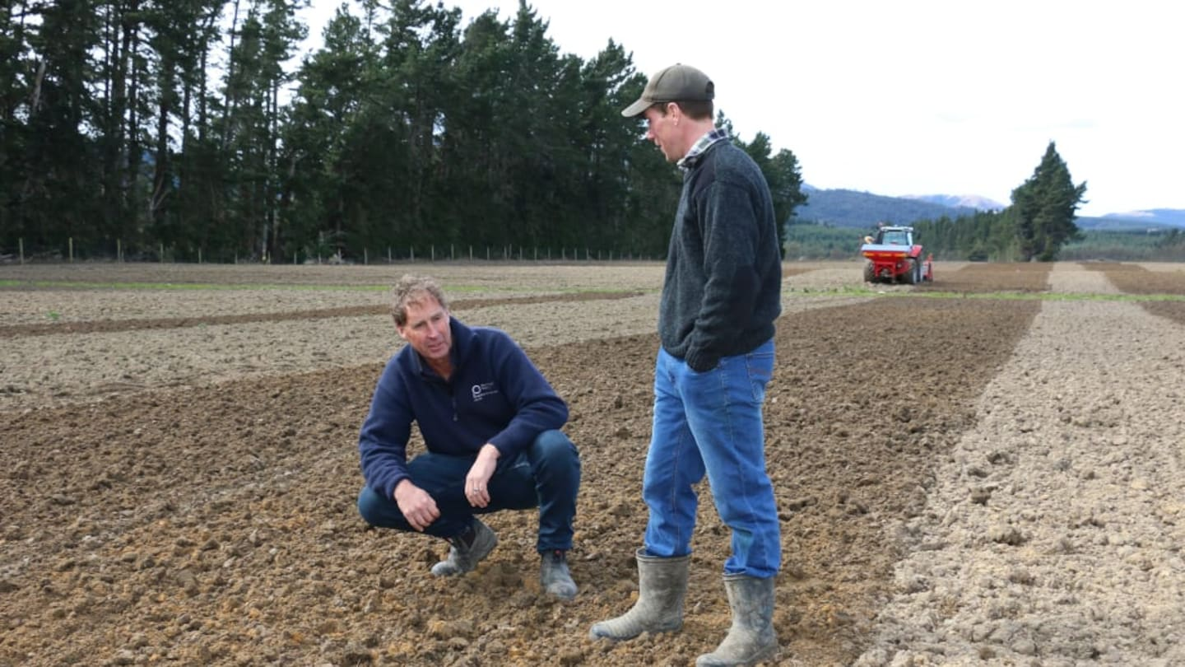

Special crops are soaking up the nasties from dairy cows’ pee in an “eye-opening” farm trial which could help clean up New Zealand’s rivers and streams.

The trials on a North Canterbury dairy farm have found that early sown oats and Italian ryegrass take up excess urine deposited by winter grazing cows.

Shane Maley from Plant & Food Research with farmer Tom Turner. Photo / RNZ / Cosmo Kentish-Barnes

“It has reduced our footprint in terms of nitrogen leaching and we have got a forage there that is capturing not just nitrogen in the soil, but carbon as well,” farmer Tom Turner said.

Urinary nitrogen can leach whenever the rain is such that water moves through the soil to groundwater. This can lead to the contamination of waterways. The trial on Turner’s Waimakariri Gorge farm has been conducted by Plant & Food Research. Similar trials have also been running in Canterbury, Southland and on a West Coast farm. Field operations science team leader Shane Maley has been working closely with Turner.

“We started looking at catch crops and trying to work in a system approach of supporting farmers following winter grazing and trying to have an impact on any nutrient losses potentially after those winter months,” he said.

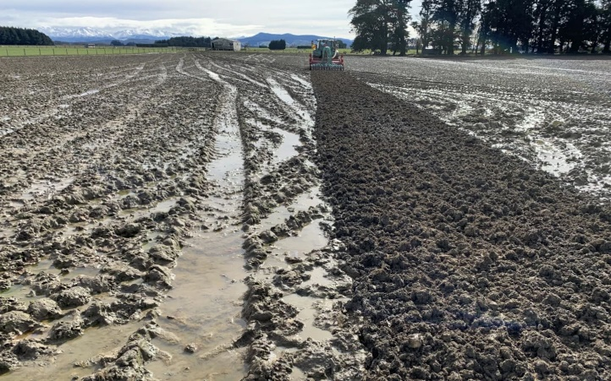Catch crops are cool-tolerant cereals that can be planted as quickly as possible after winter grazing. Typical catch crops include oats, triticale, ryecorn, Italian ryegrass and faba beans.

“We literally started with three or four strips of oats just to see if it would actually work in the middle of winter,” Maley said. “Would it grow? Would it take up nitrogen? And to our surprise, it did a fantastic job!”

A spader drill drilling oats in Southland at the beginning of August 2023, following winter grazed swedes. Photo / Shane Maley

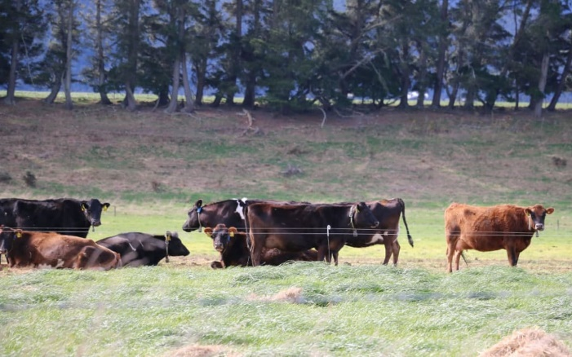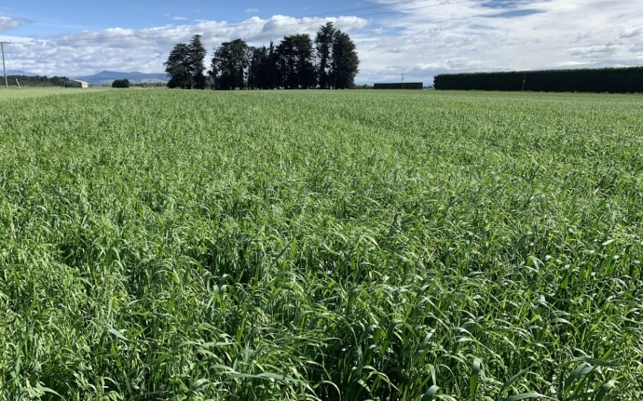There is more nitrogen in the grass than cows can use so the excess is returned to the soil, mainly as urine. Dairy cows can urinate up to a dozen times a day, with an average volume of two litres each time. The average equivalent urinary nitrogen application rate is estimated to be approximately 600kg of nitrogen per hectare. Autumn and winter are the highest risk times for nitrate leaching because of the low temperatures, slow plant uptake and higher rainfall and drainage.

The same site as above in November and ready for silage removal. The crop produced nine tonnes a hectare. Photo / Shane Maley

“Obviously we were looking at nitrogen losses to begin with, but now we are also showing that catch crops can actually reduce sediment losses as well,” Maley said.

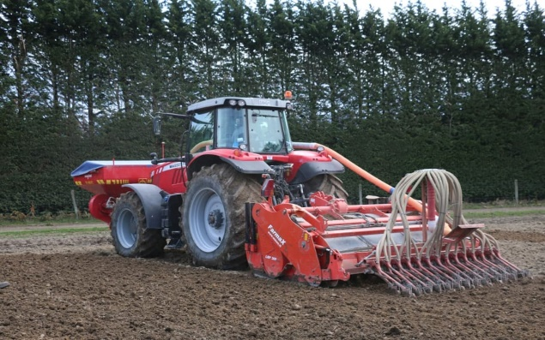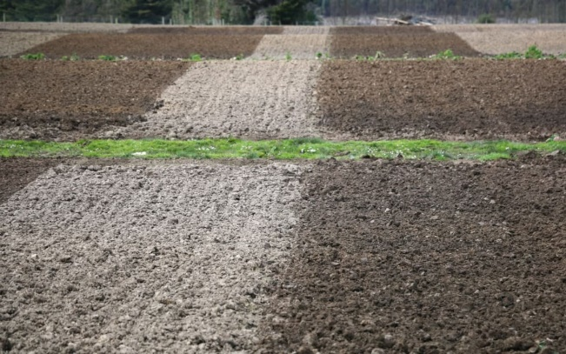Results from the trials had been eye-opening, he said.

Cows winter grazed on swedes in this paddock, prior to it being sown with catch crops. Photo / Cosmo Kentish- Barnes

The spader drill is a game-changer for Tom Turner. Photo / Cosmo Kentish- Barnes

“We’ve reduced sediment movement or losses on-farm by 40%. In terms of the catch crop, we are between 40 and 60% of potential losses of nitrogen which those crops are picking up.”

Woodstock Farm is tucked up against the foothills just south of Oxford. One of its dairy platforms is on flat irrigated land and the other is on sloping down country.

“We’re milking just under 3000 cows, along with 1000 head of young stock across 800 hectares of dairy platform and another 800 hectares of dairy support,” Turner said.

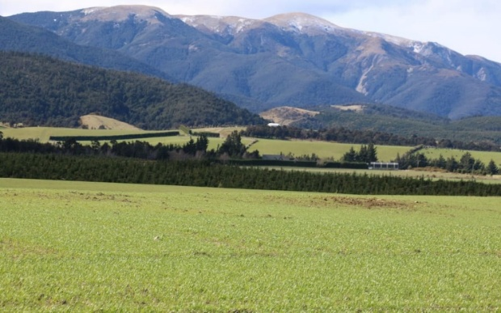When RNZ’s Country Life visited the farm in early September, a spader drill was sowing oats and Italian ryegrass in behind a 12-tonne dry land swede crop.

A few years earlier, the paddock would lie fallow until November as it was too wet to get any good results from a conventional cultivator going through.

The spader drill is a rare beast in Aotearoa. The Dutch machine is designed to work best on heavier soils with not too many stones.

A sloping paddock at Woodstock Farm that has been sown in catch crops. Photo / Cosmo Kentish-Barnes

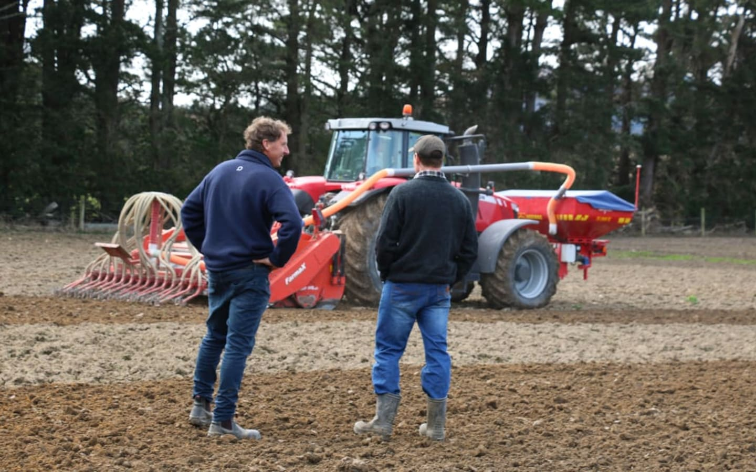Shane Maley and Tom Turner admire the spader drill's ability to sow crops on muddy ground. Photo / Cosmo Kentish-Barnes

Turner said getting catch crops in early with the spader was not only a win for the environment but also for yields.

“We’re gaining a lot of kilograms of dry matter growing in that period as opposed to being short and buying in or just having to find other alternatives of a feed source.”

This year, he is putting 50ha into catch crops after winter grazing.

One of the major beneficiaries lives under the ground. A farm research site in Southland showed the difference between two plots - one that had catch crops and one that did not. The soil after harvesting the crops with deep roots had a lot more earthworm activity.

The project on Turner’s farm has finished after four years but sowing catch crops to reduce nitrogen leaching and sediment losses is catching on.

“So, we’re working with farmers in the high country. We’ve also got trials set up in Central Otago and cooler inland areas around Wānaka and up through Middlemarch as well. So, it is a good continuation, and this is really led by catchment groups as well, who are fantastic to be involved with.”

**Discussion Questions**

1. Why is nitrogen leaching a problem for the environment, especially for rivers and streams?
2. What are the risks of leaving paddocks bare (fallow) after winter grazing?
3. How do catch crops help reduce environmental damage caused by dairy farming?
4. What role do earthworms play in healthy farming systems, and how are they affected by catch crops?
5. How did scientists test whether catch crops were effective at soaking up nitrogen?
6. What do the results of the catch crop trials suggest as a solution to leaching of Nitrogen?
7. Why might oats and Italian ryegrass be especially good at reducing nitrogen and sediment loss?
8. Why might the spader drill be described as a “game-changer” for dairy farmers?
9. What are the benefits of being able to sow crops earlier in the season?
10. How do strategies like catch crops and new machinery make farming more sustainable and profitable?
11. Why is it important for dairy businesses to balance profit with protecting the environment?
12. What could happen to dairy farms if they do not change the way they manage waste and protect the land?

**Answers**

1. Why is nitrogen leaching a problem for the environment, especially for rivers and streams?

Nitrogen leaching occurs when excess nitrogen (mainly from cow urine) seeps through the soil into groundwater and eventually into rivers and streams.  
This can cause:

* Water pollution
* Toxic algal blooms
* Harm to aquatic life
* Unsafe drinking water

1. What are the risks of leaving paddocks bare (fallow) after winter grazing?

Bare paddocks:

* Do not absorb nutrients like nitrogen, leading to more leaching into waterways
* Are more likely to suffer soil erosion and sediment runoff
* Lose valuable nutrients and organic matter, reducing soil health

1. How do catch crops help reduce environmental damage caused by dairy farming?

Catch crops (like oats and ryegrass):

* Absorb excess nitrogen from cow urine before it leaches
* Hold the soil together, reducing sediment runoff
* Capture carbon, improving soil structure and reducing emissions

1. What role do earthworms play in healthy farming systems, and how are they affected by catch crops?

Earthworms:

* Improve soil aeration, structure, and nutrient cycling
* Help increase water retention and root penetration
* Thrive in soils with plant cover, like those with catch crops
* Catch crops improve soil conditions, which leads to increased earthworm activity.

1. How did scientists test whether catch crops were effective at soaking up nitrogen?

Scientists ran field trials across different regions:

* Planted catch crops (like oats) immediately after winter grazing
* Measured nitrogen levels in soil and runoff
* Compared results from planted vs. fallow paddocks

1. What do the results of the catch crop trials suggest as a solution to leaching of nitrogen?

Results showed catch crops:

* Reduced nitrogen leaching by 40–60%
* Also reduced sediment loss by around 40%  
  This suggests that planting catch crops is a practical, science-based solution to nitrogen leaching.

1. Why might oats and Italian ryegrass be especially good at reducing nitrogen and sediment loss?

They are:

* Fast-growing, even in cool, wet conditions
* Have deep root systems that absorb nitrogen and hold soil
* Effective at covering bare soil, reducing erosion

1. Why might the spader drill be described as a “game-changer” for dairy farmers?

Because it:

* Sows crops earlier in muddy, wet conditions where other machines fail
* Allows for faster planting after winter grazing
* Helps capture nitrogen sooner, preventing loss to the environment

1. What are the benefits of being able to sow crops earlier in the season?

Early sowing:

* Maximises nitrogen uptake
* Reduces leaching risk
* Produces more forage (dry matter) for animal feed
* Improves soil health and carbon capture

1. How do strategies like catch crops and new machinery make farming more sustainable and profitable?

They:

* Protect the environment (clean water, healthier soil)
* Increase on-farm feed production, reducing costs
* Support long-term productivity by maintaining soil fertility
* Help meet regulatory and consumer expectations

1. Why is it important for dairy businesses to balance profit with protecting the environment?

Because:

* Environmental damage can lead to regulations, fines, or loss of market access
* Consumers increasingly demand sustainable products
* Healthy land and water are essential for long-term farm success
* Protecting the environment is part of being a responsible land steward

1. What could happen to dairy farms if they do not change the way they manage waste and protect the land?

Potential consequences:

* Increased water pollution, damaging public trust
* Stricter regulations or legal penalties
* Loss of export markets due to environmental concerns
* Degraded land and water, leading to lower productivity and higher costs  
  Ultimately, failing to adapt could threaten the farm’s viability and reputation.

**Questions**

1. Using science and technology as influences outline some of the short- and long-term impacts on a dairy farming business.
2. Using the science influence, explain the impact beyond the dairy farming business e.g. environmentally.
3. What are the consequences of these impacts on the dairy farming business?
4. Using these consequences, explain how each consequence might affect the viability of the dairy farming business?

**Answers**

1. Using science and technology as influences, outline some of the short- and long-term

impacts on a dairy farming business.

**Short-term impacts:**

* Catch crops like oats and Italian ryegrass absorb urinary nitrogen before it leaches into groundwater reducing nitrate leaching.
* Early sowing using technology like the spader drill provides extra feed (dry matter) during times when land would otherwise be fallow.
* The spader drill allows sowing in muddy, heavy soils that were previously too wet for conventional methods.
* By growing more feed on-farm, there is less need to buy supplementary feed, reducing costs and improving financial efficiency.

**Long-term impacts:**

* Deep-rooted crops increase earthworm activity, improving soil structure and fertility.
* Reducing nitrogen and sediment runoff supports long-term land productivity and sustainability goals.
* Adoption of environmentally responsible practices can help the business meet future regulations and improve public perception.
* Healthier land, soil, and water systems ensure the farm can continue operating successfully for future generations.

2. Using the science influence, explain the impact beyond the dairy farming business (e.g.

environmentally).

* Improved freshwater quality as less nitrogen and sediment enters waterways reducing pollution in rivers and streams, protecting aquatic ecosystems and public water sources.
* Catch crops absorb carbon as well as nitrogen, contributing to greenhouse gas mitigation.
* Catch crops protect soil from erosion during vulnerable winter months.
* Healthier soils and reduced chemical runoff can support more biodiversity both above and below ground.
* Systems that improve resilience to weather variability (e.g. high rainfall) help farms and communities adjust to changing climate conditions.

3. What are the consequences of these impacts on the dairy farming business?

Positive consequences:

* Higher on-farm productivity due to better use of land and increased dry matter yields.
* Lower environmental footprint, improving public image and social license to operate.
* Practices help meet environmental compliance, avoiding penalties or restrictions.
* Less need for bought-in feed and fertilisers thanks to natural nutrient recycling reducing costs.
* Healthy soils and water systems ensure sustainable operations improving long-term profitability.

Negative consequences:

* Purchasing or accessing advanced technology like spader drills can be expensive which can add financial pressure to the business.
* Requires farmer education and support to understand new systems and apply them correctly which takes time and cost.
* Even with technology, poor conditions may still limit catch crop success in some areas.

4. Using these consequences, explain how each consequence might affect the viability of the

dairy farming business.

Positive impacts on viability:

* Increased dry matter yields and lower reliance on external inputs reduce operating costs and increase profit margins.
* Improved soil and water health help the business withstand climate shocks such as drought or heavy rain improve resilience.
* Environmentally responsible practices support access to returns from milk processor
* Alignment with environmental regulations reduces risk of future compliance costs or limitations, supporting long-term business viability.

Challenges to viability if unmanaged:

* If farms cannot afford the upfront cost of the new technology or practices, they may fall behind or miss opportunities.
* Adapting to new practices takes time, effort, and possibly training, which could strain resources in the short term.
* If crop establishment fails due to unforeseen weather or soil issues, it could lead to feed shortages or reduced returns.